Unit 2 — Register Transfer, Microoperations & Control
CSE23CT201 · Computer Organization & Architecture · CO2 — Topic-wise exam question bank (what to write in the exam)

Chapter 1 — Register Transfers & Microoperations

Key definitions (high-frequency answers)
- Microoperation — an elementary operation on register data carried out in one clock pulse (load, clear, count, shift, add).
- Instruction vs microoperation — one instruction is carried out as a SEQUENCE of microoperations.
- RTL: R2 ← R1 — source unchanged, destination overwritten. Symbols: letters = a register, ( ) = part of a register, ← = transfer, comma = two transfers in the same clock.
- Control function: P : R2 ← R1 — the transfer occurs only when P = 1.

Common bus
- Built from multiplexers, OR from tri-state buffers + a decoder.
- Only one source may drive the bus at a time; enabling two at once causes bus contention (an invalid value).

Memory transfers (all data passes through MDR)
- Address in MAR, data in MDR; there is no direct register↔memory path.
- Read (fetch a word): MDR ← M[MAR].
- Write (store a word): MDR ← R1, then M[MAR] ← MDR.

Chapter 2 — Arithmetic, Logic & Shift Microoperations

Arithmetic microoperations
- Operations: add, subtract (via 2’s complement), increment, decrement.
- Subtraction: A − B = A + (2’s complement of B) = A + B′ + 1.

Adder–subtractor (one circuit, two jobs)
- Each B bit passes through an XOR gate controlled by a mode line M; the carry-in Cin = M.
- M = 0 → B unchanged, Cin = 0 → A + B (ADD).
- M = 1 → B flipped, Cin = 1 → A + B′ + 1 = A − B (SUBTRACT). Cin = 1 supplies the “+1”.
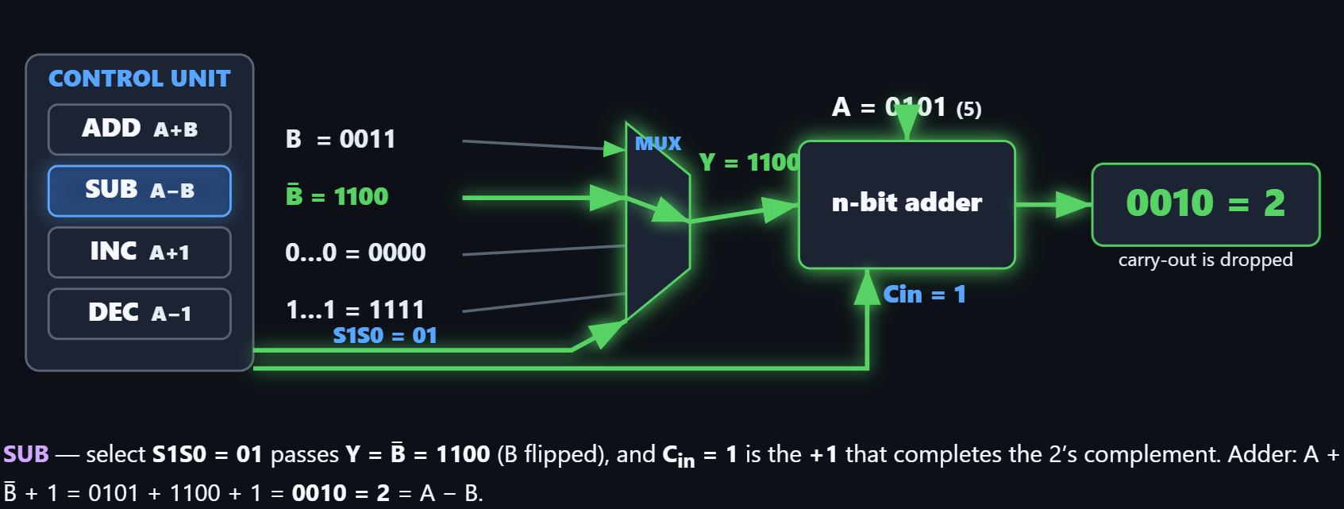
Example — 5 − 3: 3 = 0011 → flip → 1100 → +1 → 1101; 0101 + 1101 = 1 0010; drop the carry → 0010 = 2.

Logic (bitwise) microoperations
- AND — mask / clear a bit; OR — selective-set a bit; XOR — toggle; NOT — complement.
- There are 16 logic microoperations, all built from 4 basic ones: AND, OR, XOR, NOT.
- Clear a flag bit (lets clear the third bit) with AND:
- Flags-register contains 1011
- Now let’s AND 1101(0s only where you want to clear) with the reg to clear the third bit
- 1001 is the result of that AND (that bit → 0, others unchanged).
- Similarly, Set with OR: flags 1001 OR 0100 = 1101 (that bit → 1, others unchanged).
- Extract a field: word AND 0000 1111 keeps the low nibble. Insert a field: AND to clear the field, then OR the new bits in.

Shift microoperations
- Logical shift — 0 fills the vacated end.
- Arithmetic shift — the sign bit is preserved on shift-right (ashr), so dividing a negative number by 2 stays negative.
- Circular shift — the bit wraps around.
- Left shift = ×2, right shift = ÷2; shift by k = ×2^k or ÷2^k.

Multiply & divide
- Multiply = shift-and-add: for each 1 in the multiplier, add a shifted copy of the multiplicand.
- An n-bit multiplier needs at most n shifts + n adds.
- Divide = shift-and-subtract (the mirror of multiply).

ALU
- The ALU = arithmetic unit + logic unit + shift unit, the operation chosen by select lines.

Chapter 3 — Execution of Complete Instructions

The datapath
- Register file — two read ports (A, B) and one write port (C).
- Interstage registers — RA, RB (operands), RZ (ALU result), RM (memory data out), RY (data written back).
- A multiplexer (MuxY) chooses the ALU result (for arithmetic) or the memory data (for a load); RY holds the value for write-back.
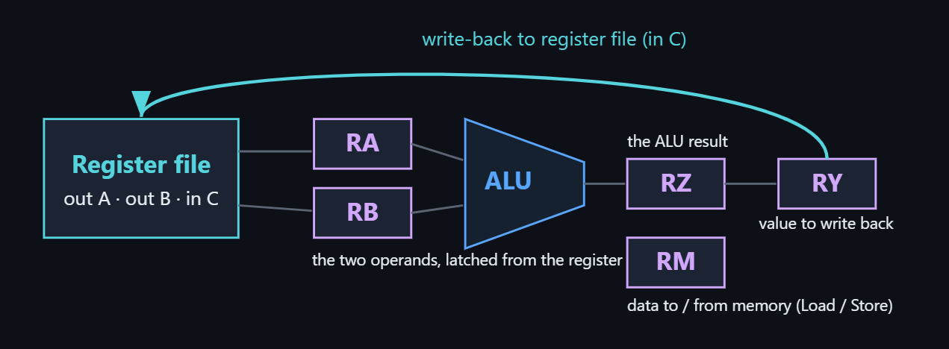
Processor datapath — register file → RA/RB → ALU → RZ → RY → back to port C; RM to memory.

The five-step sequence
- 1 Fetch — read the instruction at [PC]; increment the PC.
- 2 Decode — work out the operation; read the source registers.
- 3 Compute — the ALU performs the operation or computes an address.
- 4 Memory — read/write data (only for Load / Store).
- 5 Write-back — the result returns to the destination register.

Trace: Load R2, A (absolute)
Step | Register transfers
1 Fetch | MAR ← [PC]; MDR ← M[MAR]; IR ← [MDR]; PC ← PC + 4
2 Decode | opcode = Load; dest = R2
3 Compute | — no ALU work (A is already the address)
4 Memory | MAR ← A; MDR ← M[MAR]; RY ← [MDR]
5 Write-back | R2 ← [RY]

Effective address (indexed load)
- Load R2, 20(R5): effective address = [R5] + 20; the ALU adds base + offset in the Compute step.
- If R5 = 1000, the effective address is 1020.

Chapter 4 — Bus Organization

Single-bus vs three-bus
- Single-bus — one shared internal path; one transfer per clock; cheap but slow (bottleneck). Memory is reached only through MAR (address) and MDR (data).
- Three-bus (multiple-bus) — Bus A and Bus B carry both operands to the ALU at once; Bus C returns the result — the whole operation in one step.
- Add R4, R2, R3: single-bus ≈ 3 steps; three-bus = 1 step. More buses = fewer clocks, more wiring.
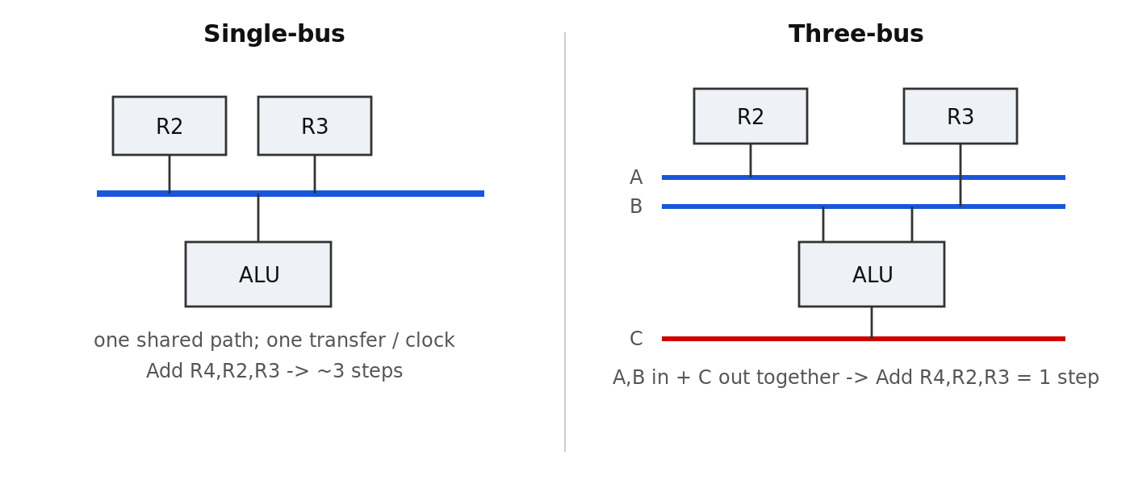
Single-bus (one shared path) vs three-bus (A, B in — C out) datapath.

Who builds which
- Single/multi-bus datapath — micro-programmed CISC (8086, 68000, VAX) and simple microcontrollers (8051-class, IoT nodes); chosen when cost/area/power matter.
- Five-beat pipeline — RISC machines chop the same datapath into five fixed stages and overlap instructions for throughput.

Chapter 5 — Control Unit

What the control unit does
- Turns (IR + step counter + condition flags Z,N,C,V) into control signals, every clock.
- Drives the control points: register loads (MARin, MDRin …), bus enables (PCout …), the ALU function, memory Read / Write.
- Two ways to build it: hardwired or microprogrammed.

Hardwired control
- Three parts: instruction decoder + step counter (T1–T5) + control-signal generator (combinational logic).
- Each control signal is a Boolean equation, e.g. Read = T1 + T4·LOAD, and MARin = T1 + T4·(LOAD+STORE).
- Fast but rigid (changing an instruction means redesigning the logic) → suits RISC.

Microprogrammed control
- Control signals are stored as microinstructions in a control store; a μPC / CAR and an address generator sequence them.
- Microinstruction = control word (the signal bits) + sequencing word (the next address); the End bit ends a microroutine.
- Flexible but slower (a control-memory read each step) → suits CISC.
- Sequencing (4 ways the μPC picks the next microinstruction): increment (in-line), branch / conditional branch, opcode map, End.

Hardwired vs microprogrammed (exam table)
Property | Hardwired | Microprogrammed
Decision lives in | fixed logic gates | a control store (memory)
Speed | faster — one gate delay | slower — a memory read per step
Flexibility | rigid — rewire to change | flexible — rewrite microcode
Complex instruction sets | hard (huge logic) | easy (just more microcode)
Best fit | RISC (simple, regular) | CISC (rich, complex)

