Name :- Aishwarya Subhash Kasulkar
Task :-
Part 1 and Part 2
NOTE :- The exact format for JSON fields were not specified so while extracting data the generic assumptions have been considered
I could not finish the RND for pipeline in 1-2 paages
Your parsing pipeline should implement the following workflow:
graph TD
LoadURLs[Load Document URLs]
--> DownloadPDFs[Download PDFs]
--> DetectType[Detect Document Type]
--> ParseContent[Parse Content]
--> ValidateData[Validate & Clean Data]
--> OutputJSON[Generate JSON Output]
Proposed Solution :- https://github.com/aishunewgithub/task-proposed-solution.git
Part 3
Search System Architecture (Design Only)
Design a comprehensive search system that enables users to query the parsed financial data
using natural language. Note: Implementation is not required - provide a detailed
architecture diagram and explanation.

Proposed Solution :-

Overview :-
Architecture Diagram :-
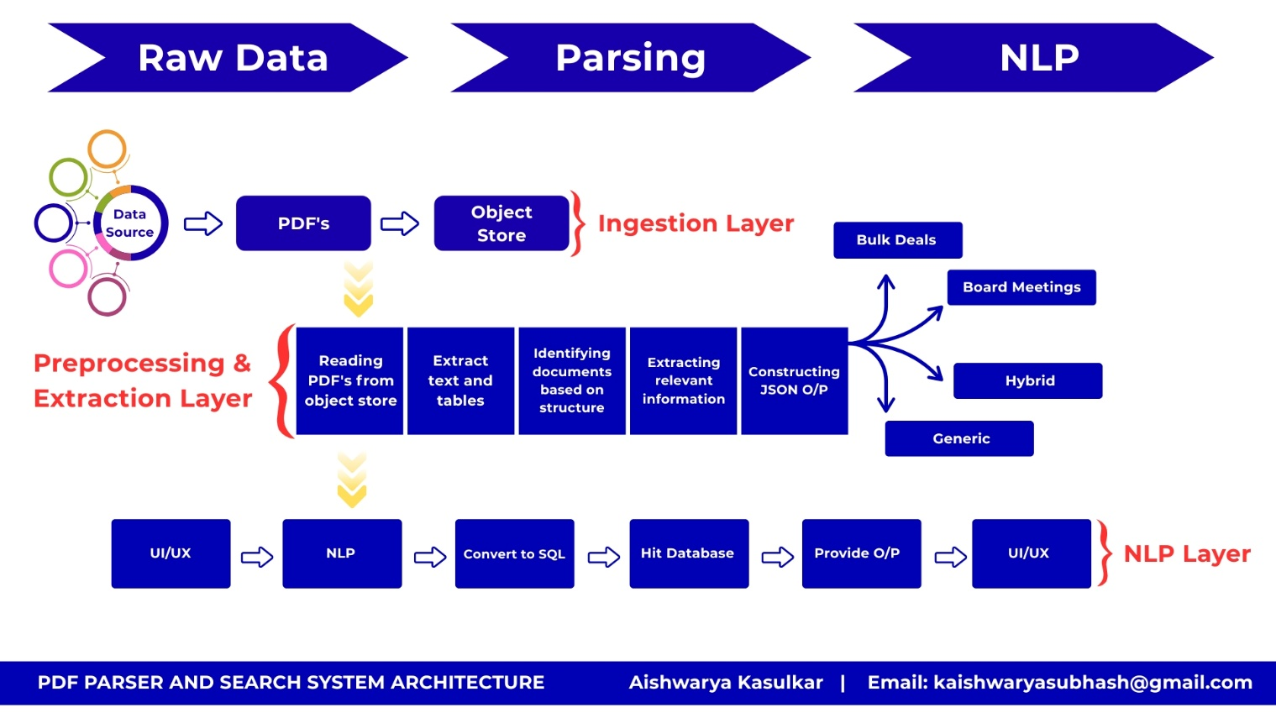
Fig.1 - PDF Parser and Search System Architecture

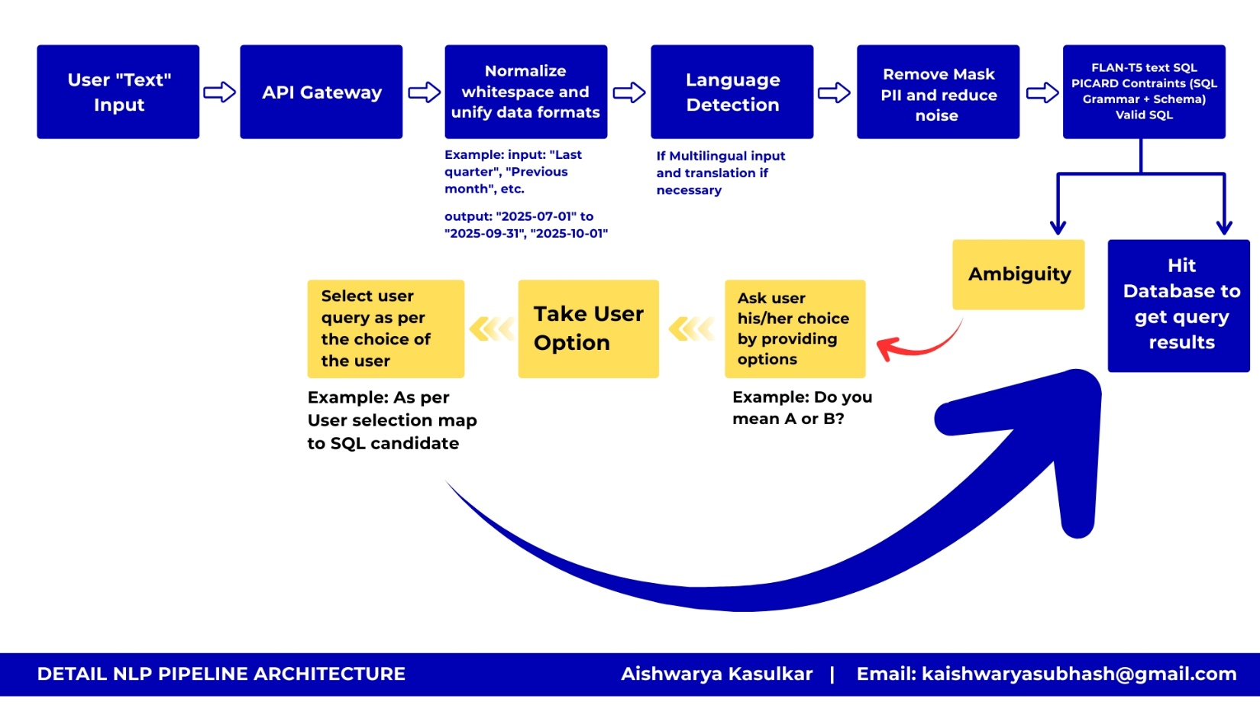
Fig. 2 - Detail NLP Pipeline Architecture

High-level architecture
UI → API Gateway → NL→SQL Service (parser + validator + execution layer) → RDBMS (or Federated DBs) → Results → Postprocessor → UI
Supporting systems: Auth, Schema service, Cache, Vector DB (optional), Observability, Model Serving infra

Detailed NL → SQL pipeline (step-by-step)
I’ll break this into stages
2.1 Ingest & Preprocess (UI → backend)
- Tasks
  - Normalize whitespace, punctuation; unify date formats (e.g., "last quarter" → canonical window).
  - Language detection (if multi-lingual) and translation step if necessary.
  - Remove or mask PII if user text may contain sensitive identifiers.
- Why
  - Reduce noise for the parser; normalize date/time and monetary expressions.
- Tech
  - Python text normalization (regex + dateparser) or spaCy pipelines.
  - Optionally a small translation model (if we accept other languages).
2.2 Schema & Catalog Lookup (essential)
- Purpose
  - Provide the parser with the DB schema (tables, columns, types, joins, primary keys), column value examples, and table relationships.
- How
  - A lightweight Schema Service that returns structured JSON for a DB: {tables:[{name, columns:[{name,type,example_values}]}, relationships: [...]]}.
  - Keep sample values for each column (200-500 tokens) to enable schema linking and value grounding.
- Why
  - Text->SQL models depend heavily on schema linking; embedding-centric semantic matching or pointer-copy also need it.
2.3 Schema Linking & Entity Resolution
- Task
  - Map tokens in the user query to columns/tables and example values (e.g., "revenue" → financials.revenue, "2024 Q3" → date filter).
- Techniques
  - Rule-based heuristics (token normalization + fuzzy string match)
  - Embedding-based similarity: embed column names and query tokens, find nearest neighbors.
  - Use morphological normalization and Chinese/Japanese tokenization if multi-lingual.
- Why
  - Accurate linking reduces hallucination and improves constrained decoding success.
- Recommended approach (balanced): Use a schema-aware model (RAT-SQL or a fine-tuned Flan-T5 with schema tokens) plus constrained decoding (PICARD) and execution-guided reranking (run candidate SQL in a safe read-only sandbox to check results and errors).
- Why
  - Constrained decoding prevents syntactic nonsense and enforces use of real columns. Execution-guided checks reduce semantic errors (e.g., column types mismatch).
2.6 Reranking & Result Selection
- Generate N candidates (beam), validate execution status, and rank:
  - Rank features: execution success, row count sanity, match to user intent (semantic similarity between query result header and query), precision of filters.
- Optionally present 2- 3 candidate interpretations to users as clarifying options (e.g., “Did you mean A or B?”).
2.7 Postprocessing & Formatting
- Format numeric types, date types, units; compute aggregates.
- Return structured JSON: metadata, extracted SQL, result preview, confidence score, warnings.

3 - Recommended technologies (model & infra) and why
Splitting into Modeling and Infrastructure
3.1 Modeling / ML stack Best-in-class (production-readiness)
- Model type: Schema-aware Transformer (RAT-SQL style) OR Fine-tuned Flan-T5 / Text-to-SQL variant + PICARD constrained decoding.
  - Why: RAT-SQL excels at complex multi-join queries and explicit schema linking; Flan-T5 / T5 is flexible and works well when you can fine-tune a lot of domain examples.
- Constrained decoding / PICARD: enforce grammar to produce only valid SQL AST tokens.
- Execution-guided reranking: run candidate SQL and prefer the candidate which executes correctly and returns sensible rows.
Concrete models (open-source choices)
- RAT-SQL + Spider dataset family (useful for cross-domain text-to-SQL). Good for generalization.
- T5/Flan-T5 / CodeT5 fine-tuned on your domain examples (if you can create an annotated dataset).
- Picard (a wrapper that enforces grammar during decoding for seq2seq models).
- Embedding model for schema linking: MiniLM / SBERT or Open-source CLIP-style sentence-transformers (fast and cheap).
Hosted / managed options (if you prefer less ops)
- OpenAI / Anthropic / Cohere text-generation endpoints (ease-of-use), but check costs + data residency.
- Vertex AI / Azure ML / Sagemaker for managed fine-tuning & model serving (if you want to host large models with less infra setup).
3.2 Infrastructure & tooling
Model serving
- Ray Serve / TorchServe / KFServing (KServe): scalable model serving, supports batching and autoscaling.
  - Use GPU-backed nodes for latency-sensitive paths; CPU for small/light models.
- Containerization: Docker images for model servers (makes CI / CD easy).
- Orchestration: Kubernetes (k8s) with Horizontal Pod Autoscaler.
- Batching: Aggregate multiple user requests into a single model forward pass to improve throughput.
Database
- Transactional DB: PostgreSQL (good defaults), or MySQL if legacy.
- Analytics / Data Warehouse: BigQuery, Snowflake or ClickHouse for large historical queries.
- Schema service: Lightweight microservice storing schemas & cached sample values (Redis + Postgres).
Caching & Search
- Result cache: Redis or Memcached for repeated queries.
- Vector DB (optional): Milvus / Weaviate / Pinecone for retrieval-augmented features or to find column examples and synonyms.
API & Orchestration
- API Gateway: Kong / AWS API Gateway / Nginx for rate-limiting and routing.
- Auth: OAuth2 / JWT, role-based access control to DBs.
- Job Queue: RabbitMQ / Kafka for async large queries and retries.
Observability
- Metrics: Prometheus + Grafana
- Tracing: OpenTelemetry
- Logging: ELK stack (Elastic) or Loki.
DevOps / CI
- CI/CD: GitHub Actions or GitLab CI to build and deploy Docker images.
- Infra as Code: Terraform, Helm charts for k8s.

4 - Concrete design decisions, pros & trade-offs
Model choices
- Fine-tuned Flan-T5 / T5
  - Pros: flexible, strong with fine-tuning, works well for sequence generation.
  - Cons: needs labeled data; may hallucinate column names unless constrained.
- RAT-SQL / schema-aware transformer
  - Pros: built for text→SQL; explicit schema linking; handles joins better.
  - Cons: heavier to integrate; more research-engineering to fine-tune.
- Managed API (OpenAI/Cohere)
  - Pros: low setup, fast experimentation.
  - Cons: data privacy concerns, cost at scale, limited control.
Recommendation: start with RAT-SQL or fine-tune a T5 with PICARD enforced decoding. For a quick POC, experiment with managed LLMs, then migrate to fine-tuned open-source for scale/control.
Execution-guided validation
- Why: prevents nonsensical queries from running; fixes type mismatches and wrong aggregations.
- Trade-off: extra round-trip latency and DB load for validation. Mitigate via sandbox DB (smaller sample) or EXPLAIN instead of full runs.
Caching & Result Sampling
- Cache results for identical queries.
- For heavy queries, return a sampled preview and provide a background job to compute full results.
Safety & SQL injection
- Do not execute raw model output directly. Parse SQL and convert literal values to parameters.
- Use DB user with read-only permissions for NL->SQL execution.

5 - Scalability & performance strategy
Autoscaling
- Model servers: scale by CPU/GPU usage, latency SLOs using HPA (k8s).
- API nodes: scale horizontally behind load balancer.
- DB: Connection pooling (PgBouncer) + read replicas for large read workloads.
Latency optimization
- Model quantization / distillation: use ONNX or 8-bit quantization for faster CPU serving.
- Batching & asynchronous processing: batch model calls across requests; return “preview” quickly and compute expensive aggregations asynchronously.
- Cache frequently run queries and their results.
Cost trade-offs
- GPUs reduce latency but cost more; CPU+quantized model can be cheaper but with higher latency.
- Mixed inference: small models for simple queries; route complex queries to larger models.
Throughput & DB load
- Rate-limit and throttle large ad-hoc queries.
- Provide pre-aggregations or materialized views for commonly asked questions.
- Use a data warehouse for heavy analytics; the NL→SQL service can decide whether to target OLTP (Postgres) vs DW (BigQuery).

6 - Security, privacy & governance
- Least privilege DB roles: read-only users for model-generated queries.
- SQL whitelist or grammar checks: disallow DDL/DML beyond SELECT.
- Parameterization: replace literals with parameters before execution.
- Audit & explainability: log original NL query, generated SQL, execution plan, returned rows (mask PII).
- Rate limiting and quota per user.
- Data residency: keep models and inference inside necessary jurisdiction if required.

7 - Example data flow (concrete JSON outputs)
When the user asks: “Show total revenue by product for Q3 2024”, the system returns structured JSON (example):
{
"query": "Show total revenue by product for Q3 2024",
"detected_doc_type": null,
"sql_candidates": [
{
"sql": "SELECT product_name, SUM(revenue) as total_revenue FROM sales WHERE date >= '2024-07-01' AND date <= '2024-09-30' GROUP BY product_name ORDER BY total_revenue DESC LIMIT 100;",
"confidence": 0.86,
"execution_status": "success",
"row_count": 42,
"warnings": []
}
],
"selected_sql": "...",
"result_preview": [
{"product_name":"A","total_revenue":123456.78},
{"product_name":"B","total_revenue":98765.43}
],
"extraction_timestamp": "2025-11-30T12:34:56Z"
}

8 - Monitoring & quality metrics
Track:
- NL→SQL accuracy (measured on golden set).
- Execution success rate (SQL candidates that run without errors).
- Latency percentiles for model + DB.
- Cost per query (for billing).
- User feedback loop: allow users to mark results “correct/incorrect” to collect training data for fine-tuning.

10 - Concrete component list + suggested stack
- UI: React + TypeScript
- API Gateway: Kong / Nginx / AWS API Gateway
- Auth: OAuth2 / JWT
- NL→SQL Service: Python microservice (FastAPI)
- Model serving: Ray Serve or KServe; models packaged in Docker
- Models: RAT-SQL or T5 (Hugging Face), PICARD for constrained decoding
- Schema service: Flask/FastAPI + Postgres + Redis (cache)
- Executor: SQL sandbox with PgBouncer + read replicas
- Cache: Redis (result cache)
- Vector DB (optional): Milvus / Weaviate for schema embedding & retrieval
- Observability: Prometheus + Grafana, OpenTelemetry
- CI/CD: GitHub Actions + Docker + Helm
- Infrastructure: Kubernetes (EKS/GKE/AKS) + Terraform
- Data Warehouse: BigQuery / Snowflake (for analytics)

