AWS CloudWatch Monitoring & Alerts Practical
Service: Amazon CloudWatch | Supporting services: Amazon EC2 and Amazon SNS

1. Objective
To view an EC2 CPU utilization metric in CloudWatch, create an alarm using a 70% threshold, configure notification actions, and verify the alarm state.

2. Configuration
- Metric namespace: AWS/EC2
- Metric: CPUUtilization
- Statistic: Average
- Period: 5 minutes
- Condition: CPU utilization greater than 70%
- Evaluation: 1 datapoint within 5 minutes
- Alarm name: EC2-CPU-High-Alarm
- Notification topic: EC2-CPU-Alerts (as documented in the supplied README)

3. Procedure
- Open AWS Management Console and select the Asia Pacific (Mumbai) region.
- Open CloudWatch → Metrics → EC2 → Per-Instance Metrics.
- Select CPUUtilization for the EC2 instance and choose Create alarm.
- Set the threshold to Greater than 70 and the period to 5 minutes.
- Configure an SNS topic and email endpoint if notifications are required.
- Name the alarm EC2-CPU-High-Alarm, review the configuration, and create it.
- Open CloudWatch → Alarms and check the alarm state.

4. Result and Observation
The supplied README states that the alarm was created successfully and the final captured screen shows the alarm in the OK state. OK means the alarm condition was not breached at the time of the screenshot; it does not mean the alarm was triggered.

5. Screenshot Evidence
Figure 1. EC2 CPU utilization metric.
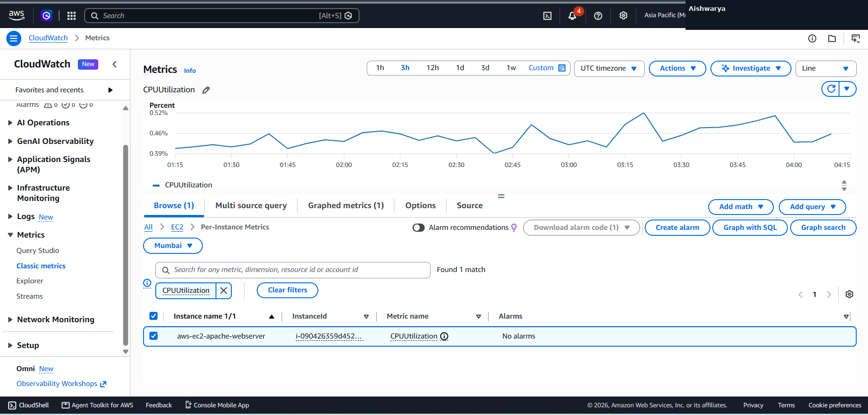
Figure 2. Alarm threshold configuration.
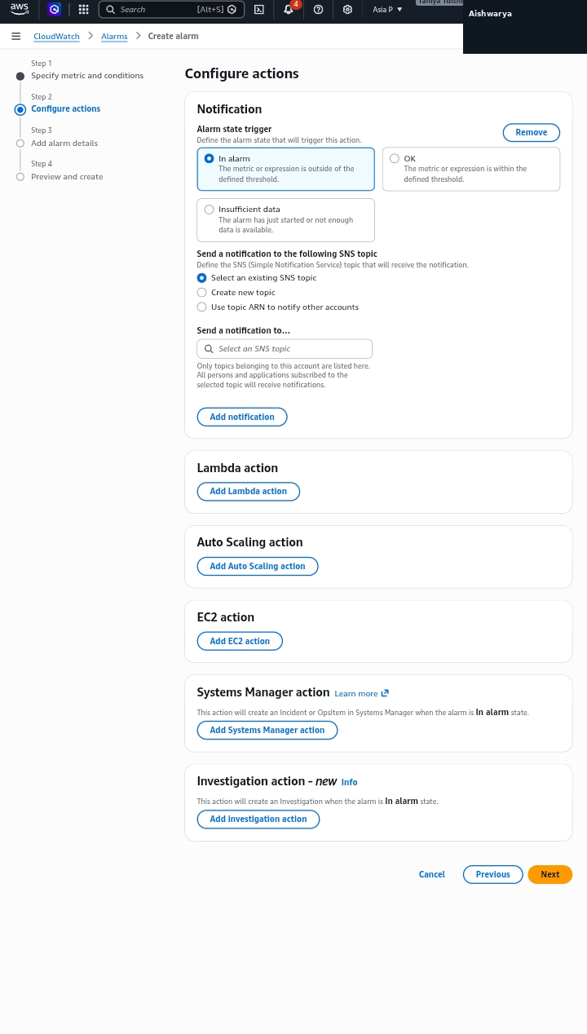
Figure 3. Notification actions configuration.
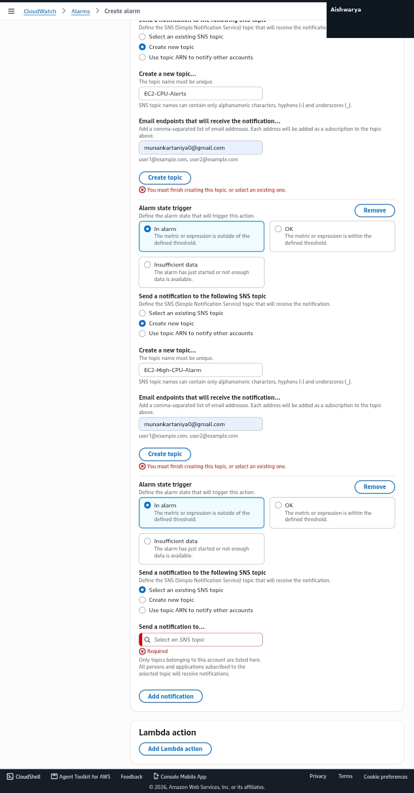
Figure 4. Alarm name and description.
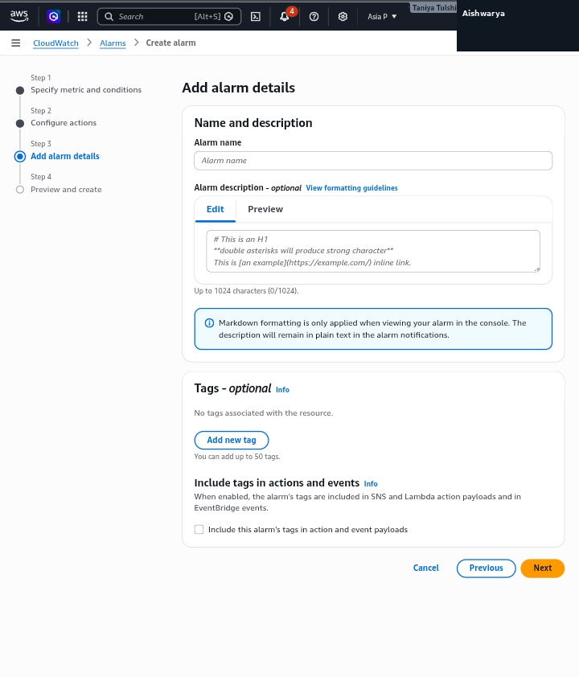
Figure 5. Review before alarm creation.
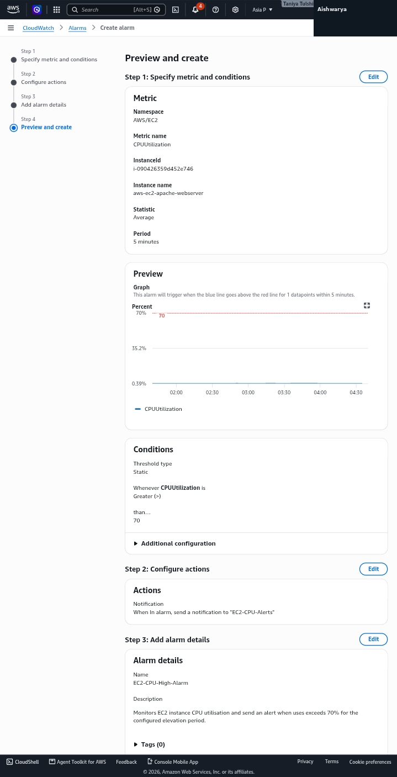
Figure 6. Alarm shown in the alarms list.
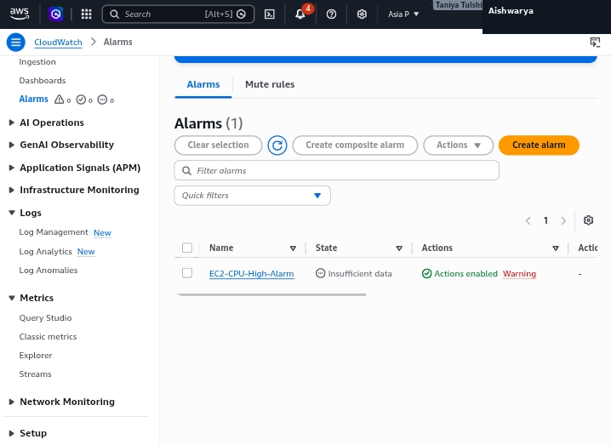
Figure 7. Alarm details showing OK state.
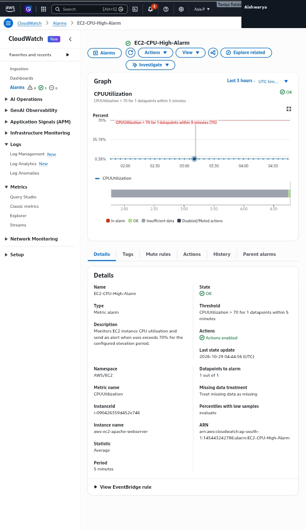

6. Safety and Privacy Notes
The AWS profile-name area in the screenshots has been replaced with “Aishwarya” for this presentation copy. Review all screenshots for account IDs, email addresses, instance identifiers, or other details before publishing the repository publicly. Never upload AWS credentials or MFA codes.

7. Conclusion
This practical demonstrates viewing an EC2 CPU metric and configuring a CloudWatch alarm with an SNS notification action. The final evidence shows the alarm in the OK state.

