AWS S3 Bucket Versioning Practical
Platform: Amazon Web Services (AWS) | Service: Amazon S3 | Region shown: Asia Pacific (Mumbai), ap-south-1

1. Objective
To enable bucket versioning in Amazon S3, upload a test object, and verify that multiple object versions are available.

2. Procedure
- Open Amazon S3 and create a general-purpose bucket.
- Open the bucket Properties tab.
- Edit Bucket Versioning, enable it, and save the change.
- Upload the text file version-test.txt.
- Open the object's Versions tab and confirm that versions are listed.

3. Results and Observations
The supplied screenshots show Bucket Versioning enabled, a successful upload of version-test.txt, and two object versions. One is identified as the current version.

4. Screenshot Evidence
Figure 1. S3 bucket list.
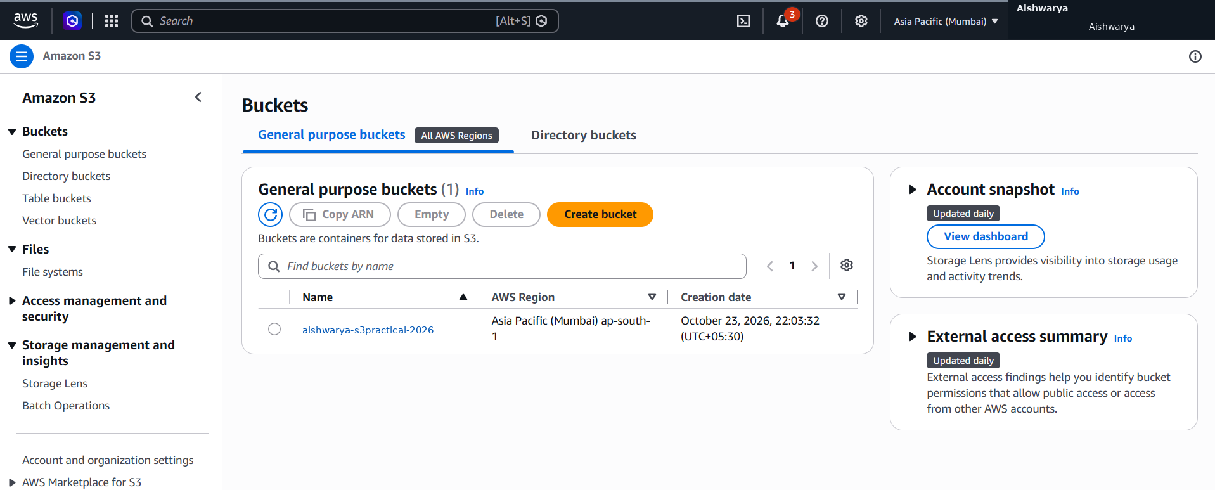
Figure 2. Bucket Versioning enabled.
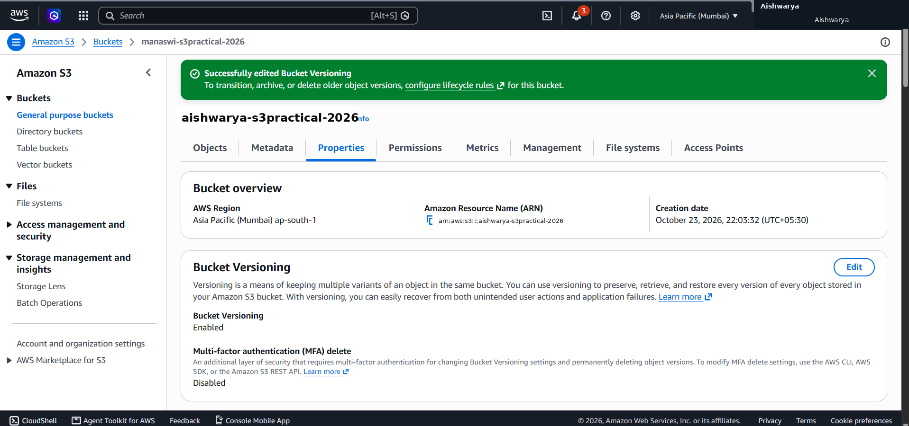
Figure 3. Successful file upload.
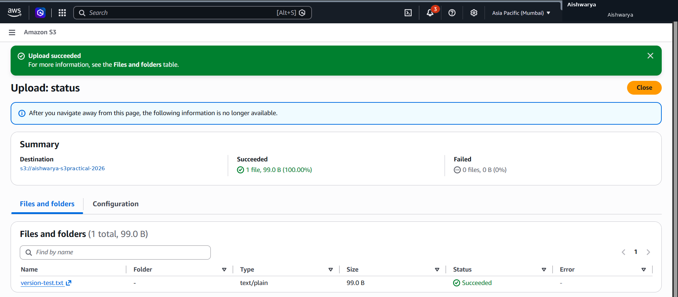
Figure 4. Object versions listed.
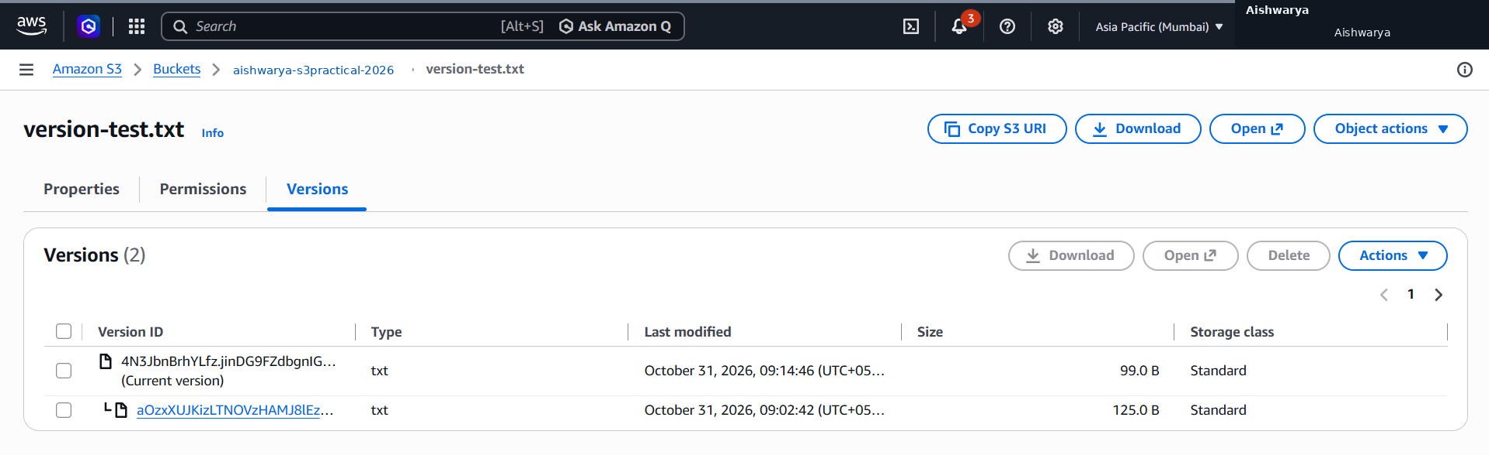

5. Screenshot Label Note
The visible name “Manaswi” was replaced with “Aishwarya” in the screenshots as requested. These are presentation copies; the actual bucket name in AWS may still differ. Ensure the final report matches the resources in your own AWS account.

6. Conclusion
Bucket Versioning was shown as enabled, and the object's Versions tab displayed two versions of version-test.txt.

