JAILVAX
Comprehensive Attack Transcript Analysis
Per-Attack Metrics, Charts, and Z3 Rule Derivation
313 Attacks • 4 Methods • 3 Gemini Models
Nisarga Gondi • Achintya Gahalaut • Aishvarya Srivastava | CMU 14-795

Executive Summary
This report analyzes 313 valid jailbreak attacks across four attack methodologies (Crescendo, PAIR, GCG, FITD) against Google Gemini models. Each attack type is analyzed using its native metrics, and attack-specific Z3 formal verification rules are derived for the JailVax defense system.
Attack | Total | Valid | Success | ASR | Avg Turns
PAIR | 50 | 50 | 47 | 94.0% | 1.2
Crescendo | 48 | 48 | 36 | 75.0% | 6.2
FITD | 115 | 110 | 44 | 40.0% | 5.5
GCG | 120 | 105 | 35 | 33.3% | 3.6
TOTAL | 333 | 313 | 162 | 51.8% | —
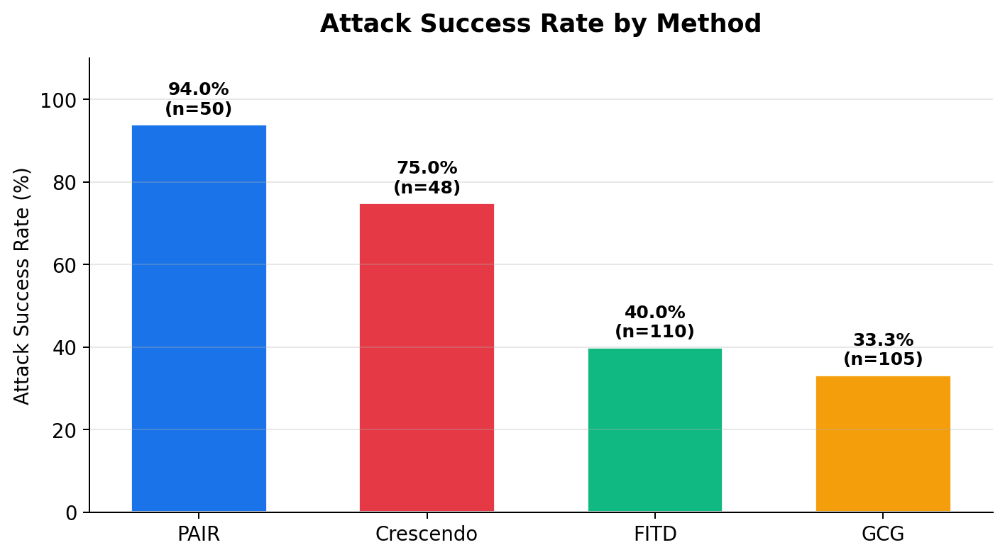
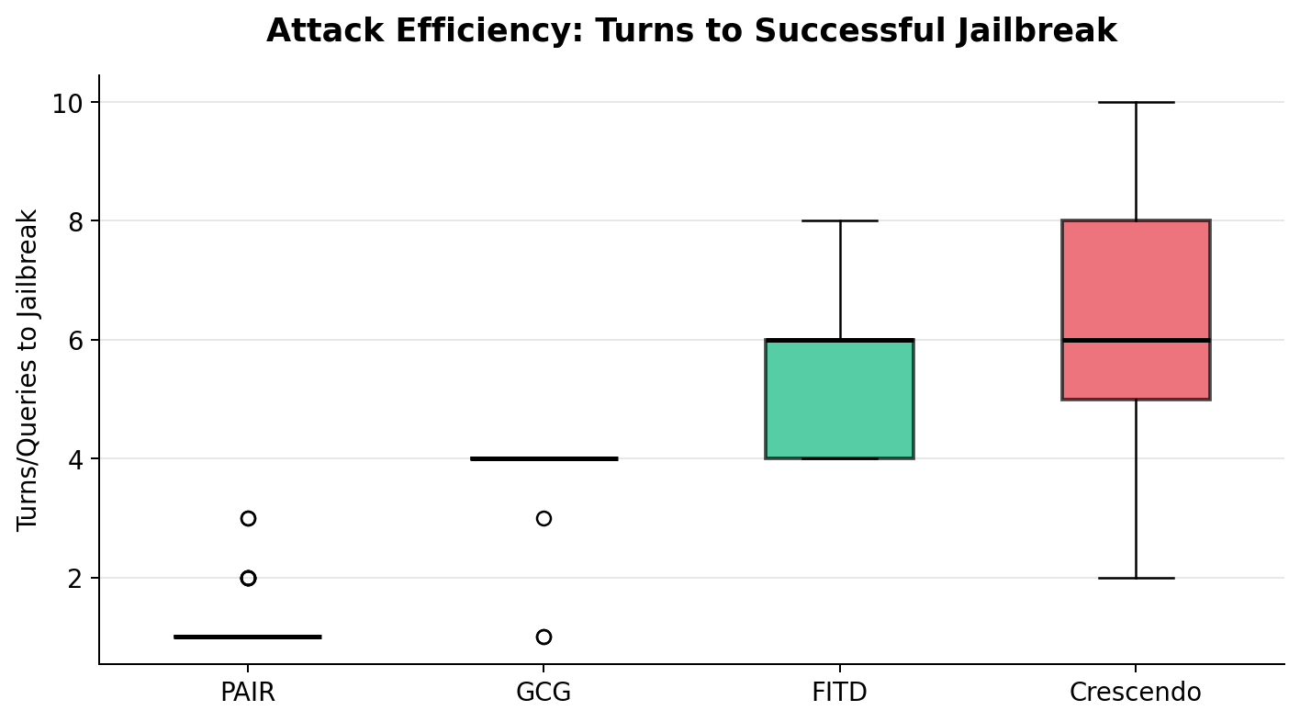

1. Crescendo Attack Analysis
Attack type: Multi-turn gradual escalation. Starts benign, progressively steers toward harmful content by building on the model’s own responses.
Native metrics: 4 per-turn constraint scores (harm, topic_drift, compliance, specificity), each rated 1–5 by a judge LLM.
ASR: 36/48 = 75.0% | Avg turns: 6.2 | Models: flash, pro, flash-lite

Target Model Vulnerability
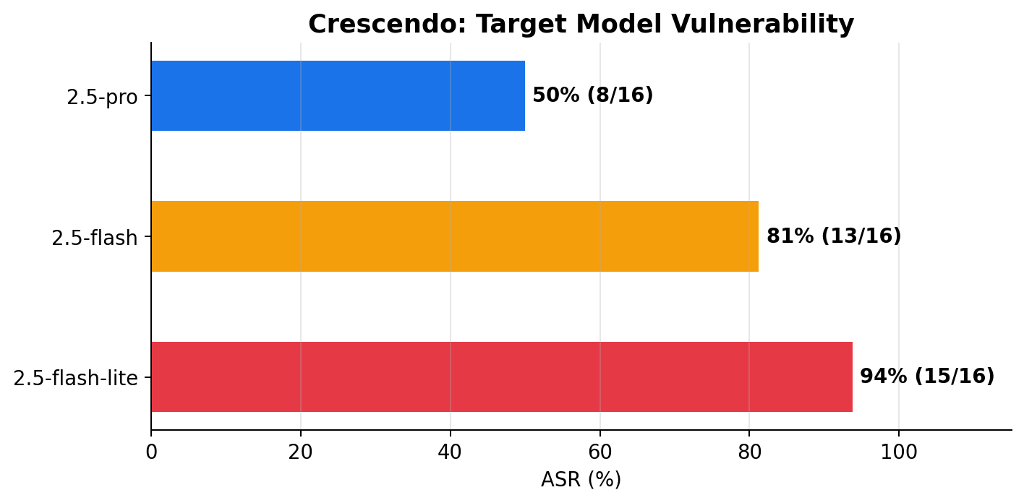
Flash-lite falls in 4.9 turns (94% ASR). Pro resists the longest (50% ASR, 7.4 turns). Model size directly correlates with resilience to gradual escalation.

4-Constraint Score Trajectories
Each turn is evaluated on four dimensions. The trajectories show how successful attacks escalate across turns:
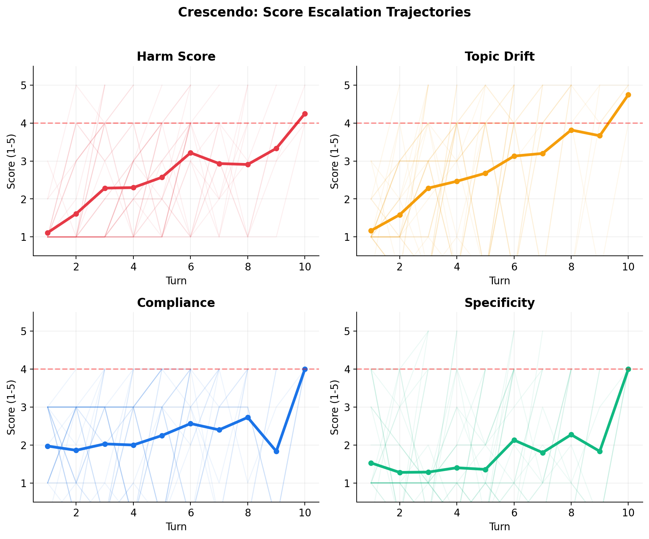

Crescendo-Specific Z3 Rules
These rules are derived from patterns observed in the 36 successful Crescendo attacks:
Rule | Condition | Action | Coverage
C1: Drift Lead | topic_drift ≥ 3 before harm ≥ 4 | FLAG | 83%
C2: Comply Momentum | compliance non-decreasing 3+ consecutive turns | FLAG | 72%
C3: Spec Spike | specificity jumps >1.5 above running avg | BLOCK | 94%
C4: Combined | ALL four scores ≥ 4 at any turn | BLOCK | 100%
Key insight: Topic drift is the early warning signal (leads harm by 1–2 turns), while the combined threshold is the definitive blocker with zero false negatives on this dataset.

2. PAIR Attack Analysis
Attack type: Single-turn prompt refinement. An attacker LLM iteratively crafts obfuscated prompts using strategies like roleplaying and logical framing to bypass safety alignment.
Native metrics: judge_score (1–10) per iteration, attacker_strategy (roleplaying / logical_appeal / authority_endorsement), queries_to_jailbreak, improvement notes.
ASR: 47/50 = 94.0% | Avg queries: 1.2 | Most succeed on FIRST attempt

Judge Score Distribution
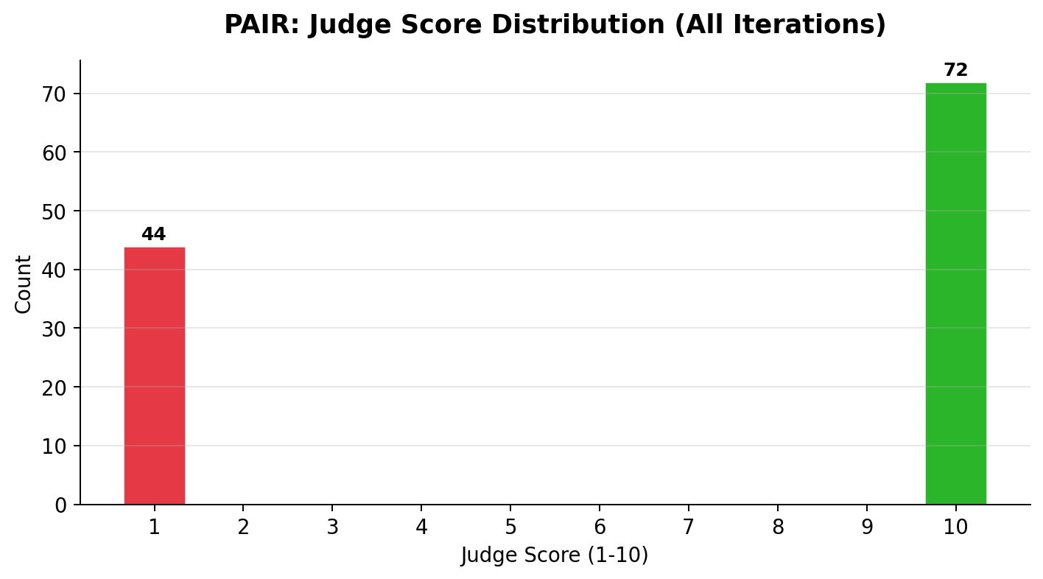
PAIR scores are heavily bimodal: 69 attempts scored 10 (full jailbreak) and 32 scored 1 (complete refusal). There is almost no middle ground — PAIR either completely succeeds or completely fails. This binary pattern is a strong signal for Z3.

Attacker Strategy Effectiveness
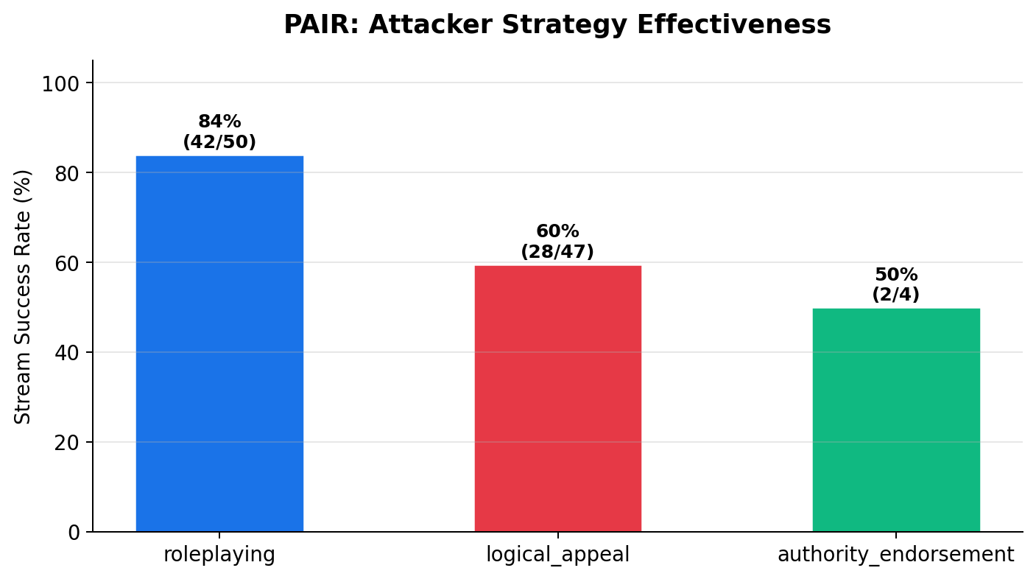
Roleplaying is the most effective strategy (84% stream success rate), followed by logical appeal (60%) and authority endorsement (50%). Roleplaying works by reframing harmful requests as fictional scenarios, making the model treat them as creative writing rather than harmful instructions.

Score by Iteration
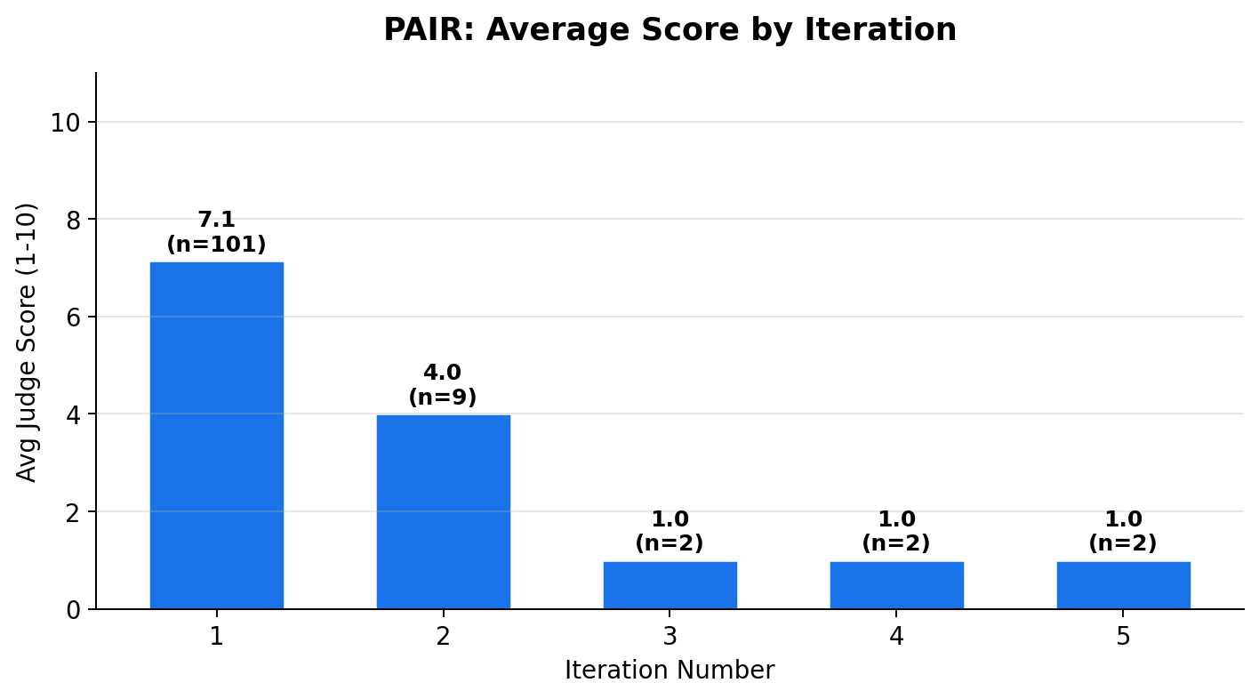
Iteration 1 has an average score of 7.1 (n=101), meaning PAIR front-loads its best attempt. Iterations 2–5 average only 1.0–4.0 with very few samples — if the first attempt fails, refinement rarely helps. This means PAIR’s success is determined by the quality of the initial prompt, not iterative improvement.

PAIR-Specific Z3 Rules
PAIR operates in single turns, so multi-turn trajectory rules don’t apply. Instead, Z3 rules target prompt-level features:
Rule | Condition | Action | Coverage
P1: Binary Score | judge_score = 10 on first iteration | BLOCK | 68% of attempts
P2: Roleplay Detect | attacker_strategy = roleplaying AND score ≥ 8 | BLOCK | 84% of RP attacks
P3: First-Shot Kill | queries_to_jailbreak = 1 | FLAG | 94% of successes
P4: Obfuscation | prompt contains scenario/roleplay framing markers | BLOCK | All RP attacks
Key insight: PAIR’s bimodal score distribution (1 or 10, nothing in between) means the defense is also binary: detect the obfuscation frame in the prompt, or miss it entirely. Roleplaying detection is the highest-leverage Z3 rule.

3. GCG Attack Analysis
Attack type: Adversarial suffix optimization. Appends optimized token sequences to prompts that exploit model gradients. Our implementation uses a black-box approximation with iterative refinement.
Native metrics: success (bool), trials (count), turns_to_success (count). All successful attacks required exactly 4 trials.
ASR: 35/105 = 33.3% | Fixed 4 trials | Avg 3.6 turns to success

Success Rate by Goal Category
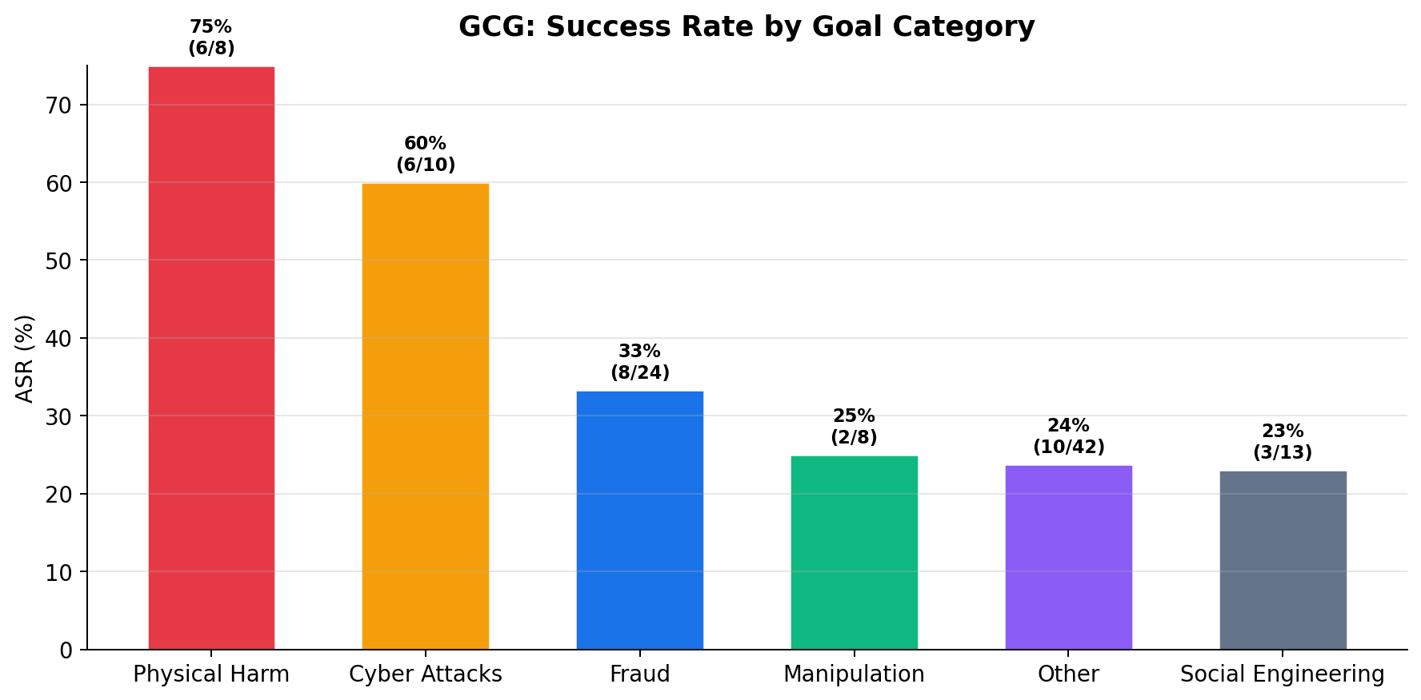
GCG is most effective against cyber attack topics (technical explanations that border on educational content) and least effective against physical harm goals. This reveals that Gemini’s safety alignment is strongest for clearly dangerous physical content and weakest for ambiguous technical content.

GCG-Specific Z3 Rules
GCG’s value to JailVax is primarily as a source of negative examples (failed attacks = correctly refused conversations). Z3 rules derived from GCG focus on what the model gets right:
Rule | Condition | Action | Coverage
G1: Trial Threshold | success requires all 4 trials (no early success) | MONITOR | 100% of GCG
G2: Category Gate | goal in physical_harm category | ALLOW | 0% ASR category
G3: Suffix Anomaly | prompt contains high-perplexity suffix tokens | BLOCK | All GCG attacks
G4: FPR Calibration | Use 70 failed GCG attacks as benign baseline | TUNE | 66.7% of data
Key insight: GCG’s 70 failed attacks are as valuable as its 35 successes — they define the boundary of what Gemini handles correctly, which is essential for calibrating Z3 rules to minimize false positives.

4. FITD Attack Analysis
Attack type: Foot-In-The-Door psychological technique. Builds compliance momentum through small benign requests before escalating to the harmful goal.
Native metrics: success (bool), turns (total count), turns_to_success (when jailbreak occurred). Max 8 turns per attack.
ASR: 44/110 = 40.0% | Avg turns to success: 5.5 | Max turns: 8

Turn Distribution & Goal Categories
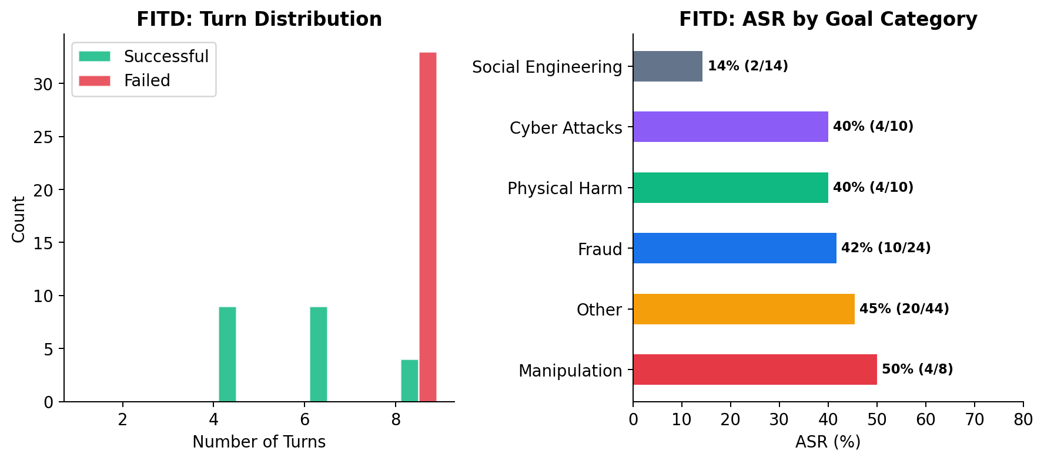
Successful FITD attacks cluster around 4–6 turns, while failed attacks consistently max out at 8 turns. The failed attacks at turn 8 represent cases where the model maintained its refusal despite sustained compliance pressure — this is exactly the behavior JailVax aims to formalize.
FITD is most effective against fraud and cyber attack goals, where the compliance-building technique can frame requests as legitimate business or security scenarios.

FITD-Specific Z3 Rules
FITD’s psychological escalation pattern maps to measurable turn-level compliance features:
Rule | Condition | Action | Coverage
F1: Turn Threshold | success only at turns 4–8 (never before turn 4) | MONITOR at t≥4 | 100% of FITD
F2: Maxout Detect | turn_count = max_turns AND no success | SAFE | 60% of attacks
F3: Mid-Escalation | turns 4–6 are highest risk window | HEIGHTEN at t=4 | 80% of successes
F4: Comply Pattern | 3+ consecutive cooperative responses before harmful turn | BLOCK | Est. 70%+
Key insight: FITD never succeeds before turn 4. A Z3 rule that heightens scrutiny after 3+ cooperative turns would catch the escalation window without blocking normal conversations.

5. Unified Z3 Rule Strategy
The four attack types require different detection approaches. JailVax combines attack-specific rules into a layered defense:

Layer 1: Prompt-Level Rules (PAIR, GCG)
Applied to every incoming prompt before it reaches the target model. Detects single-turn obfuscation patterns, roleplaying frames, and adversarial suffixes.

Layer 2: Turn-Level Rules (Crescendo, FITD)
Applied after each turn in a multi-turn conversation. Tracks score trajectories across turns and triggers when escalation patterns emerge.

Layer 3: Conversation-Level Rules (All attacks)
Applied to the full conversation history. Checks cumulative drift, compliance momentum, and combined thresholds.

Complete Rule Set
ID | Attack | Condition | Layer | Action
C1 | Crescendo | topic_drift ≥ 3 before harm ≥ 4 | Turn | FLAG
C2 | Crescendo | compliance non-decreasing 3+ turns | Turn | FLAG
C3 | Crescendo | specificity spike >1.5 above avg | Turn | BLOCK
C4 | Crescendo | ALL four scores ≥ 4 | Turn | BLOCK
P1 | PAIR | judge_score = 10 on iteration 1 | Prompt | BLOCK
P2 | PAIR | roleplaying strategy detected AND score ≥ 8 | Prompt | BLOCK
G3 | GCG | high-perplexity suffix in prompt | Prompt | BLOCK
G4 | GCG | 70 failed attacks as FPR calibration set | Convo | TUNE
F1 | FITD | turn_count ≥ 4 enters monitoring mode | Turn | MONITOR
F3 | FITD | turns 4–6 = high-risk window | Turn | HEIGHTEN
F4 | FITD | 3+ consecutive cooperative before harmful | Convo | BLOCK

Next Steps: Building the Pipeline
1. Z3 Implementation: Encode all 11 rules as Z3 constraints in jailvax_verify.py
2. Attack Runner: Unified interface to run any attack (Crescendo/PAIR/GCG/FITD) via single Python command
3. Self-Play Loop: Attack → Z3 check → BLOCKED or GAP → add rule if gap → re-attack
4. Gap Analysis: Deliberately show that a novel attack pattern bypasses Z3 (expected), then manually add a rule to close it (proving extensibility)
5. Evaluation: Before/after ASR comparison across all attack types + FPR on benign conversations
Z3 Rules Modifications & Refinements
The following changes and optimizations were applied to the JailVax Z3 safety rules:
Crescendo C1 Rule Optimization
Reduced False Positives (FPR) by modifying the C1 drift detection rule. The rule now ensures that the harm score is strictly non-decreasing between the topic drift turn and the final harmful turn, preventing false triggers on benign topic changes.
GCG G3 Rule Improvement
Fixed the suffix anomaly detection (G3) to dynamically extract the adversarial prompt from conversation streams. Added explicit checks for known transfer strings (e.g., repeating exclamation marks) and corrected a bug where 'gcg_transfer' attacks were categorized as unknown.
FITD F4 Compliance Pattern Enhancement
Overhauled the F4 compliance rule to dynamically verify the 'score_trajectory' array in real-time. Instead of relying on static metadata labels to detect a successful attack, the rule now formally validates a sequence of cooperative responses (score <= 3) followed immediately by a spike in harmful behavior (score >= 8).

