01/08/2023

1)write a java program to create generic method that take list of numbers and return the sum of all even and odd number

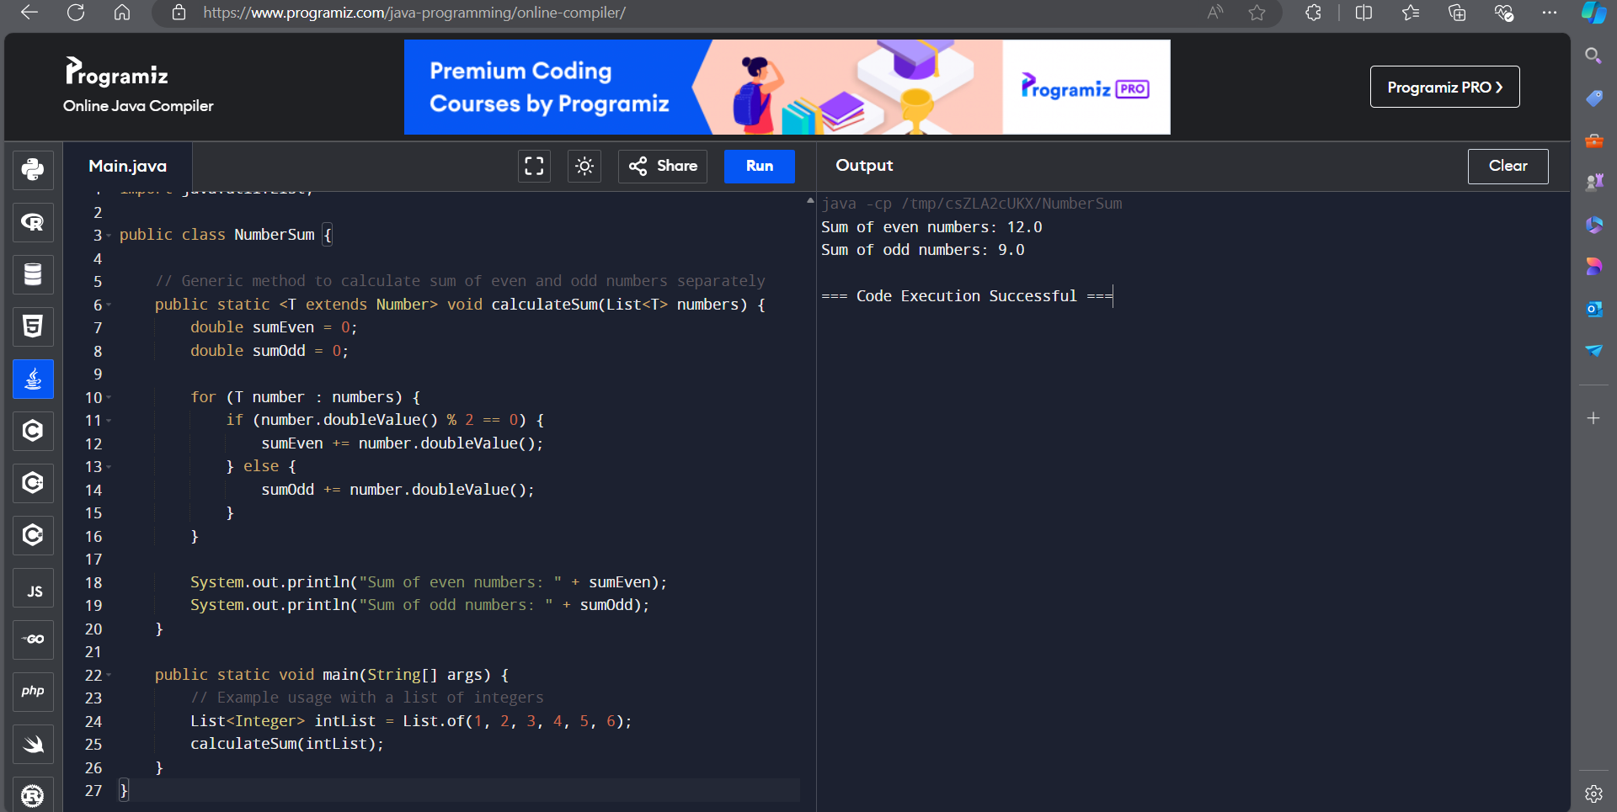

2)write a java program to create generic method that take list of any types and a target element it return the index of first occurece of the target element in the list

return -1 the target element cannot be found

