08/08/2024

1)CONSTRUCTOR OVERLOADING

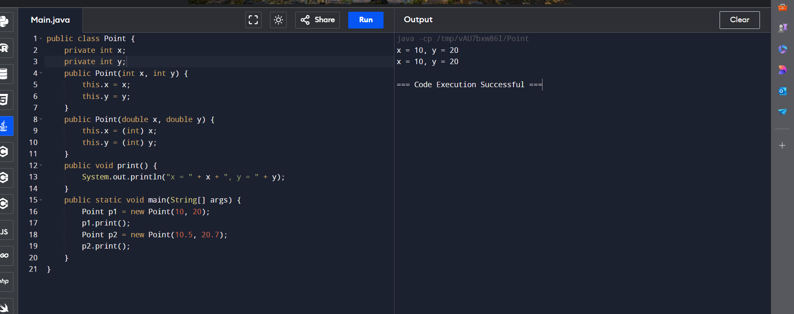

2)SEARCH A KEY

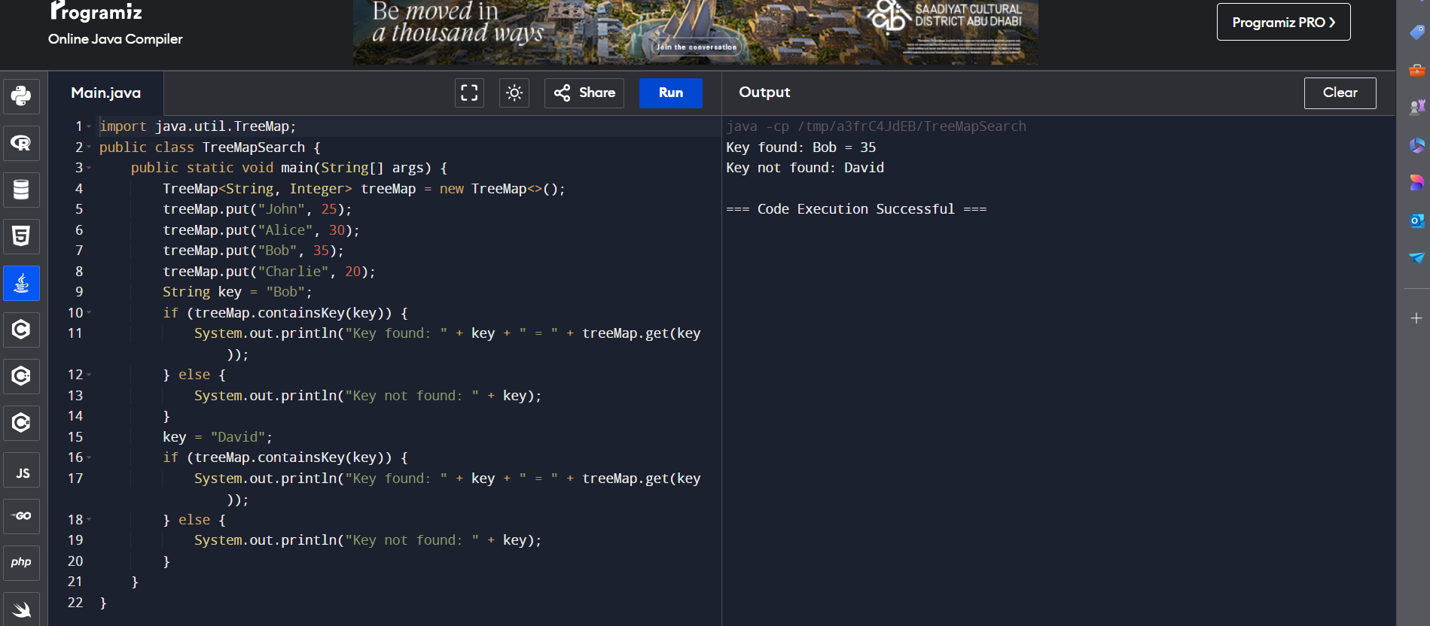

3)SORT KEYS IN A TREEMAP

