13/08/2024

1)IMAGE PROCESSING IN JAVAFX

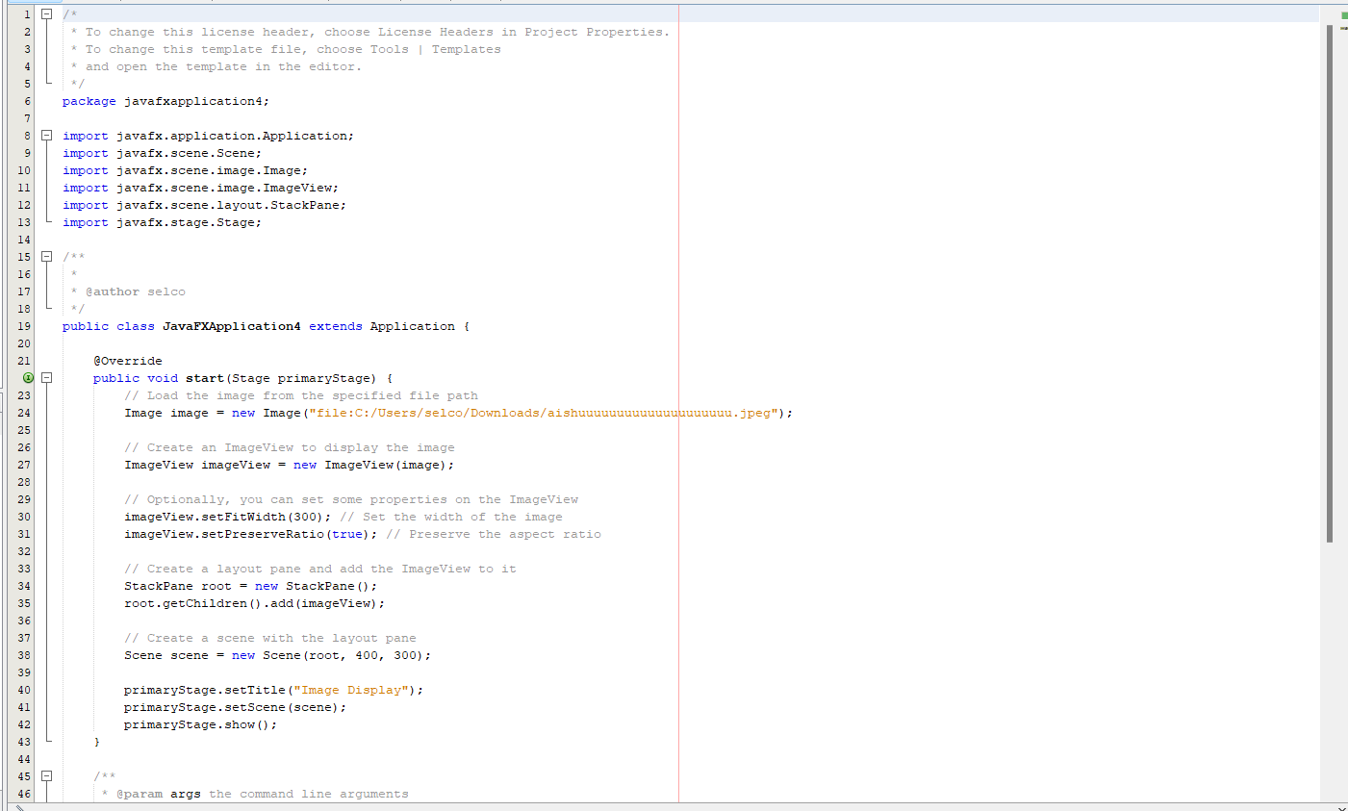

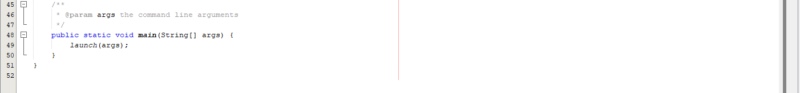

OUTPUT:

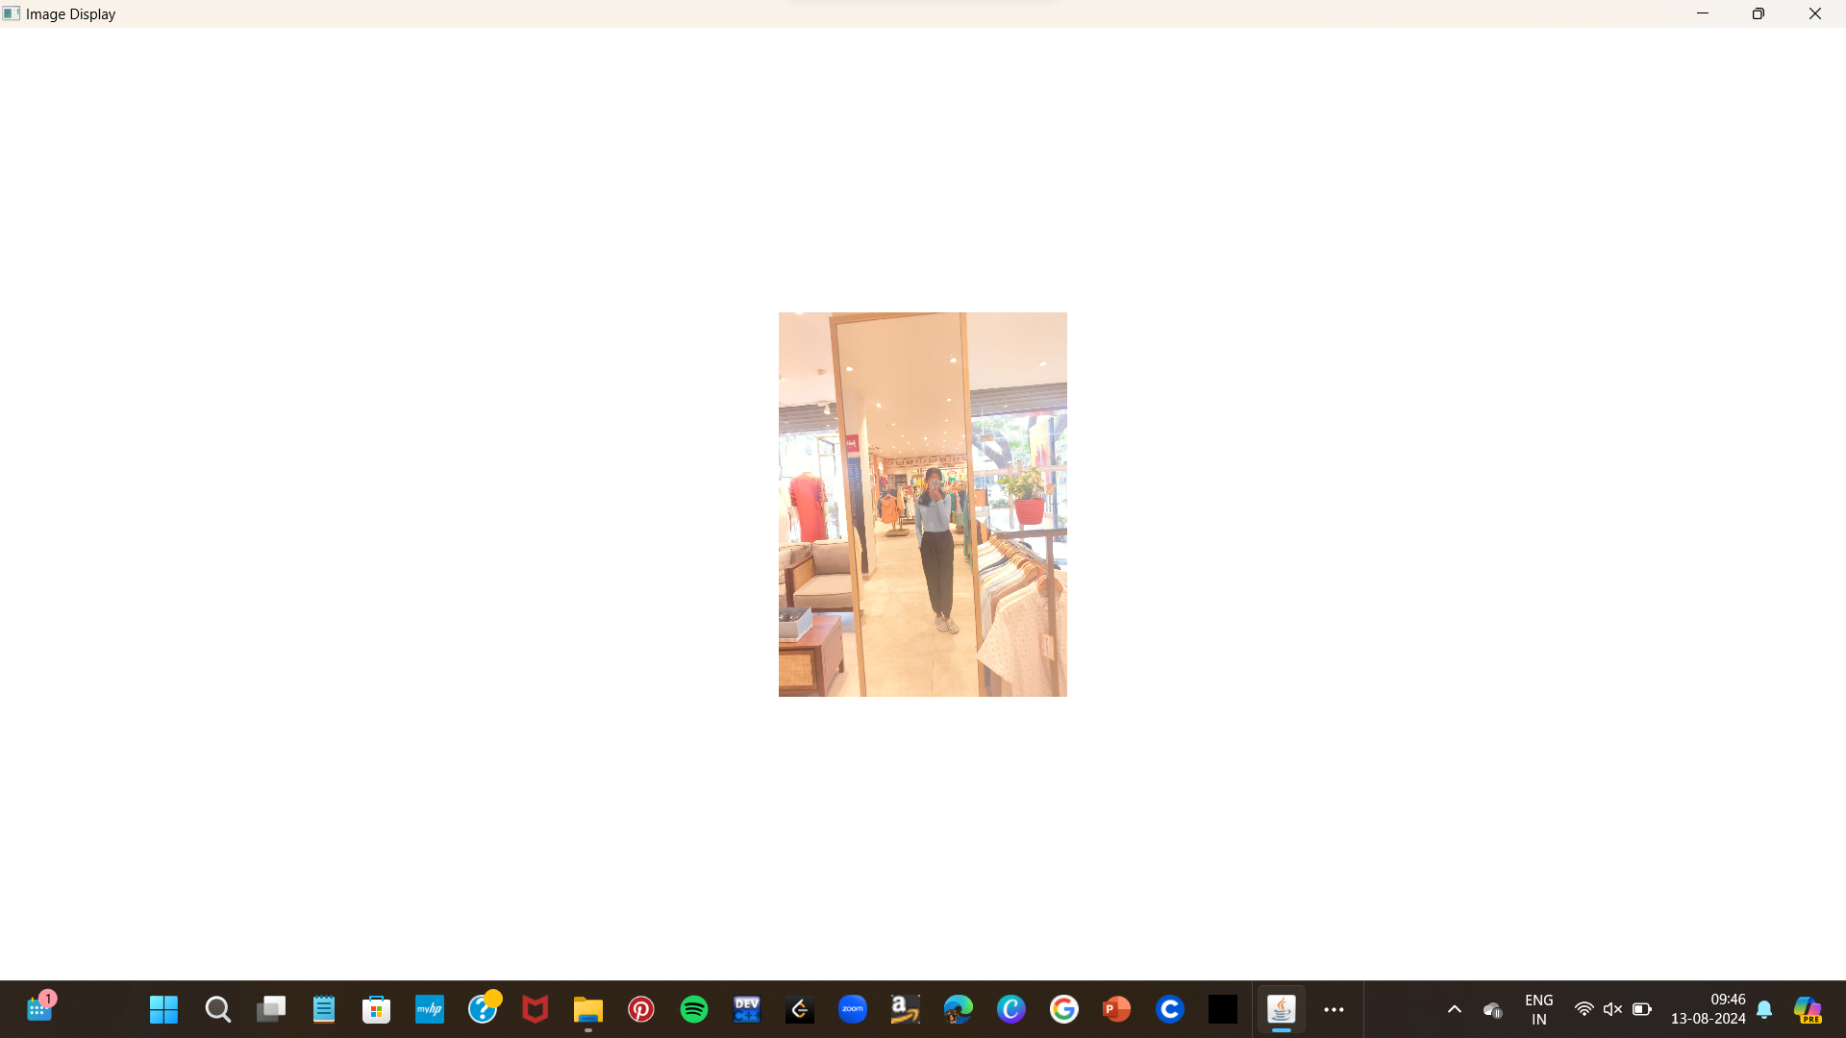

2)AUDIO PROCESSING

AUDIO PATH:

["C:\\Users\\selco\\Downloads\\chin-tapak-dum-dum-made-with-Voicemod.mp3"](https://tuna.voicemod.net/sound/3cf66a5f-47d2-40b7-bb86-a89b4ade7fa2)

CODE:

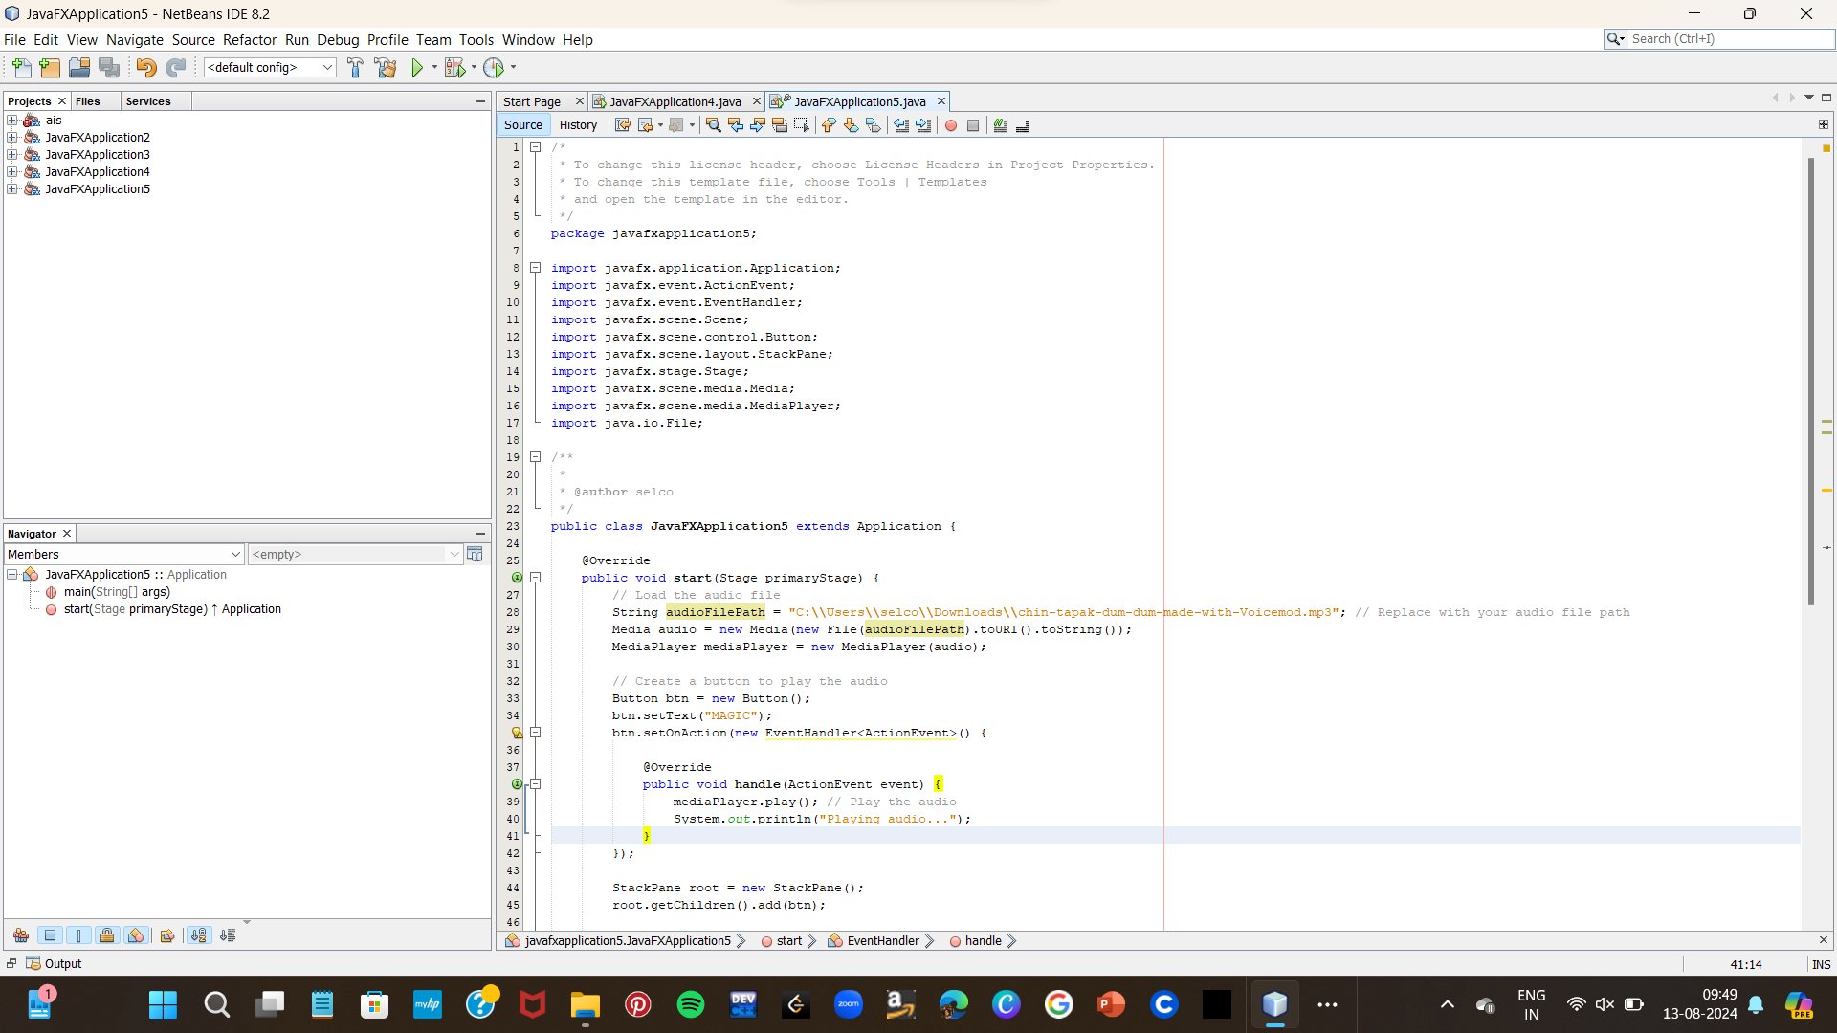

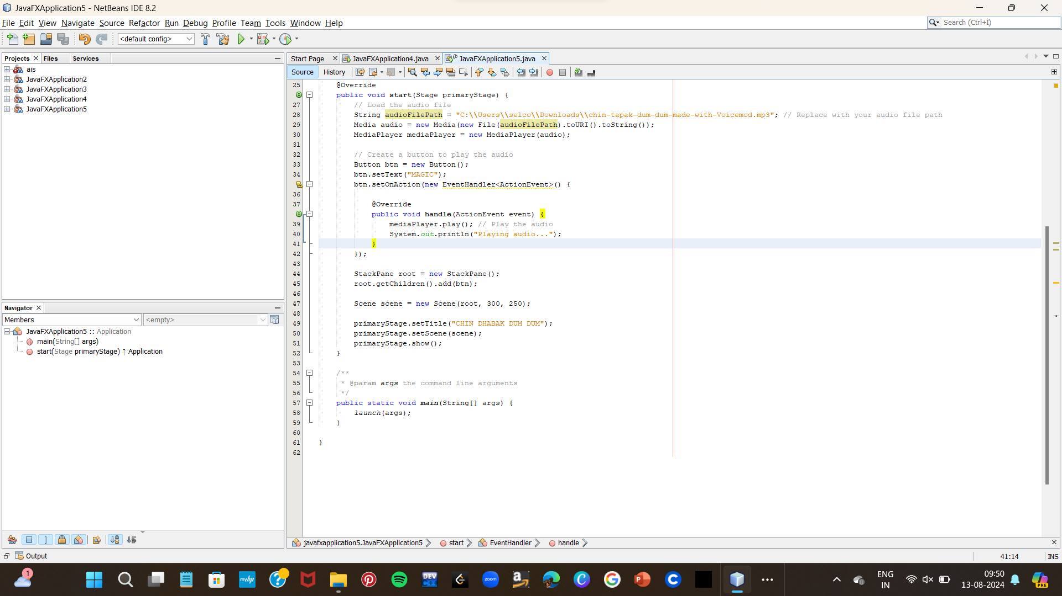

OUTPUT:

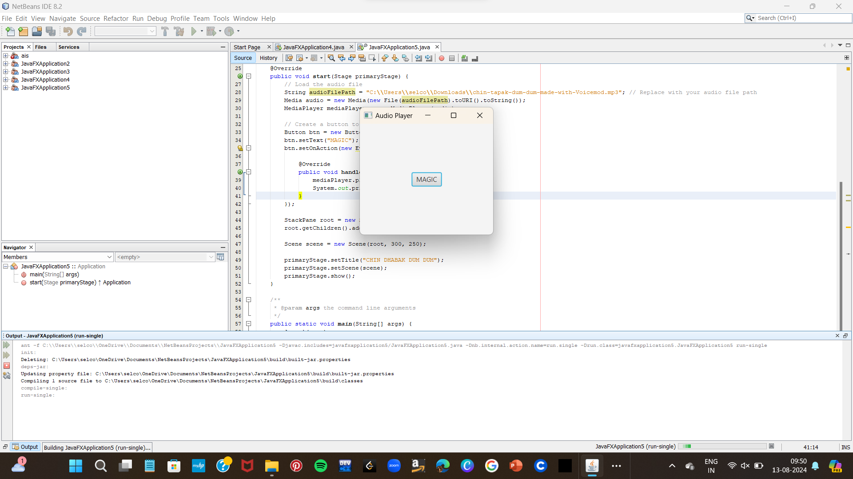

3)MOUSE EVENT HANDLING

CODE

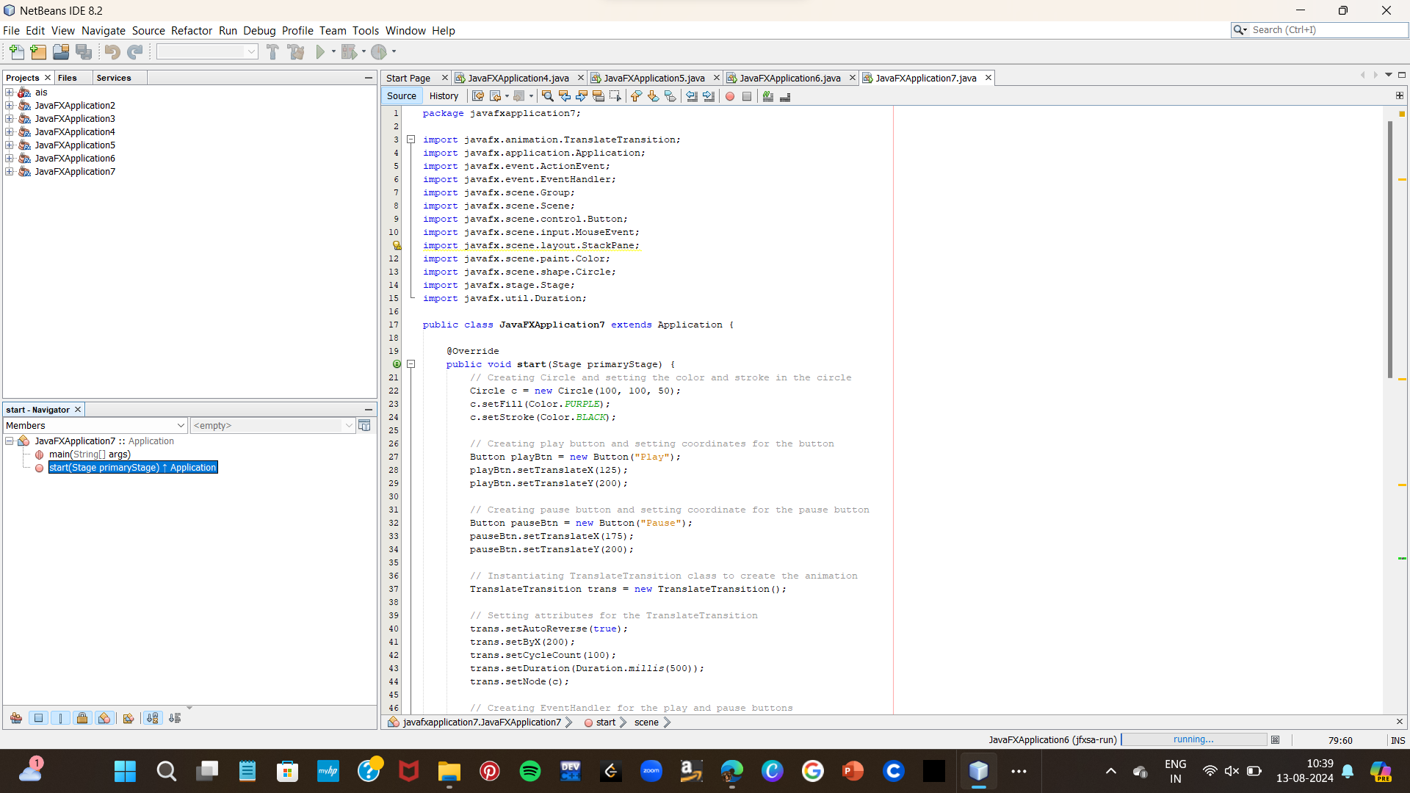

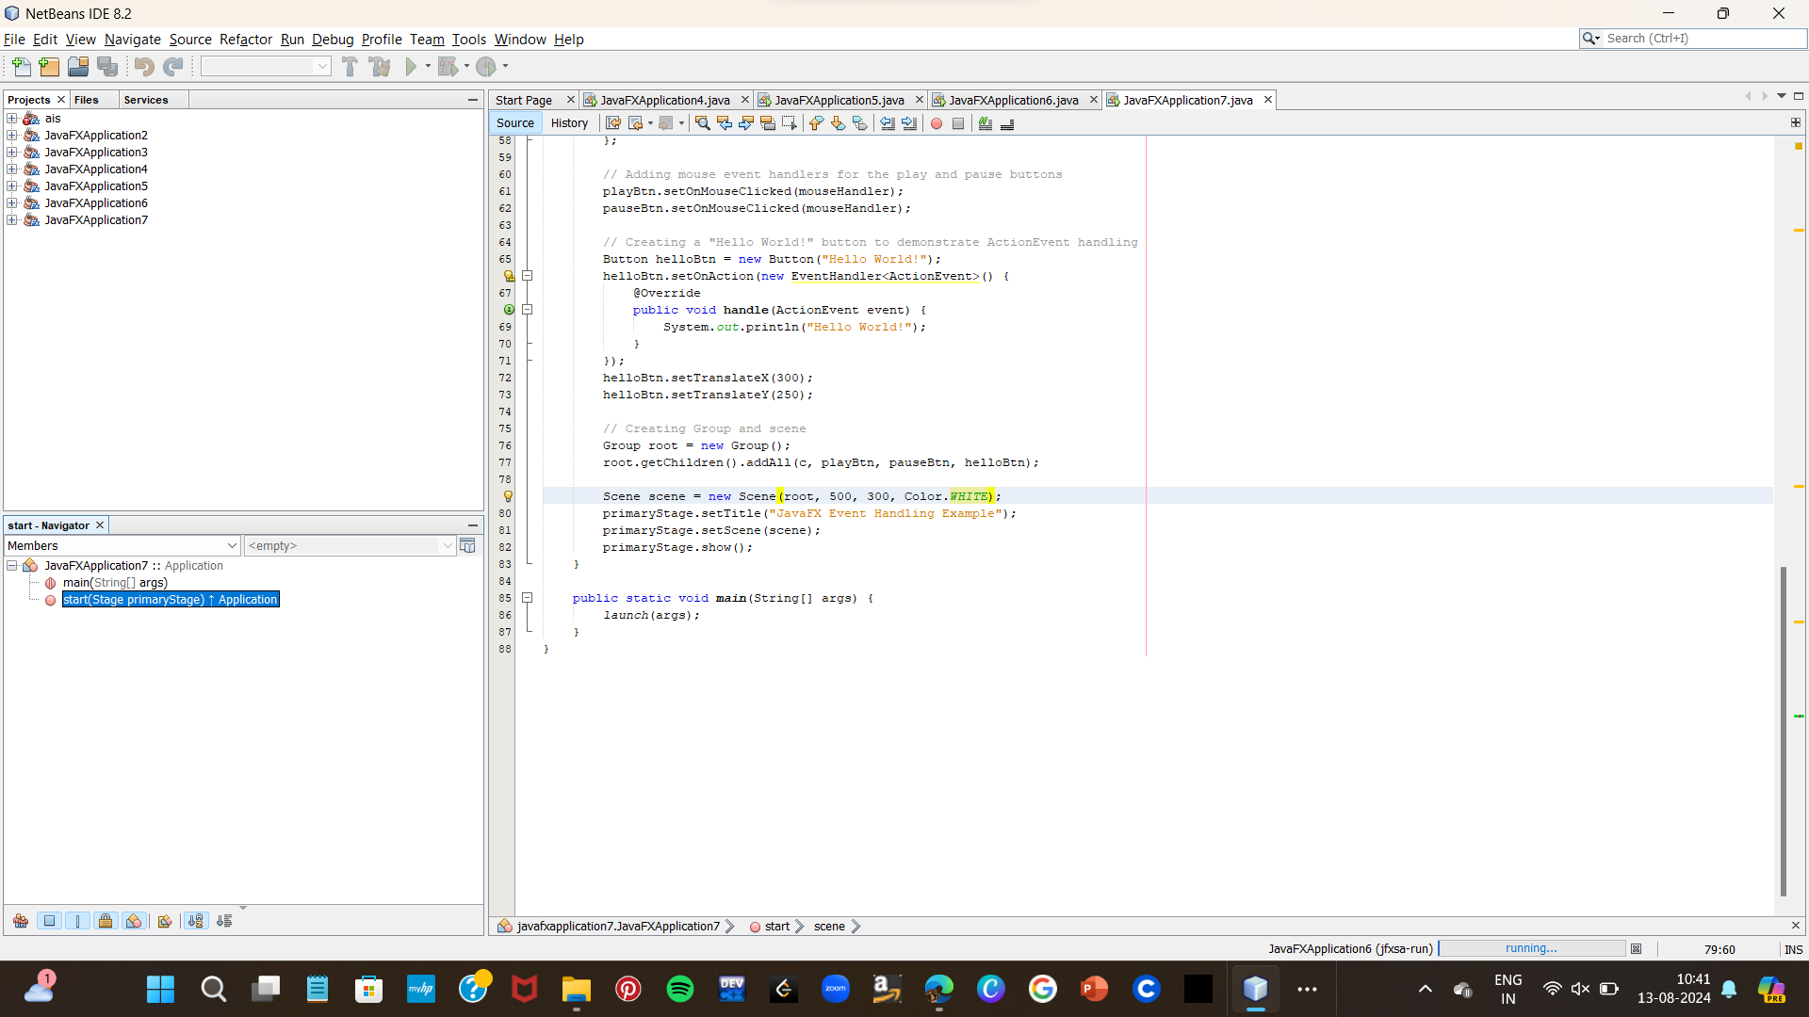

OUTPUT;

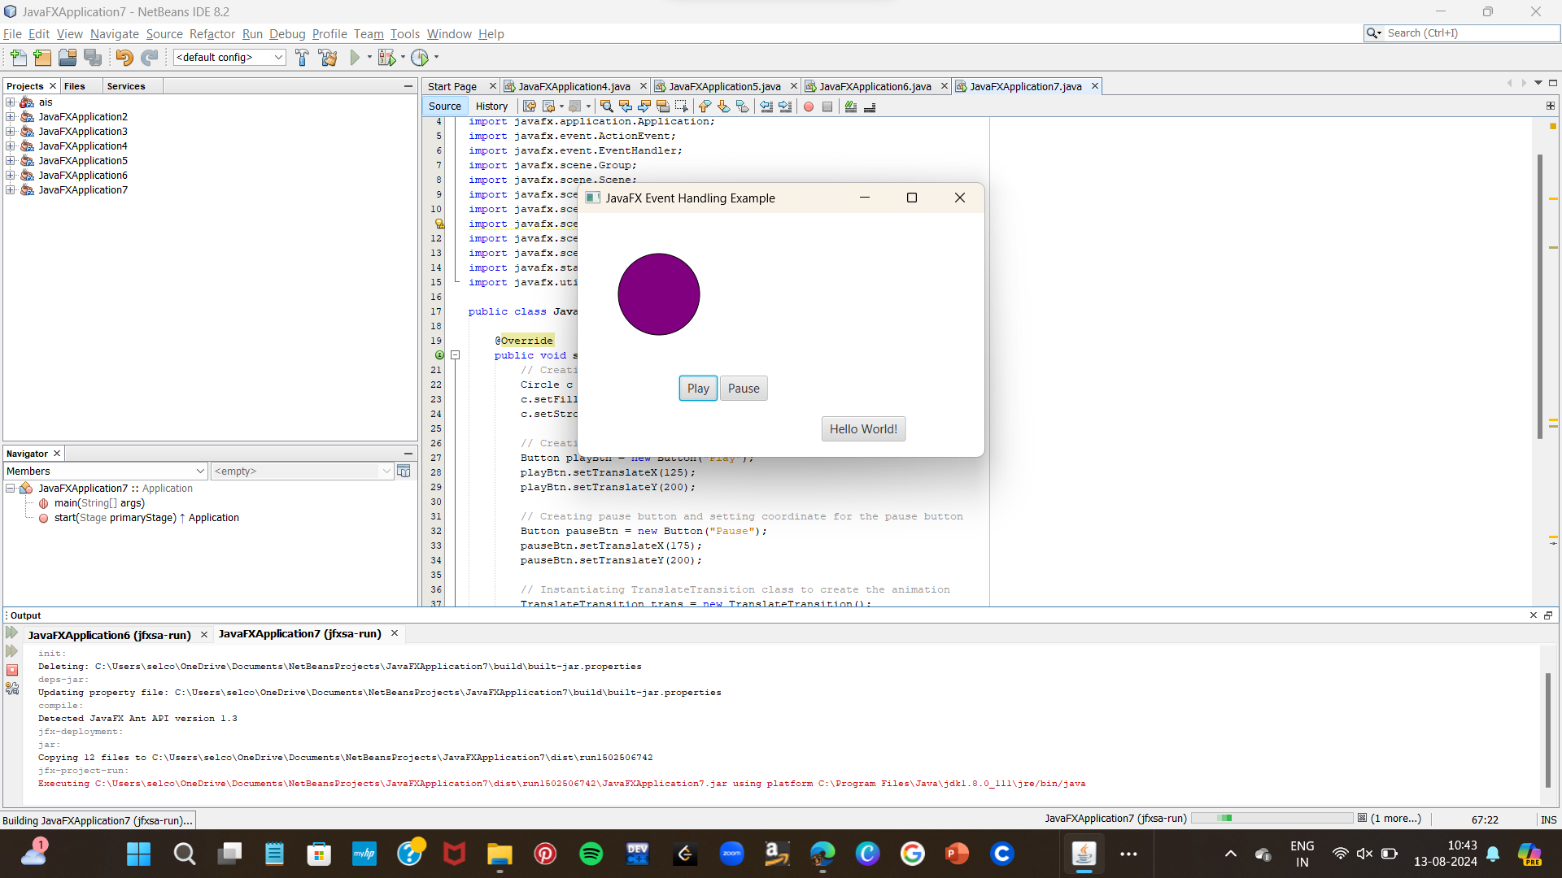

4)

CODE:

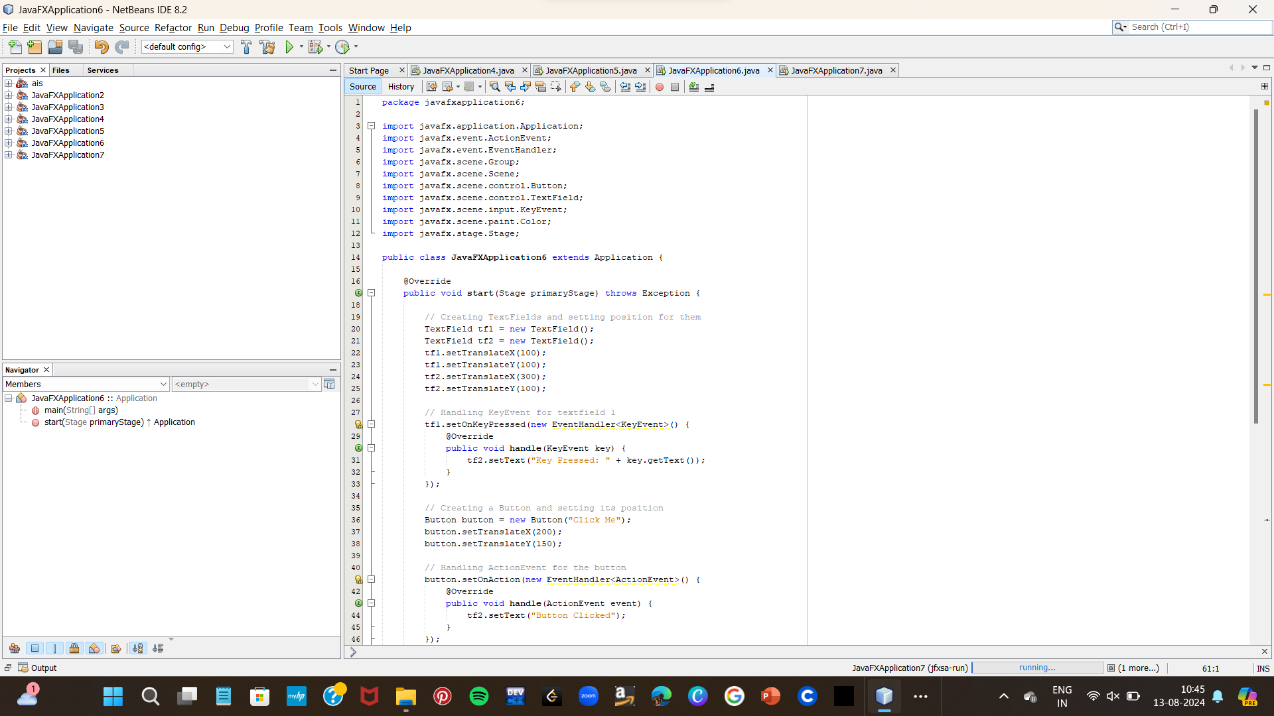

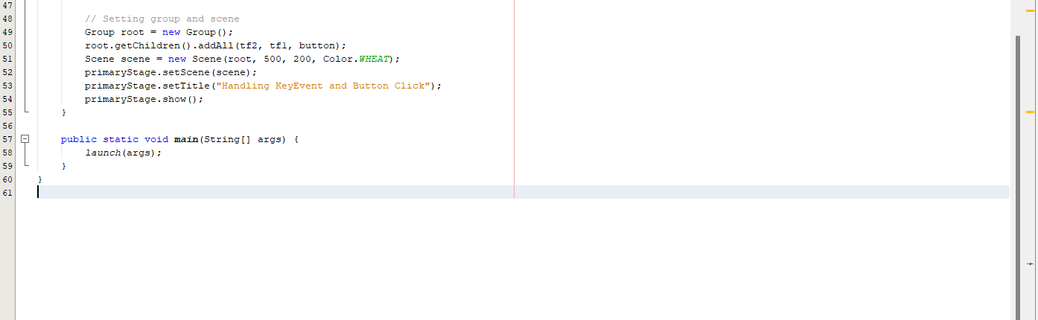

OUTPUT:

