31/07/2024

1)BANK APPLICATION USING ENUM KEYWORD

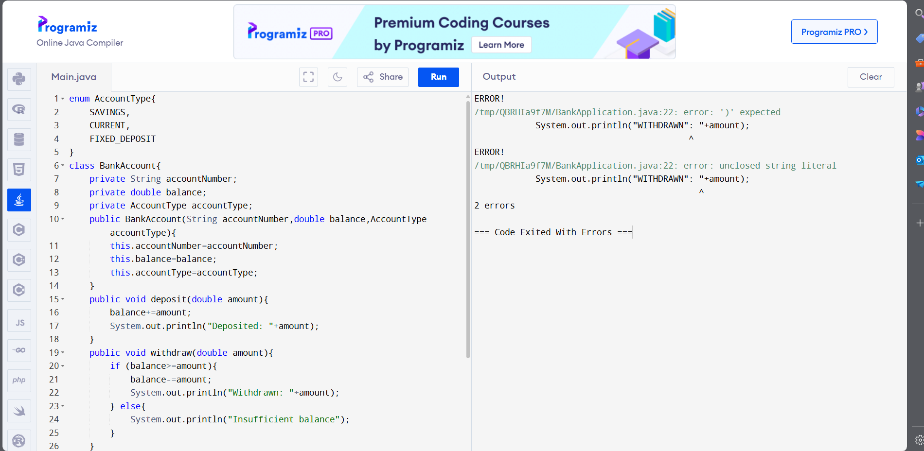

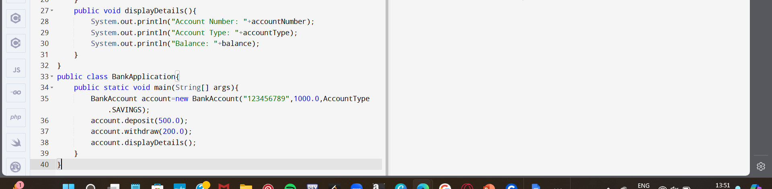

OUTPUT;

