**Question 1: -**

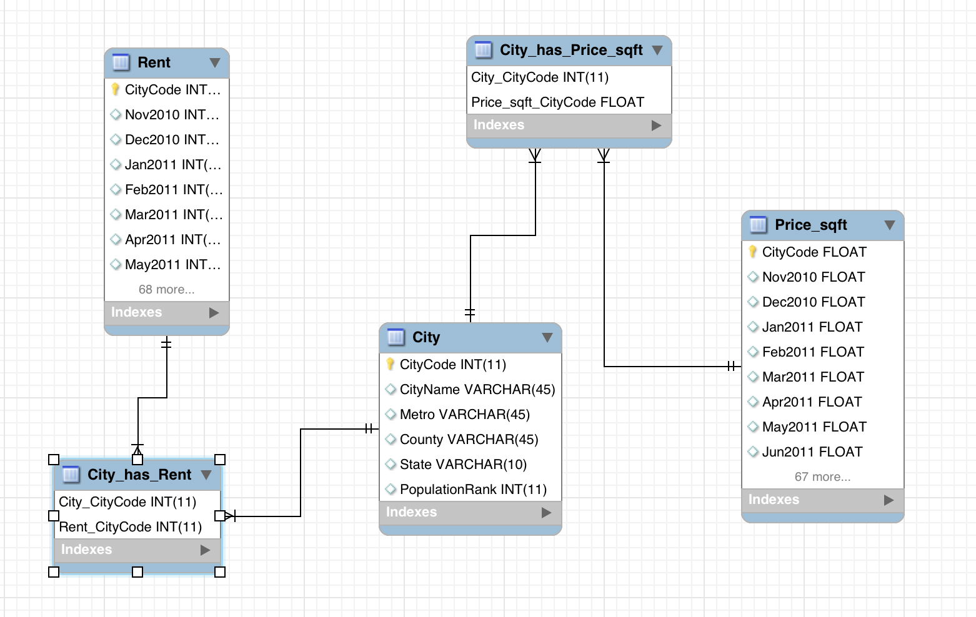

**Assumptions on Data Model: -**

1. City table and Rent table are in M:M relationship because, one city can have multiple values of rent (multiple months) and one rent value can be in multiple cities.
2. City table and Price_sqft table are in M:M relationship because, one city can have multiple sqft price (multiple months) and one price value of sqft can be for multiple cities.

**Normalization: -** Our data is in 3NF. The reasons for it being in 3NF are: -

1. Every column in the tables has an atomic value.
2. There is unique identifier (Primary Key) for each of the tables.
3. There are no transitive dependencies in tables. It means, all the non-key columns in tables are only dependent on the Primary key of that table.