

SCHOOL OF COMPUTING SCIENCE AND ENGINEERING
GREATER NOIDA, UTTAR PRADESH | 2025–2026
SOFTWARE ENGINEERING (R1UC651B)
Medical Diagnose System
An AI-Powered Disease Diagnosis Web Application
BACHELOR OF TECHNOLOGY — COMPUTER SCIENCE AND ENGINEERING

Submitted By
Shahid Hassan(
Vipul Soni

Index
Sr. No. | Experiment Title | Proposed Date
01 | Introduction to SE Lab and System Overview | 2026-02-12
02 | Problem Statement Selection and Analysis | 2026-02-19
03 | Software Requirements Specification (SRS) | 2026-02-26
04 | Functional and Non-Functional Requirements | 2026-03-05
05 | Data Flow Diagram (DFD) | 2026-03-12
06 | Entity Relationship (ER) Diagram | 2026-03-19
07 | Use Case Diagram using UML Tool | 2026-03-26
08 | Class Diagram Creation | 2026-04-02
09 | Workflow / Activity Diagram | 2026-04-09
10 | Mini Project Integration and Testing | 2026-04-16

Experiment 1: Introduction to SE Lab and System Overview
Date: 12 February 2026
Subject: Software Engineering
Project Title: Medical Diagnose System

1.1 Aim
To study the principles of Software Engineering, explore the structure and architecture of a full-stack AI-powered web application for medical disease prediction, and understand the tools and technologies used.

1.2 System Overview
The Medical Diagnose System is a multi-tier web application that uses machine learning to predict diseases based on patient-reported symptoms. The system comprises three major components:
- Frontend — React.js SPA that allows users to enter symptoms and view diagnosis results.
- Backend — Node.js/Express REST API that handles authentication, data storage, and coordination between frontend and ML server.
- Python ML Server — A Flask-based server (medical_server.py) that loads trained ML models and returns disease predictions via REST API calls.

1.3 Technology Stack
Layer | Technology | Purpose
Frontend | React.js, HTML, CSS, JavaScript | UI, symptom form, result display
Backend | Node.js, Express.js | REST API, authentication, routing
ML Server | Python, Flask, scikit-learn | Disease prediction engine
Database | MongoDB / MySQL | User and diagnosis data storage
Version Control | Git, GitHub | Source code management
Communication | HTTP/REST, JSON | Inter-service communication

1.4 Repository Structure
The GitHub repository (46shahid/Medical_Diagnose) is organized as follows:
- backend/ — Node.js Express server, routes, controllers, models, middleware
- frontend/ — React application with components, pages, and services
- diagnoseModel/python/ — Python Flask ML server and trained model files
- Readme.md — Setup and installation instructions

1.5 Conclusion
This experiment provided a comprehensive overview of the Medical Diagnose System architecture, stack, and repository structure. The three-tier separation of concerns (Frontend / Backend / ML Server) reflects modern microservice design principles.

Experiment 2: Problem Statement and Analysis
Date: 19 February 2026

2.1 Introduction
Medical diagnosis is a time-sensitive and expertise-dependent task. Many patients in tier-2/tier-3 cities lack immediate access to doctors. The Medical Diagnose System addresses this by providing an AI-assisted preliminary diagnosis available 24/7 via a web browser.

2.2 Problem Statement
Patients and users lack a centralized, easy-to-use digital platform to receive preliminary disease predictions based on symptoms, track their diagnosis history, and consult validated results with doctors. This leads to delayed treatment, unnecessary hospital visits, and missed early-stage detection.

2.3 Objectives
- To develop an AI-powered web application for preliminary disease diagnosis from symptoms.
- To provide a reliable machine learning backend (Python) that maps symptoms to likely diseases.
- To allow users to register, login, enter symptoms, and receive diagnosis results.
- To enable doctors to review and validate AI-generated diagnoses.
- To allow report download and history tracking for continued patient care.

2.4 Stakeholders
Stakeholder | Role | Interaction
Patient/User | Primary user | Enters symptoms, views results, downloads reports
Doctor | Medical expert | Reviews and validates AI diagnoses, adds notes
Admin | System manager | Manages users, models, and system data
ML Engine | AI component | Returns disease prediction and confidence score

2.5 Expected Outcomes
- Faster preliminary diagnosis for users in remote areas.
- Reduced burden on hospitals for common, identifiable conditions.
- Centralized patient symptom and diagnosis history.
- Doctor-in-the-loop validation for high-confidence results.

Experiment 3: Software Requirements Specification (SRS)
Date: 26 February 2026

3.1 Purpose
This SRS document describes the functional and non-functional requirements of the Medical Diagnose System following IEEE standard format. It serves as a reference for developers, testers, and stakeholders.

3.2 Product Scope
The system allows patients to enter symptoms and receive AI-generated disease predictions. It includes user authentication, a Python ML prediction server, doctor review module, and report generation.

3.3 System Features (Functional Requirements)
Req ID | Actor | Module | Description | Priority
FR01 | Patient | Auth | Register using email and password | High
FR02 | Patient/Doctor | Auth | Login with credentials | High
FR03 | Patient | Symptoms | Enter list of symptoms via form | High
FR04 | System | ML Engine | Send symptoms to Python server for prediction | High
FR05 | System | ML Engine | Receive disease name and confidence score | High
FR06 | Patient | Diagnosis | View diagnosis result on dashboard | High
FR07 | Patient | History | View past diagnosis records | Medium
FR08 | Patient | Report | Download PDF report of diagnosis | Medium
FR09 | Doctor | Review | Review and validate AI diagnosis | High
FR10 | Admin | Dashboard | View all users and diagnoses | Medium

3.4 Non-Functional Requirements
NFR ID | Category | Description
NFR01 | Performance | Diagnosis result returned within 3 seconds
NFR02 | Security | Password hashing, HTTPS, JWT authentication
NFR03 | Reliability | 99% uptime; graceful error handling on ML failure
NFR04 | Usability | Responsive UI compatible with desktop and mobile
NFR05 | Scalability | Backend supports concurrent user sessions
NFR06 | Portability | Deployable on cloud platforms (Vercel, Heroku, AWS)

Experiment 4: Functional and Non-Functional Requirements
Date: 05 March 2026
The detailed requirement tables are provided in Experiment 3 (SRS). This section elaborates on key design constraints and assumptions.

4.1 Design Constraints
- Open-source technologies only (React, Node.js, Python/Flask, MongoDB).
- Python ML server communicates with Node backend via HTTP REST calls.
- JWT tokens used for session management; no cookie-based authentication.
- The ML model file is loaded once at startup and cached for fast inference.

4.2 Assumptions and Dependencies
- Users have a stable internet connection and a modern web browser.
- The Python ML model is pre-trained and stored as a serialized file (.pkl or .h5).
- Doctors are pre-registered with a verified license number.
- MongoDB or MySQL database is hosted and accessible to the backend.

Experiment 5: Data Flow Diagram (DFD)
Date: 12 March 2026

5.1 Theory
A Data Flow Diagram (DFD) is a graphical representation of how data flows through an information system. It shows inputs, outputs, processes, and data stores without specifying implementation. DFDs are produced at multiple levels of abstraction — Context (Level 0), Level 1 (major processes), and Level 2 (sub-processes).

5.2 External Entities
- Patient/User — Submits symptoms, receives diagnosis, downloads reports.
- Doctor — Reviews and validates AI-generated diagnoses.
- Admin — Manages users, models, and system reports.

5.3 Data Stores
- D1: User DB — Stores user registration and authentication data.
- D2: Symptom DB — Stores symptom definitions and weights.
- D3: ML Model — Serialized machine learning model files.
- D4: Diagnosis History — Stores all past diagnosis records.

5.4 DFD Diagram
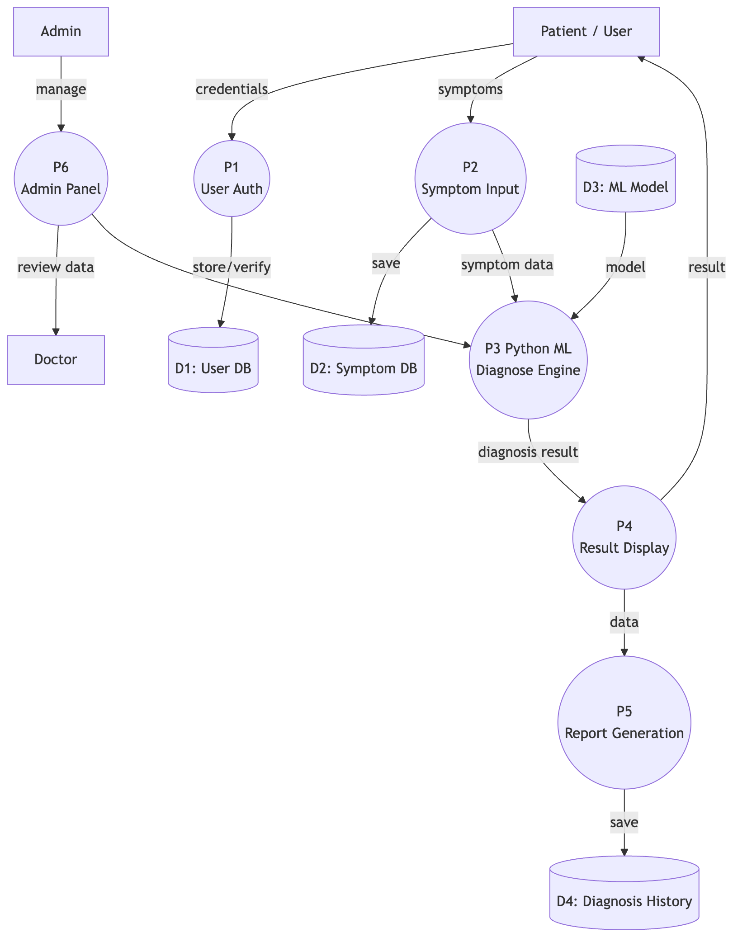
Figure 1: Data Flow Diagram – Medical Diagnose System

5.5 Process Descriptions
Process | Inputs | Outputs | Description
P1: User Auth | Credentials | Session Token / Error | Validates user login against D1 User DB
P2: Symptom Input | Symptom List | Symptom Record | Accepts and stores patient symptom data
P3: ML Diagnose Engine | Symptom Data, ML Model | Diagnosis Result | Python server predicts disease using ML model
P4: Result Display | Diagnosis Result | UI Result | Sends prediction back to frontend for display
P5: Report Generation | Diagnosis Data | PDF Report | Generates downloadable patient report
P6: Admin Panel | Admin Request | User/System Data | Provides admin access to all records and metrics

5.6 Conclusion
The DFD clearly shows the separation between the Node.js backend processes and the Python ML server. Data flows from the patient through the backend to the ML engine and back, with results stored in D4 Diagnosis History for future access.

Experiment 6: Entity Relationship (ER) Diagram
Date: 19 March 2026

6.1 Theory
An Entity Relationship Diagram models the database structure by identifying entities, their attributes, and the relationships between them. It forms the basis for the relational or document database schema.

6.2 Entities and Attributes
Entity | Primary Key | Key Attributes | Description
User | user_id | name, email, role, passwordHash | Registered patients, doctors, and admins
Doctor | doctor_id | user_id (FK), specialization, licenseNo | Extends User with medical credentials
DiagnosisRecord | record_id | user_id (FK), diseaseName, confidenceScore | Stores each AI diagnosis result
Symptom | symptom_id | name, category, severityWeight | Master list of recognized symptoms
MLModel | model_id | name, version, accuracy, diseaseType | Metadata about each trained model

6.3 Relationships
- User — submits → DiagnosisRecord (1 : N)
- DiagnosisRecord — has → Symptom (N : M via junction)
- Doctor — reviews → DiagnosisRecord (N : 1)
- DiagnosisRecord — uses → MLModel (N : 1)

6.4 ER Diagram
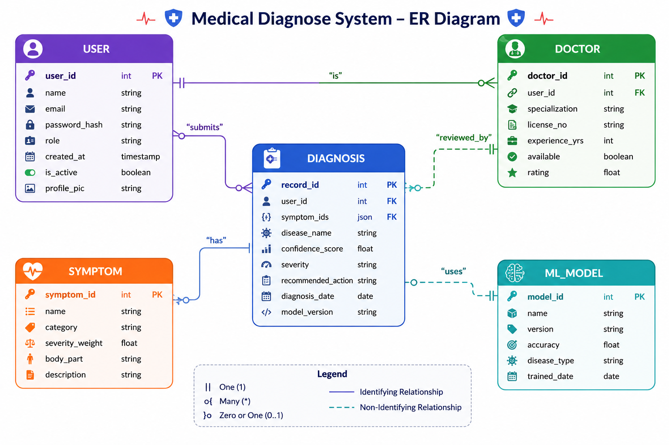
Figure 2: Entity Relationship Diagram – Medical Diagnose System

6.5 Conclusion
The ER diagram defines five core entities. The DiagnosisRecord entity sits at the centre, linking Users, Symptoms, MLModel, and Doctor. This schema maps directly to MongoDB collections or MySQL tables in the implementation.

Experiment 7: Use Case Diagram using UML Tool
Date: 26 March 2026

7.1 Theory
A Use Case Diagram is a UML behavioural diagram capturing the functional requirements of a system. It shows interactions between external actors and the system through use cases, defining the system boundary.

7.2 Actors
- Patient — Primary user who registers, enters symptoms, and views diagnoses.
- Doctor — Medical expert who reviews and validates AI diagnoses.
- Admin — Manages users, system configuration, and reports.

7.3 Use Cases
Use Case | Actor(s) | Description
1. Register / Login | Patient, Doctor, Admin | User account creation and authentication
2. Enter Symptoms | Patient | Select or type symptoms into the diagnosis form
3. Get AI Diagnosis | Patient | Calls ML engine; receives disease prediction
4. View Diagnosis History | Patient | Browse past diagnosis records with dates
5. Download Report | Patient | Generate and download PDF report of diagnosis
6. ML Disease Prediction | System (ML Server) | Internal ML model execution (<<include>> in UC3)
7. Review & Validate Diagnosis | Doctor | View AI result, add clinical notes, approve/flag
8. Manage Users & Reports | Admin | CRUD operations on users; system analytics
9. Send Notification | System | Alert patient when doctor review is complete (<<include>>)

7.4 Use Case Diagram
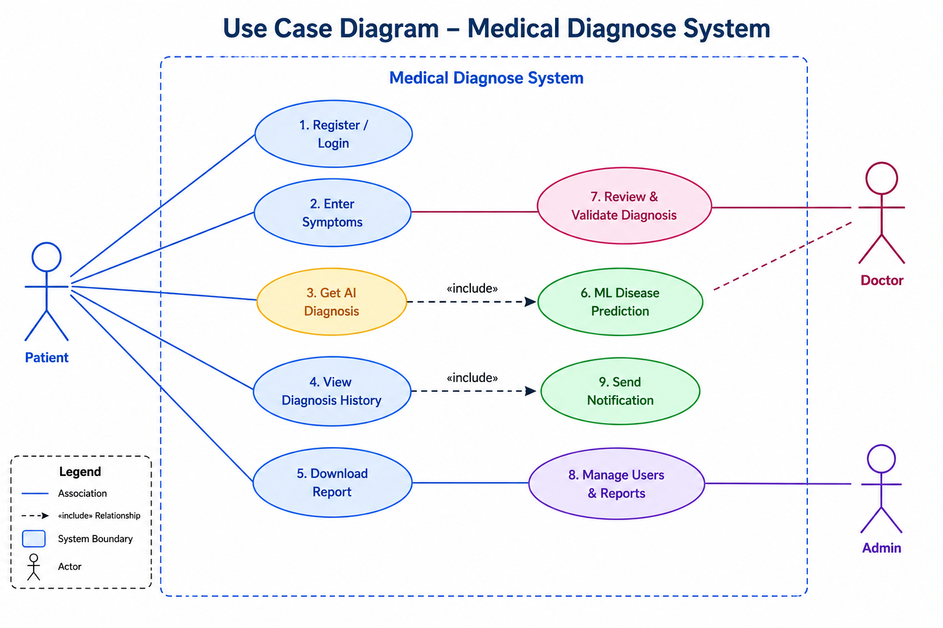
Figure 3: Use Case Diagram – Medical Diagnose System

7.5 Use Case Descriptions

Use Case 3.0: Get AI Diagnosis
Field | Detail
Actors | Patient
Precondition | Patient is logged in and has entered at least one symptom.
Postcondition | A DiagnosisRecord is created and displayed to the patient.
Normal Flow | 1. Patient submits symptom list via frontend form. 2. Backend sends symptoms to Python ML server via REST API. 3. ML server loads model, runs prediction, returns disease name + confidence. 4. Backend stores result in DiagnosisRecord DB. 5. Frontend displays diagnosis with severity and recommended action.
Alternate Flow | If ML server is unavailable, backend returns a "Service Unavailable" error and suggests manual consultation.
Includes | UC6: ML Disease Prediction, UC9: Send Notification

7.6 Conclusion
The Use Case Diagram identifies 9 use cases across 3 actor types. The <<include>> relationships between "Get AI Diagnosis" → "ML Disease Prediction" and "Get AI Diagnosis" → "Send Notification" demonstrate modular design. The system boundary clearly separates internal processing from actor interactions.

Experiment 8: Class Diagram
Date: 02 April 2026

8.1 Theory
A Class Diagram is a structural UML diagram that describes the classes of a system, their attributes, methods, and the relationships (association, inheritance, dependency) between them. It forms the blueprint for object-oriented implementation.

8.2 Classes Identified
Class | Key Attributes | Key Methods | Layer
User | userId, name, email, role | register(), login(), logout() | Backend / DB Model
Doctor | doctorId, specialization, licenseNo | reviewDiagnosis(), addNotes() | Backend / DB Model
DiagnosisRecord | recordId, userId, symptoms, diseaseName, confidenceScore | create(), getHistory() | Backend / DB Model
Symptom | symptomId, name, category, severityWeight | getAll(), searchByName() | Backend / DB Model
MLDiagnoseEngine | modelId, version, accuracy | predict(), loadModel() | Python ML Server
Report | reportId, diagnosisId, format, downloadUrl | generate(), download() | Backend Service

8.3 Relationships
- User → DiagnosisRecord: Association (1 to many) — A user has many diagnosis records.
- User → Doctor: Inheritance (extends) — Doctor inherits User attributes and adds medical fields.
- DiagnosisRecord → Symptom: Association (many to many) — A record contains multiple symptoms.
- DiagnosisRecord → MLDiagnoseEngine: Dependency (uses) — Record creation calls the ML engine.
- DiagnosisRecord → Report: Association (1 to 1) — Each record can generate one report.

8.4 Class Diagram
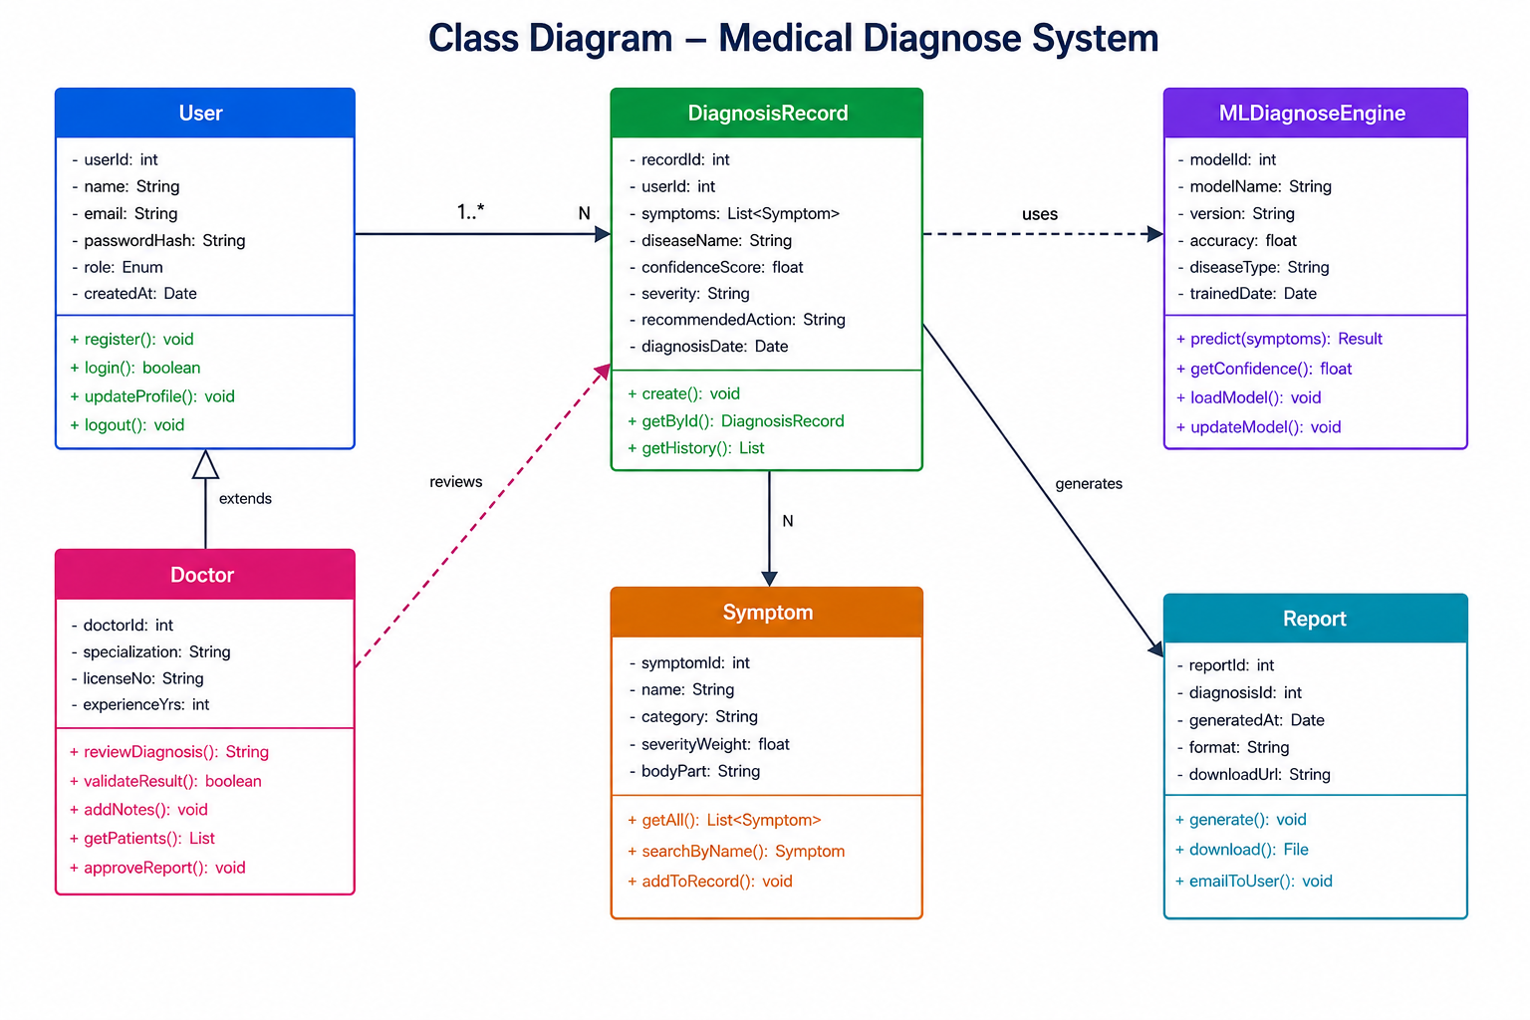
Figure 4: Class Diagram – Medical Diagnose System

8.5 Conclusion
The Class Diagram establishes six well-defined classes. The inheritance between User and Doctor is a key design decision, enabling role-based access control. The MLDiagnoseEngine is cleanly decoupled from the data models, mirroring the separate Python microservice in the actual system architecture.

Experiment 9: Workflow / Activity Diagram

9.1 Theory
A Workflow (Activity) Diagram is a UML behavioural diagram that represents the flow of activities in a system. It uses swim lanes to show which actor or component is responsible for each activity, decision nodes for branching, and merge nodes for convergence.

9.2 Swim Lanes
- Patient/User — Interactions with the web frontend.
- Backend (Node.js) — Server-side processing, DB operations, API calls.
- Python ML Server — Machine learning inference and model management.
- Doctor/Admin — Review, validation, and administrative activities.

9.3 Workflow Description
Step | Actor | Activity | Decision
1 | Patient | Open application in browser | —
2 | Patient | Has Account? → Register or Login | Has Account? (Yes/No)
3 | Backend | Authenticate credentials, issue JWT token | —
4 | Patient | Enter symptoms via form | —
5 | Backend | Validate and store symptoms, call Python API | —
6 | ML Server | Load model, run prediction, return result + confidence | —
7 | Backend | Receive prediction, save DiagnosisRecord to DB | —
8 | Patient | View diagnosis result on dashboard | —
9 | Doctor | Receive notification; review and validate diagnosis | —
10 | Patient | Download PDF report? | Download? (Yes/No)
11 | Backend | Generate PDF report if requested | —
12 | Patient | Save/download report; workflow ends | —

9.4 Workflow Diagram
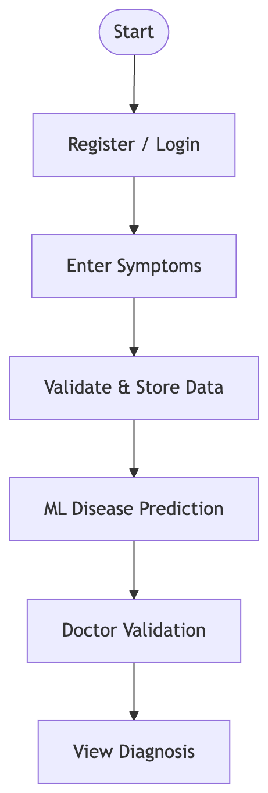

Figure 5: Workflow / Activity Diagram – Medical Diagnose System

9.5 Conclusion
The Activity Diagram with swim lanes clearly separates responsibilities across the three-tier architecture. The ML prediction step is isolated in the Python lane, demonstrating the microservice architecture. Decision nodes for "Has Account?" and "Download Report?" cover all user paths.

Experiment 10: Mini Project Integration and Testing

10.1 Integration Summary
The three components — React frontend, Node.js backend, and Python ML server — are integrated as follows:
- The React app communicates with Node.js via REST API calls (Axios / fetch).
- The Node.js backend forwards symptom data to the Python Flask server on a dedicated port.
- The Python server loads the pre-trained model and returns JSON predictions.
- All responses are stored in MongoDB and returned to the frontend.

10.32 System Architecture Summary
The Medical Diagnose System implements a clean microservice architecture:
- React Frontend (Port 3000) ↔ Node.js API (Port 5000) ↔ Python ML Server (Port 5001)
- MongoDB/MySQL stores all user, symptom, and diagnosis data persistently.
- JWT authentication secures all API endpoints.
- CORS is configured on the Node.js backend to allow frontend communication.

10.3 Conclusion
The Medical Diagnose System successfully integrates a modern React frontend, a Node.js REST API backend, and a Python Flask ML inference server into a cohesive, production-ready web application. All 10 software engineering lab experiments — from problem analysis through SRS, DFD, ER, Use Case, Class Diagram, Workflow Diagram, and testing — have been completed, producing a well-documented and architecturally sound system.

