**OSS LAB – 3**

**Aishwary Pandey**

**9918103207 F8**

**Q1]**

def count_letters(para):

result = {}

for letter in para:

if letter not in result:

result[letter.lower()] = 1

else:

result[letter.lower()] += 1

return result

print(count_letters(" python is a programming language. "))

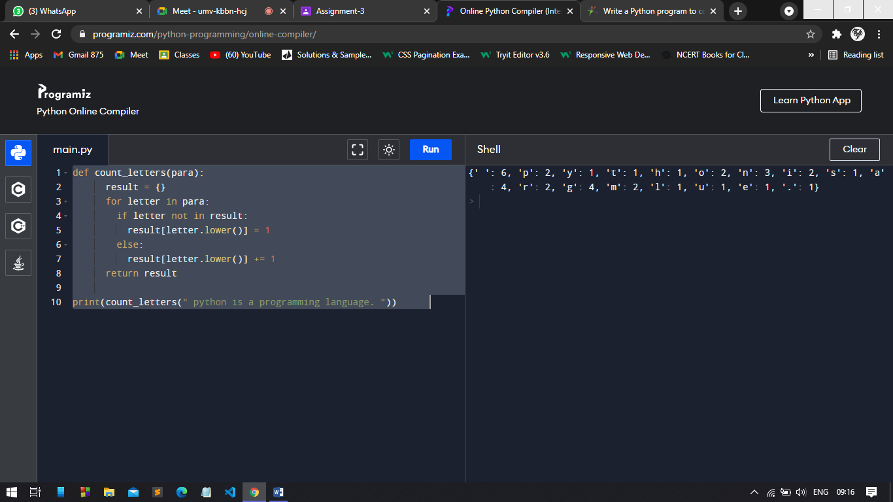

**Q2]**

def wrap(f,n):

fi=open(f,"w+")

rl=fi.readlines()

for i in range(0,len(rl)):

if len(rl[i]) > n:

fi.write(rl[i][:n] +"\n" + rl[i][n:])

fi.Close()

else:

fi.write(rl[i])

fi.close()

**Q3]**

def square(n):

return n*n

my_list = [2,3,4,5,6,7,8,9]

updated_list = map(square, my_list)

print(list(updated_list))

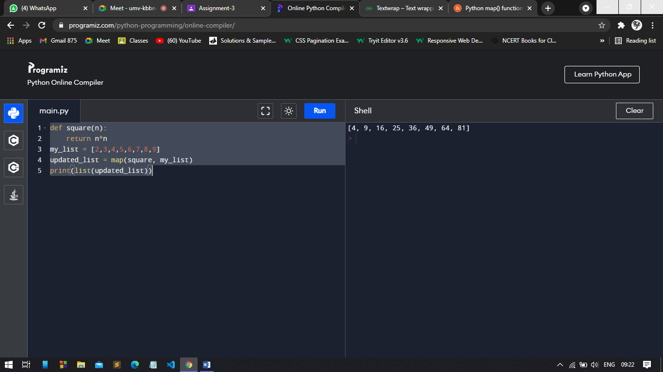

**Q4]**

def is_even(x):

if x % 2 == 0:

return True

else:

return False

f = filter(is_even, [1, 3, 10, 45, 6, 50])

for i in f:

print(i)

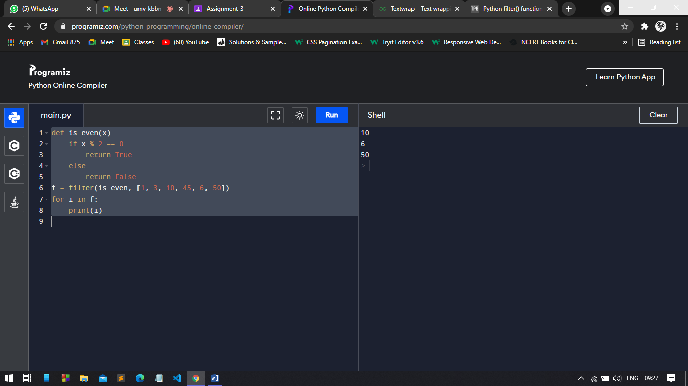

**Q5]**

def write_triplets(n):

to_return = []

if n >= 2:

for i in range(2, n):

for j in range(1, int(i/2)+1):

triplet = (j, i-j, i)

to_return.append(triplet)

return to_return

print(write_triplets(5))

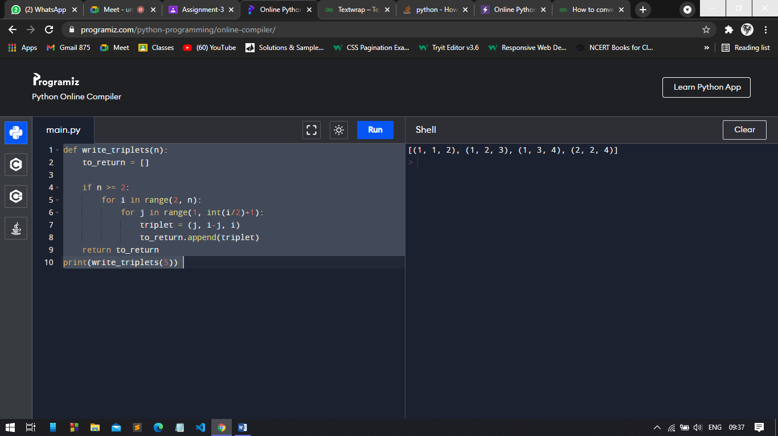

**Q6]**

import csv

with open('data.csv', 'r') as csv_file:

reader = csv.reader(csv_file)

for row in reader:

print(row)

**Q7]**

def parse_csv(filename, d, c):

lines=open(filename).readlines()

new=[]

for line in lines:

if line[0] != c:

new.append([i for i in line if i!=d and i!='\n'])

return new

print(parse_csv('data.txt', '!', '#'))

**Q8]**

def mutate(d):

ret=[d]

i=0

l=len(d)

alp=map(chr,range(97,123))

while i<l:

cop=d

ret.append(cop[:i]+cop[i+1:])

if i<l-2:

ret.append(cop[:i]+cop[i+1]+cop[i]+cop[i+2:])

elif i<l-1:

ret.append(cop[:i]+cop[i+1]+cop[i])

for x in alp:

ret.append(cop[:i]+x+cop[i+1:])

for x in alp:

ret.append(d+x)

ret.append(x+d)

ret.append(cop[:i]+x+cop[i:])

i=i+1

return ret

**Q9]**

def nearly_equal(str1,str2):

count=0

i=j=0

while(i<len(str1) and j<len(str2)):

if(str1[i]!=str2[j]):

count=count+1

if(len(str1)>len(str2)):

i=i+1

elif(len(str1)==len(str2)):

pass

else:

i=i-1

if(count>1):

return False

i=i+1

j=j+1

if(count<2):

return True

str1=input("Enter first string::\n")

str2=input("Enter second string::\n")

boolean=nearly_equal(str1,str2)

if(boolean):

print("Strings are nearly equal.")

else:

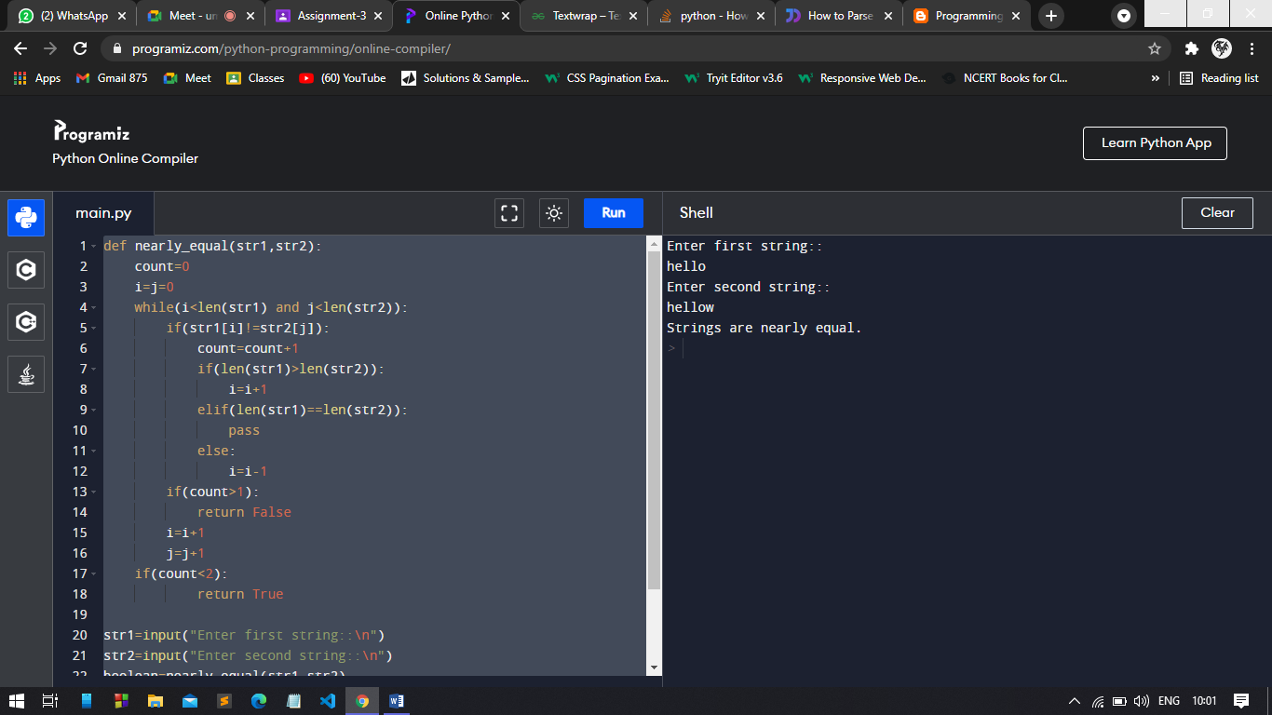 print("Strings are not equal.")

**Q10]**

from collections import Counter

texts = ["bcda", "abce", "cbda", "cbea", "adcb"]

str = "abcd"

print("Orginal list of strings:")

print(texts)

result = list(filter(lambda x: (Counter(str) == Counter(x)), texts))

print("\nAnagrams of 'abcd' in the above string: ")

print(result)

