Q1. create Lifecycle rule to move only files in logs folder to other storage class

ans:

Steps:

1.go to s3 console

2. select the bucket

3.go to management

4.click on add lifecycle rule.

5.write name of rule and prefix as logs.

6.click next.

7. add expiration and transition.

8.create the rule

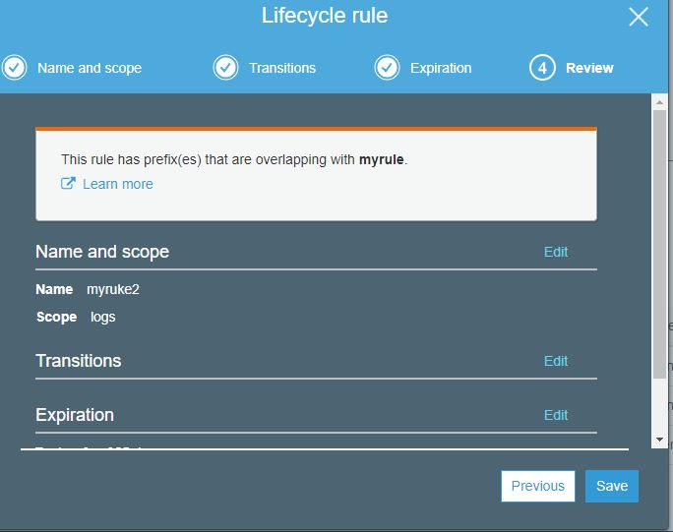

Q2.Set up CORS between two buckets in two different regions.

ans:

steps:

<CORSConfiguration>

<CORSRule>

<AllowedOrigin>http://www.example1.com</AllowedOrigin>

<AllowedMethod>PUT</AllowedMethod>

<AllowedMethod>POST</AllowedMethod>

<AllowedMethod>DELETE</AllowedMethod>

<AllowedHeader>\*</AllowedHeader>

</CORSRule>

<CORSRule>

<AllowedOrigin>http://www.example2.com</AllowedOrigin>

<AllowedMethod>PUT</AllowedMethod>

<AllowedMethod>POST</AllowedMethod>

<AllowedMethod>DELETE</AllowedMethod>

<AllowedHeader>\*</AllowedHeader>

</CORSRule>

<CORSRule>

<AllowedOrigin>\*</AllowedOrigin>

<AllowedMethod>GET</AllowedMethod>

</CORSRule>

</CORSConfiguration>

The CORS configuration also allows optional configuration parameters, as shown in the following CORS configuration. In this example, the CORS configuration allows cross-origin PUT, POST, and DELETE requests from the http://www.example.com origin.

<CORSConfiguration>

<CORSRule>

<AllowedOrigin>http://www.example.com</AllowedOrigin>

<AllowedMethod>PUT</AllowedMethod>

<AllowedMethod>POST</AllowedMethod>

<AllowedMethod>DELETE</AllowedMethod>

<AllowedHeader>\*</AllowedHeader>

<MaxAgeSeconds>3000</MaxAgeSeconds>

<ExposeHeader>x-amz-server-side-encryption</ExposeHeader>

<ExposeHeader>x-amz-request-id</ExposeHeader>

<ExposeHeader>x-amz-id-2</ExposeHeader>

</CORSRule>

</CORSConfiguration>

Q3.Create event notification to trigger lambda function (as and when put event occurs, use any existing lambda function.)

