Kenzol Shipping Tracking
What changed, and how to use the website
A simple guide for everyone in the team. No technical knowledge needed.
November 2026

Contents
1. The short version 3
2. What was wrong, and what we fixed 3
The problem: wrong dates 3
Real examples of what was fixed 3
Other things we fixed 4
3. Guide to the website 4
Getting around: the side menu 4
The reminder pop-up 5
The bell (all notifications) 6
Dashboard (main page) 6
Opening a row and updating it 8
Track shipment 9
Shipping agents 10
Register 10
4. How do I…? (quick answers) 12
5. Keeping the data clean 12
6. Words used in this guide 13

1. The short version
The shipment website was updated. Here is everything in five lines:
- Wrong dates were fixed. Some shipments looked like they had already arrived when they had not. That is fixed.
- There is a new main Dashboard with the columns the team asked for: EST number, Date, Exit number, Cheque number and amount, Agent name, Vessel ETA, BL number and Telex status.
- Reminders now pop up 15 days before a ship arrives, and 15 days before a cheque refund is due.
- New pages: shipments sorted into Export, Import and Local / internal transfer, and a Shipping agents page.
- The look is simpler and cleaner, and the side menu can be folded away to give more space.

2. What was wrong, and what we fixed

The problem: wrong dates
People noticed that some shipments showed as “arrived” even though the ship was still at sea. We checked every row of the register and found the cause.
Why it happened: in our Excel sheet we write dates as day / month / year (for example 9/11/2026 means 9 November). But in some cells Excel read the date the American way, as month / day / year. So 9 November quietly became 11 September. To the website, that ship looked like it had arrived weeks ago.
On top of that, when the Excel sheet was first loaded into the website, some dates also moved back by one day.

Real examples of what was fixed
Row | What it showed before | What it shows now
457 (BL ONEYPSQG01557400) | ETA 10 Sep 2026: looked “arrived 51 days ago” | ETA 9 Nov 2026
530 (cheque 4600) | ETA 11 Jun 2026: looked “arrived” months ago | ETA 6 Dec 2026
73 to 89 | Dates in April, May, June… in the middle of February rows | 4 to 10 Feb 2026 (correct)
429 to 431 | 9 Oct and 9 Nov | 10 and 11 Sep 2026 (correct)
482 | ETA typed as “2911/2026”: ignored by the website | ETA 29 Nov 2026
Many others | Date one day early | Correct day

In total 550 dates were corrected. Nothing else was touched: payments already marked as received and other updates made in the website were kept.
Good to know: The website no longer says “arrived” just because the expected date has passed. It now says “ETA passed”. A ship is only shown as “Arrived” when the shipping line itself confirms it.

Other things we fixed
- Downloaded Excel files now have proper dates. When you download the register, dates are saved as real dates (dd/mm/yyyy), so Excel cannot mix up day and month again.
- No more duplicate rows. If a row had two BL numbers (like “MEDUH9310408/MEDUH9309160”), updating one of them used to create a new, duplicate row. Now it updates the right row.
- Cheque amounts are saved per cheque. Before, a cheque amount was copied to every row with the same BL, even though each row has its own cheque. Now each cheque keeps its own amount.
- Tracking page is more honest. The shipping line’s planned steps (for example “arrival at port” next week) are now shown separately as “Planned”, instead of looking like they already happened.

3. Guide to the website

Getting around: the side menu
On the left side of the screen is the menu. Click any item to go to that page.
Menu item | What it is for
Dashboard | The main page. Every shipment in one table, with the most important columns.
Track shipment | Look up where a ship is right now, using its BL number. Under it are three smaller links: Export, Import and Local / internal transfer.
Shipping agents | See all shipments handled by one agent.
Register | The full original sheet with every column, plus downloading to Excel.

To fold the menu away: click Collapse at the bottom of the menu. It becomes a thin bar with only icons, so the tables get more room. Click the same button again to open it.
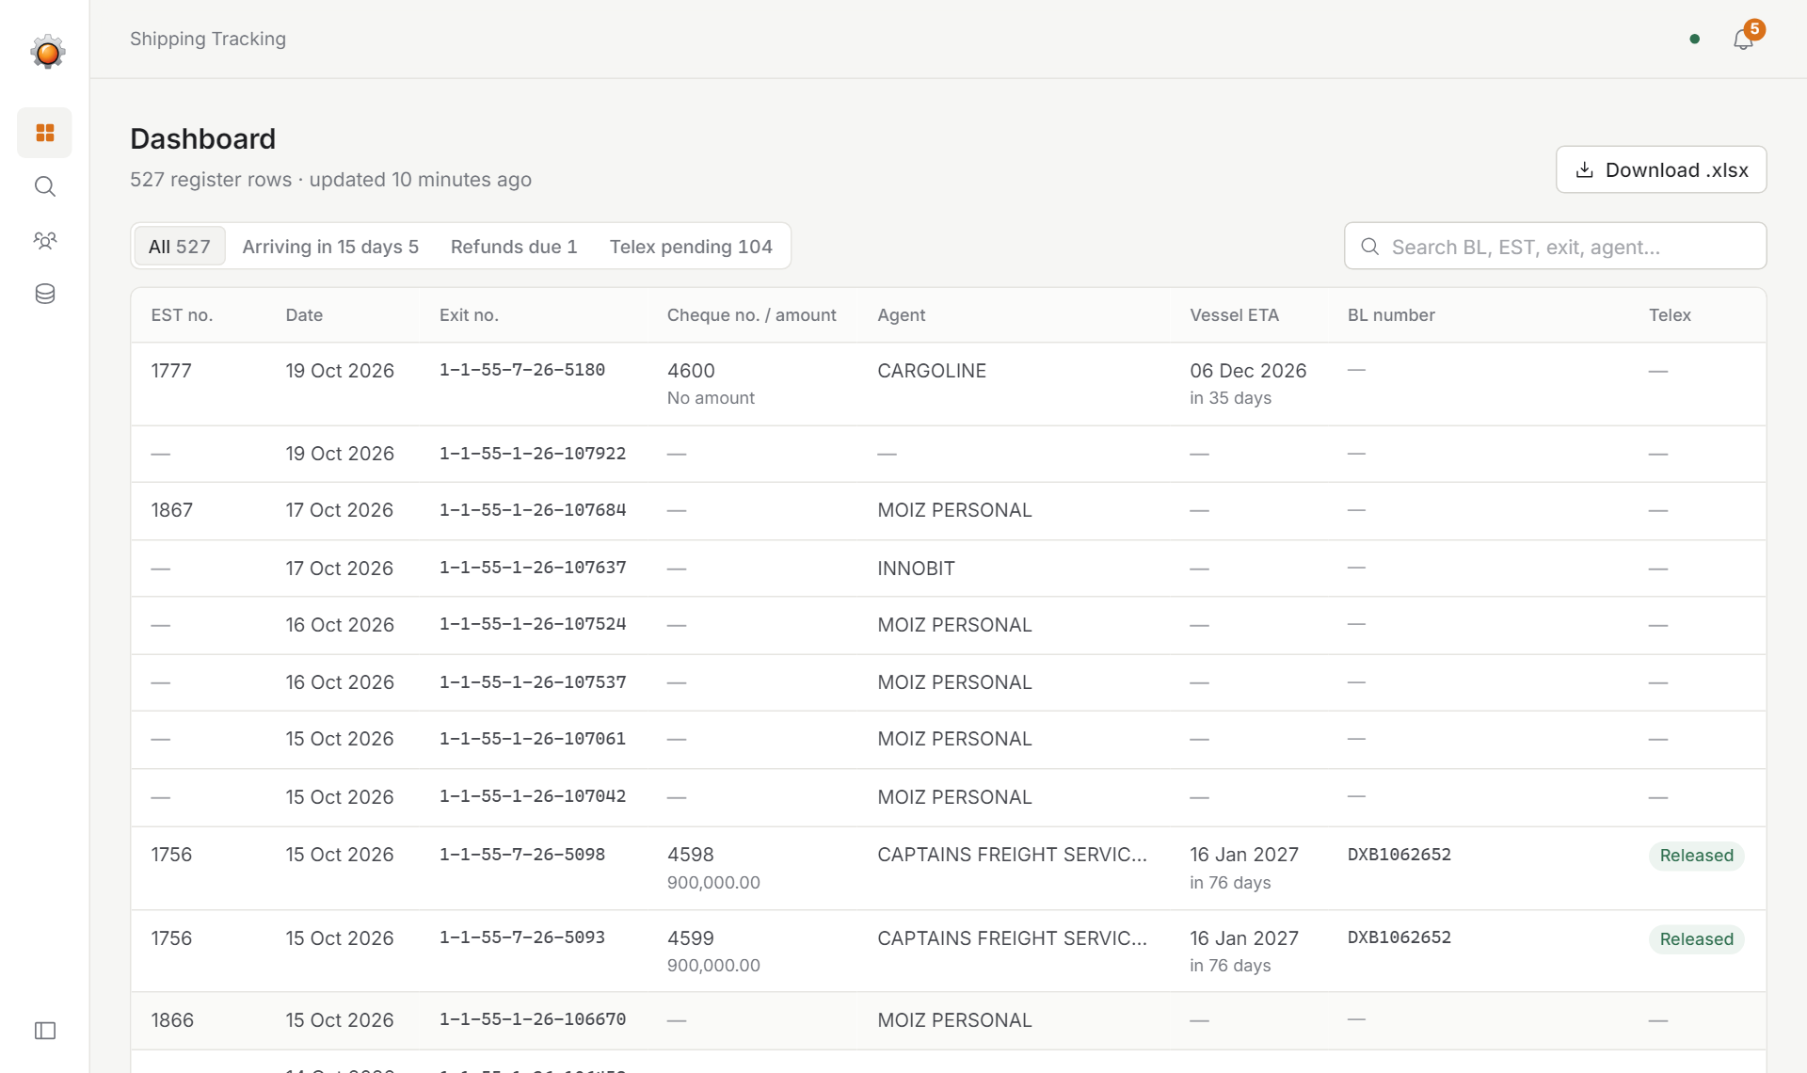
The menu folded away. Only the icons are shown.
On a phone: the menu is hidden. Tap the three lines (☰) at the top left to open it.

The reminder pop-up
When you open the website, a box may appear saying “items need attention”. This is the reminder. It shows:
- Arrival: a ship is arriving in 15 days or less, so payment should be requested from the consignee (customer).
- Refund: a cheque refund is due in 15 days or less.
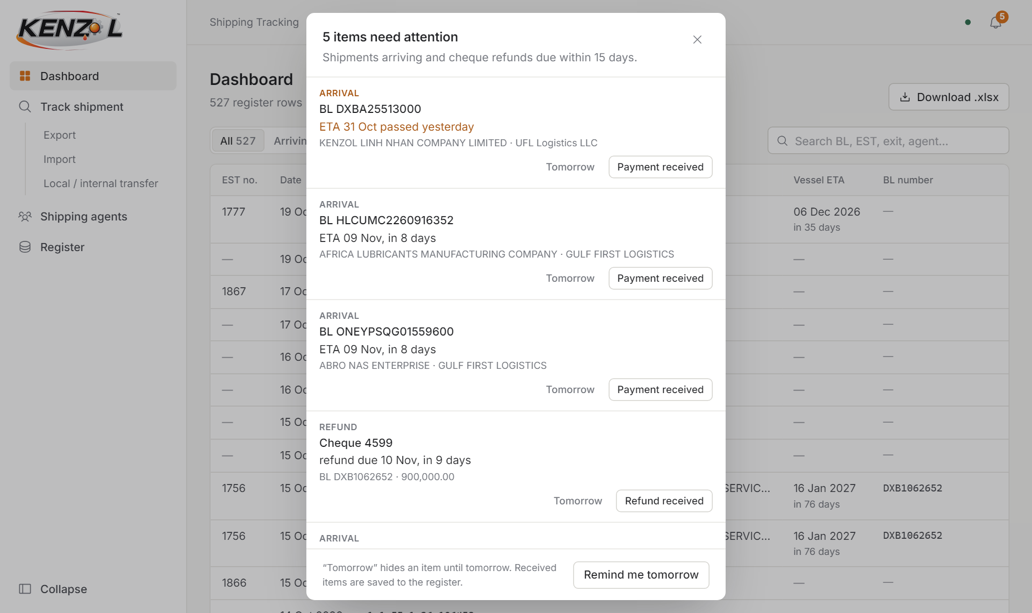
The reminder pop-up. Each item has two buttons.
For each item you can click:
- Payment received (or Refund received): the money has come in. The reminder disappears for good, and this is saved for everyone.
- Tomorrow: not yet. The reminder hides for today and comes back tomorrow.
- Remind me tomorrow (at the bottom): hides all of them until tomorrow.
- The X in the corner: just closes the box for now.
Click on the BL number in a reminder to open that shipment’s details.
Orange text means it is urgent: 3 days or less, or the date has already passed.

The bell (all notifications)
At the top right there is a bell. The small orange number on it shows how many reminders are open. Click the bell to see the full list at any time, even the ones you hid until tomorrow.
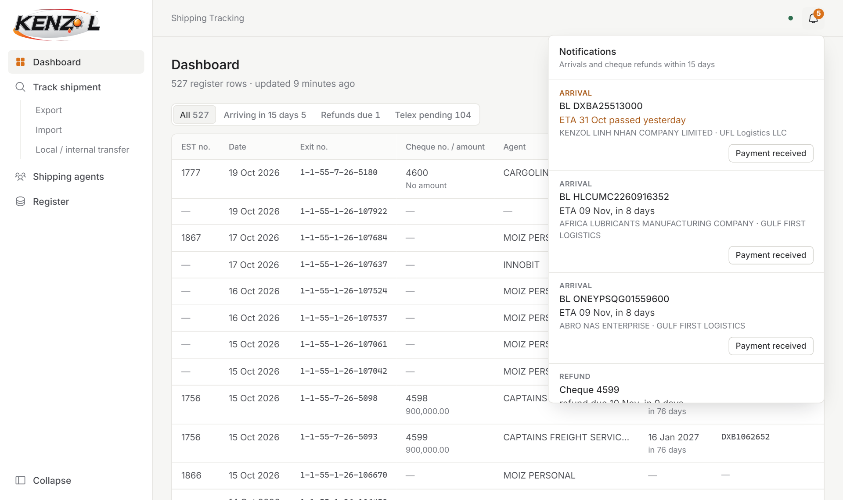
Click the bell to see every open reminder.

Dashboard (main page)
This is the page you will use most. Each line is one row from the register, newest at the top.
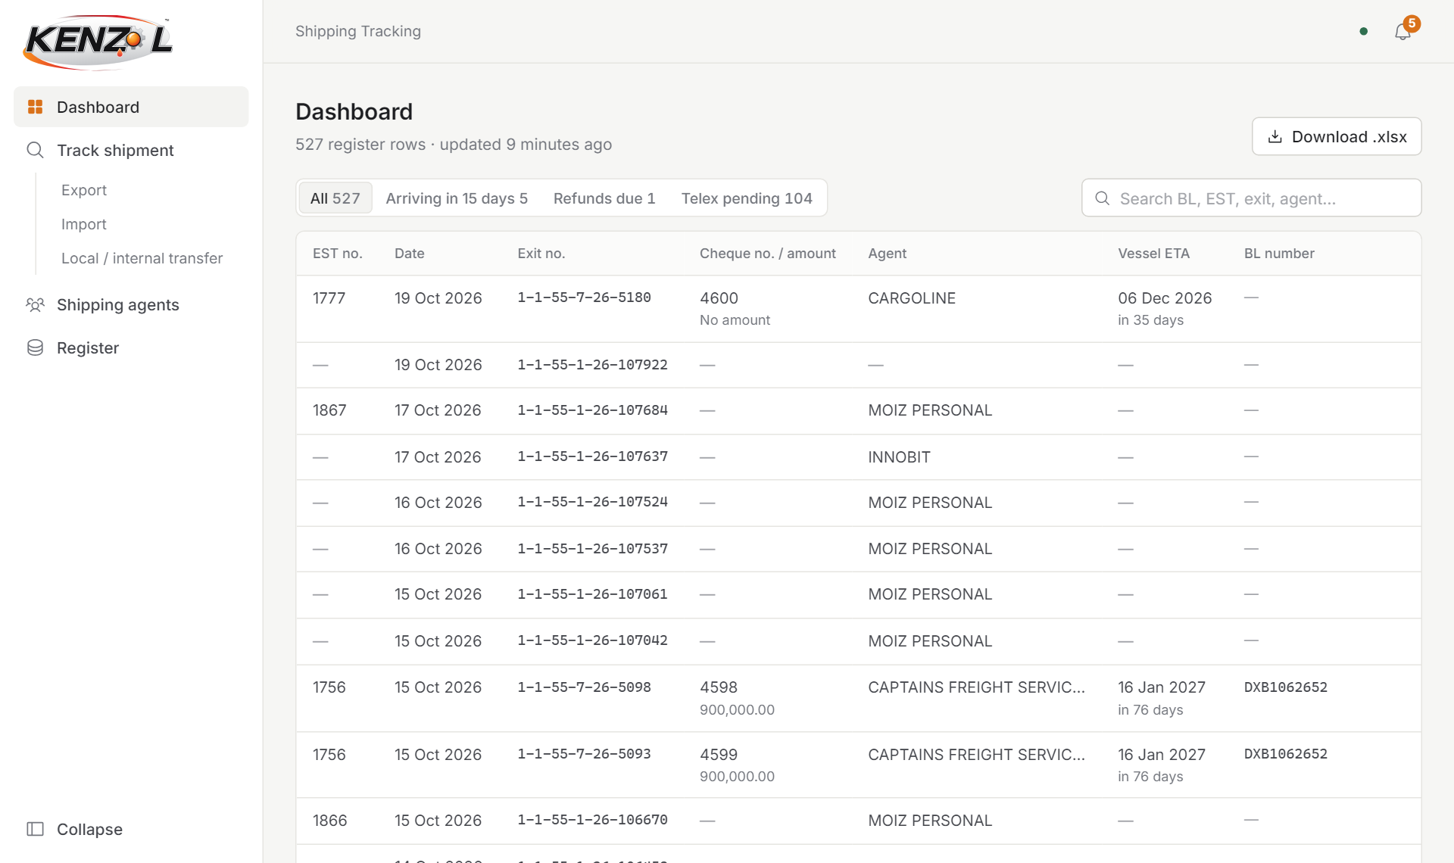
The Dashboard.

What the columns mean
Column | Meaning
EST no. | The EST number for the shipment.
Date | The customs exit date.
Exit no. | The customs exit number.
Cheque no. / amount | The cheque number on top, and its amount underneath. “No amount” means nobody has entered it yet.
Agent | The shipping agent handling it.
Vessel ETA | When the ship is expected to arrive. Underneath it says how many days are left (“in 8 days”) or “ETA passed” if the date is over. Orange means it is within 15 days.
BL number | The Bill of Lading number.
Telex | Pending (yellow) or Released (green). A dash means the row has no BL.

Filters and search
Above the table are four quick filters. Click one to show only those rows:
- All: every row.
- Arriving in 15 days: ships arriving soon.
- Refunds due: cheques whose refund is due within 15 days.
- Telex pending: BLs where the telex has not been released yet.
The search box on the right finds rows by BL, EST number, exit number, agent, consignee, destination, container or cheque number. Just start typing.
The Download .xlsx button saves the whole register as an Excel file.

Opening a row and updating it
Click on any row in a table. A panel slides in from the right with all the details of that shipment. At the bottom is an Update section.
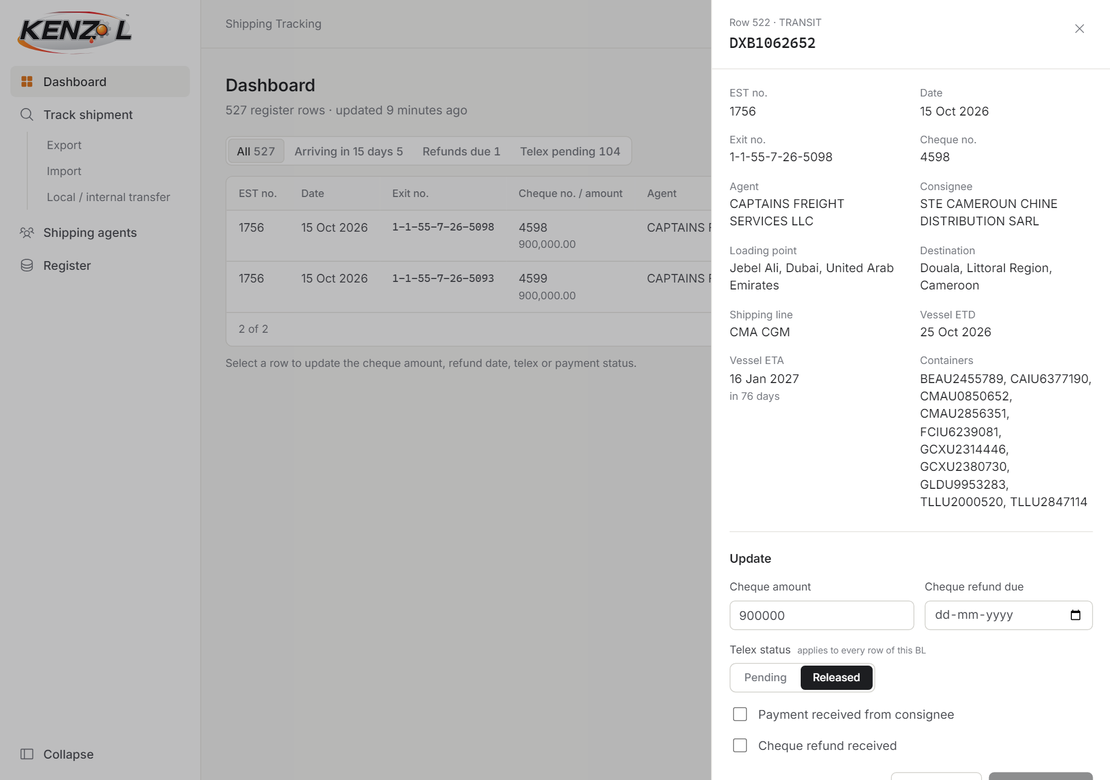
The details panel. Change what you need, then click Save changes.
Field | What to put in
Cheque amount | The amount of the cheque for this row. Numbers only, for example 1250.50.
Cheque refund due | The date the cheque refund is due. The website will remind you 15 days before this date.
Telex status | Click Pending or Released. This changes every row with the same BL number.
Payment received from consignee | Tick when the customer has paid. This stops the arrival reminder.
Cheque refund received | Tick when the refund has come back. This stops the refund reminder.

Then click Save changes. The button only works after you have changed something. To close without saving, click the X at the top or press the Esc key.
If the row has a BL number, the Track BL button takes you straight to the live tracking for it.

Track shipment
Use this page to ask the shipping line where a ship is right now.
- Click Track shipment in the menu.
- Type the BL number in the long box at the top.
- Leave the shipping line on Auto-detect carrier. If the search fails, choose the shipping line (MSC, Maersk, CMA CGM, Hapag-Lloyd) and try again.
- Click Track. It can take up to a minute.
You will then see:
- The status: Planned, In transit or Delivered.
- From and To: where it left from and where it is going.
- Estimated arrival: or Arrived, once the shipping line confirms it.
- Milestones: every step the ship has taken, newest first. The newest real step is marked Latest. Future steps are greyed out and marked Planned.
- Containers: the container numbers.
Click Save to register to copy the latest shipping line details (ETA, ETD, containers, ports) into the register. Click Refresh to ask the shipping line again.
Note: The shipping line only updates its information from time to time. This is not a live GPS map of the ship.
Your last five searches appear as small buttons under the search box, so you can repeat them with one click.

Export, Import, Local / internal transfer
Below the search there is a list of shipments sorted by type. You can also reach these from the small links under Track shipment in the menu.
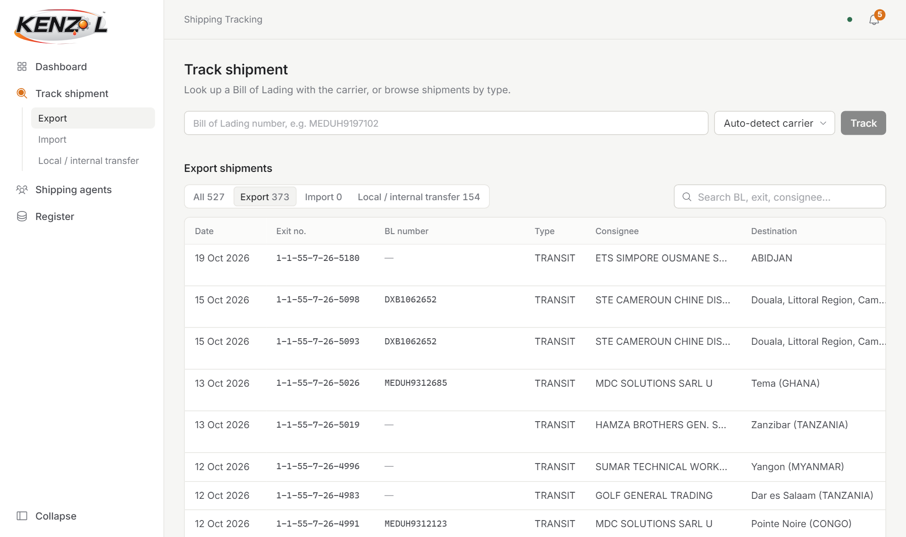
Shipments sorted by type.
Tab | Which shipments
Export | Rows with TYPE set to TRANSIT or EXPORT.
Import | Rows with TYPE set to IMPORT. This is empty for now, because no rows are marked IMPORT yet.
Local / internal transfer | Rows with TYPE set to LOCAL or INTERNAL TRANSFER.

Older rows (before September) have no TYPE filled in. For those, the website guesses from the destination: places inside the UAE count as Local, other countries count as Export. These rows show “Not recorded” in the Type column so you know it was a guess.
Click Track at the end of a row to look that BL up with the shipping line.

Shipping agents
This page shows every agent and how many register rows they have.
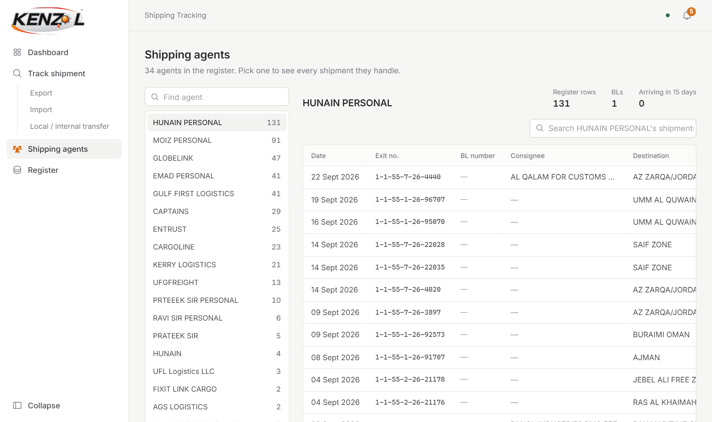
Pick an agent on the left to see their shipments on the right.
- Click Shipping agents in the menu.
- Click an agent name in the list on the left. Use Find agent to search for one.
- On the right you see their totals (rows, BLs, ships arriving in 15 days) and all their shipments.
- Click any shipment to open its details.
Tip: The same agent is sometimes spelled differently in the Excel sheet (for example “HUNAIN” and “HUNAIN PERSONAL”). The website shows these as separate agents. Using one spelling in the Excel sheet will fix this.

Register
This is the full original sheet, with nothing hidden. Use it when you need every column.
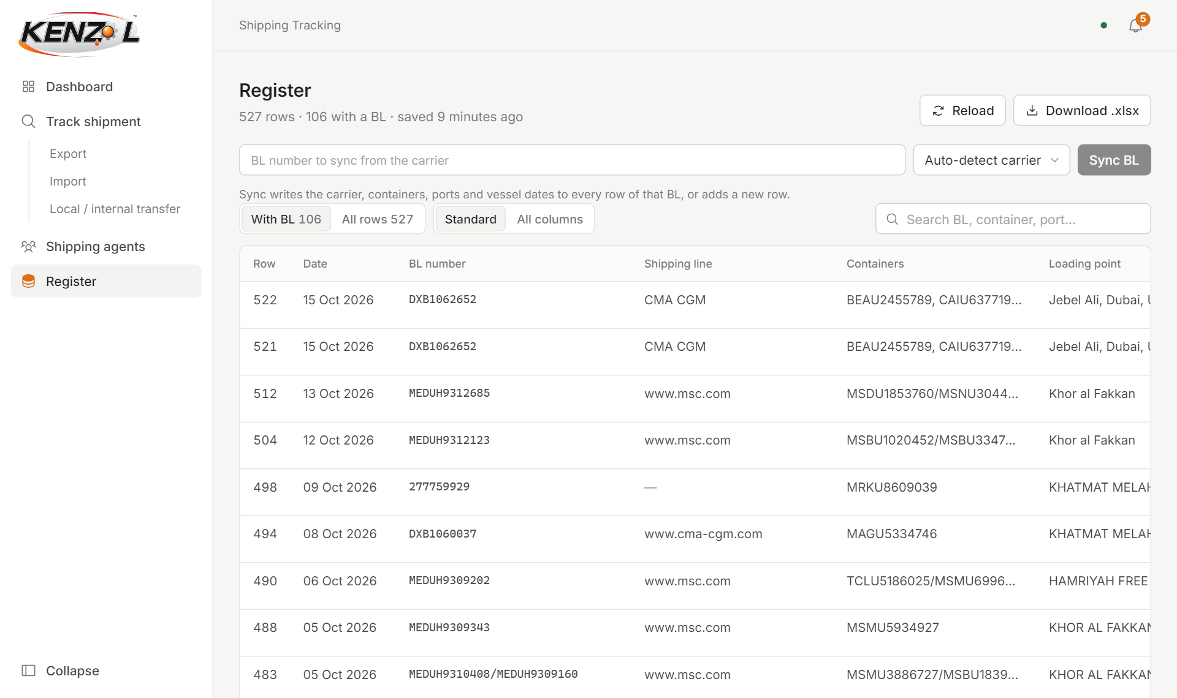
The Register page.
- Sync BL: type a BL number and click Sync BL to fetch the latest shipping line details into the register.
- With BL / All rows: show only rows that have a BL number, or every row.
- Standard / All columns: show the main columns, or every column in the sheet.
- Download .xlsx: save the register as an Excel file.
- Bin icon: deletes that row. You will be asked to confirm. Deleting cannot be undone.

4. How do I…? (quick answers)

…mark that a customer has paid?
- Click the row on the Dashboard (or click the reminder).
- Tick Payment received from consignee.
- Click Save changes. Or simply click Payment received in the reminder.

…get reminded about a cheque refund?
- Click the row with that cheque on the Dashboard.
- Pick the date in Cheque refund due.
- Click Save changes. You will be reminded 15 days before.

…mark the telex as released?
- Click any row of that BL.
- Click Released under Telex status.
- Click Save changes. All rows of that BL change together.

…find out where a ship is today?
- Go to Track shipment.
- Type the BL number and click Track.

…see everything one agent is handling?
- Go to Shipping agents.
- Click the agent’s name.

…get the data in Excel?
- Click Download .xlsx on the Dashboard or Register page.
- The file is saved to your Downloads folder.

…see ships arriving soon?
- Go to the Dashboard.
- Click the Arriving in 15 days filter.

5. Keeping the data clean
Most of the wrong dates came from small typing habits in the Excel sheet. These simple rules prevent it happening again:
- Always write dates as day/month/year with slashes, for example 09/11/2026. Before typing, set the column format to Text or dd/mm/yyyy, so Excel does not change it.
- Only put a date in a date column. Words like “DO” (ditto), “ya” or notes in the ETA/ETD columns cannot be read. Leave it empty or write N/A.
- Check the year and the slashes. “2911/2026” is missing a slash; “28/11/26” should be 28/11/2026.
- Spell each agent the same way every time.
- Always fill in the TYPE column (TRANSIT, EXPORT, IMPORT, LOCAL or INTERNAL TRANSFER), so shipments land in the right tab.

Rows that still need a look in the Excel sheet
Row | Problem | What to do
314 | ETA says “DO” | Write the real ETA, or leave it empty.
457 | ETD says “ya” | Write the real ETD, or leave it empty.
521 and 522 | Both cheques (4598 and 4599) show 900,000. This may be one amount copied to both by the old system. | Check the real amount of each cheque and correct it in the website.

6. Words used in this guide
Word | Meaning
BL / Bill of Lading | The shipping document number that identifies a shipment with the shipping line.
ETA | Estimated Time of Arrival: when the ship is expected at its destination.
ETD | Estimated Time of Departure: when the ship is expected to leave.
EST number | Our internal EST reference for the shipment.
Exit no. | The customs exit number.
Consignee | The customer receiving the goods.
Shipping agent | The company or person handling the shipment for us.
Shipping line / carrier | The ship company, for example MSC, Maersk or CMA CGM.
Telex release | The shipping line’s release of the goods without the paper BL. “Pending” means not yet released.
Register | The full list of all shipments (our Excel sheet, kept inside the website).
Sync | Copy the latest details from the shipping line into the register.

