**SMART TIME TABLE GENERATOR SYSTEM**



**BTech/III Year CSE/V Semester**

**15CSE302/Database Management Systems**

**Project Review -1**

|  |  |
| --- | --- |
| Rollno | Name |
| CB.EN.U4CSE18303 | **ADITHI GIRIDHARAN** |
| CB.EN.U4CSE18304 | **AISHWARYA BABU** |
| CB.EN.U4CSE18333 | **AKHILA KOLLI** |

**Amrita School of Engineering, Coimbatore**

**Department of Computer Science and Engineering**

**2020 -2021 Odd Semester**

Table of Contents

**Title Page number**

**Chapter 1 Introduction 3**

**Abstract 4**

**Chapter 2 Logical Database Design ER Diagram 5**

**Entities 5**

**Attributes 5**

**Relationships 5**

**Schema Diagram ……………..…………………………………………………6**

**ER Diagram …………………………………………………………………….7**

**Chapter 3 ER to Relational Schema Mapping 7**

**Chapter 4 User Interface Screens 8**

**References 9**

# Chapter 1 Introduction

**About the project**

Most of the colleges use a tedious manual way of preparing timetables, it is usually very time consuming. This can end up with clashing of courses and may be at the same room or with the same teachers having more than one course at a time. These are just due to common human errors which are difficult to prevent.To overcome these problems, we propose the system of smart time table generator. This system will take inputs like details of students, subjects, classrooms and teachers available. Depending upon these inputs, it will generate a possible timetable, making the utilization of all of these resources in a way that will best suit constraints of the college rules.

**Objective**

To create an online platform to ease the tedious work of creating a timetable system to facilitate dynamic addition of classes and substitution of professors on their absence.

**Abstract**

Smart Timetables helps education providers deliver more value to students and keep admin costs down, even as student numbers grow.

It does this by automating the delivery of up-to-date, personalized timetables – enriched with information such as professor availability, assignment due dates and tutorial reminders – directly into the phone and tablet calendars of students and staff.

It also enables staff to manage their timetables and deal with clashes or other issues straight away. This makes things simpler and easier for them, and helps to reduce their admin burden.

There are many situations where a particular period might be wasted because of the absence of a professor. This Smart Time Table ensures that a substitute professor is notified to take over the class.

**Business Rules**

* Separate timetable for the individual class, faculty and labs are to be generated automatically by this system.
* Slot clashes do not occur.
* Faculty replacement is also to be made possible by listing out the available faculty who are eligible to be assigned as temporary faculty until a replacement faculty is assigned.

**Chapter 2 Logical Database Design ER Diagram**

## Entities

1. Faculty
2. Course
3. Lab
4. ClassRoom
5. Period
6. Department
7. Building
8. Students
9. TimeTable
10. Class
11. Section
12. Admin

## 

## Attributes

1. **Faculty -** fac_Id, full_name (F_name,L_name), email_Id, courses[]
2. **Course –** course_Id, course_name, credits, type
3. **Lab –** lab_Id, capacity, lab_location, lab_incharge
4. **ClassRoom –** room_no**,**capacity, location
5. **Period –** hour, day, class, faculty, type
6. **Department -** dept_id, name, employee_count, dean
7. **Building** - building_no, department
8. **Students –** roll_no, name, class
9. **TimeTable –** class_id, allocation[ ]
10. **Class –** class_id, department, advisor
11. **Section –** section, year, semester
12. **Admin –** name, admin_Id, email_id, password

## 

## Relationships

1. Replaces - faculty_id, faculty_replacements[ ]
2. Mentors - course_id, faculty_id
3. Teaches - course_id, faculties[ ]
4. Includes - course_id[ ], lab_id[ ]
5. Enrolls - student_id[ ], courses[ ]
6. Heads - dept_id, faculty_id
7. Belongs_to - class_id, dept_id
8. Consists_of - periods[ ], timetable
9. Assigned - timetable, class_id
10. Allocated - class_id, room_no

**Schema Diagram**

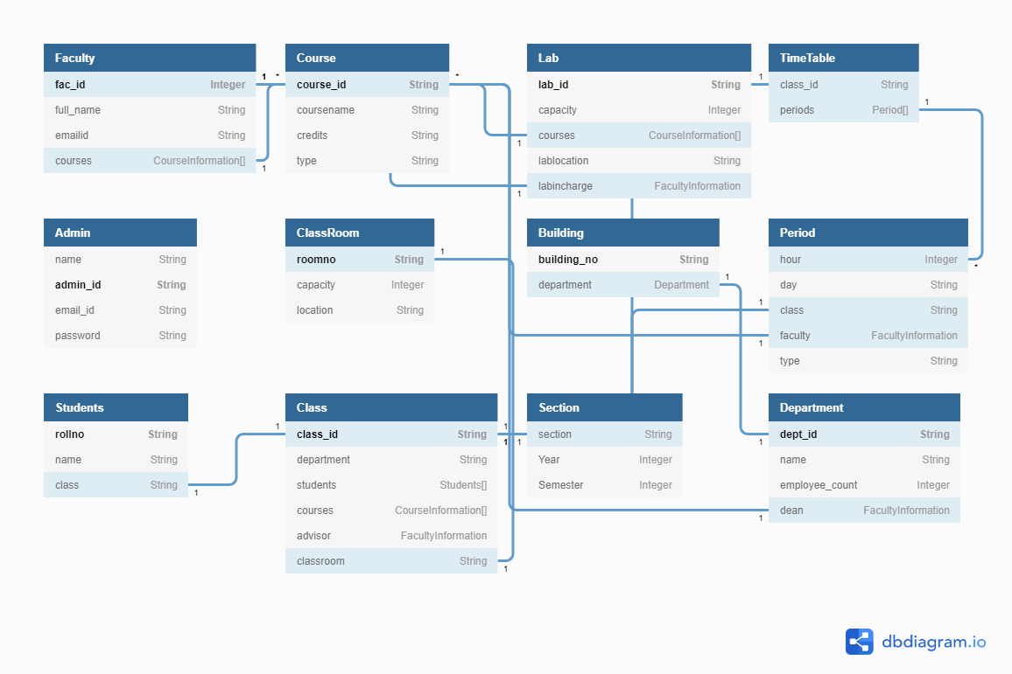

**ER Diagram**

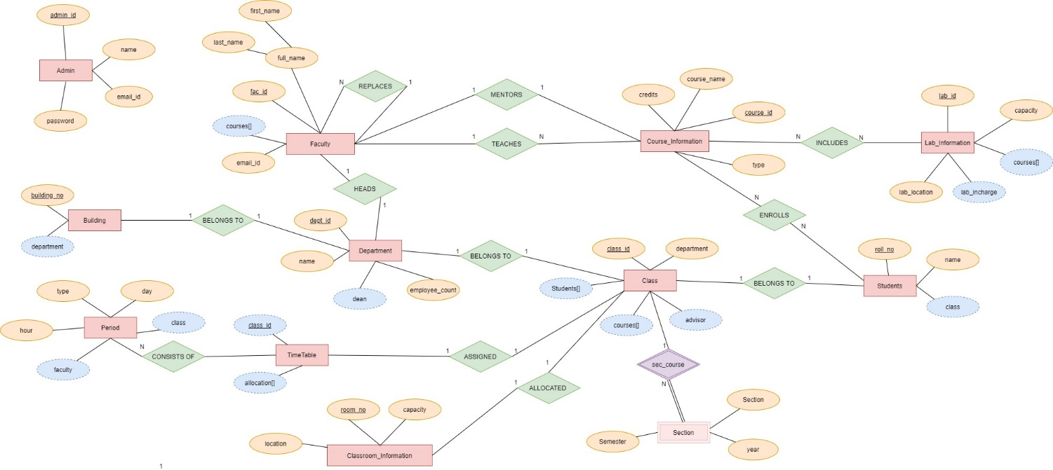

**Chapter 3 ER to Relational Schema Mapping**

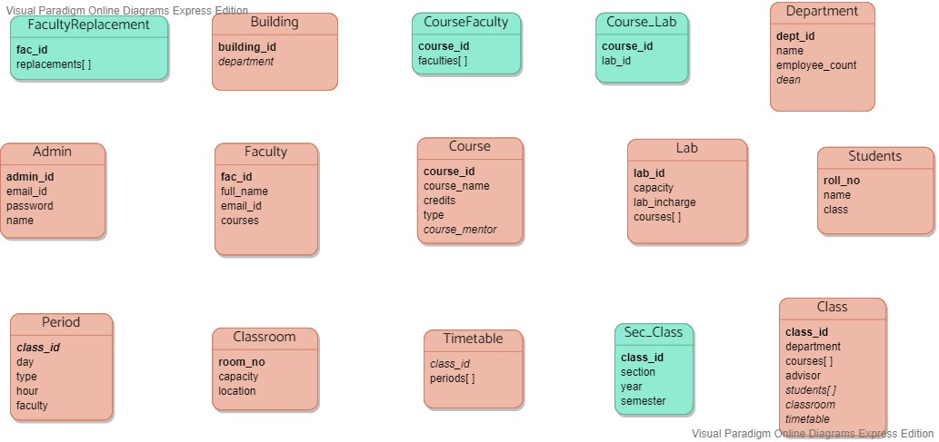

**Chapter 4 User Interface Screens**

# References

**/*Books reference format**

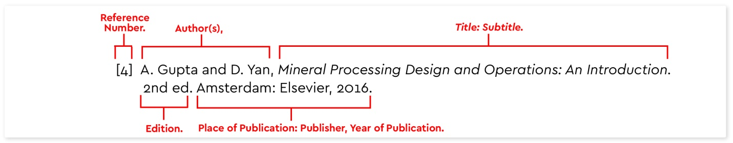

**Websites reference format**

[#] INITIAL(S). Surname, “Page Title,” Website Name. Accessed: date of access. [Online]. Available: URL.

**\*/**