CHAPTER 1

INTRODUCTION

* 1. GENERAL INTRODUCTION

Wind energy has emerged as a highly promising source of renewable energy in recent times. However, wind turbines regularly suffer from operational inconsistencies, leading to significant costs and challenges in operations and maintenance. Condition-based monitoring (CBM) and performance assessment/analysis of turbines are vital aspects for ensuring efficient operations and maintenance planning and cost minimization. Data-driven decision making techniques have witnessed rapid evolution in the wind industry for such operations and maintenance tasks during the last decade, from applying signal processing methods in early 2010 to artificial intelligence (AI) techniques, especially deep learning in 2020.

Here we utilise statistical computing to present a scientometric review of the conceptual and thematic evolution of AI in the wind energy sector, providing evidence-based insights into present strengths and limitations of data-driven decision making in the wind industry. Here we provide a perspective into the future and on current key challenges in data availability and quality, lack of transparency in black box-natured AI models, and prevailing issues in deploying models for real-time decision support, along with possible strategies to overcome these problems.

* 1. GOAL OF THE PROJECT
* **The system will collect data directly from the wind farms with monitoring and report generation in real-time, to improve decision making and reliability. This can result in increased efficiency, better spare-parts forecasting, reduced downtime, and lower unplanned maintenance costs.**
* **Create AI models of normal turbine behavior, which serve to quickly identify abnormalities and notify the wind-farm operator.**
* **Many types of forecasts are possible, including power production, availability, spare parts needs, and other such use cases.**
* **Informs about the components that are likely to fail and helps in replacing the components in due time.**

CHAPTER 2

LITERATURE SURVEY

2.1 STUDY OF SIMILAR WORK

Control of Synchronous Generator in Wind Power Systems Using Neuro-Fuzzy Approach

This system presents the control scheme of a synchronous generator in wind energy power system using adaptive neuro-fuzzy approach. A neuro-fuzzy-based controller is used for controlling a permanent magnet synchronous generator (PMSG) that is used in wind power systems. The variables have been controlled are the angular velocity, dc voltage, reactive power, active power, a phase current and voltage phase of generator output. The simulation results show that the adaptive neuro-fuzzy controller has successfully controlling all variables in a relatively short time to get back to a stable state.

Production of electricity from renewable energy sources like wind energy increases due to environmental problems and the shortage of traditional energy sources. Nowadays, permanent magnet synchronous generators (PMSG) are used in wind turbine because of its advantages: better reliability, less maintenance and more effective. In this system the control scheme of a synchronous generator in wind energy power system using adaptive neuro-fuzzy approach. A neuro-fuzzy-based model reference adaptive system is continuously tuned with actual permanent magnet synchronous generator (PMSG) to neutralize the effect of parameter variations such as stator resistance, inductance, and torque constant. This neuro-fuzzy-tuned estimator is able to estimate the rotor position and speed accurately over a wide speed range with a great immunity against parameter variation.

2.1.1 EXISTING SYSTEM

The current system is using software only for maintaining

* Employ attendance- Software is able to mark the employ attendance and managing the leave register.
* Staff management- Manually and automatically arranges the shift of the employees and maintaining the staff in a HR manner.
* Expense management- Accounting the overall wind mill expense and recording the amount of energy generated. Also calculate the profit and loss made by the wind mill.

2.1.2 DRAWBACKS OF EXISTING SYSTEM

Existing management system is not integrated, they have separate employee attendance system and accounts software. No AI models are created for predicting turbine behavior, power production etc. Because of not forecasting the maintenance requirements and spare parts needs, heavy financial loss is there due to the unexpected shutdown of wind mills. Manpower utilization is also not in a better way, since there is no manpower management system is present in the current software. Wind speed forecasts can boost the quality of wind energy generation by increasing the efficiency and enhancing the economic viability of this variable renewable resource, this feature is also not available in existing system.

CHAPTER 3

OVERALL DESCRIPTION

3.1 PROPOSED SYSTEM

The proposed method proved to provide an effective way of fault identification at minimum cost. The method further proves to minimize the maintenance cost as well by saving the components prior to the occurrence of the intensive faults. The accuracy of the method and the error rate of the method were considerably low compared to the existing methodologies. **In addition to the whole farm monitoring, data from the individual turbines will allow detection of deviations from the design parameters and potential emerging maintenance issues.**

AI models are used for maintaining wind mills operations. **The sources from which AI can pull information may include maintenance data, failure histories, and management software. Here software serve to quickly identify abnormalities and notify the wind-farm operator. Many types of forecasts are possible, including power production, availability, spare parts needs, and other such use cases. Having such increased visibility provides tremendous benefits to wind-turbine operators.**

3.2 FEATURES OF PROPOSED SYSTEM

Creating AI models for increasing **efficiency, better spare-parts forecasting, reduced downtime, and lower unplanned Maintenance costs. This system will collect data directly from the wind farms with monitoring and report generation in real-time, to improve decision making and reliability. Informs about the components that are likely to fail and helps in replacing the components in due time. Predict the parts which may fail before the failure of that particular part.**

3.3 FUNCTIONS OF PROPOSED SYSTEM

* Fault detection optimization- Detecting machine faults at an early stage of development is one of the fundamental concepts of machine condition monitoring. The objective is to detect developing faults as early as possible so the lead-time up to the point where operational/productional capacity drops off as the fault develops and is sufficient for cost-effectively planning maintenance up until that time.
* Prognostics to failure**-** After a fault has been automatically detected and the specialist has sufficiently identified the fault, determined its severity, and established a trend, the next step is to predict when the component needs to be replaced or repaired with minimal maintenance intervention and without interrupting production.
* Speed sensor substitute- Speed reference sensors are used extensively in wind-turbine condition monitoring. Wind turbines inherently operate at a wide range of speeds because of variable wind conditions, and because the gearbox itself has several speeds according to the stages built into it, ranging from the low-speed blade hub up to the high-speed generator.
* Collects **maintenance data, failure histories, and management software, which are used to create AI models**

**Here it collects every data of a wind mill operation and evaluate it for training AI norms. This can predict the outcomes early before it happen.**

* **Analyzing energy produced and its expense.**

3.4 REQUIREMENTS SPECIFICATION

System analyst tasks to a variety of persons to gather details about the business process and their opinions of why things happen as they do and their ideas for changing the process. These can be done through questionnaires, details investigation, observation, collection of samples etc. As the details are collected, the analyst study the requirements data to identify the features the new system should have, including both the information the system produce and operational features such as processing controls, response times, and input output methods.

Requirement specification simply means, “Figuring out what to make before you make it”. It determines what people need before you start developing a product for them. Requirement definition is the activity of translating the information gathered in to a document that defines a set of requirements. These should accurately reflect what consumer wants. It is an abstract description of the services that the system should provide and the constraints under the system must operate.

The notations used for requirements definition should be based on natural languages, forms and simple intuitive diagrams. The requirements fall into two categories: functional requirements and non-functional requirements.

The requirements of specification of the proposed system are as follows:

* Minimum time needed for various processing
* Better Service
* Faster response time

3.5 FEASIBILITY ANALYSIS

The main aim of the feasibility study activity is to determine. Whether it would be financially and technically feasible to develop the product. The feasibility study activity involves analysis of the problem and collection of all relevant information relating to the product such as the different data items which would be input to the system the processing required to be carried out of these data, the output data required to be carried out of these data, the output data required to be produced by the system, as well as various constraints on the behavior of the system.

In our software we would find the actual requirements of this software and add that features Such as monitoring, process scanning etc. For adding this feature, we will like take different ways to solving this last find the best way to complete these features.

Feasibility studies aim to objectively and rationally uncover the strengths and weakness of the existing business or proposed venture, opportunities and threats as presented by the environment, the resources required to carry through, and ultimately the prospects for success. In its simplest term, the two criteria to judge feasibility are cost required and value to be attained As such, a well-designed feasibility study should provide a historical background of the business or project, description of the product or vice, accounting statements, details of the operations and management, marketing research and policies, financial data, legal requirements and tax obligations. Generally, studies precede technical development and project implementation.

3.5.1 TECHNICAL FEASIBILITY

The assessment is based on an outline design of system requirements in terms of Input, Processes, Output, Fields, Programs, and Procedures. This can be quantified in terms of volumes of data, trends, frequency of updating, etc. in order to estimate whether the new system will perform adequately or not. Technological feasibility is carried out to determine whether the company has the capability, in terms of software, hardware, personnel and expertise, to handle the completion of the project when writing a feasibility report, the following should be taken to consideration. A brief description of the business the part of the business being looked towards. The human and economic factor the possible solutions to the problems.

The system is technically feasible.

3.5.2 OPERATIONAL FEASIBILITY

Operational analysis is the most frequently used method for evaluating the effectiveness of a new system. More commonly known as cost/benefit analysis, the procedure is to determine the benefits and saving that are expected from a candidate system and compare them with costs. If benefits outweigh costs, then the decision is made to design and implement the system. An entrepreneur must accurately weigh the cost versus benefits before taking an action. Cost-based study: It is important to identify cost and benefit factors, which can be categorized as follows:

1. Development costs.
2. Operating costs.

This is an analysis of the costs to be incurred in the system and benefits derivable out of the system. Time-based study: This is an analysis of the time required to achieve a return on investments the future value of a project is also a factor. The system is operationally feasible.

* + 1. ECONOMICAL FEASIBILITY

In the economic feasibility the development cost of the system is evaluated weighing it against the ultimate benefit derived from the new system. Benefits can be tangible and intangible, direct or indirect. As assessment of the economic justification for a computer based system project is cost benefit. Cost benefit analysis is complicated by criteria that vary with the characteristics of the system to be developed, the relative size of the project and the respected return on investment derived as part of the strategic plan. The project AI Pedagogue is economically feasible because IDE used for developing software is free of cost.

3.5.4 BEHAVIORAL FEASIBILITY

Behavioral analysis is an operational principle for all requirements analysis methods. An estimate should be made of how strong a reaction the user is likely to have towards the development of a system. Behavioral analysis is an operational principle for all requirements analysis methods. The state-transition diagram represents the behavior of a system by depicting its status and the events that use the system to change state. AI Pedagogue is behaviorally feasible because of the effective use of the resource and also the system satisfies user needs and is user friendly.

CHAPTER 4

OPERATING ENVIRONMENT

4.1 HARDWARE REQUIREMENTS

Processor : Intel i5 8th Gen

RAM : 16GB ddr4

Hard disk : 2048 GB SSD

Drives : CD ROM, C-type Port, USB 3.1*2 Port

Display Size : Compatible Size (Recommend 15’inch)

Screen Resolution : 1920*1080 Pixels

Keyboard : Wireless Enabled Keyboard (Recommend: Logitech)

Keyboard Mouse : Wireless Enabled Mouse (Recommend: Logitech)

Monitor : Touch Capacity LED Monitor

Dedicated Graphics Card : Nvidia GeForce GTX 1050 4GB DDR5

Camera : 8 Megapixel Full HD 1.8f lens

Extra : Wi-Fi Adapter, Bluetooth Adapter

4.2 SOFTWARE REQUIREMENTS

Operating System : Windows (7/8/10)/Ubuntu (14/16/18/20)

Software Drivers : Wi-Fi drivers .Bluetooth Drivers, Visual Studio Drivers Nvidia GeForce Graphics drivers, Intel Drivers and Camera Drivers

Programming Language : Python

IDE : OpenCV, keras

Scripting Languages : HTML, CSS, JavaScript

Web Browser : Google Chrome

Front-End : Python, Django

Back-End : My SQL

4.3 Tools and platforms

4.3.1 PYTHON:

Python is a general purpose, dynamic, high-level, and interpreted programming language. It supports Object Oriented programming approach to develop applications. It is simple and easy to learn and provides lots of high-level data structures. Python is easy to learn yet powerful and versatile scripting language, which makes it attractive for Application Development. Python's syntax and dynamic typing with its interpreted nature make it an ideal language for scripting and rapid application development. Python supports multiple programming pattern, including object oriented, imperative, and functional or procedural programming styles. Python is not intended to work in a particular area, such as web programming. That is why it is known as multipurpose programming language because it can be used with web, enterprise, 3D CAD, etc.

**Features of Python**

* Easy-to-learn − Python has few keywords, simple structure, and a clearly defined syntax. This allows the student to pick up the language quickly.
* Easy-to-read − Python code is more clearly defined and visible to the eyes.
* Easy-to-maintain − Python's source code is fairly easy-to-maintain.
* Python's bulk of the library is very portable and cross-platform compatible on UNIX, Windows, and Macintosh.
* Interactive Mode − Python has support for an interactive mode which allows interactive testing and debugging of snippets of code.
* Portable − Python can run on a wide variety of hardware platforms and has the same interface on all platforms.
* Extendable − Can add low-level modules to the Python interpreter. These modules enable programmers to add to or customize their tools to be more efficient.
* Databases − Python provides interfaces to all major commercial databases.
* GUI Programming − Python supports GUI applications that can be created and ported to many system calls, libraries and windows systems, such as Windows MFC, Macintosh, and the X Window system of Unix.
* Scalable − Python provides a better structure and support for large programs than shell scripting.

4.3.2 MySql

MySQL Server is the world's most used relational database management system (RDBMS) that runs as a server providing multi-user access to a number of databases. This stores data in the form of multiple related tables. The SQL phrase stands for Structured Query Language. The MySQL development project has made its source code available under the terms of the GNU General Public License, as well as under a variety of proprietary agreements. MySQL was owned and sponsored by a single for-profit firm, the Swedish company MySQL AB, now owned by Oracle Corporation.

**Features of MySQL**

* Relational Database Management System (RDBMS) - MySQL is a relational database management system.
* Easy to use - It is easy to use. You have to get only the basic knowledge of SQL. You can build and interact with MySQL with only a few simple SQL statements.
* Secure - MySQL consist of a solid data security layer that protects sensitive data from intruders. Passwords are encrypted in MySQL.
* Free to download - MySQL is free to use and you can download it from MySQL official website.
* Scalable - MySQL can handle almost any amount of data, up to as much as 50 million rows or more. The default file size limit is about 4 GB. However, you can increase this number to a theoretical limit of 8 TB of data.

CHAPTER 5

DESIGN

5.1 System Design

System can be defined, as an orderly grouping of interdependent components can be simple or complex. The most creative and challenging phase of the system life cycle is system design. The term design describes a final system and the process by which it is developed .It refers to the technical specifications that will be applied in implementing the candidate system .It also includes the construction of programs and program testing.

The first step in the system design is to determine how the output is to be produced and in what format. Samples of the output and the inputs are also presented .In the second step, input data and master files are to be designed to meet requirement of the proposed output .The processing phase’s system’s objectives and complete documentation.

System design has two phases:

* Logical
* Physical

The logical design reviews the present physical system, prepares the input and output and also prepares a logical design walk- through .We have to deal with how to take entries required and whether and how to process the user data.

Physical design maps out the details of the physical system, plans the system implementation, devices a test and implementation plan and new hardware and software. We have to decide how and where to store the input data and how to process it so as to present it to the user in an easy, informative and attractive manner.

Modules

* Manager
* Maintenance and spare parts prediction

About the project

Applying AI in wind turbines for better maintenance practices, to increase efficiency, better spare parts forecasting, reduced downtime and lower unplanned maintenance cost. For this AI models were created by collecting **information may include maintenance data, failure histories, and management software data.** **Many types of forecasts are possible, including power production, availability, spare parts needs, and other such use cases. Having such increased visibility provides tremendous benefits to wind-turbine operators. Below listed are some core features of our system but there are many functions and features provided in this system.**

* Manager

Administrative module controls the entire system, manage the entire application, core functions managed by admin are-

1. Employ management

In employ management function manager can manage all day today activities. Plant manager add employ by entering name, designation, phone number, email and employ id. Employ can login his/her id using employ id and password given by the manager. Manager can view the attendance, salary and also can edit employ details. Also manager can block or unblock employees and can restrict their movements. Generate wages report, update hourly wages. Calculate employee efficiency and report based on daily log. Update job sheet and verify and approve job sheet.

1. Wind mill management

In wind mill management function plant manager can add new wind mill turbines details by entering windmill id, location name and output cost. Also plant manager can add parts name, weight, material used etc. In this function windmill specifications can be recorded like power efficiency, noise level, rotor diameter, blade length, swept area, hub height and rotor weight.

1. Power production

In this function power production report generation based on the auto updated power generation log. Predict the amount of power will be generate. Also plant manager can manage the power outcome from the windmill. Using windmill id manager can view amount of generated power its date, time and from which turbine.

1. Service management

In service management function it update daily machine status, service history, periodic checkup update. Plant manager can inspect day today service of employees and the machines as well. Check parts availability, service validity and current status. Also record wind mill id of damaged or serviced report for further examining.

* Maintenance and spare parts prediction

Determine the condition of equipment and predicting when maintenance should be performed. Usage history data is an important indicator of wind mill condition. It also wants information about maintenance and service history. All this information is updated periodically from the maintenance portal.

Linear Regression Algorithm is used to find the remaining life of a part

5.2 Data Flow Diagram

Data Flow Diagram (DFD) are directed graphs in which the nodes specify processing activities and the arcs that specify data items transmitted between processing nodes. Like flow charts DFD can be used at any desired level of abstraction. A DFD might represent data flow between individual statements or block of statements in a routine, data flow between concurrent process and data flow in a distributed computing system. Unlike flow charts DFD do not indicate a decision logic or condition under where various processing nodes in the diagram might be activated.

DFD is necessary for communicating for customer during requirement analysis; they are also widely used for representing external and internal design specifications. In the lack of structure DFD’s are quite valuable for establishing meaning, conventions and names of system components such as subsystems, files and data links. A database is a collection of interrelated data stored with minimum redundancy to serve many users quickly and efficiently to make the data access easy, inexpensive and flexible to the user

A DFD consists of a series of bubbles joined by lines. The bubble represents data transformation and line represents data flow in the system. In the normal convention a DFD has four major symbols:

* Square, this defines source or destination of data.

|  |
| --- |
|  |

* Arrow, which shows data flow
* Circle, which represents a process that transforms incoming data into outgoing

flow.

* Open rectangle, which shows a data set.

## Figure 5.1 DFD Components

5.2.2 Project DFD

Manager (LEVEL 0) (CONTEXT LEVEL)

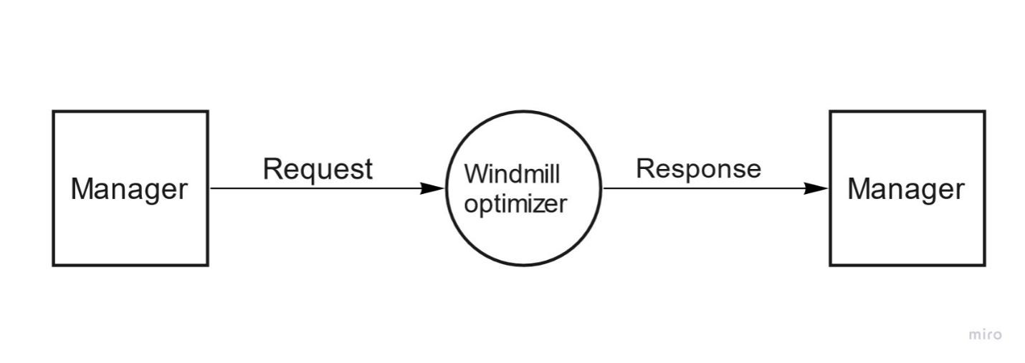

Figure 5.2 Manager (Level 0)

Level 1 Login

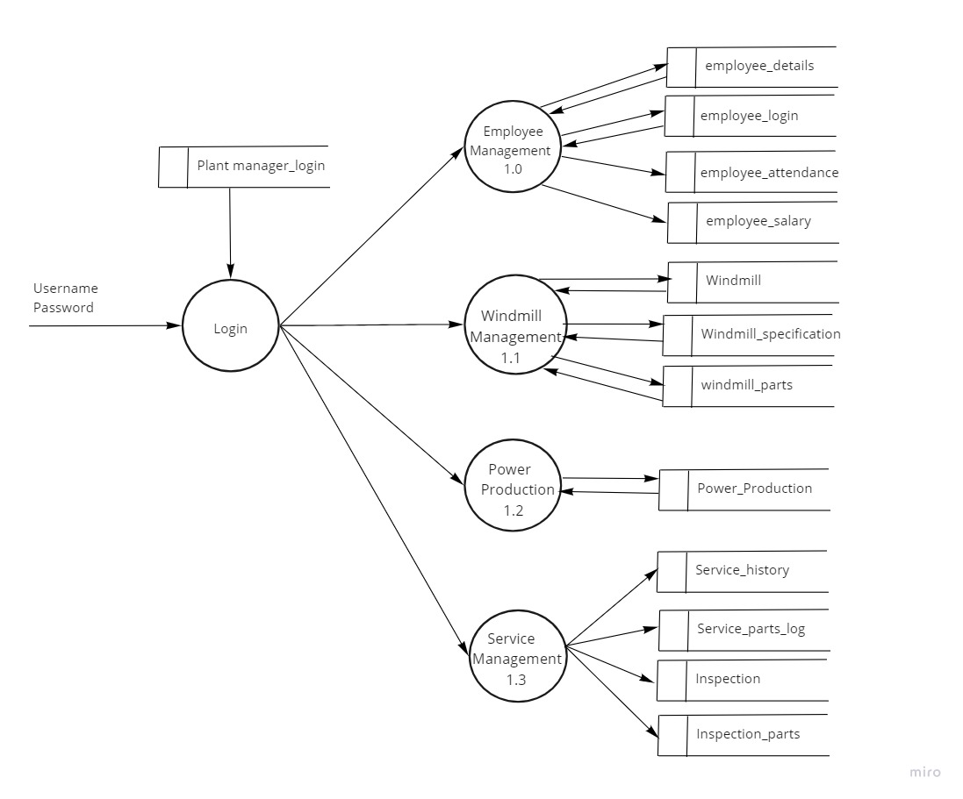

Figure 5.3 Login (level 1)

Level 1.0 Employee management

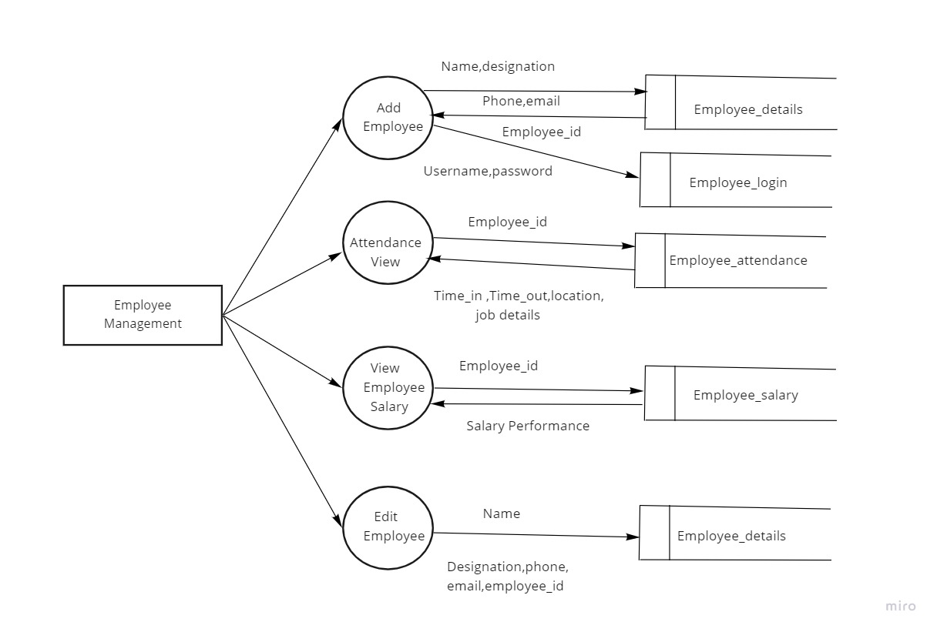

Figure 5.4 Employee management (level 1.0)

Level 1.1 Wind mill management

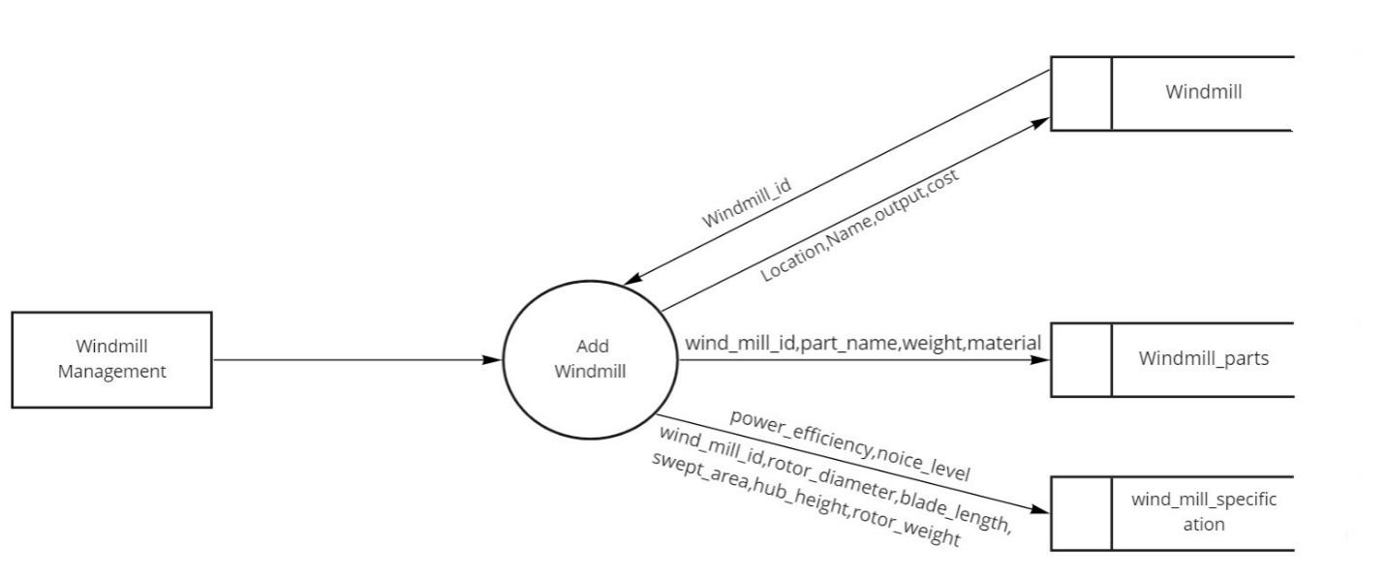

Figure 5.5 Wind mill management (level 1.1)

Level 1.2 Power production

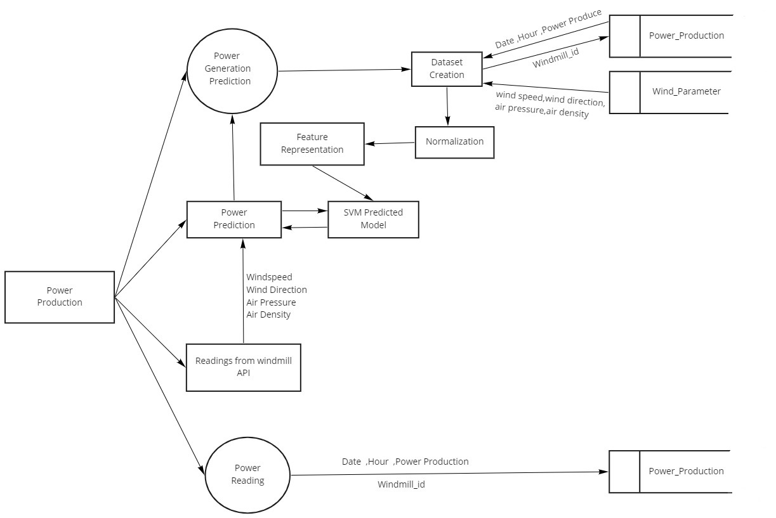

Figure 5.6 Power production (level 1.2)

Level 1.3 Service management

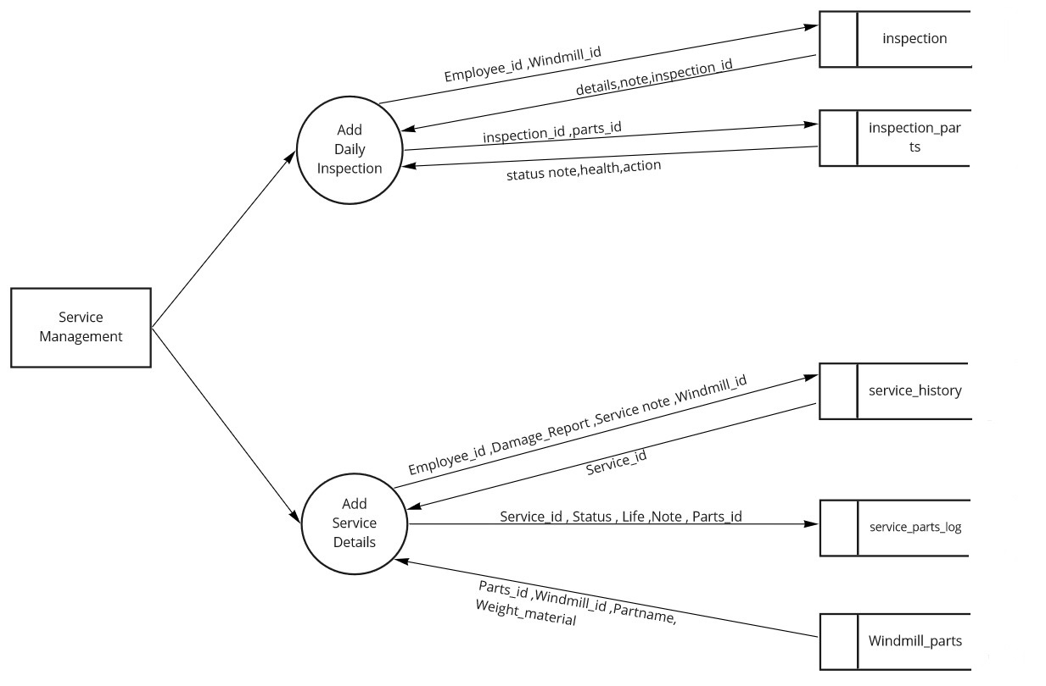

Figure 5.7 Service management (level 1.3)

5.3 Database Design

The database design is a logical development in the methods used by the computers to access and manipulate data stored in the various parts of the computer systems. Database is defined as an integrated collection of data. The overall objective in the development of database technology has been to treat data as an organizational resource and as an integrated whole. The main objectives of databases are data integrity and data independence.

A database is a collection of interrelated data stored with minimum redundancy to serve many users quickly and effectively. The database serves as the repository of data, so a well-designed database can lead to a better program structure and reduce procedural complexity. In a database environment, common data are available and used by several users

Database Management System (DBMS) allow the data to be protected and organized separately from other resources like hardware, software, and programs. DBMS is a software package, which contains components that are not found other data management packages. The significant of DBMS is the separation of data as seen by the programs and data as stored on the direct access storage devices. That is the difference between the logical and physical data.

The main objectives covered in database design are:

• Controlled redundancy

• Data independence

• Accuracy and integrity

• Privacy and security

• Performance

**Plant_manager_login**

Table 5.1

|  |  |
| --- | --- |
| Table Name: Plant manager login Primary key: login_id | |
| Description: Plant manager login and it contains 3 fields | |
| Field name | Data type |
| login_id | int |
| User name | varchar(20) |
| Password | varchar(20) |

**Employee_details**

Table 5.2

|  |  |
| --- | --- |
| Table Name: Employee Details Primary key: Employee_id | |
| Description: Employee details and it contains 4 fields | |
| Field name | Data type |
| Employee_id | int |
| Name | varchar |
| Designation | varchar(20) |
| email | varchar(20) |

**Employee_login**

Table number 5.3

|  |  |
| --- | --- |
| Table name: Employee login Primary key: employee_login_id  Foreign key: employee_id | |
| Description: Employee login and it contains 4 fields | |
| Field name | Data type |
| employee_login_id | varchar(20) |
| Password | varchar(20) |
| employee_id | int |

**Wind_Mill**

Table number 5.4

|  |  |
| --- | --- |
| Table Name: Wind Mill Primary key: wind_mill_id | |
| Description: Wind mill details and it contains 6 fields | |
| Field name | Data type |
| wind_mill_id | Int |
| Location | varchar(100) |
| Name | varchar(100) |
| Output | double |
| Cost | double |
| Status | varchar(20) |

**Wind_Mill_Specification**

Table number 5.5

|  |  |
| --- | --- |
| Table name: Wind Mill Specification Primary key: windmill_sp_id  Foreign key: wind_mill_id | |
| Description: Wind mill specification and it contains 10 fields | |
| Field name | Data type |
| windmill_sp_id | int |
| wind_mill_id | int |
| Rotor diameter | double |
| Blade length | double |
| Swept area | double |
| Hub height | double |
| Rotor weight | double |
| Power efficiency | double |
| Noise level | double |
| Warranty | double |

**Wind_mill_parts**

Table number 5.6

|  |  |
| --- | --- |
| Table name: Wind mill parts Primary key: Parts_id | |
| Description: Wind mill parts details and it contains 3 fields | |
| Field name | Data type |
| Parts_id | int |
| wind_mill_id | int |
| Part_name | varchar(20) |

**Employee_attendance**

Table number 5.7

|  |  |
| --- | --- |
| Table name: Employee attendance Primary key: attendance_id  Foreign key: employee_id, location_id | |
| Description: Employee attendance and it contains 6 fields | |
| Field name | Data type |
| attendance_id | int |
| time_in | datetime |
| time_out | datetime |
| employee_id | int |
| location_id | int |
| Job_details | text |

**Employee_Salary**

Table number 5.8

|  |  |
| --- | --- |
| Table name: Employee salary Primary key: salary_id  Foreign key: employee_id | |
| Description: Employee salary and it contains 4 fields | |
| Field name | Data type |
| salary_id | int |
| employee_id | int |
| Salary | double |
| Performance | double |

**Power_production**

Table number 5.9

|  |  |
| --- | --- |
| Power production Primary key: Power_production  Foreign key: wind_mill_id | |
| Description: Power production details and it contains 5 fields | |
| Field name | Data type |
| Power_production_id | Int |
| wind_mill_id | Int |
| Date | date |
| Hour | Int |
| Power_production | double |

**Service_History**

Table number 5.10

|  |  |
| --- | --- |
| Table name: Service history Primary key: service_id  Foreign key: employee_id, wind_mill_id | |
| Description: Service history and it contains 6 fields | |
| Field name | Data type |
| service_id | int |
| employee_id | int |
| damage_report | text |
| service_note | text |
| wind_mill_id | Int |
| date | datetime |

**Service_parts_log**

Table number 5.11

|  |  |
| --- | --- |
| Table name: Service parts log Primary key: service_parts_log_id  Foreign key: service_id, parts_id | |
| Description: Service parts log and it contains 6 fields | |
| Field name | Data type |
| service_parts_log_id | int |
| service_id | Int |
| status | varchar(20) |
| Life | double |
| Note | text |
| Parts_id | int |

**Inspection**

Table number: 5.12

|  |  |
| --- | --- |
| Table name: Inspection Primary key:inspection_id  Foreign key: employee_id, windmill_id | |
| Description: Inspection details and it contains 5 fields | |
| Field name | Data type |
| inspection_id | int |
| employee_id | Int |
| windmill_id | Int |
| Details | text |
| Note | text |

**Inspection_parts**

Table number: 5.13

|  |  |
| --- | --- |
| Table name: Inspection parts Primary key:inspection_parts_id  Foreign key: inspection_id, parts_id | |
| Description: Inspection parts and it contains 7 fields | |
| Field name | Data type |
| inspection_parts_id | int |
| inspection_id | int |
| parts_id | int |
| Status | varchar(30) |
| Note | text |
| Health | varchar(50) |
| Action | varchar(50) |

5.4 Input design

Input designing is the basic theory to be considered during system study. The input media used in the system is the keyboard. Details are entered in the system through different data entry screens. The system is designed in a user-friendly manner. Appropriate error messages are displayed when a false data is entered. Design of the system is web-oriented and is highly interactive to the users. The user interface design is very important for any application. The interface design defines how the software communicates within itself, to system that interpreted with it and with human who use it. The interface design is very good. The user will fall into an interactive software application.

The input design is the process of converting the user-oriented description of inputs into a programmer-oriented specification. The objective of input design is to create an input layout that is easy to follow and prevents the user from committing errors. It covers all phases of input, right from the creation of initial databases to the actual data entry into the system. The input design is the link that ties the system into the world of its users. Hence, lays its importance in the design phase. The input design makes sure that while entering data, the end-users understand the format in which the data is to be entered so that it is accepted by the system, the data values that are mandatory for the system to function, the order in which transactions need to be processed etc. The goal designing input data is to make the automation as easy and free from errors as possible. Input design, involves determining the record media, method of input, speed of capture and entry to the system. The main objectives that are guiding as in the input stages are:

• Controlling the amount of inputs

• Keeping the process simple

• To achieve highest level accuracy.

5.5 Output design

A quality output is one, which meets the requirement of the end user and presents the information clearly. In any system results of processing are communicated to the user and to other system through output. In output design it is determined how the information is to be displaced for immediate need and also the hard copy output. It is the most important and direct source information to the user. Efficient and intelligent output designs improve the system’s relationship to help user decision-making.

Output forms are the forms where the respective module. We may also see the outputs in reports. The reports often refresh for every change in the database. We can create reports by using SQL queries. Outputs form the system are requires to communicate the results of processing to users. Formats of outputs are defined during output design. The success of the system depends on how well the output reports are generated.

Designing output the following things are to be considered.

* Determine what information to present.
* Arrange the presentation of information in an acceptable format.
* Decide how to distribute the output to intend receipts.
* Depending on the nature and future use of output required, they can be displayed on the monitor for immediate need and for obtaining the hardcopy.
* Efficient and intelligent output design should improve system relation with the user and help in decision making that is, this makes system user friendly to be displayed or printed as per the user’s choice.

Table number: 5.14

|  |  |  |
| --- | --- | --- |
| **Process** | **Input design** | **Output design** |
| Login page for manager | Enter user name, password | Show home page |
| Add employ | Enter Name, designation, phone, email | Employee added |
| View attendance | Enter employee id | Show attendance |
| View employee salary | Enter employee id | Show salary and performance |
| Edit employee | Enter Name, designation, phone, email | Edit successfully |
| Add windmill | Enter windmill id, location, output cost | Wind mill added |
| Power reading | Enter wind mill id | Show generated power |
| Add daily inspection | Enter employ id, windmill id | Show inspection details of both employee and windmill |
| Add service details | Enter employee id, damage report, service note, windmill id | Service details added and show service id |

5.6 Program design

1. Manager

Step 1: Start

Step 2: Once logged in the Plant manager has the privilege to manage the employee, windmill, power production and service management.

Step 3: In employee management Plant manager can add employee, view attendance, view employee salary and can edit employee.

Step 4: In windmill management manager can add wind mill, location and output cost of the windmill. Also can add windmill parts name its weight and material.

Step 5: In power production, it predict the power generation, reads windmill data, reads generated power.

Step 6: In service management, plant manager can inspect employee status and parts status. Also inspect service log and record service logs, damage history, replaced parts details and record it as in a service id.

CHAPTER 6

FUNCTIONAL AND NON FUNCTIONAL

REQUIREMENTS

6.1 Functional Requirements

In software engineering, a functional requirement defines a function of a software system or its component. A function is described as a set of inputs, the behavior, and outputs. Functional requirements may be calculations, technical details, data manipulation and processing and other specific functionality that define what a system is supposed to accomplish. Generally, functional requirements are expressed in the form "system must do requirement ".

Functional requirements for each of the uses cases described below:

* All employ should register in the application.
* Attendance of every employ should mark, salary is calculated by attendance.
* Previous history of spare parts details should be recorded for creating spare parts predicting models.
* Previous history of power production should be recorded for creating models of power production.

6.2 Non-Functional Requirements

A non-functional requirement is a requirement that specifies criteria that can be used to judge the operation of a system, rather than specific behaviors. Non-functional requirements are “system shall be requirement ". Non-functional requirements are often called qualities of a system. Other terms for non-functional requirements are "constraints", "quality attributes”, “quality goals", "quality of service requirements" and "non-behavioral requirements.

Some of the non-functional requirements are mentioned below:

i. **Usability**: The system shall have a clean interface with only needed features, clear terminology and tool tips wherever necessary. Warnings or alerts shall be specified in clear way.

ii. **Efficiency**: The system shall respond to different searches being conducted like searching particular product, search quantity, etc. in a very fast way.

iii. **Interoperability**: The system shall be able to interact with other systems. The system should able to be supported at least one software which has a relationship with payment process

iv. **Portability**: The system shall be independent of the specific technological platform used to implement it.

v. **Reliability**: Reliability defined as a measure of the time between failures occurring in a system (measure show frequently the system fails), so that the system shall operate without any failure for a particular period of time

vi. **Availability**: Availability measures the percentage of time the system is in its operational state so that the system shall be available for use 24 hours per day and 365days per year.

CHAPTER 7

TESTING

7.1 Testing strategies

An engineered product can be tested in one of these two ways. These testing strategies include:

* Black box testing
* White box testing

**White box testing**

White-box testing is a method of testing the application at the level of the source code. White-box testing (also known as clear box testing, glass box testing, transparent box testing, and structural testing) is a method of testing software that tests internal structures or workings of an application, as opposed to its functionality. In white-box testing an internal perspective of the system, as well as programming skills, are chooses inputs to exercise paths through the code and determine the expected outputs.

**Black box testing**

Black-box testing is a method of software testing that examines the functionality of an application without peering into its internal structures or workings. This method of test can be applied virtually to every level of software testing: unit, integration, system and acceptance. It is sometimes referred to as specification-based testing.

7.2 Unit testing

In computer programming, unit testing is a software method by which individual units of source code, sets of one or more computer program modules together with associated control data, usage procedures ,are tested to determine whether they are fit for use intuitively, one can view a unit as the smallest testable part of an application. In procedural programming a unit could be an entire module, but it is more commonly an individual function or procedure. In object-oriented programming, a unit is often an entire interface, such as a class, but could be an individual method.

Unit tests are short code fragments created by programmers or occasionally by white box testers during the development process. If forms the basis for component testing.

In the project each module is tested individually and is found to be an error free one.

7.3 Integration testing

This is the final step in testing. In this case all the modules were combined and given the test data. The combined module works successfully without any side effect on other programs. Everything was found to be working correctly.

In this the entire system was tested as a whole with all modules. This form of testing is popularly known as Black Box testing or system testing. Black Box testing methods focus on the functional requirement of the software. That is, Black Box testing enables the software engineer to derive sets of input conditions that will fully exercise all functional requirements for a program. Black Box testing attempts to find errors in the following categories; incorrect or missing functions, interface errors, errors in data structures or external database access, performance errors and initialization errors and termination errors.

In this project each module is tested individually and all the modules are integrated together and the integration testing is carried out for the whole system. The whole system is working accurately without any errors.

7.4 System testing

Software testing is critical element of software quality assurance and represents the ultimate review of specifications, design and code generation. System testing is the stage of implementation, it is aimed for ensuring that the system works accurately and efficiently before live operations commences. Nothing is complete without testing, as it is vital success of the system.

Testing Objectives:

There are several rules that can serve as testing objectives, they are

• Testing is a process of executing a program with the intent of finding an error

• A good test case is one that has high probability of finding an undiscovered error.

• A successful test is one that uncovers an undiscovered errors.

A test case is a specification of the inputs, execution conditions, testing procedure, and expected results that define a single test to be executed to achieve a particular software testing objective, such as to exercise a particular program path or to verify compliance with a specific requirement. Test cases underlie testing that is methodical rather than haphazard. A battery of test cases can be built to produce the desired coverage of the software being tested. Formally defined test cases allow the same tests to be run repeatedly against successive versions of the software, allowing for used to design test cases. The tester effective and consistent regression testing.

7.5 Testing Results

Table number: 7.1

|  |  |  |  |  |
| --- | --- | --- | --- | --- |
| Sl. No | Test case | Input | Expected output | Result |
| 1 | User login | Correct email id and password | Manager dashboard | Pass |
| 2 | User login | Incorrect email id and | Invalid user name and password | Pass |
| 3 | Forgot password | Email id | Get password on registered email id | Pass |
| 4 | Add employ | Name, User name, Password, Re password Salary, Description, Email, Mobile | Employ added successfully | Pass |
| 5 | Add Parts | Part name, Weight, Material, | Part added successfully | Pass |
| 6 | Add windmill | Location, Name, Output, Cost, Status, Warranty, Power efficiency, Roater Diameter,….. | Windmill added successfully | Pass |
| 7 | Edit employee | Username, Password, Re password, Salary, Designation, Email, Mobile | Employ edited | Pass |
| 8 | Add Service details | Name, Service engineer, Service note, Damage Report | Service details added | Pass |
| 9 | Add Inspect Report Parts | Part name, Status, Health, Note, Action taken | Inspect parts report added | Pass |

CHAPTER 8

RESULT AND DISCUSSION

8.1 Results (Salient features)

The main motivation and objective of this system is to provide a solution to reduce inconvenience in finding a better ornament for the customer through augmented reality experience. Enabling the user experiencing a friendly user interface. Systematic handling of the schedules in such a way is a key to increasing its manageability and its competence. The proposed system incorporated with the following features.

* Human effort can be reduced.
* Improved efficiency.
* Easy access to the machine related documents
* Efficient management of the relationship between the main asset and its sub-components, modules and parts
* Dynamic tracing of the status of maintenance, depending on whether the maintenance action is planned or performed.

8.2 Screen shots

1. User login

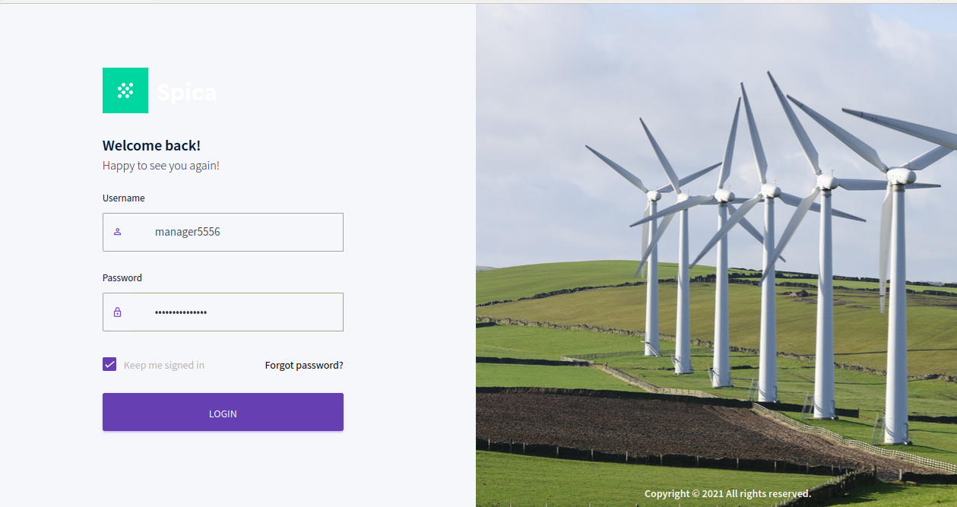

1. Add Employee

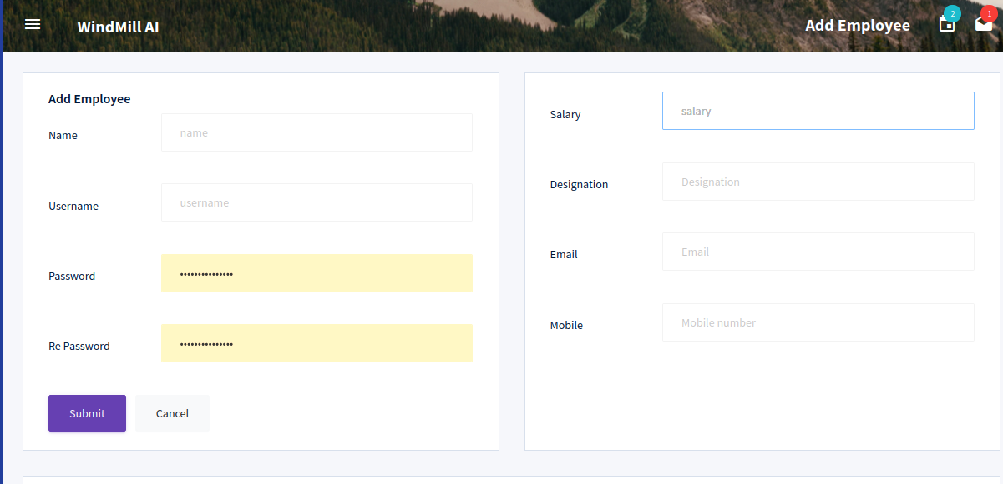

1. Edit Employee

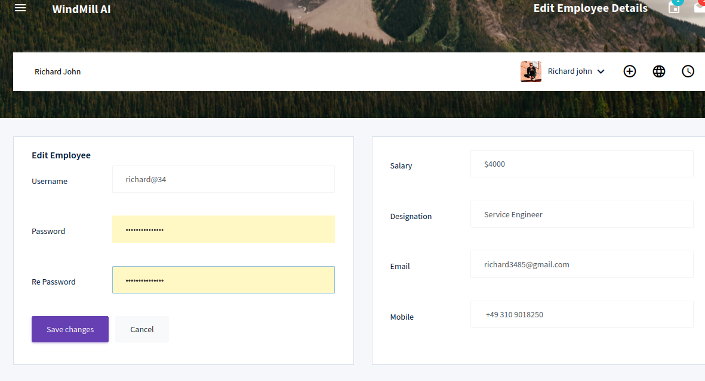

1. Attendance Details

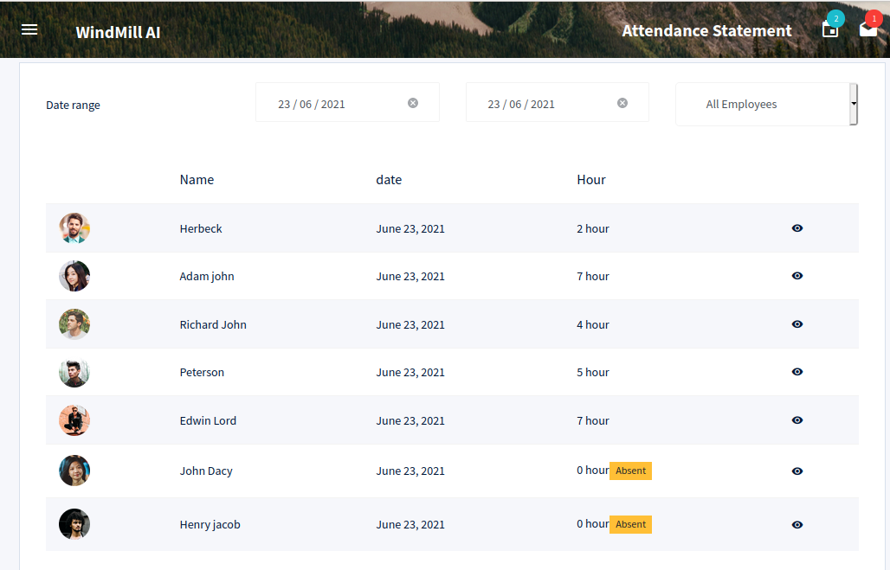

1. Add Windmill

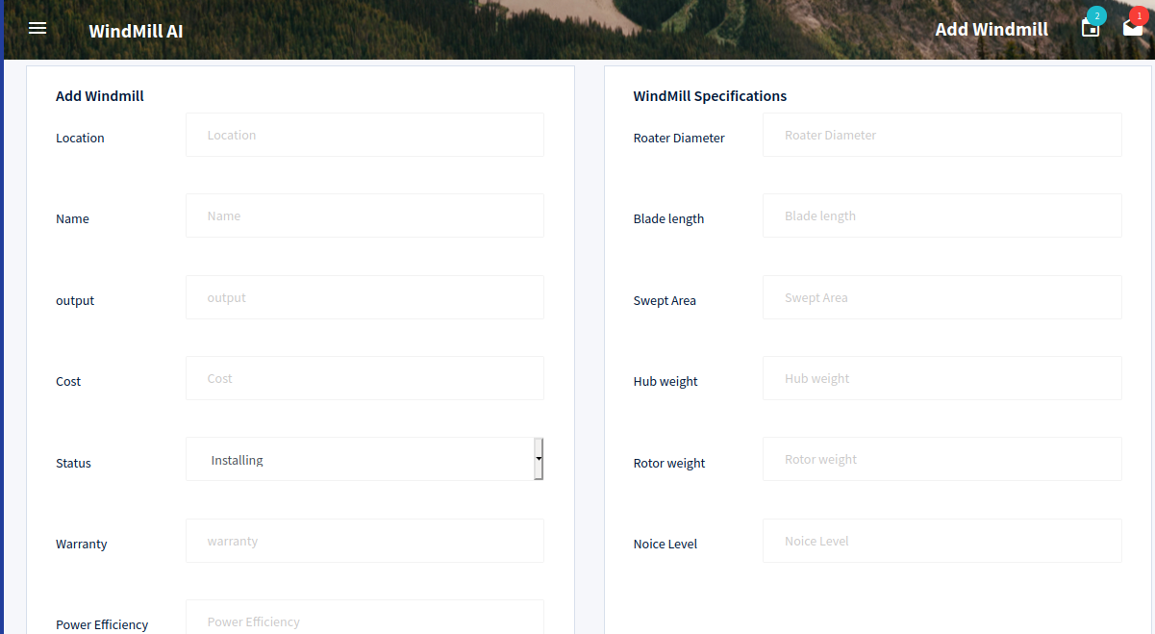

1. Add Inspection parts

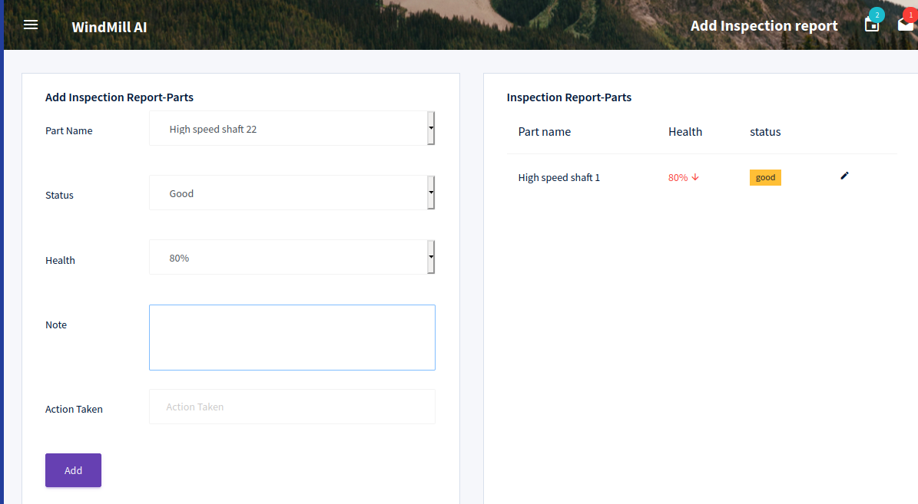

1. Add Inspection report

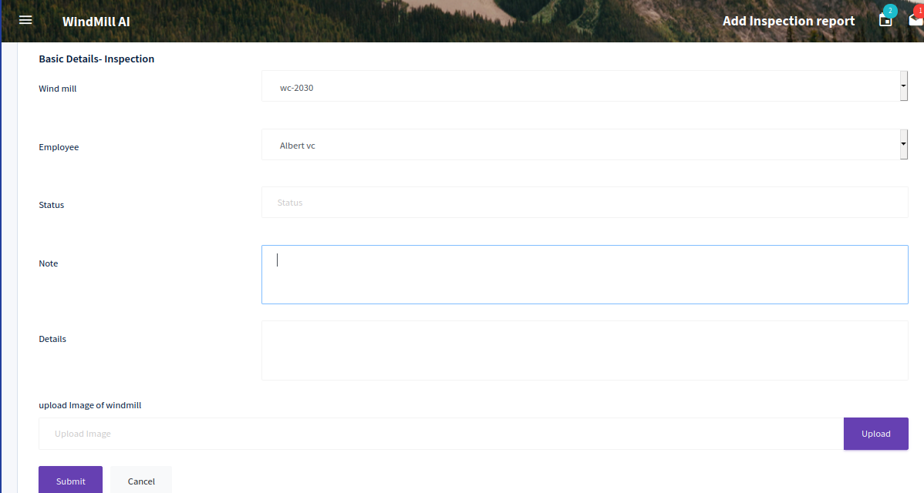

1. Add Spare

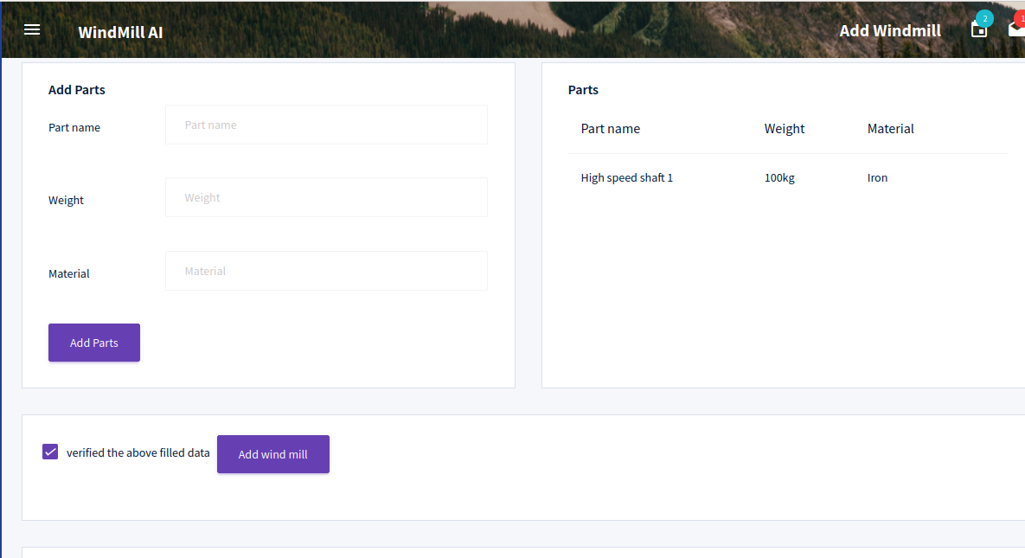

1. Salary details

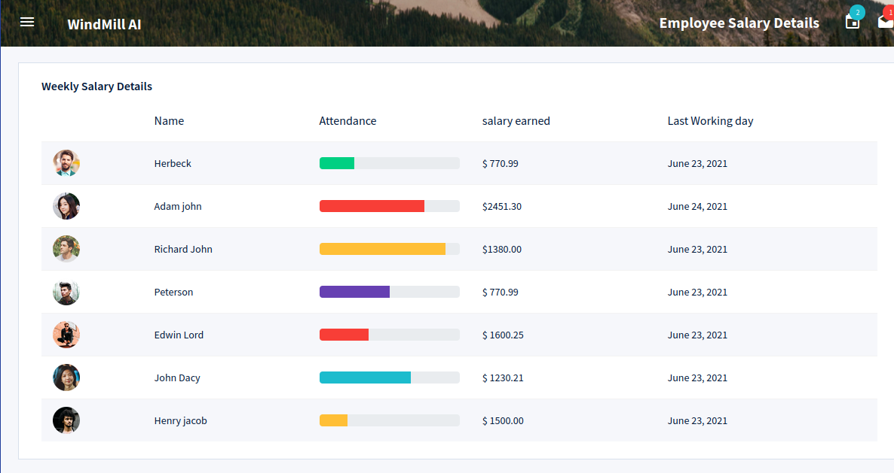

1. Power prediction

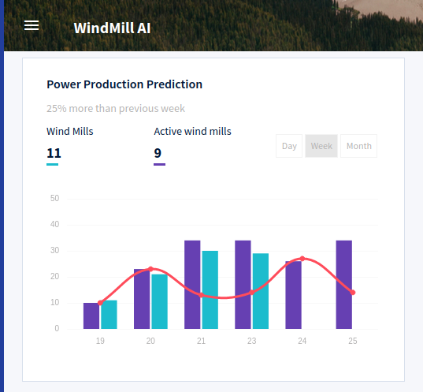

1. Service report

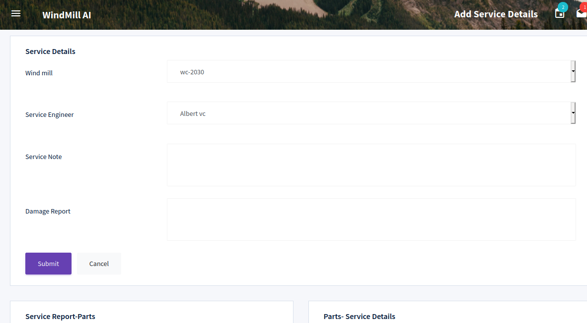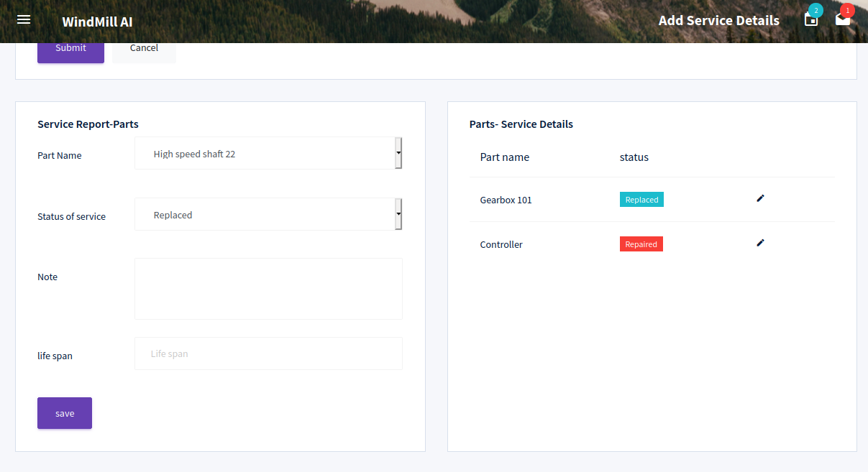

CHAPTER 9

CONCLUSION

9.1 System Implementation

The purpose of System implementation as making the new system making available to be prepared set of users and positioning ongoing support and maintenance of the system within the performing organization. At a final level of detail, deploying the system consists of executing all steps necessary to educate the consumers on the use of a new system, placing the newly developed system into production, continuing that all data required at the start of the operations is available and accurate, and validating that business functions that interact with the system are functioning properly.

The implementation involves following things:

• Careful planning.

• Investigation of the system considerations.

• Design the method to achieve the changeover.

• Evaluation of change over method.

There are three types of implementations:

• Implementation of a computer system to replace a manual system. The problems encountered are converting files, training users, creating accurate files and verifying printouts for integrity.

• Implementation of a new computer system to replace an existing one. This is usually a difficult conversion. If not properly planned, there can be many problems. Some large computer systems have taken as long as a year to convert.

• Implementation of a modified application to replace the existing one, using the same computer. This type of conversion is relatively easy to handle, provided there are no major changes in the files. Every system requires periodic evaluation after implementation.

This is to review the performance of the system and to evaluate against established standard or criteria. A study is conducted for measuring the performance of the system against pre-defined requirements. This study results a post-implementation review that determines how well the system continues to meet the performance specification.

9.2 Conclusion

Today’s power system is facing growing challenges in main-training a secure and reliable energy supply. Part of the growing challenge is the possibility of significant levels of uncertain wind generation being installed on power system. This brings new challenges involving the management of wind intermittence. Accurate forecasting of wind power is necessary to meeting these challenges.

The main objectives of this project is to create a AI model for **wind-turbine maintenance practices and can result in increased efficiency, better spare-parts forecasting, reduced downtime, and lower unplanned Maintenance costs. The sources from which AI can pull information may include maintenance data, failure histories, and management software, which are used to create AI models of normal turbine behavior, which serve to quickly identify abnormalities and notify the wind-farm operator. Many types of forecasts are possible, including power production, availability, spare parts needs, and other such use cases. Having such increased visibility provides tremendous benefits to wind-turbine operators.** However, stoppage hours of wind turbine for grid maintenance, turbine maintenance, etc., should be done during the off-seasonal period where the power generation is intermittent due to high fluctuation in the wind speed in the cut-in range of the wind turbine. The predicted wind energy output for the seven wind farms using ANN model shows a good agreement with the actual values. This model is helpful for energy planners and wind farm owners for future planning and execution.

9.3 Future Enhancement

* This project can be modified at any time by adding any more features and can develop the databases with more new features.
* Mobile application can be implemented with AR experience.
* Additional use of online wind measurement data has the potential for improved forecasts, especially for very short-term and short-term wind power forecasting.
* Forecasting extreme events, as opposed to common behavior, would be very valuable to protecting the power system.
* Extending the forecasts further into the future, enabling long-term planning.
* Further improvements in both physical and statistical forecasting approaches and improved approaches for the combination of different forecasting approaches can be expected to further reduce forecasting errors.

BIBLOGRAPHY

1. **Books**

* Kenneth.S.Rubin, Essential Scrum: A Practical Guide to the Most Popular Agile Process, First Edition
* Allen B. Downey Think Python: An Introduction to Software Design, Second Edition

1. **Websites**

* <https://www.javatpoint.com/python-tutorial>
* <https://www.tutorialspoint.com/python/index.html>
* <https://www.tutorialspoint.com/mysql/mysql-introduction.html>

1. **Journal and Publications**

* Lei M, Shiyan L, ChuanwenJ, Hongling L, YanZ .A review on the forecasting of wind speed and generated power , Renew Sustain Energy Rev 2009;13:915–20.
* Cutler N. Wind energy forecasting issues paper. Centre for Energy and Environmental Markets, The University of New South Wales; 2006.
* Bhaskar M, Jain A, Venkata Srinath N. Wind speed forecasting: present status. In: Proceedings of the 2010 international conference on power system technology (POWERCON); 2010.

Git History

APPENDICES

1. LIST OF TABLES

|  |  |  |
| --- | --- | --- |
| Table No | Table name | Page No |
| 5.1 | Plant_manager_login | 30 |
| 5.2 | Employee_details | 30 |
| 5.3 | Employee_login | 31 |
| 5.4 | Wind_mill | 31 |
| 5.5 | Wind_mill_specification | 32 |
| 5.6 | Wind_mill_parts | 32 |
| 5.7 | Employee_attendance | 33 |
| 5.8 | Employee_Salary | 33 |
| 5.9 | Power_production | 34 |
| 5.10 | Service_History | 34 |
| 5.11 | Service_parts_log | 35 |
| 5.12 | Inspection | 35 |
| 5.13 | Inspection_parts | 36 |
| 5.14 | Input output design | 39 |
| 7.1 | Testing results | 48 |

1. LIST OF FIGURES

|  |  |  |
| --- | --- | --- |
| Figure No | Figure name | Page no |
| 5.1 | DFD Components | 22 |
| 5.2 | Manager (level 0) | 23 |
| 5.3 | Login (level 1) | 24 |
| 5.4 | Employ management (level 1.0) | 25 |
| 5.5 | Wind mill management (level 1.1) | 26 |
| 5.6 | Power production | 27 |
| 5.7 | Service management | 28 |
| I | User login | 52 |
| II | Add Employee | 52 |
| III | Edit Employee | 53 |
| IV | Attendance Details | 53 |
| V | Add Windmill | 54 |
| VI | Add Inspection parts | 54 |
| VII | Add Inspection report | 55 |
| VIII | Add spare | 55 |
| IX | Salary details | 56 |
| X | Power prediction | 56 |
| XI | Service | 57 |

1. ABBREVIATIONS AND NOTATION

* DFD

(Data Flow Diagram) is a graphical representation of the "flow" of data through an information system, modeling its process aspects. A DFD is often used as a preliminary step to create an overview of the system without going into great detail, which can later be elaborated. DFDs can also be used for the visualization of data processing (structured design).

* DB

A database is an organized collection of data, generally stored and accessed electronically from a computer system. Where databases are more complex they are often developed using formal design and modeling techniques.