SUBQUERIES

**1.** Write a [MySQL](https://www.w3resource.com/mysql-exercises/subquery-exercises/) query to find the name (first_name, last_name) and the salary of the employees who have a higher salary than the employee whose last_name='Bull'.

[SELECT](http://localhost:8080/phpmyadmin/url.php?url=https://dev.mysql.com/doc/refman/8.0/en/select.html) FIRST_NAME, LAST_NAME, SALARY FROM employees WHERE SALARY > ([SELECT](http://localhost:8080/phpmyadmin/url.php?url=https://dev.mysql.com/doc/refman/8.0/en/select.html) SALARY FROM employees WHERE LAST_NAME = 'Bull');

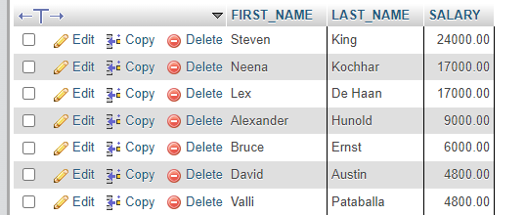

**2.** Write a [MySQL](https://www.w3resource.com/mysql-exercises/subquery-exercises/) query to find the name (first_name, last_name) of all employees who works in the IT department.

[SELECT](http://localhost:8080/phpmyadmin/url.php?url=https://dev.mysql.com/doc/refman/8.0/en/select.html) FIRST_NAME, LAST_NAME FROM employees WHERE DEPARTMENT_ID = ([SELECT](http://localhost:8080/phpmyadmin/url.php?url=https://dev.mysql.com/doc/refman/8.0/en/select.html) DEPARTMENT_ID FROM departments WHERE DEPARTMENT_NAME = 'IT');

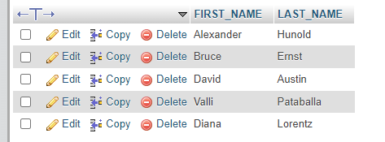

**3.** Write a [MySQL](https://www.w3resource.com/mysql-exercises/subquery-exercises/) query to find the name (first_name, last_name) of the employees who have a manager and worked in a USA based department.

SELECT FIRST_NAME, LAST_NAME FROM employees WHERE MANAGER_ID IS NOT NULL AND DEPARTMENT_ID IN (SELECT DEPARTMENT_ID FROM departments WHERE LOCATION_ID IN (SELECT LOCATION_ID FROM locations WHERE COUNTRY_ID = 'US'));

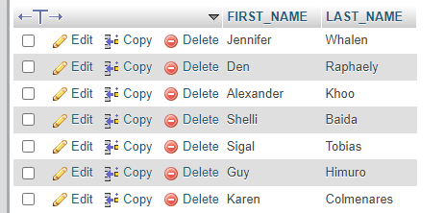

**4.** Write a [MySQL](https://www.w3resource.com/mysql-exercises/subquery-exercises/) query to find the name (first_name, last_name) of the employees who are managers.

[SELECT](http://localhost:8080/phpmyadmin/url.php?url=https://dev.mysql.com/doc/refman/8.0/en/select.html) FIRST_NAME, LAST_NAME FROM employees WHERE EMPLOYEE_ID [IN](http://localhost:8080/phpmyadmin/url.php?url=https://dev.mysql.com/doc/refman/8.0/en/comparison-operators.html%23function_in) ([SELECT](http://localhost:8080/phpmyadmin/url.php?url=https://dev.mysql.com/doc/refman/8.0/en/select.html) MANAGER_ID FROM employees);



**5.** Write a [MySQL](https://www.w3resource.com/mysql-exercises/subquery-exercises/) query to find the name (first_name, last_name), and salary of the employees whose salary is greater than the average salary.

[SELECT](http://localhost:8080/phpmyadmin/url.php?url=https://dev.mysql.com/doc/refman/8.0/en/select.html) FIRST_NAME, LAST_NAME, SALARY FROM employees WHERE SALARY > ([SELECT](http://localhost:8080/phpmyadmin/url.php?url=https://dev.mysql.com/doc/refman/8.0/en/select.html) [AVG](http://localhost:8080/phpmyadmin/url.php?url=https://dev.mysql.com/doc/refman/8.0/en/aggregate-functions.html%23function_avg)(SALARY) FROM employees);

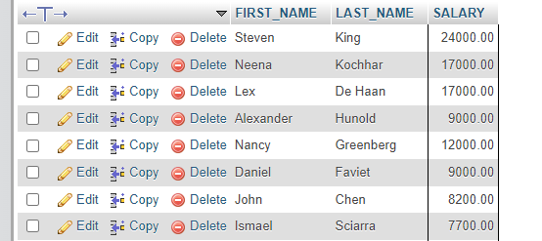

**6.** Write a [MySQL](https://www.w3resource.com/mysql-exercises/subquery-exercises/) query to find the name (first_name, last_name), and salary of the employees whose salary is equal to the minimum salary for their job grade.

[SELECT](http://localhost:8080/phpmyadmin/url.php?url=https://dev.mysql.com/doc/refman/8.0/en/select.html) FIRST_NAME, LAST_NAME, SALARY FROM employees AS E WHERE SALARY [IN](http://localhost:8080/phpmyadmin/url.php?url=https://dev.mysql.com/doc/refman/8.0/en/comparison-operators.html%23function_in) ( [SELECT](http://localhost:8080/phpmyadmin/url.php?url=https://dev.mysql.com/doc/refman/8.0/en/select.html) J.MIN_SALARY FROM jobs AS J WHERE J.JOB_ID = E.JOB_ID );



**7.** Write a [MySQL](https://www.w3resource.com/mysql-exercises/subquery-exercises/) query to find the name (first_name, last_name), and salary of the employees who earns more than the average salary and works in any of the IT departments.

[SELECT](http://localhost:8080/phpmyadmin/url.php?url=https://dev.mysql.com/doc/refman/8.0/en/select.html) FIRST_NAME, LAST_NAME, SALARY FROM employees WHERE SALARY > ([SELECT](http://localhost:8080/phpmyadmin/url.php?url=https://dev.mysql.com/doc/refman/8.0/en/select.html) [AVG](http://localhost:8080/phpmyadmin/url.php?url=https://dev.mysql.com/doc/refman/8.0/en/aggregate-functions.html%23function_avg)(SALARY) FROM employeeS) [AND](http://localhost:8080/phpmyadmin/url.php?url=https://dev.mysql.com/doc/refman/8.0/en/logical-operators.html%23operator_and) DEPARTMENT_ID [IN](http://localhost:8080/phpmyadmin/url.php?url=https://dev.mysql.com/doc/refman/8.0/en/comparison-operators.html%23function_in) ([SELECT](http://localhost:8080/phpmyadmin/url.php?url=https://dev.mysql.com/doc/refman/8.0/en/select.html) DEPARTMENT_ID FROM departments WHERE DEPARTMENT_NAME = 'IT');



**8.** Write a [MySQL](https://www.w3resource.com/mysql-exercises/subquery-exercises/) query to find the name (first_name, last_name), and salary of the employees who earns more than the earning of Mr. Bell.

[SELECT](http://localhost:8080/phpmyadmin/url.php?url=https://dev.mysql.com/doc/refman/8.0/en/select.html) FIRST_NAME,LAST_NAME, SALARY FROM employees WHERE SALARY > ALL([SELECT](http://localhost:8080/phpmyadmin/url.php?url=https://dev.mysql.com/doc/refman/8.0/en/select.html) SALARY FROM employees WHERE LAST_NAME = 'Bell') ORDER BY FIRST_NAME;



**9.** Write a [MySQL](https://www.w3resource.com/mysql-exercises/subquery-exercises/) query to find the name (first_name, last_name), and salary of the employees who earn the same salary as the minimum salary for all departments.

[SELECT](http://localhost:8080/phpmyadmin/url.php?url=https://dev.mysql.com/doc/refman/8.0/en/select.html) FIRST_NAME, LAST_NAME, SALARY FROM employees WHERE SALARY > ([SELECT](http://localhost:8080/phpmyadmin/url.php?url=https://dev.mysql.com/doc/refman/8.0/en/select.html) SALARY FROM employeeS WHERE LAST_NAME = 'Bell') ORDER BY FIRST_NAME;



**10.** Write a [MySQL](https://www.w3resource.com/mysql-exercises/subquery-exercises/) query to find the name (first_name, last_name), and salary of the employees whose salary is greater than the average salary of each department.

[SELECT](http://localhost:8080/phpmyadmin/url.php?url=https://dev.mysql.com/doc/refman/8.0/en/select.html) SALARY FROM employees WHERE SALARY > ALL( [SELECT](http://localhost:8080/phpmyadmin/url.php?url=https://dev.mysql.com/doc/refman/8.0/en/select.html) [AVG](http://localhost:8080/phpmyadmin/url.php?url=https://dev.mysql.com/doc/refman/8.0/en/aggregate-functions.html%23function_avg)(SALARY) FROM employees GROUP BY DEPARTMENT_ID);



**11.** Write a [MySQL](https://www.w3resource.com/mysql-exercises/subquery-exercises/) query to find the name (first_name, last_name) and salary of the employees who earn a salary that is higher than the salary of all the Shipping Clerk (JOB_ID = 'SH_CLERK'). Sort the results of the salary of the lowest to highest.

[SELECT](http://localhost:8080/phpmyadmin/url.php?url=https://dev.mysql.com/doc/refman/8.0/en/select.html) FIRST_NAME, LAST_NAME, SALARY,JOB_ID FROM employees WHERE SALARY > ALL([SELECT](http://localhost:8080/phpmyadmin/url.php?url=https://dev.mysql.com/doc/refman/8.0/en/select.html) SALARY FROM employees WHERE JOB_ID = 'SH_CLERK') ORDER BY SALARY;



**12.** Write a [MySQL](https://www.w3resource.com/mysql-exercises/subquery-exercises/) query to find the name (first_name, last_name) of the employees who are not supervisors.

[SELECT](http://localhost:8080/phpmyadmin/url.php?url=https://dev.mysql.com/doc/refman/8.0/en/select.html) FIRST_NAME,LAST_NAME FROM employees WHERE EMPLOYEE_ID [NOT](http://localhost:8080/phpmyadmin/url.php?url=https://dev.mysql.com/doc/refman/8.0/en/logical-operators.html%23operator_not) [IN](http://localhost:8080/phpmyadmin/url.php?url=https://dev.mysql.com/doc/refman/8.0/en/comparison-operators.html%23function_in) ([SELECT](http://localhost:8080/phpmyadmin/url.php?url=https://dev.mysql.com/doc/refman/8.0/en/select.html) MANAGER_ID FROM employees);

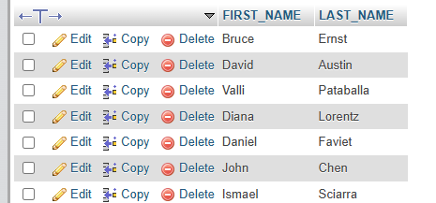

**13.** Write a [MySQL](https://www.w3resource.com/mysql-exercises/subquery-exercises/) query to display the employee ID, first name, last name, and department names of all employees.

[SELECT](http://localhost:8080/phpmyadmin/url.php?url=https://dev.mysql.com/doc/refman/8.0/en/select.html) FIRST_NAME, LAST_NAME, ([SELECT](http://localhost:8080/phpmyadmin/url.php?url=https://dev.mysql.com/doc/refman/8.0/en/select.html) D.DEPARTMENT_NAME FROM departments AS D WHERE D.DEPARTMENT_ID = E.DEPARTMENT_ID) AS JOBS FROM employees AS E;

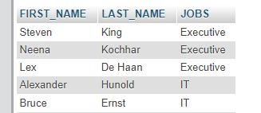

**14.** Write a [MySQL](https://www.w3resource.com/mysql-exercises/subquery-exercises/) query to display the employee ID, first name, last name, salary of all employees whose salary is above average for their departments.

[SELECT](http://localhost:8080/phpmyadmin/url.php?url=https://dev.mysql.com/doc/refman/8.0/en/select.html) EMPLOYEE_ID, FIRST_NAME, LAST_NAME, SALARY FROM employees AS E WHERE SALARY > ( [SELECT](http://localhost:8080/phpmyadmin/url.php?url=https://dev.mysql.com/doc/refman/8.0/en/select.html) [AVG](http://localhost:8080/phpmyadmin/url.php?url=https://dev.mysql.com/doc/refman/8.0/en/aggregate-functions.html%23function_avg)(SALARY) FROM employees WHERE DEPARTMENT_ID = E.DEPARTMENT_ID );



**15.** Write a [MySQL](https://www.w3resource.com/mysql-exercises/subquery-exercises/) query to fetch even numbered records from employees table.

[SELECT](http://localhost:8080/phpmyadmin/url.php?url=https://dev.mysql.com/doc/refman/8.0/en/select.html) EMPLOYEE_ID FROM employees WHERE [MOD](http://localhost:8080/phpmyadmin/url.php?url=https://dev.mysql.com/doc/refman/8.0/en/mathematical-functions.html%23function_mod)(EMPLOYEE_ID,2) = 0;

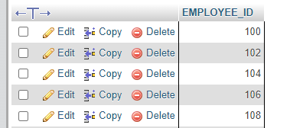

**16.** Write a [MySQL](https://www.w3resource.com/mysql-exercises/subquery-exercises/) query to find the 5th maximum salary in the employees table.

[SELECT](http://localhost:8080/phpmyadmin/url.php?url=https://dev.mysql.com/doc/refman/8.0/en/select.html) DISTINCT SALARY FROM employees ORDER BY SALARY DESC LIMIT 1 OFFSET 4;



**17.** Write a [MySQL](https://www.w3resource.com/mysql-exercises/subquery-exercises/) query to find the 4th minimum salary in the employees table.

[SELECT](http://localhost:8080/phpmyadmin/url.php?url=https://dev.mysql.com/doc/refman/8.0/en/select.html) DISTINCT SALARY FROM employees ORDER BY SALARY LIMIT 1 OFFSET 3;



**18.** Write a [MySQL](https://www.w3resource.com/mysql-exercises/subquery-exercises/) query to select last 10 records from a table.

[SELECT](http://localhost:8080/phpmyadmin/url.php?url=https://dev.mysql.com/doc/refman/8.0/en/select.html) * FROM ([SELECT](http://localhost:8080/phpmyadmin/url.php?url=https://dev.mysql.com/doc/refman/8.0/en/select.html) * FROM employees ORDER BY EMPLOYEE_ID DESC LIMIT 10) SUB ORDER BY EMPLOYEE_ID;

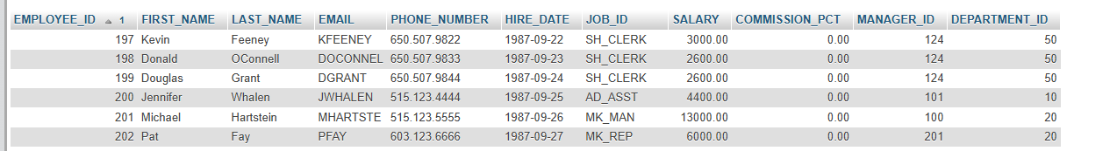

**19.** Write a [MySQL](https://www.w3resource.com/mysql-exercises/subquery-exercises/) query to list the department ID and name of all the departments where no employee is working.

[SELECT](http://localhost:8080/phpmyadmin/url.php?url=https://dev.mysql.com/doc/refman/8.0/en/select.html) DEPARTMENT_ID, DEPARTMENT_NAME FROM departments WHERE DEPARTMENT_ID [NOT](http://localhost:8080/phpmyadmin/url.php?url=https://dev.mysql.com/doc/refman/8.0/en/logical-operators.html%23operator_not) [IN](http://localhost:8080/phpmyadmin/url.php?url=https://dev.mysql.com/doc/refman/8.0/en/comparison-operators.html%23function_in) ([SELECT](http://localhost:8080/phpmyadmin/url.php?url=https://dev.mysql.com/doc/refman/8.0/en/select.html) DEPARTMENT_ID FROM employees);



**20.** Write a [MySQL](https://www.w3resource.com/mysql-exercises/subquery-exercises/) query to get 3 maximum salaries.

[SELECT](http://localhost:8080/phpmyadmin/url.php?url=https://dev.mysql.com/doc/refman/8.0/en/select.html) DISTINCT SALARY FROM employees ORDER BY SALARY DESC LIMIT 3;



**21.** Write a [MySQL](https://www.w3resource.com/mysql-exercises/subquery-exercises/) query to get 3 minimum salaries.

[SELECT](http://localhost:8080/phpmyadmin/url.php?url=https://dev.mysql.com/doc/refman/8.0/en/select.html) DISTINCT SALARY FROM employees ORDER BY SALARY LIMIT 3;



**22 .** Write a MySQL query to get nth maximum salaries of employees.

SELECT DISTINCT salary FROM employees ORDER BY salary DESC LIMIT 1 OFFSET n-1;

**NOTE :** OUTPUT SHOULD DEPEND UPON **Nth** VALUE.

Assignment No. 6

1. Write a [MySQL](https://www.w3resource.com/mysql-exercises/join-exercises/) query to find the addresses (location_id, street_address, city, state_province, country_name) of all the departments.  
   Hint : Use NATURAL JOIN.

Ans:- SELECT L.LOCATION_ID, L.STREET_ADDRESS, L.CITY, L.STATE_PROVINCE, C.COUNTRY_NAME FROM locations AS L NATURAL JOIN countries AS C;

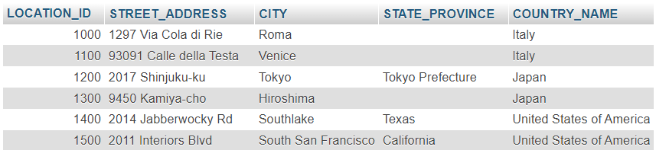

1. Write a MySQL query to find the name (first_name, last name), department ID and name of all the employees.

Ans:- SELECT E.FIRST_NAME, E.LAST_NAME, E.DEPARTMENT_ID, D.DEPARTMENT_NAME FROM employees AS E INNER JOIN departments AS D ON E.DEPARTMENT_ID = D.DEPARTMENT_ID;

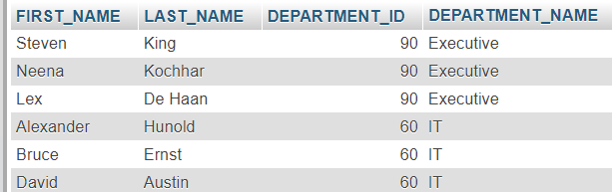

1. Write a [MySQL](https://www.w3resource.com/mysql-exercises/join-exercises/) query to find the name (first_name, last_name), job, department ID and name of the employees who works in London.

Ans:- SELECT E.FIRST_NAME, E.LAST_NAME, E.JOB_ID, L.CITY, D.DEPARTMENT_NAME FROM locations AS L INNER JOIN departments AS D ON L.LOCATION_ID = D.LOCATION_ID INNER JOIN employees AS E ON D.DEPARTMENT_ID = E.DEPARTMENT_ID WHERE L.CITY='LONDON';



1. Write a [MySQL](https://www.w3resource.com/mysql-exercises/join-exercises/) query to find the employee id, name (last_name) along with their manager_id and name (last_name)

Ans:- SELECT E.FIRST_NAME, E.LAST_NAME, IFNULL(M.LAST_NAME, 'Top Authority') AS MANAGER FROM employees AS E LEFT JOIN employees AS M ON E.MANAGER_ID=M.EMPLOYEE_ID;

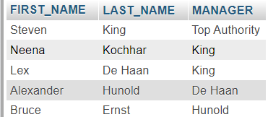

1. Write a [MySQL](https://www.w3resource.com/mysql-exercises/join-exercises/) query to find the name (first_name, last_name) and hire date of the employees who was hired after 'Jones'.

Ans:- SELECT E1.FIRST_NAME, E1.LAST_NAME,E1.HIRE_DATE FROM employees AS E1 INNER JOIN employees AS E2 ON E2.LAST_NAME='Jones' AND E1.HIRE_DATE>E2.HIRE_DATE;

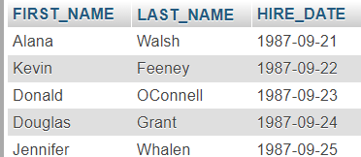

1. Write a [MySQL](https://www.w3resource.com/mysql-exercises/join-exercises/) query to get the department name and number of employees in the department.

Ans:- SELECT DEPARTMENT_NAME, COUNT(*) FROM departments AS D INNER JOIN employees AS E ON E.EMPLOYEE_ID=D.DEPARTMENT_ID GROUP BY DEPARTMENT_NAME;

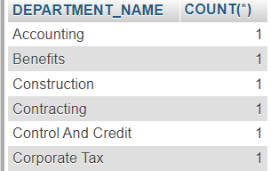

1. Write a [MySQL](https://www.w3resource.com/mysql-exercises/join-exercises/) query to find the employee ID, job title, number of days between ending date and starting date for all jobs in department 90.

Ans:- SELECT E.FIRST_NAME, J.JOB_TITLE, JH.START_DATE, JH.END_DATE, DATEDIFF(JH.END_DATE, JH.START_DATE) AS Days

FROM employees AS E, jobs AS J, job_history AS JH WHERE E.JOB_ID=J.JOB_ID AND E.EMPLOYEE_ID=JH.EMPLOYEE_ID AND E.DEPARTMENT_ID=90;

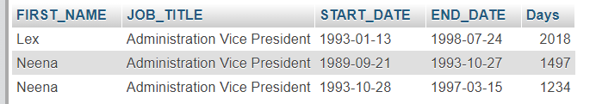

1. Write a [MySQL](https://www.w3resource.com/mysql-exercises/join-exercises/) query to display the department ID and name and first name of manager.

Ans:- SELECT D.DEPARTMENT_NAME, D.DEPARTMENT_ID, E.FIRST_NAME FROM departments AS D, employees AS E WHERE E.DEPARTMENT_ID=D.MANAGER_ID;

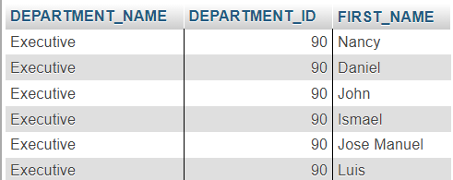

1. Write a [MySQL](https://www.w3resource.com/mysql-exercises/join-exercises/) query to display the department name, manager name, and city.

Ans:- SELECT D.DEPARTMENT_NAME,CONCAT(E.FIRST_NAME, '', E.LAST_NAME) AS MANAGER, L.CITY FROM departments AS D, employees AS E, locations AS L WHERE D.MANAGER_ID=E.EMPLOYEE_ID AND D.LOCATION_ID=L.LOCATION_ID;

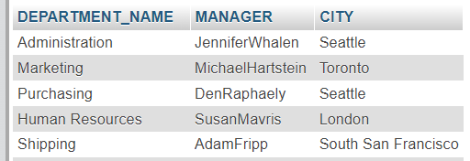

1. Write a [MySQL](https://www.w3resource.com/mysql-exercises/join-exercises/) query to display the job title and average salary of employees.

Ans:- SELECT J.JOB_TITLE, AVG(E.SALARY) FROM employees AS E, jobs As J WHERE E.JOB_ID=J.JOB_ID GROUP BY J.JOB_TITLE;



1. Write a [MySQL](https://www.w3resource.com/mysql-exercises/join-exercises/) query to display job title, employee name, and the difference between salary of the employee and minimum salary for the job.

Ans:- SELECT J.JOB_TITLE, E.FIRST_NAME, (E.SALARY-J.MIN_SALARY) AS DIFF FROM employees AS E, jobs As J WHERE E.JOB_ID=J.JOB_ID;

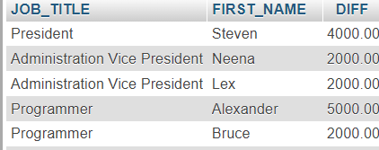

1. Write a [MySQL](https://www.w3resource.com/mysql-exercises/join-exercises/) query to display the job history that were done by any employee who is currently drawing more than 10000 of salary.

Ans:- SELECT E.FIRST_NAME, E.SALARY, JH.* FROM employees AS E, job_history AS JH WHERE E.EMPLOYEE_ID = JH.EMPLOYEE_ID AND E.SALARY>10000;

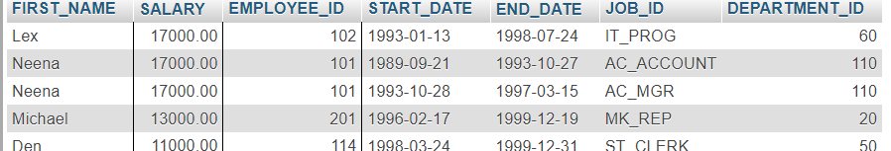

1. Write a [MySQL](https://www.w3resource.com/mysql-exercises/join-exercises/) query to display department name, name (first_name, last_name), hire date, salary of the manager for all managers whose experience is more than 15 years.

Ans:- SELECT E.FIRST_NAME, E.HIRE_DATE, D.DEPARTMENT_NAME, (DATEDIFF(NOW(), E.HIRE_DATE) / 365) AS DIFF FROM employees AS E, departments AS D WHERE E.DEPARTMENT_ID=D.MANAGER_ID;

