Ecuador is a country in northwestern South America, bordered by Colombia on the north, Peru on the east and south, and the Pacific Ocean on the west. Ecuador also includes the Galápagos Islands in the Pacific, west of the mainland. The capital is Quito.

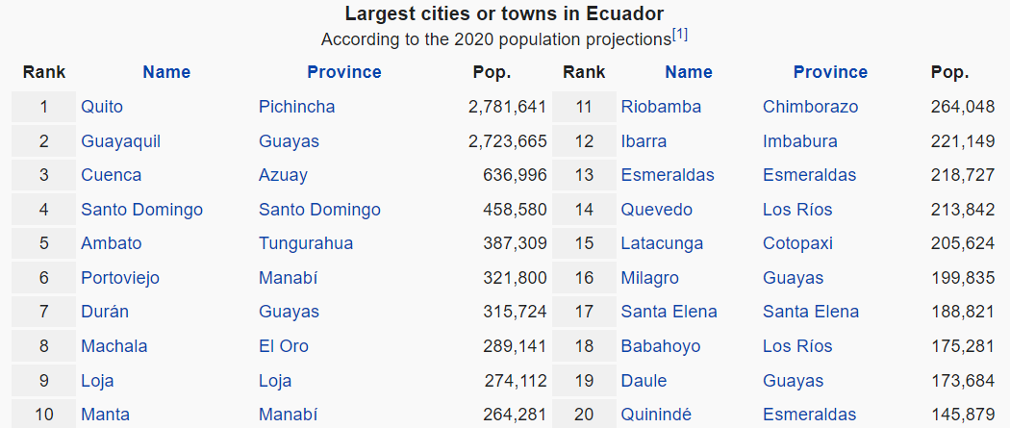

* Mundial de futbol Brasil refers to 2014 FIFA World Cup. Ecuador’s matches were only on 3 of the days.