ASSIGNMENT 2

Data Model:

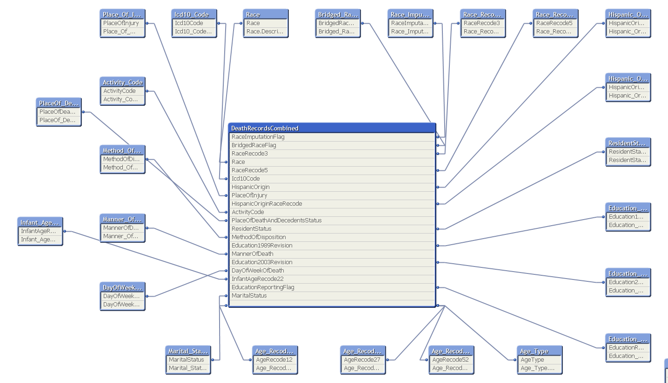

Qlikview report:

1. Main Sheet

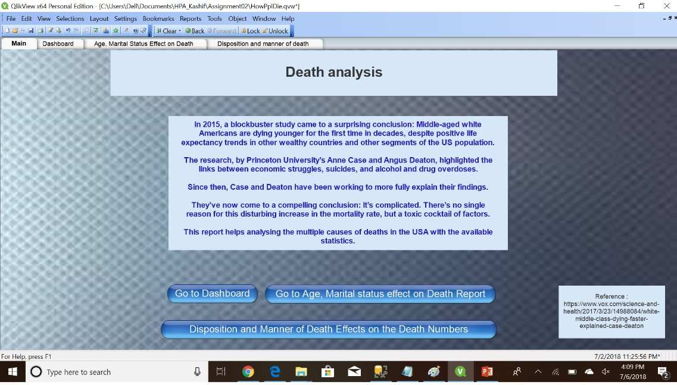

1. Dashboard

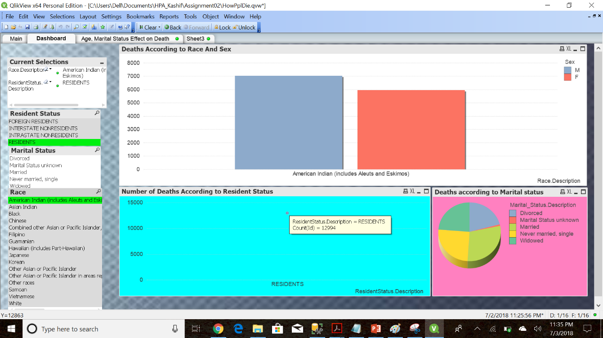

1. Report suggesting how age, marital status, race affect death

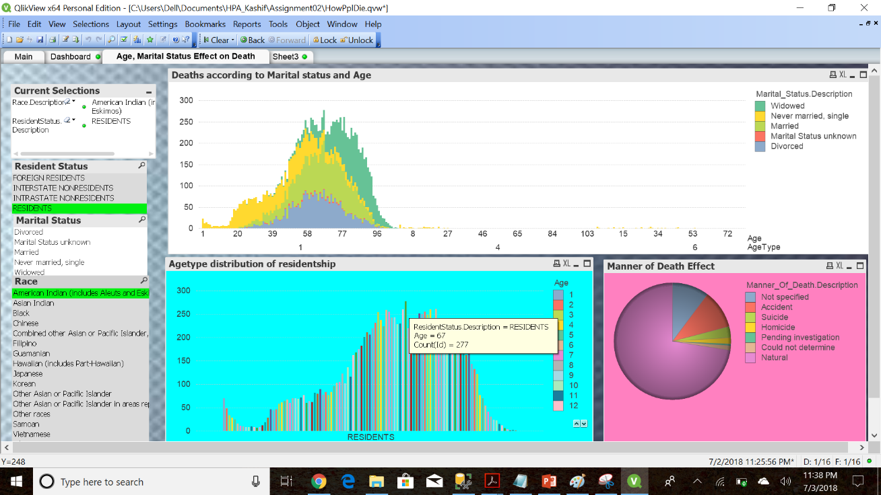

1. Report encapsulating major reasons for death in various races and age groups

