|  |  |
| --- | --- |
|  | emg controlled orthosis for grasping |
|  |  |
| 2/3/2017 | Value Proposition, Plan and Timeline |
|  | This document addresses the requirement for the value proposition for the project, the timeline and deliverables that motivate the course of the course project.  Gaurav Mukherjee  Aishwarya R. Mandyam  Larry To |

emg controlled orthosis for grasping

Value Proposition, Plan and Timeline

# value proposition

The ECOG Hand (working title) addresses an unfulfilled need for return of active extension and grasp function of the hand, for an individual with a complete spinal cord injury at the cervical 5th and 6th vertebral levels. Our solution offers EMG controlled extension of the 2nd and 3rd digit, and a splinting of the thumb to exercise a grasp.

The absence of any standard solutions to this problem for this individual with chronic SCI speaks to the need gap in the current available off the shelf solutions. After a survey of the available resources, we discovered only one device launched as recently as September 2016, the MyoPro elbow wrist and finger exoskeleton addresses grasping powered by EMG control in a commercial package. However, this device is advertised as applicable to individuals with weakened limbs rather than limbs with complete paralysis. At the time of writing, a price is not available without a consult. The device also comes as a 4 DOF system for the shoulder, elbow, wrist and grasp, which is large bulky and unnecessary for our subject and others with that category and type of injury.

# Timeline

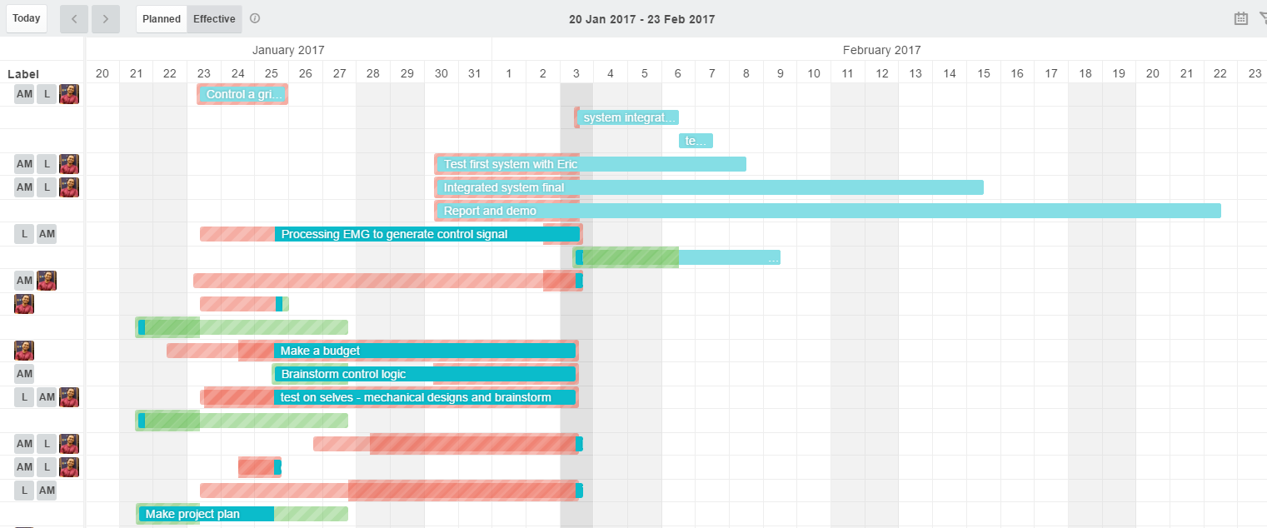

# deliverables

An active EMG controlled grasping mechanism to enable our subject to lift simple everyday objects. We are on schedule to deliver a working prototype of the primary device (finger mounted) by Feb 22. Failing this, the backup alternative is to couple a 4 bar linkage based robogripper similar to that available at the CSNE, with a wrist mounted brace, to demonstrate a simple grasp.