Instance ID
Public Ip
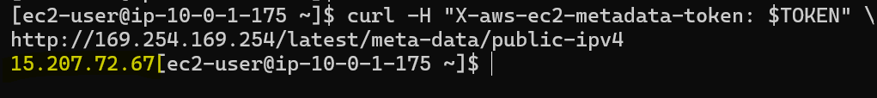
private IP
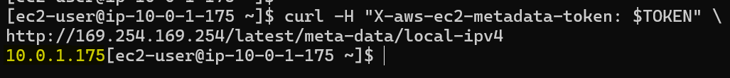
VPC iD
