CreateD 5 GB EBS Volume
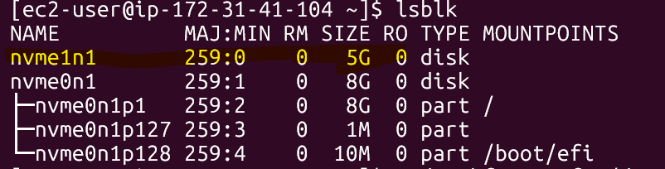
Mounted Volume
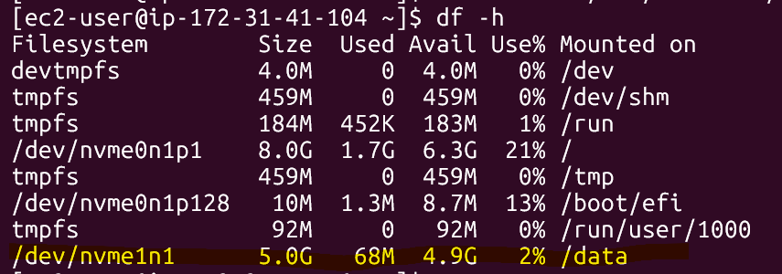
Snapshot Created for Linux
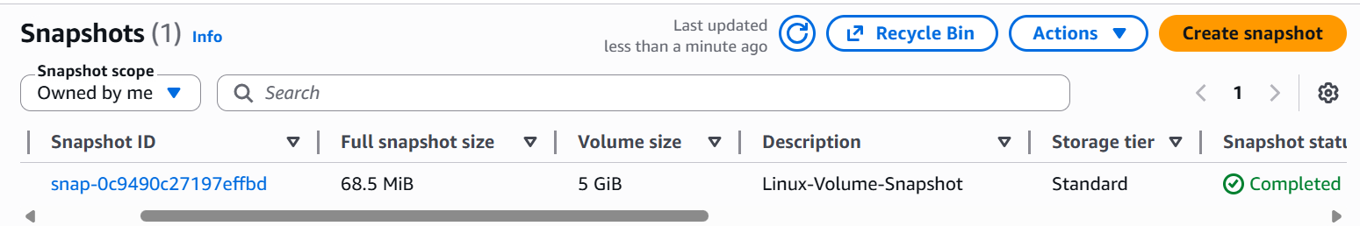

Snapshot attached with Volume
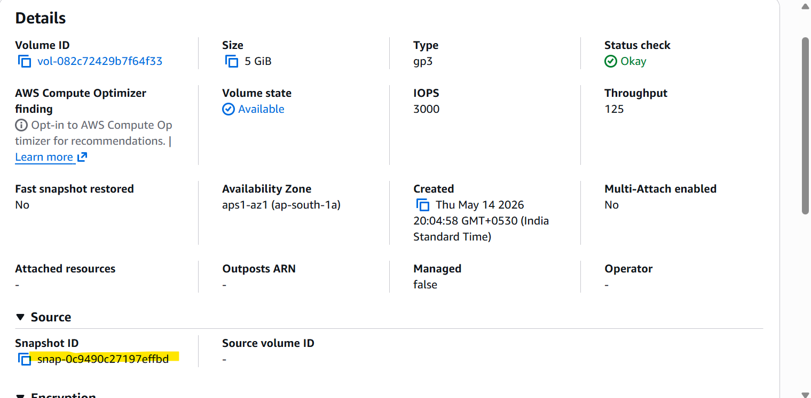

Volume Before attached Snap
