My Jenkins URLhttp://13.127.17.162:8080/

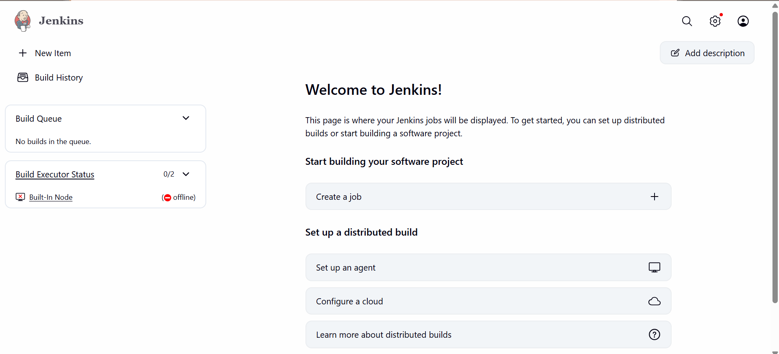

http://13.127.17.162:8080/job/Jenkins_1st_project/

Project http://13.127.17.162:8080/job/GuviTest/job/Dev_pipeline/

Created users in Jenkins:

