Created Docker Images:
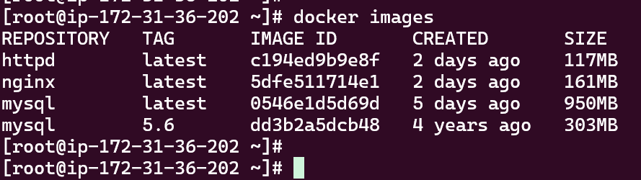
Containers are cretated:
docker run -it --name=test_centos_con centos:7
Created Volume in docker
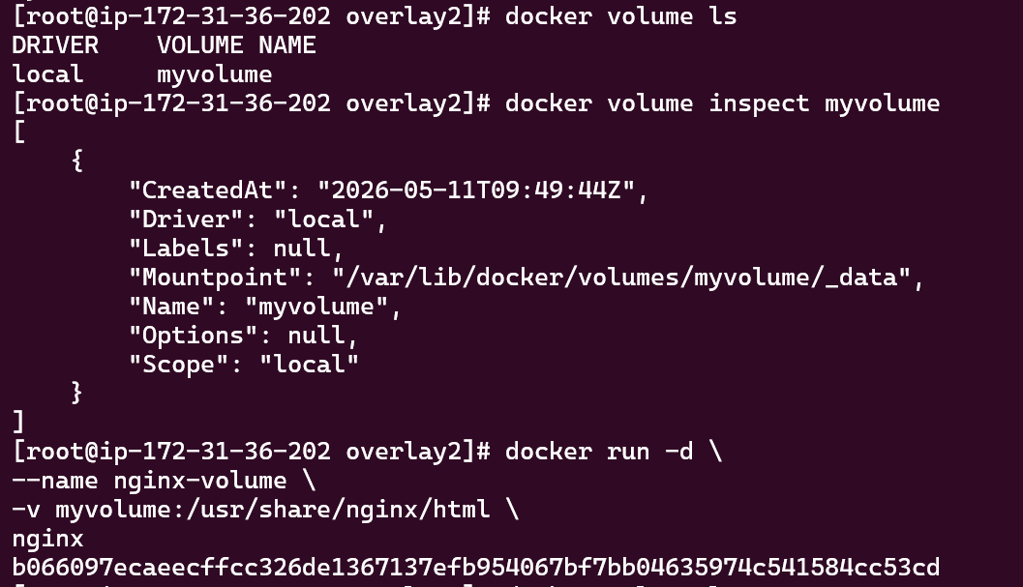

For Network below commands I have used:
