**PROGRAM:**

set ns [new Simulator]

set nf [open TCP33.nam w]

$ns namtrace-all $nf

set tf [open TCP33.tr w]

$ns trace-all $tf

proc finish {} {

global ns nf tf

$ns flush-trace

close $nf

close $tf

exec nam TCP33.nam &

exit 0

}

set n0 [$ns node]

set n1 [$ns node]

set n2 [$ns node]

set n3 [$ns node]

set n4 [$ns node]

set n5 [$ns node]

set n6 [$ns node]

$ns duplex-link $n0 $n4 1Kb 50ms DropTail

$ns duplex-link $n1 $n4 1Mb 50ms DropTail

$ns duplex-link $n2 $n5 1Kb 50ms DropTail

$ns duplex-link $n3 $n5 1Mb 50ms DropTail

$ns duplex-link $n4 $n5 100Kb 50ms DropTail

$ns duplex-link $n6 $n5 1Mb 50ms DropTail

set source1 [new Agent/TCP]

$ns attach-agent $n0 $source1

set dest [new Agent/TCP]

$ns attach-agent $n2 $dest

$ns connect $source1 $dest

set appl [new Application/FTP]

$appl attach-agent $source1

$ns at 0.0 "$appl start"

$ns at 3.9 "$appl stop"

$ns at 4.0 "finish"

$ns run

**OUTPUT:**

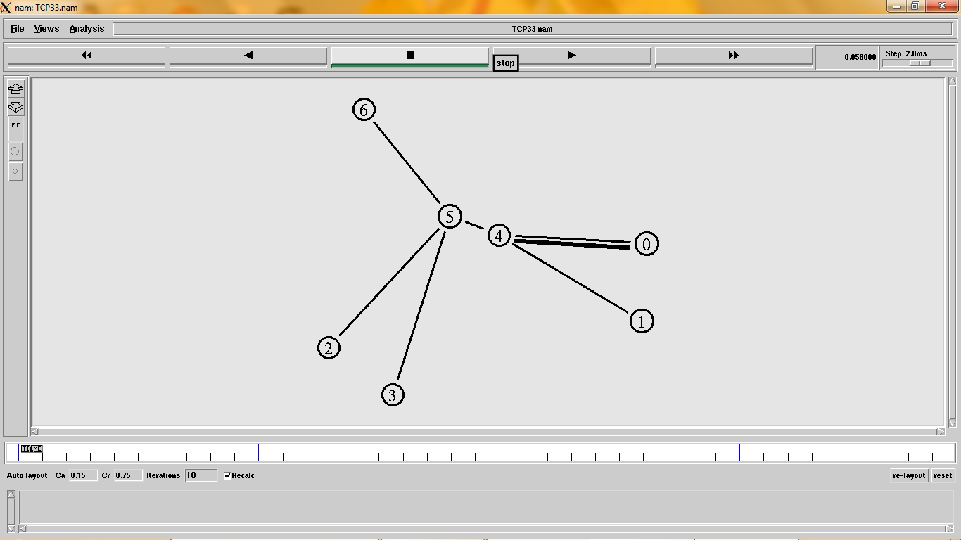

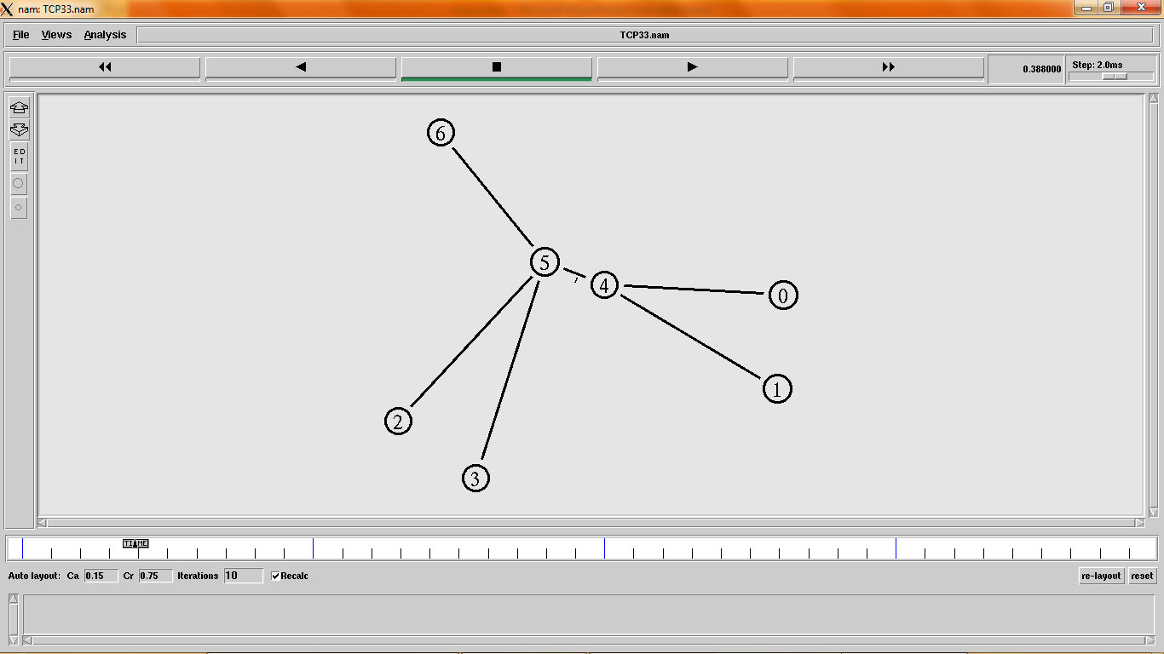

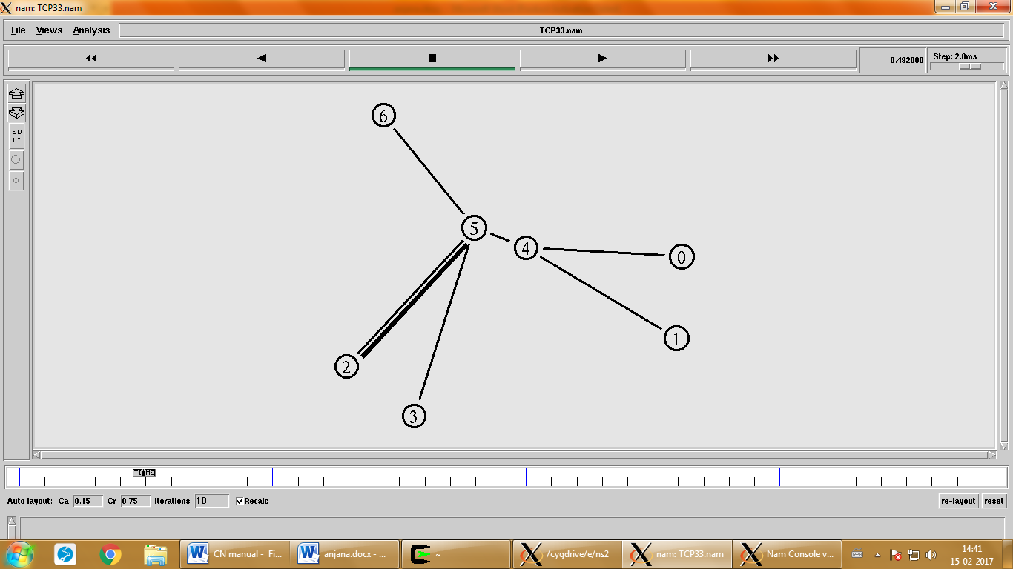

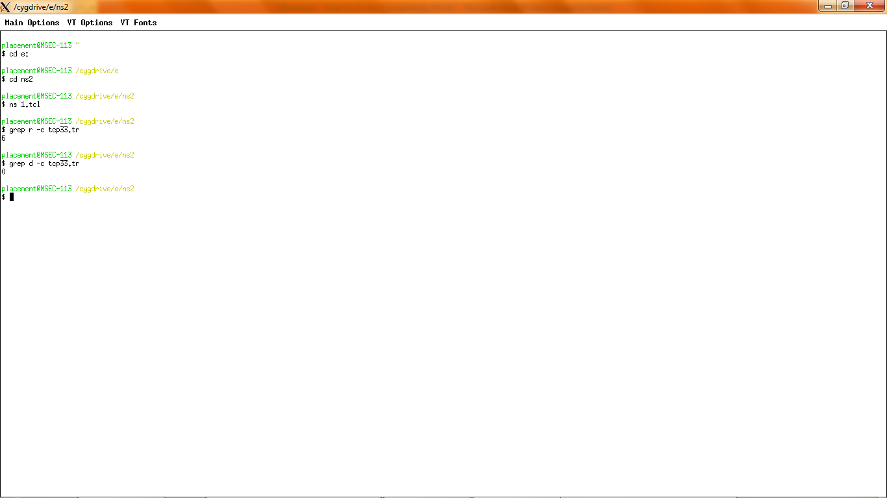

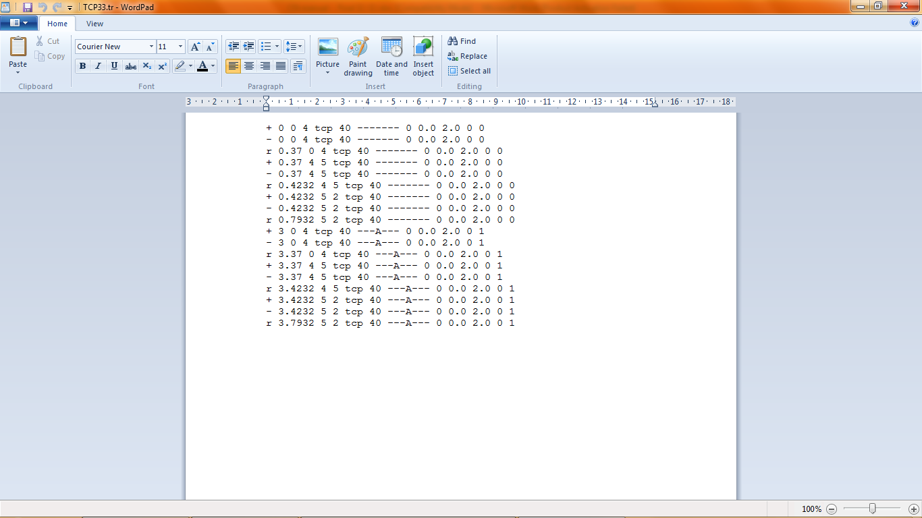

**PROGRAM**:

set ns [new Simulator]

set nf [open congout.nam w]

set tf [open congout.tr w]

$ns trace-all $tf

$ns namtrace-all $nf

proc finish {} {

global ns nf

$ns flush-trace

close $nf

exec nam congout.nam &

exit 0 }

set n0 [$ns node]

set n1 [$ns node]

set n2 [$ns node]

set n3 [$ns node]

set n4 [$ns node]

set n5 [$ns node]

**#create links between the nodes**

$ns duplex-link $n0 $n2 2Mb 10ms DropTail

$ns duplex-link $n1 $n2 2Mb 10ms DropTail

$ns simplex-link $n2 $n3 0.3Mb 100ms DropTail

$ns simplex-link $n3 $n2 0.3Mb 100ms DropTail

$ns duplex-link $n3 $n4 0.5Mb 40ms DropTail

$ns duplex-link $n3 $n5 0.5Mb 30ms DropTail

**#Set Queue Size of link (n2-n3) to 10**

$ns queue-limit $n2 $n3 20

**#Setup a TCP connection**

set tcp [new Agent/TCP/Newreno]

$ns attach-agent $n0 $tcp

set sink [new Agent/TCPSink/DelAck]

$ns attach-agent $n4 $sink

$ns connect $tcp $sink

$tcp set fid_ 1

$tcp set window_ 8000

$tcp set packetSize_ 552

**#Setup a FTP over TCP connection**

set ftp [new Application/FTP]

$ftp attach-agent $tcp

$ftp set type_ FTP

**#Setup a UDP connection**

set udp [new Agent/UDP]

$ns attach-agent $n1 $udp

set null [new Agent/Null]

$ns attach-agent $n5 $null

$ns connect $udp $null

$udp set fid_ 2

**#Setup a CBR over UDP connection**

set cbr [new Application/Traffic/CBR]

$cbr attach-agent $udp

$cbr set type_ CBR

$cbr set packet_size_ 1000

$cbr set rate_ 0.01mb

$cbr set random_ false

$ns at 0.1 "$cbr start"

$ns at 1.0 "$ftp start"

$ns at 10.0 "$ftp stop"

$ns at 10.5 "$cbr stop"

$ns at 11.0 "finish"

$ns run

**OUTPUT:**

