

SIMATS ENGINEERING

Saveetha Institute of Medical and Technical Sciences Chennai- 602105
Student Name:B Aishwarya Reg. No: 192421432
Course Code: CSA0820 Slot: C
Course Name: PYTHON PROGRAMMING FOR SCIENTIFIC COMPUTING Course Faculty: DR.P.VIJAYARAGAVAN and DR S K Aruna
Project Title: Pharmacy Management System For Inventory And Billing

Module Photographs:
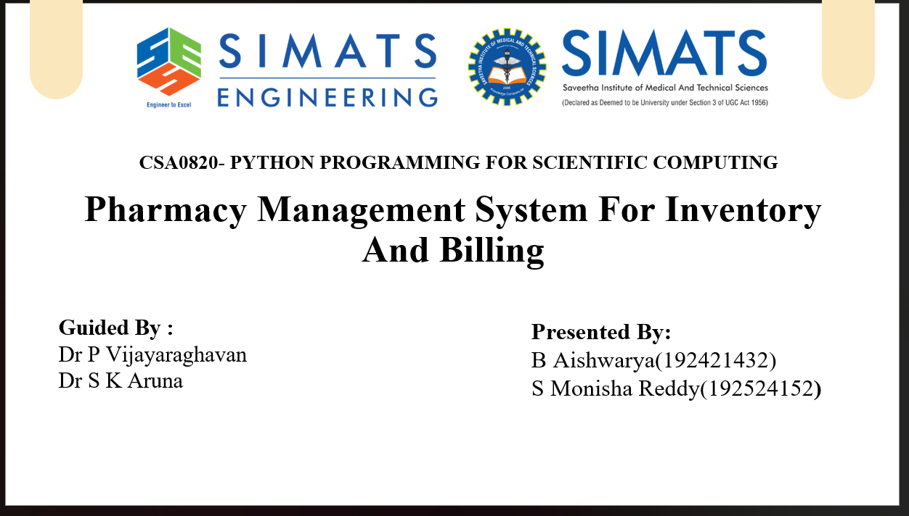 | 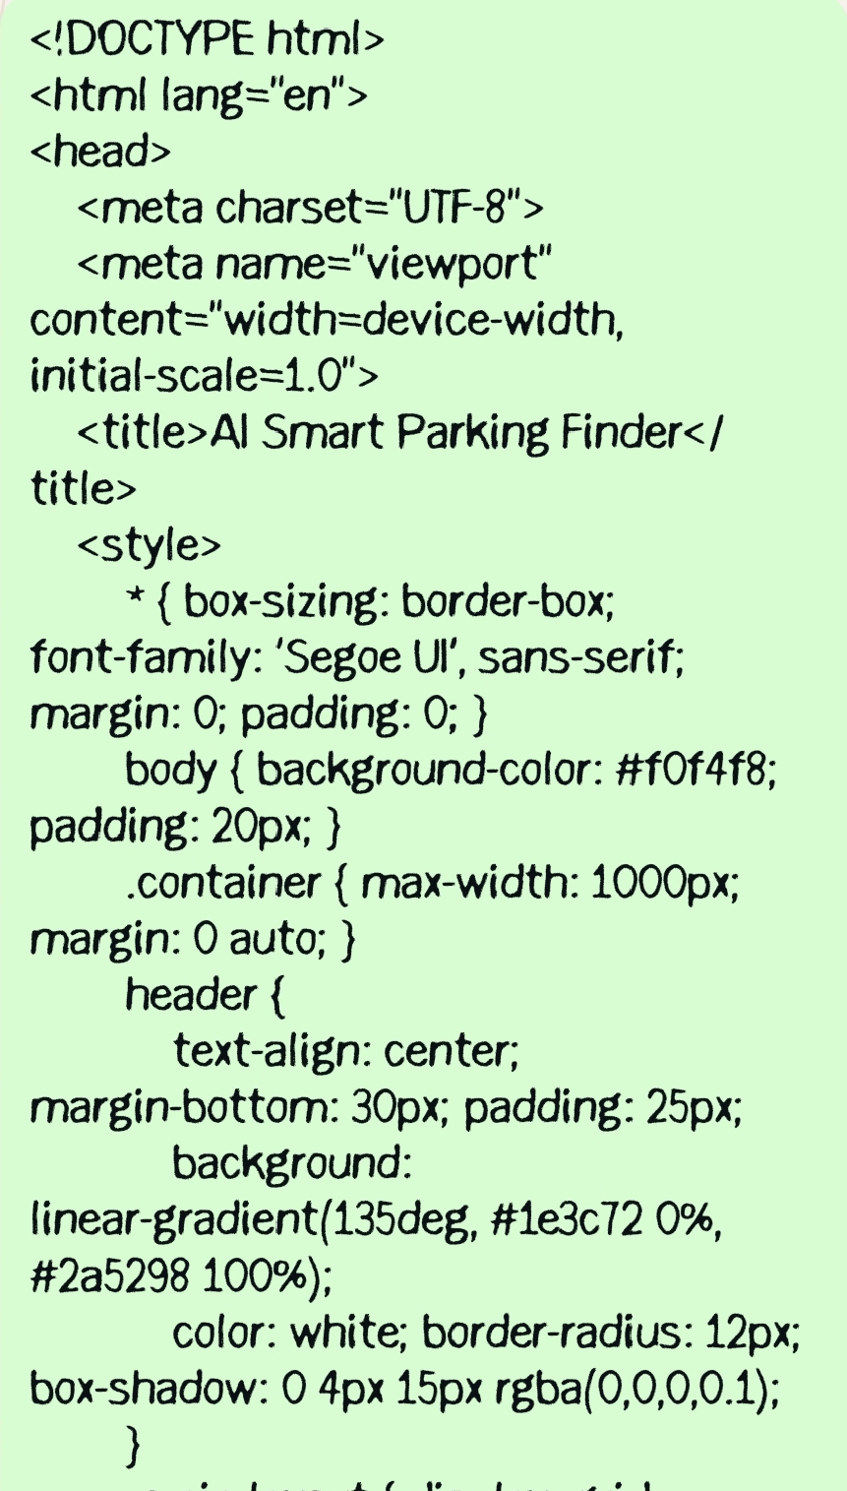 | 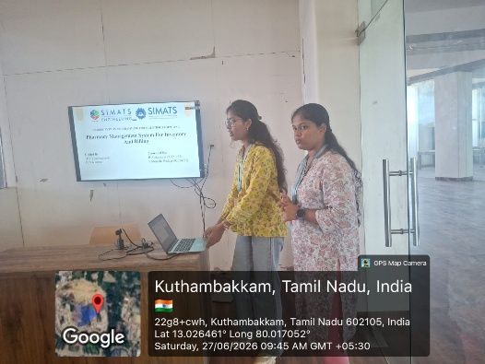
Project Description:
A Smart Parking Finder System using Python is an intelligent parking management solution designed to help drivers quickly locate available parking spaces in real time. The system utilizes cameras, sensors, or image-processing techniques to monitor parking areas and detect whether parking slots are occupied or vacant. Python-based algorithms process the collected data and continuously update the status of each parking space.The system displays real-time parking availability through a user-friendly interface, allowing users to easily identify free parking spots and navigate to them. Advanced computer vision and machine learning techniques can be integrated to improve vehicle detection accuracy and parking space monitoring. The system may also maintain a centralized database to store parking information and provide instant updates to users.

Student Signature Guide Signature

