A

Report on

**Automatic Transmission Controller**

Submitted

By

Miss. Aishwarya Rajkumar Chougule

Employee Id: 214872

Contents

1. Introduction 3

2. Analysis and Physics 3

3. Block diagram 3

4. Equations 3

5. Model 4

6. Output Results 5

7. Conclusion 5

1. Introduction

Model an automotive drivetrain with Simulink. Stateflow enhances the Simulink model with its representation of the transmission control logic. Simulink provides a powerful environment for the modeling and simulation of dynamic systems and processes.

1. Analysis and Physics

The figure below shows the power flow in a typical automotive drivetrain. Nonlinear ordinary differential equations model the engine, four-speed automatic transmission, and vehicle. The model discussed in this example directly implements the blocks from this figure as modular Simulink subsystems. On the other hand, the logic and decisions made in the Transmission Control Unit (TCU) do not lend themselves to well-formulated equations. TCU is better suited for a Stateflow representation. Stateflow monitors the events which correspond to important relationships within the system and takes the appropriate action as they occur.

1. Block Diagram

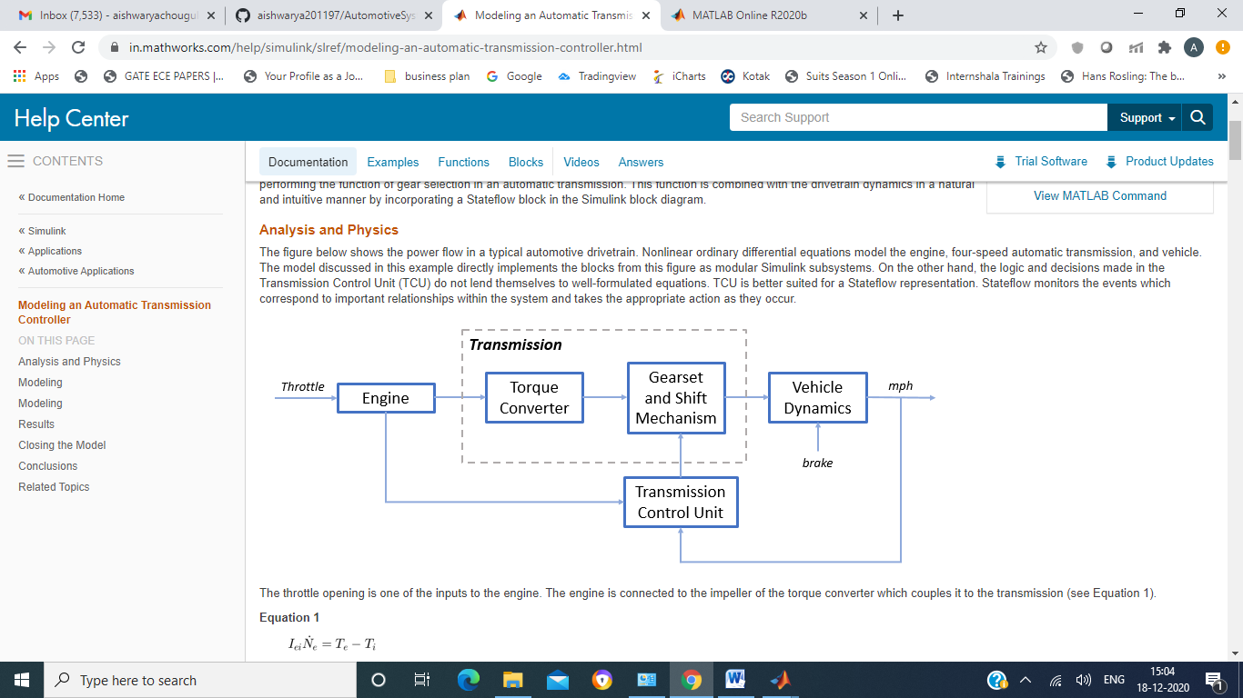

1. Equations

**Equation 1**

The throttle opening is one of the inputs to the engine. The engine is connected to the impeller of the torque converter which couples it to the transmission (see Equation 1).

$$I_{ei} \dot{N}_e = T_e -T_i $$

$$ N_e = \mbox{ engine speed (RPM)}$$

$$I_{ei} = \mbox{ moment of inertia of the engine and the impeller}$$

$$T_e, T_i = \mbox{ engine and impeller torque}$$

The input-output characteristics of the torque converter can be expressed as functions of the engine speed and the turbine speed. In this example, the direction of power flow is always assumed to be from the impeller to the turbine (see Equation 2).

**Equation 2**

$$T_i = \frac{N_e^2}{K^2}$$

$$K= f_2 \frac{N_{in}}{N_e} = \mbox{ K-factor (capacity)}$$

$$N_{in} = \mbox{ speed of turbine (torque converter output) = transmission input speed (RPM)}$$

$$R_{TQ} = f_3 \frac{N_{in}}{N_e} = \mbox{ torque ratio}$$

The transmission model is implemented via static gear ratios, assuming small shift times (see Equation 3).

**Equation 3**

$$R_{TR} = f_4(gear) = \mbox{ transmission ratio}$$

$$T_{out} = R_{TR} T_{in}$$

$$N_{in} = R_{TR} N_{out}$$

$$T_{in}, T_{out} = \mbox{ transmission input and output torques}$$

$$N_{in}, N_{out} = \mbox{ transmission input and output speed (RPM)}$$

The final drive, inertia, and a dynamically varying load constitute the vehicle dynamics (see Equation 4).

**Equation 4**

$$ I_v \dot{N}_w = R_{fd}(T_{out}-T_{load})$$

$$I_v = \mbox{ vehicle inertia}$$

$$N_w = \mbox{ wheel speed (RPM)}$$

$$R_{fd} = \mbox{ final drive ratio}$$

$$T_{load} = f_5(N_w) = \mbox{ load torque}$$

The load torque includes both the road load and brake torque. The road load is the sum of frictional and aerodynamic losses (see Equation 5).

**Equation 5**

$$ T_{load} = sgn(mph) (R_{load0} + R_{load2} mph^2 + T_{brake}) $$

$$ R_{load0}, R_{load2} = \mbox{ friction and aerodynamic drag coefficients} $$

$$ T_{load}, T_{brake} = \mbox{ load and brake torques} $$

$$ mph = \mbox{ vehicle linear velocity}$$

The model programs the shift points for the transmission according to the schedule shown in the figure below. For a given throttle in a given gear, there is a unique vehicle speed at which an upshift takes place. The simulation operates similarly for a downshift.

1. Model

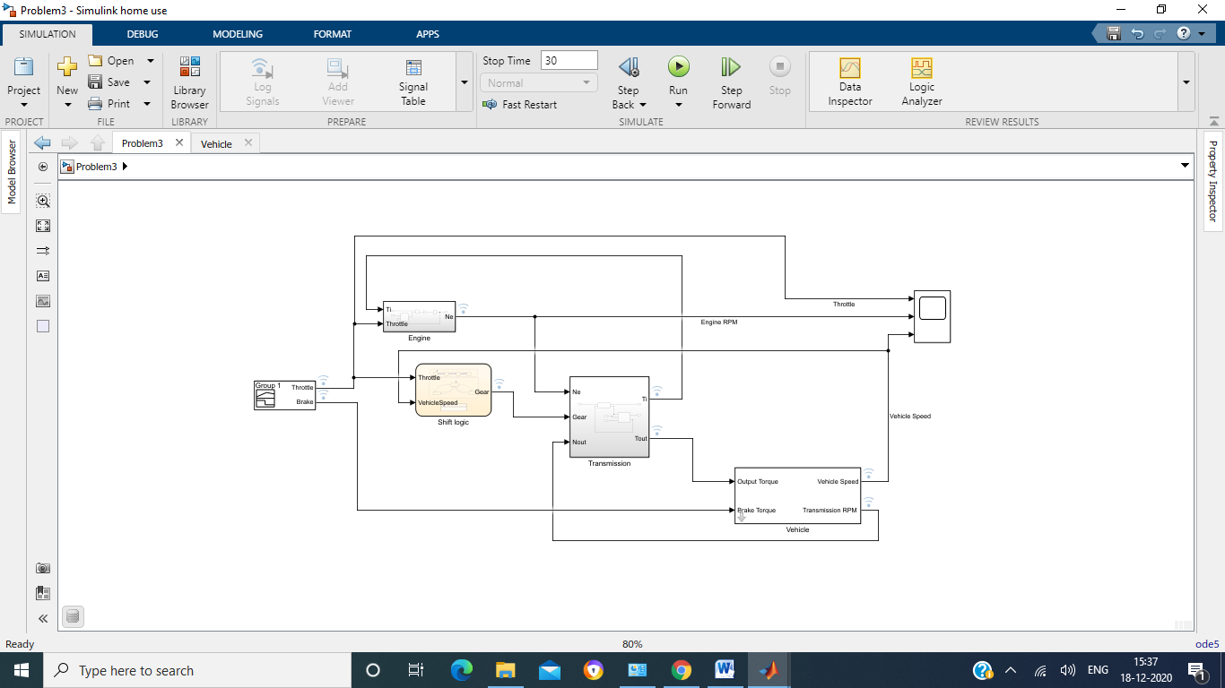

1. Output Results

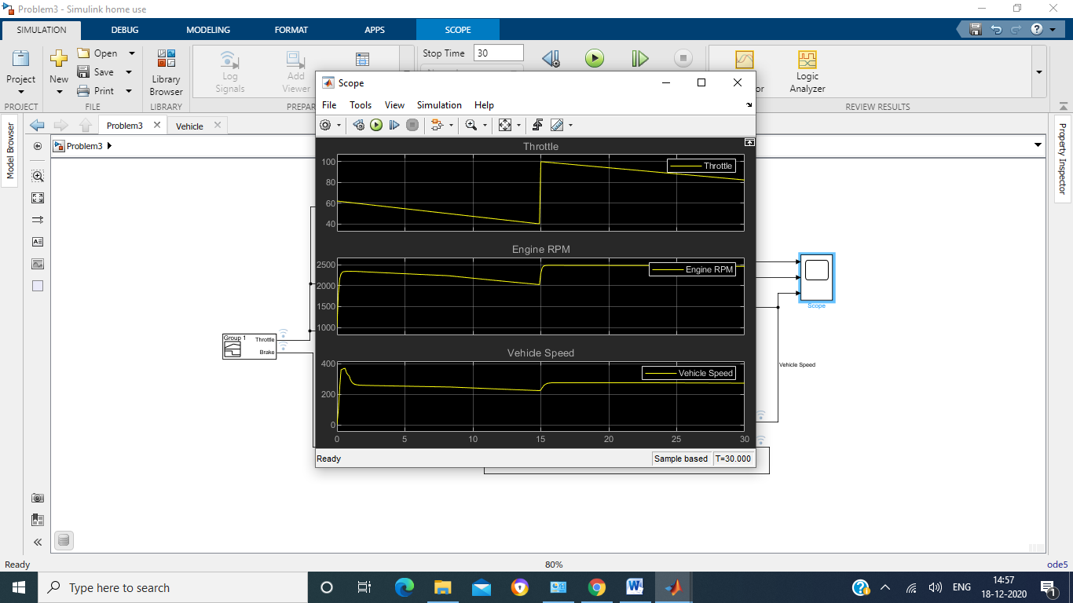

1. Conclusion

We can enhance this basic system in a modular manner, for example, by replacing the engine or transmission with a more complex model. Also, build large systems within this structure via step-wise refinement. The seamless integration of Stateflow control logic with Simulink signal processing enables the construction of a model that is efficient and visually intuitive.