**Abstract**

The purpose of this project “Hotel Management System” involves maintaining various operations like user can check the room availability and also book the room online and hotel admin can login to this system and view the room booking list and cancellation of the room, cash billing and room service. We are going to develop this project using this modules like user module in this view room, check room availability and book room. In admin module admin login, view room booking, manage rooms etc. To implement this project we will use full stack languages like HTML, CSS, JavaScript, Bootstrap, PHP, MySQL database etc.

**Project Modules**

* **Admin Module**

**Admin Login :-** Using user name and password admin can login.

**View Room Booking :-** In this module user can view the list of booking.

**Manage Rooms :-** Admin can add the room type, room photo room information etc.

* **User Module**

**View Rooms :-** In this module user can view the room.

**Check Room Available :-** In this module user can check the room availability.

**Book Room** **:-** Inthis module user can book the room.

**Literature survey**

**Existing System :-**

As per the my market survey there is no such type of system are available. In some hotel online room booking facilities are not available. And in some hotel online room booking facilities are available. So for the user we are going to develop this project by this user can book the room by call and visit the room. By this user can save the time.

**Proposed System :-**

We are going to develop the hotel management system. The purpose of this project “Hotel Management System” involves maintaining various operations like user can check the room availability and also book the room online and hotel admin can login to this system and view the room booking list and cancellation of the room, cash billing and room service. We are going to develop this project using this modules like user module in this view room, check room availability and book room. In admin module admin login, view room booking, manage rooms etc. To implement this project we will use full stack languages like HTML, CSS, JavaScript, Bootstrap, PHP, MySQL database etc.

**Data Flow Diagram**

**Phase 0**

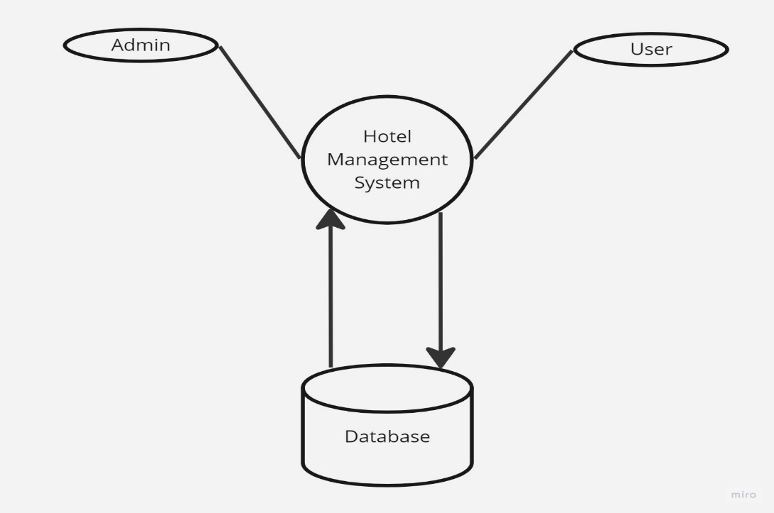

**Phase 1**

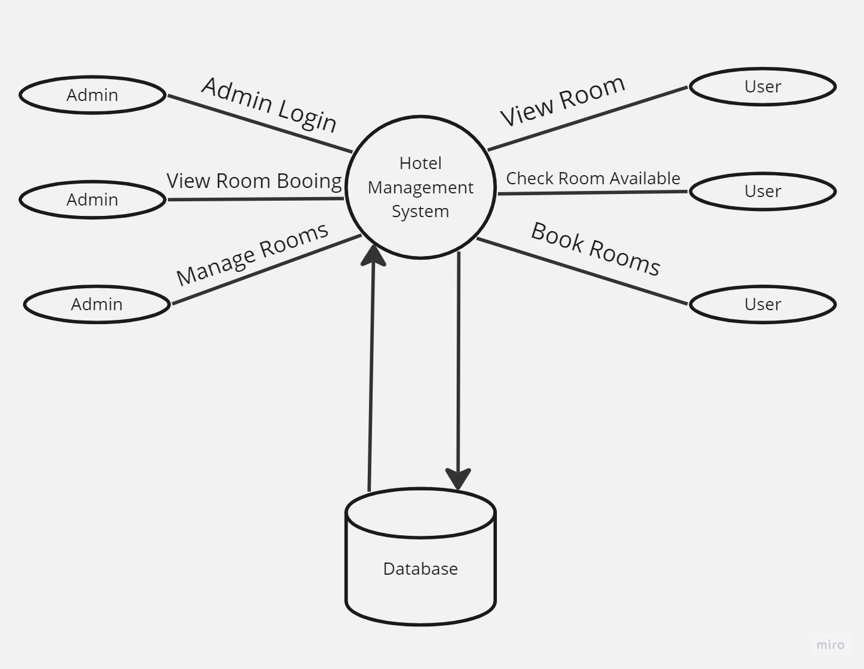

**Use-Case Diagram**

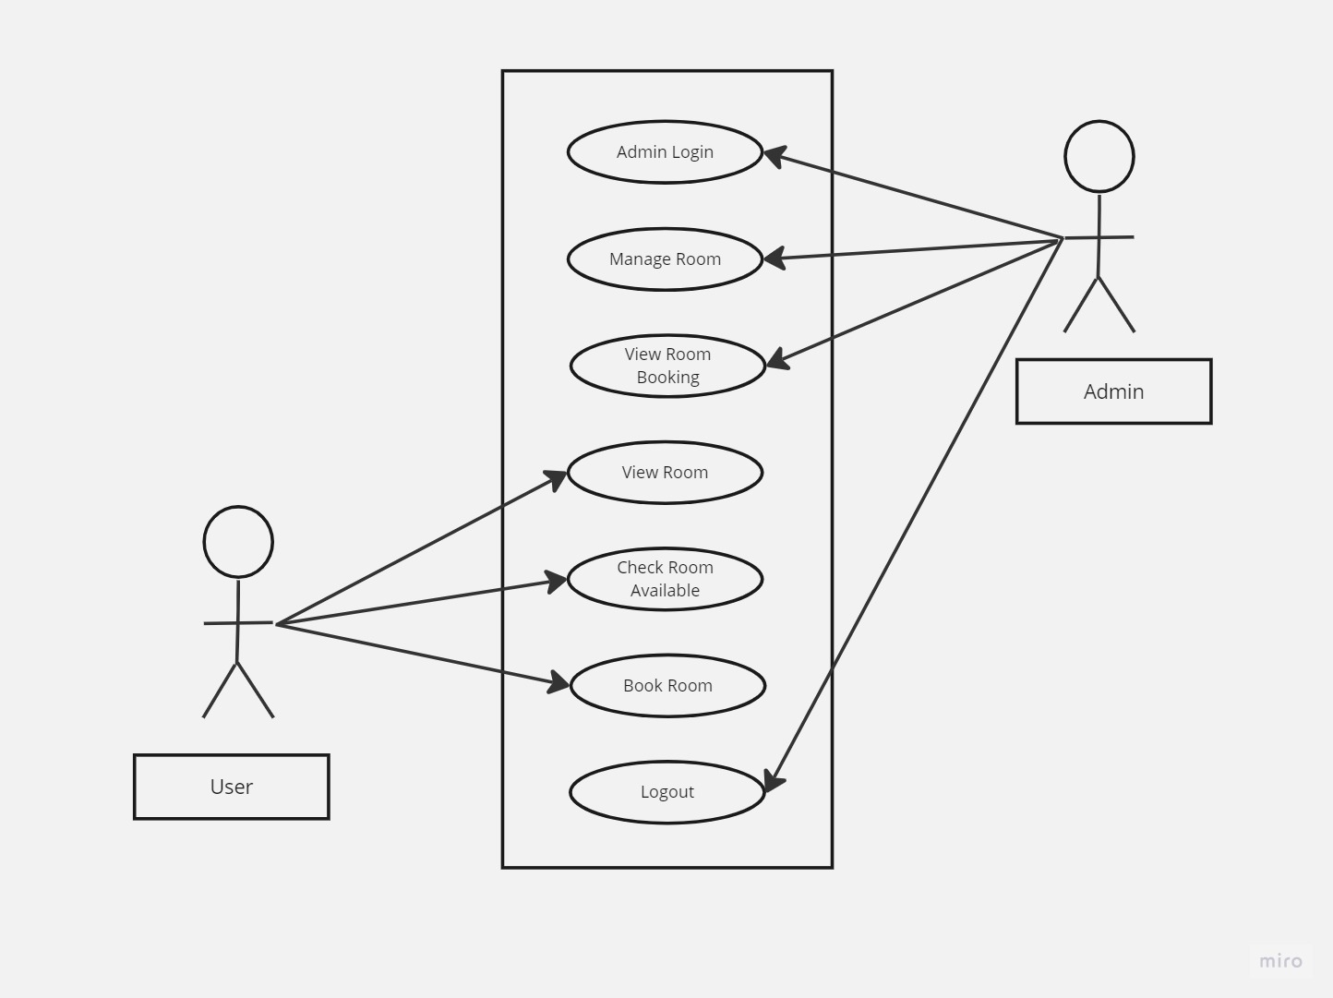

**Requirements**

**Requirements for developing:-**

* Average I3 processor.
* Average 4GB RAM.
* Average 512GB hard disk.

**Hardware requirement for deployment:-**

* average I3 processor.
* Average 2GB RAM.
* Average 256GB storage.

**Software requirement for development:-**

* OS (Window’s , MAC , Linux).
* XAMP Server.
* VS Code.
* Chrome.

**Software requirement for deployment:-**

* OS.
* Chrome.

**Language used or technology:-**

* Content language (client side language) ( HTML, CSS, bootstrap, JS).
* Backend (server side language) (PHP).
* Database (MySQL).

**Advantages**

* User can book the room from any location.
* Reduce the time.
* Reduce manual work.
* Can connect with the user easily.
* Increase your online visibility.

**Future Scope**

* In future we will implement this project to live to an to any hotel.
* We will develop the mobile application.

**Conclusion**

As per the synopsis we will implement “Hotel Management System” with all the modules like user module in this view room, check room availability and book room. In admin module admin login, view room booking, manage rooms etc. All modules name we will implement our project error free and user friendly.

**BIBLIOGRAPHY**

**Books:-**

[1] “Web Programming”, by ‘Chris Bates’ Wiley Dream tech India, 2nd Edition.

[2] “Software Engineering”, Ian Somerville, Sixth Edition, Pearson Education Ltd.

[3] “HTML Complete References” Easy steps to develop web pages.

[4] “PHP Complete Reference”

**Websites:-**

[1] [http://en.wikipedia.org/wiki/**PHP**](http://en.wikipedia.org/wiki/PHP) for PHP.

[2] [http://www.hotscripts.com/category/**php**/](http://www.hotscripts.com/category/php/) for PHP.

[3] [http://www.**mysql**.com/click.php?e=35050](http://www.mysql.com/click.php?e=35050) for MYSQL.

[4] [http://www.w3schools.com](http://www.w3schools.com/) for information on HTML.