Department Hackathon
SARATHI
Business Approval & Compliance Assistant

PROJECT REPORT

Team Name: TeamAstra
Team members:
AishwaryaVollala- 24311a6798
Yashwanthi Nagapuri-25415a6709
A Eshwari-24311a67a9
Project Title: Sarathi — Business Approval & Compliance Assistant
Domain: RegTech / GovTech / Compliance Automation
Deployed URL: https://sarathi-lemon.vercel.app

Table of Contents
1. Problem Statement
2. Solution / Approach
3. Architecture
4. Tech Stack
5. Features
6. Output Screenshots
7. Future Implementation
8. Conclusion

1. Problem Statement
Starting a business in India is notoriously complex from a regulatory standpoint. Entrepreneurs must navigate a labyrinth of licenses, registrations, and compliance requirements spread across multiple government departments — Central, State, and Local bodies. The challenges include:
- Fragmented Information: Rules for business approvals are scattered across 50+ government websites, each with different formats, languages, and update cycles.
- One-Size-Fits-All Portals: Existing government portals (like the National Single Window System) provide generic checklists that do not adapt to a specific business profile — its activity, scale, location, or legal structure.
- Legal Complexity: Determining which of the 70+ possible approvals apply requires understanding multiple Acts of Parliament and State statutes (Factories Act, FSSAI Act, Shops & Establishments Act, etc.).
- Language Barrier: Most compliance information is available only in English, creating accessibility barriers for entrepreneurs in non-English speaking regions.
- Cost of Non-Compliance: Missing a mandatory license can lead to heavy penalties, business closure, or even criminal prosecution, yet entrepreneurs have no easy way to verify completeness.

2. Solution / Approach
Sarathi is an intelligent, context-aware compliance assistant that generates a personalized regulatory checklist for any new business in India. It replaces months of manual research with a 2-minute guided questionnaire.

Core Approach
- Adaptive Questionnaire: A two-step wizard dynamically adapts its questions based on the user's previous answers. For example, food-related compliance questions only appear if the user selects "Restaurant / Cafe" or "Food Processing" as their business activity.
- Rules Engine: A comprehensive, deterministic rules engine (1,600+ lines of TypeScript) evaluates the user's business profile against 70+ regulatory rules derived from Indian statutes. Each rule encodes the exact legal condition (e.g., "GST registration is mandatory if annual turnover ≥ ₹20 Lakh").
- Three-Tier Applicability: Every approval is classified as APPLICABLE (mandatory), POTENTIALLY_APPLICABLE (needs local verification), or NOT_APPLICABLE (with a clear statutory reason).
- AI-Powered Understanding: An optional AI layer (Groq/Llama 3.3 70B via Vercel AI SDK) can parse free-text business descriptions and extract structured compliance facts automatically.
- Localized Authorities: The engine maps approvals to the correct issuing authority based on the user's state and jurisdiction (e.g., GHMC for Hyderabad, BMC for Mumbai).
- Multilingual Support: The entire interface is available in English, Hindi (हिंदी), and Telugu (తెలుగు) to ensure accessibility for regional entrepreneurs.
- Submission Type Guidance: Each approval specifies whether it can be submitted online, physically, or both, helping entrepreneurs plan their application workflow.

3. Architecture
Sarathi follows a modern Next.js App Router architecture with a clear separation between the presentation layer, business logic layer, and data layer.

Sarathi uses a three-tier layered architecture deployed on Vercel as a serverless application.
Presentation Layer: Built with React 19, Next.js 16, Tailwind CSS, and shadcn/ui. The UI consists of a Landing Page, a two-step adaptive Business Wizard, a Compliance Checklist output page, and a Government Schemes page. Multilingual support covers English, Hindi, and Telugu.
Business Logic Layer: The core Rules Engine (1,600+ lines of TypeScript) takes the user's business profile and evaluates it against 70+ statutory rules. It classifies MSME category, assigns pollution category, determines three-tier applicability (Applicable / Potentially Applicable / Not Applicable), and maps each approval to the correct local authority. An optional AI layer (Groq/Llama 3.3 70B) can parse free-text descriptions into structured facts.
Data Layer: Static JSON files (catalog.json with 50+ approval definitions, rules.json with rule mappings) store regulatory data. Supabase provides cloud-hosted PostgreSQL for user authentication and project persistence.
Data Flow: User fills the wizard → BusinessProfile JSON is saved to localStorage → Checklist page passes it to the Rules Engine → Engine evaluates rules and hydrates approval data → UI renders categorized approvals grouped by lifecycle stage (Entity → Infrastructure → Operational → Labour).

Architecture Diagram
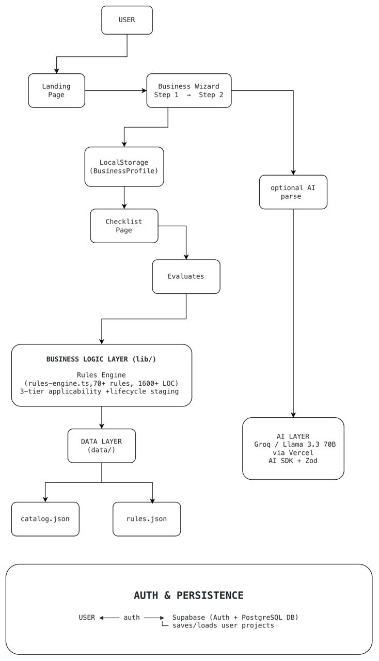

Data Flow
Step 1: User opens the landing page and clicks "Start My Approval Journey".
Step 2: Step 1 Wizard collects: Business Activity, Legal Structure, State, City, Jurisdiction, Premises Type.
Step 3: Step 2 Wizard collects: Investment, Number of Workers, and activity-specific compliance triggers (food handling, power usage, groundwater, effluents, alcohol, etc.).
Step 4: On submission, a comprehensive BusinessProfile JSON is created and saved to localStorage.
Step 5: The Checklist page reads the profile, passes it to the Rules Engine.
Step 6: The Rules Engine evaluates 70+ rules, hydrates approval data from catalog.json, and returns a categorized list of Approval objects.
Step 7: The Checklist UI renders the approvals grouped by lifecycle stage (Entity → Infrastructure → Operational → Labour), with estimated timelines, costs, required documents, and portal links.

4. Tech Stack
The following technologies were used to build Sarathi:
Frontend Development
- Next.js 16 (App Router) – Full-stack React framework supporting server-side rendering, API routes, and file-based routing.
- TypeScript – Provides type-safe JavaScript development for building robust business logic.
- React 19 – Used for developing a component-based and interactive user interface.
- Tailwind CSS 4 – Utility-first CSS framework for responsive and rapid UI development.
- shadcn/ui – Provides reusable and customizable UI components such as cards, buttons, forms, dialogs, and selectors.
- Lucide React – Used for modern and consistent icons throughout the application.
Authentication & Database
- Supabase Auth – Provides OAuth and email-based authentication with session management.
- Supabase (PostgreSQL) – Cloud-hosted relational database used for persistent application data.
AI & Machine Learning
- Groq (Llama 3.3 70B) – Used for AI-powered business description and approval-related information parsing.
- Vercel AI SDK + @ai-sdk/openai – Provides structured object generation and integration with large language models.
- Zod – Performs runtime schema validation to ensure AI-generated outputs follow the required structure.
Deployment
- Vercel – Used for deployment and hosting, with support for serverless functions and edge execution.
Internationalization
- Custom i18n using React Context – Enables multilingual support for:
  - English
  - Hindi
  - Telugu
Data & Configuration
- JSON – Used to store regulatory data, business approval catalogs, and rule definitions.
Examples:
- catalog.json – Regulatory/approval catalog
- rules.json – Business rules and approval definitions

5. Key Features
Adaptive Questionnaire: Dynamic form that shows/hides questions based on business type. Food compliance questions appear only for restaurant/food businesses; factory-related questions appear only for manufacturing.
70+ Regulatory Rules: Comprehensive coverage of Indian business approvals including GST, FSSAI, Trade License, Factory License, Pollution Consents, MSME/Udyam Registration, Shops & Establishments Act, ESI, EPF, Professional Tax, and more.
MSME Classification: Automatic Micro/Small/Medium/Large classification based on investment amounts per MSME Notification S.O. 1364(E), 2025.
Lifecycle Staging: Approvals are grouped into 4 lifecycle stages: Entity Formation → Infrastructure/Premises → Operational Compliance → Labour Compliance, providing a clear sequence for the entrepreneur.
Government Scheme Matching: Automatically identifies eligible government subsidies and incentive schemes (TS-iPASS, Startup India, etc.) based on the business profile.
Multilingual UI: Full interface available in English, Hindi, and Telugu.
Submission Type Tracking: Each approval indicates whether it should be submitted online, physically, or both.
Authentication & Project Saving: Supabase-powered auth allows users to save and revisit their compliance checklists.
Responsive Design: Fully responsive UI that works seamlessly on desktop, tablet, and mobile devices.

6. Output Screenshots
Below are placeholder areas for screenshots of the application. Please insert actual screenshots from the deployed application at https://sarathi-lemon.vercel.app.
Screenshot 1: Landing Page
The landing page with hero section showing the value proposition, step-by-step "How it Works" guide, and comparison between traditional compliance research vs. Sarathi.
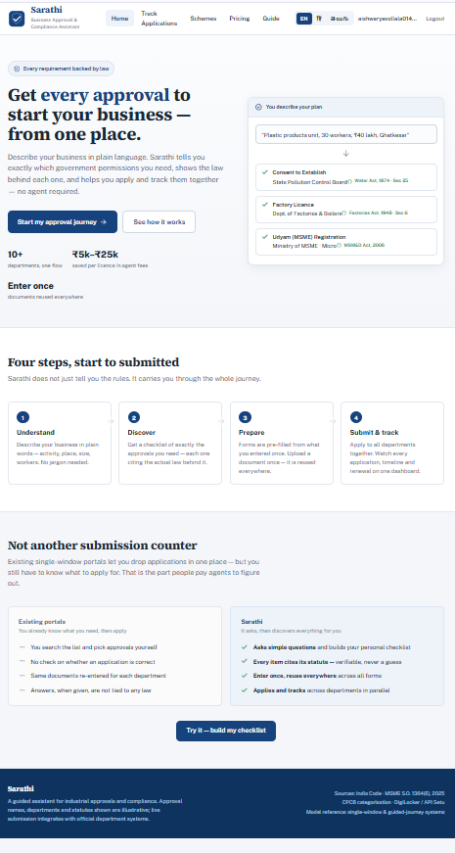

Screenshot 2: Business Profiling Wizard — Step 1
Step 1 of the questionnaire capturing: Business Activity (grid selector), Legal Structure, State, City, Local Authority Jurisdiction, and Premises Setup. 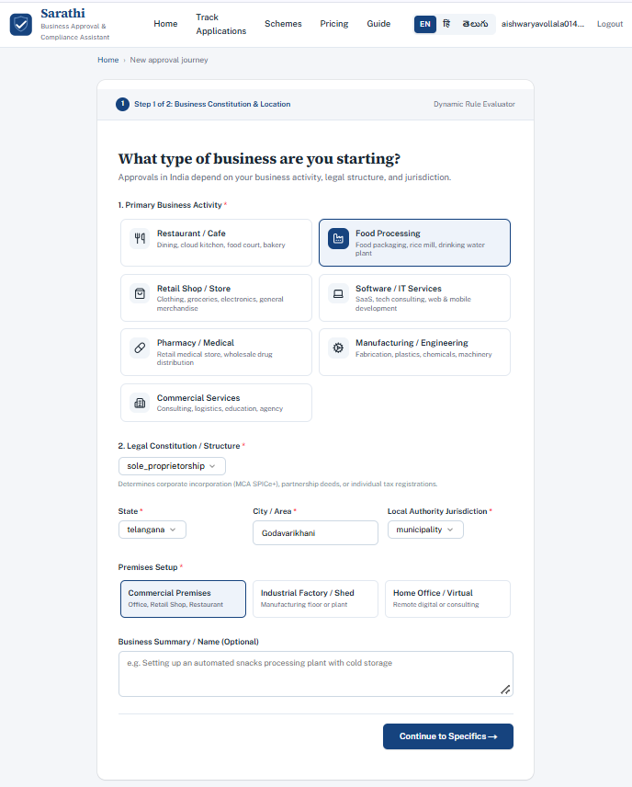

Screenshot 3: Business Profiling Wizard — Step 2
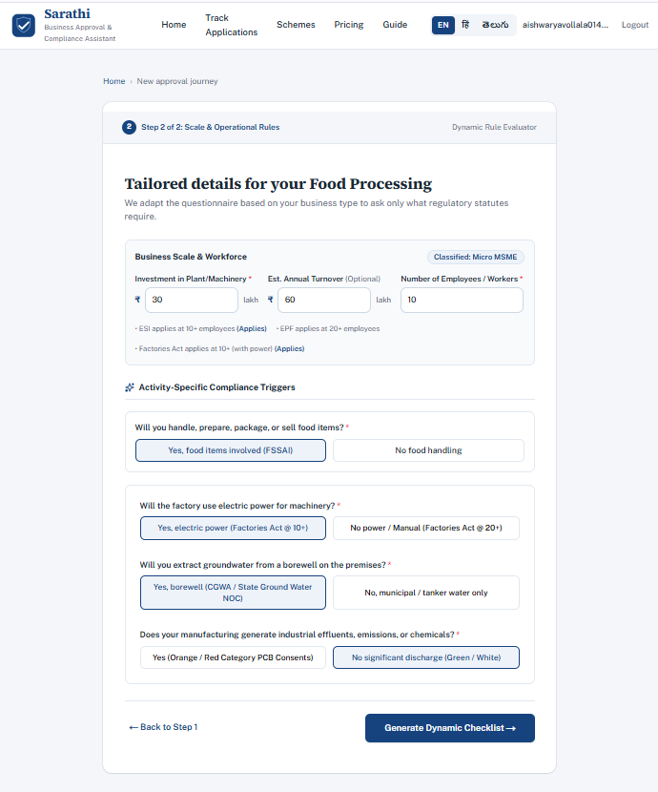
Step 2 with adaptive compliance questions: Investment, Workers, and activity-specific questions (Food handling, Power usage, Groundwater, Effluents, Alcohol license, etc.).

Screenshot 4: Compliance Checklist Output
The generated checklist showing categorized approvals with lifecycle staging, estimated timelines, required documents, issuing authorities, and submission type badges (Online/Physical/Both).
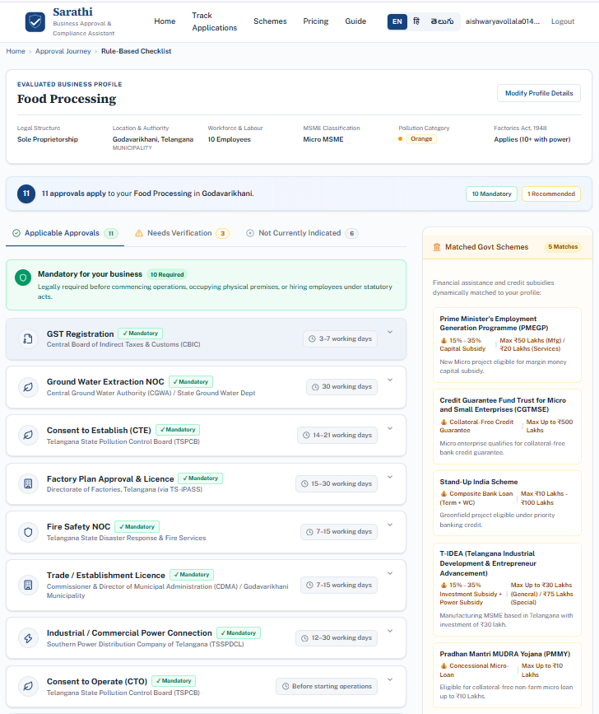
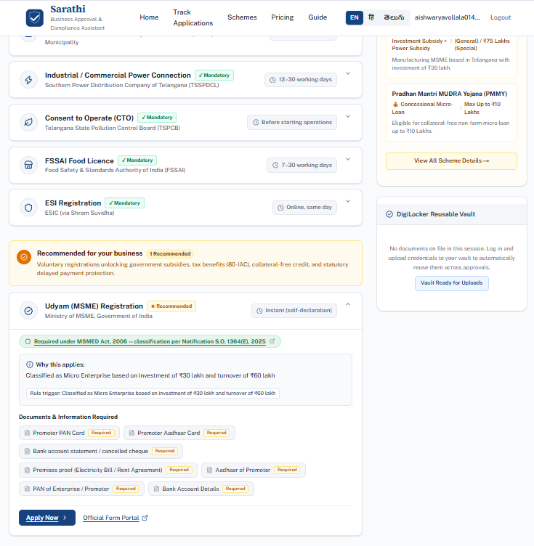
Screenshot 5: Government Schemes
The matched government schemes section showing eligible subsidies and incentive programs.
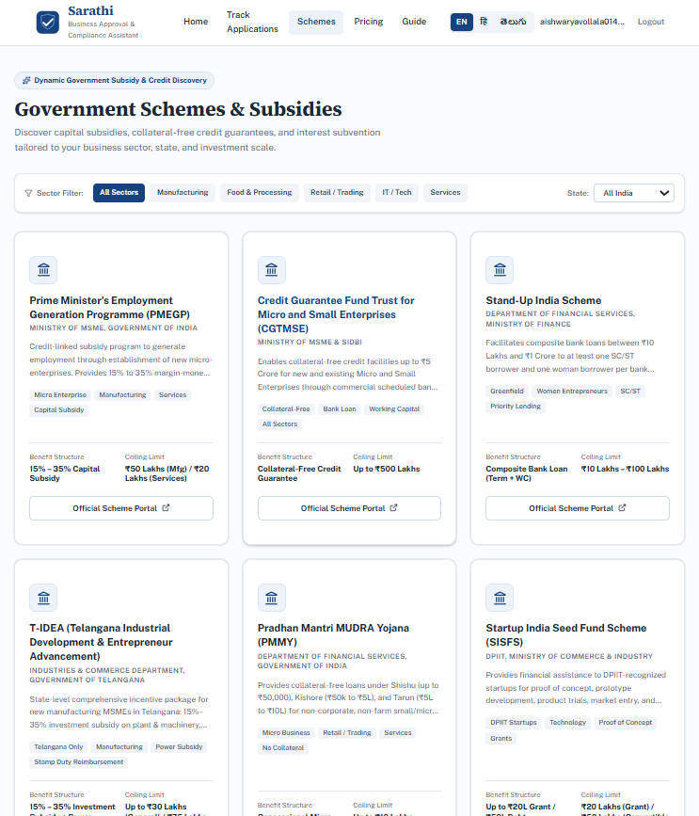
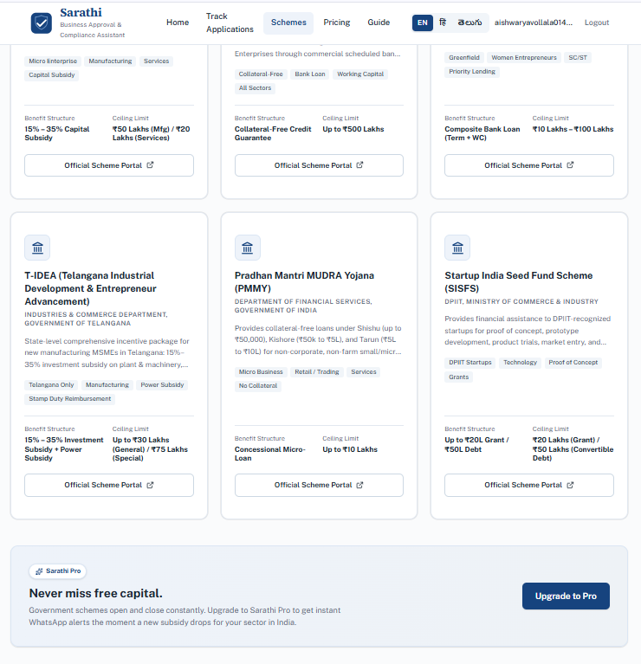
Screenshot 6: Multilingual Support
The application displayed in Hindi or Telugu, demonstrating the i18n capability.
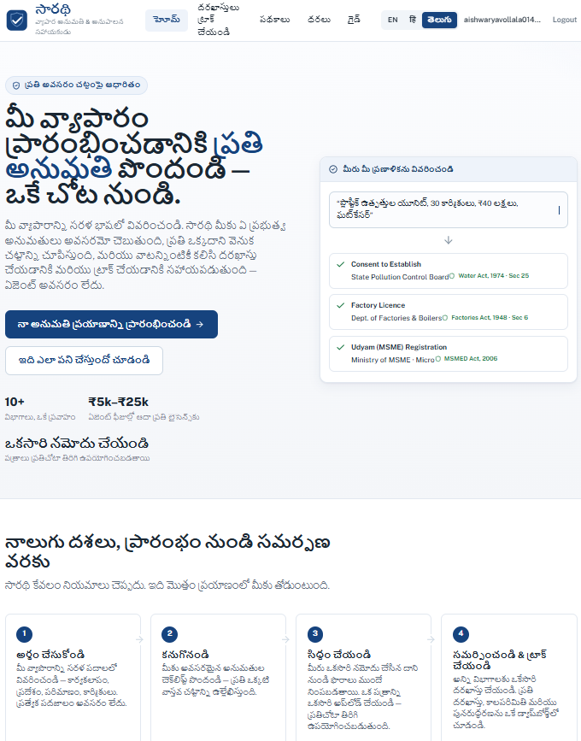
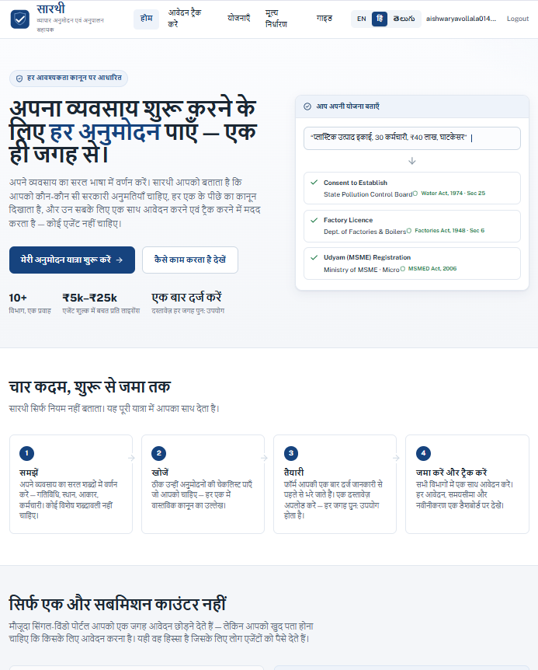

7. Future Implementation
Sarathi has a strong foundation, and the following enhancements are planned for future releases:
Pan-India State Coverage: Expand the rules engine to cover all 28 Indian states and 8 Union Territories with state-specific approval rules, authorities, and portal links. Currently optimized for Telangana and Maharashtra.
AI Chatbot Assistant: Integrate a conversational AI chatbot that can answer specific questions about individual approvals, explain legal requirements in simple language, and guide users through the application process step-by-step.
Document Generation: Auto-generate pre-filled application forms and cover letters for each approval based on the user's business profile, reducing manual paperwork.
Real-Time Status Tracking: Integration with government portal APIs (where available) to track the real-time status of submitted applications and send notifications on updates.
Cost Estimator: Provide detailed cost breakdowns for each approval including government fees, stamp duty, professional charges, and estimated total compliance cost.
Compliance Calendar: Generate a renewal and compliance calendar that reminds entrepreneurs of upcoming renewals, annual filings, and statutory deadlines.
Mobile Application: Develop native iOS and Android apps using React Native for on-the-go access to compliance checklists and status tracking.
CA/CS Professional Dashboard: A dedicated dashboard for Chartered Accountants and Company Secretaries to manage multiple client profiles and track all their compliance requirements in one place.
More Regional Languages: Expand multilingual support to cover all 22 official languages of India as listed in the Eighth Schedule of the Constitution.

8. Conclusion
Sarathi addresses a genuine and significant pain point in India's entrepreneurial ecosystem — the overwhelming complexity of regulatory compliance. By combining a deterministic rules engine with an adaptive user interface and AI-powered understanding, Sarathi transforms what was previously a weeks-long research process into a 2-minute guided experience.
The project demonstrates several important technical achievements:
- A comprehensive rules engine encoding 70+ Indian regulatory statutes into evaluable, testable conditions.
- An adaptive questionnaire that respects the user's time by only asking relevant questions.
- Three-tier applicability classification (Applicable, Potentially Applicable, Not Applicable) with clear statutory reasoning for every determination.
- Multilingual accessibility ensuring the platform reaches entrepreneurs beyond English-speaking demographics.
- AI integration that can parse unstructured business descriptions into structured compliance facts.
- Submission type guidance (Online / Physical / Both) for practical application workflow planning.

Sarathi has the potential to significantly reduce the time, cost, and uncertainty of starting a business in India. With planned expansions to cover all Indian states, integrate AI chat assistance, and provide document generation capabilities, Sarathi aims to become the definitive compliance companion for every Indian entrepreneur.

