**Importing Libraries and Setting Up Environment**

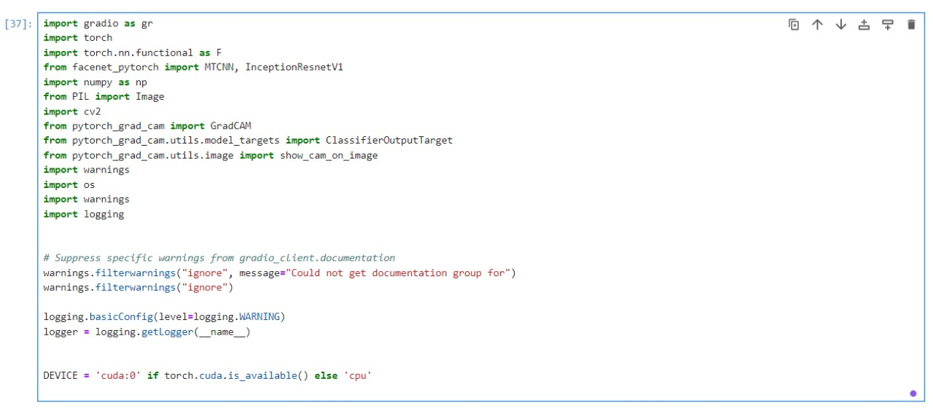

Table 6.1. Data Set

# **Loading Models**

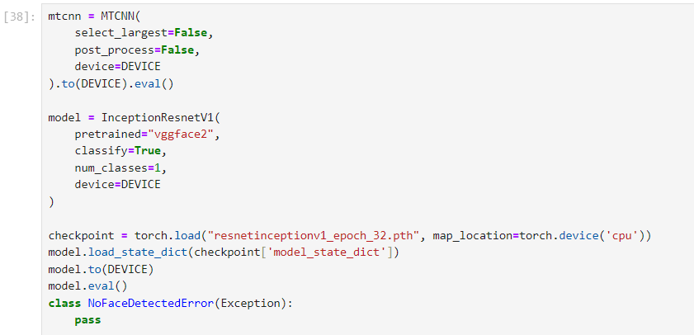

# **3.** **Predict Function for Single Image**

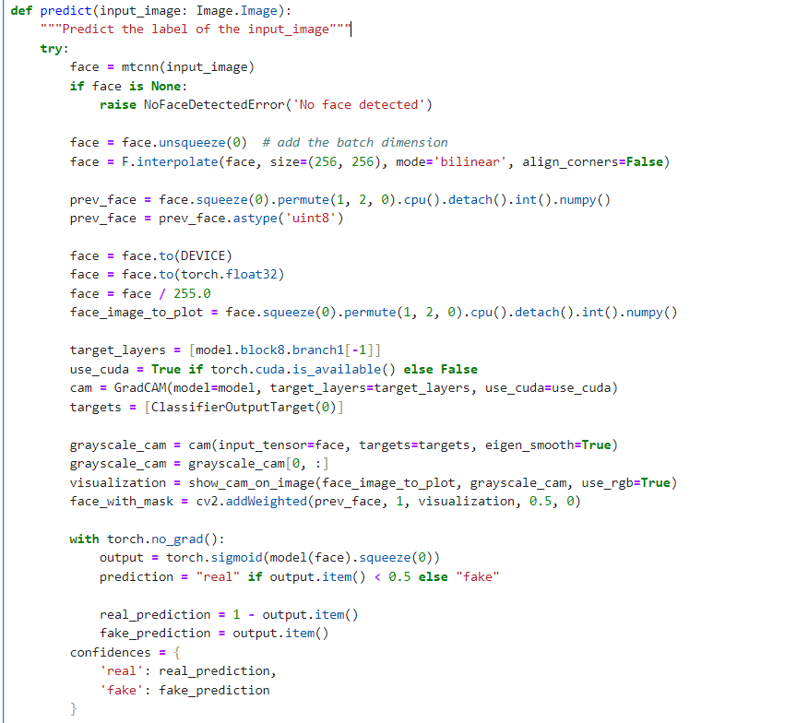

# **4.Predict Function for Batch of Images**

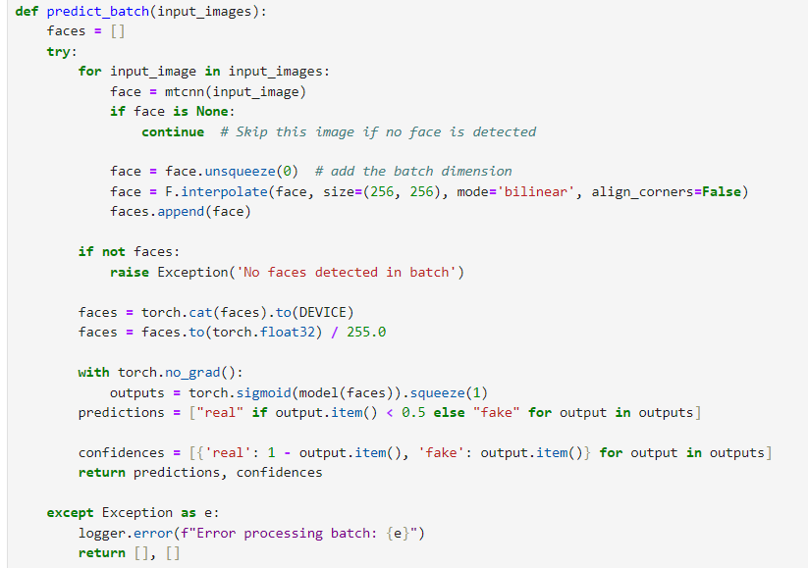

# **5.** **Extract Frames from Video**

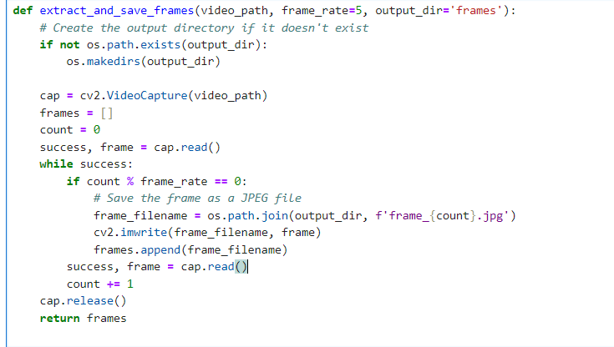

# **6.** **Classify Frames**

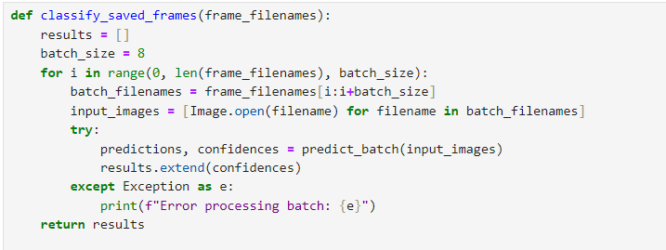

# **7.Aggregate Results**

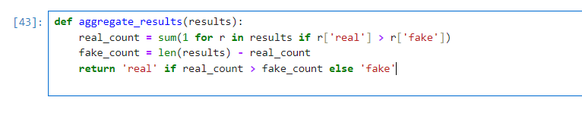

# **8. Process Video**

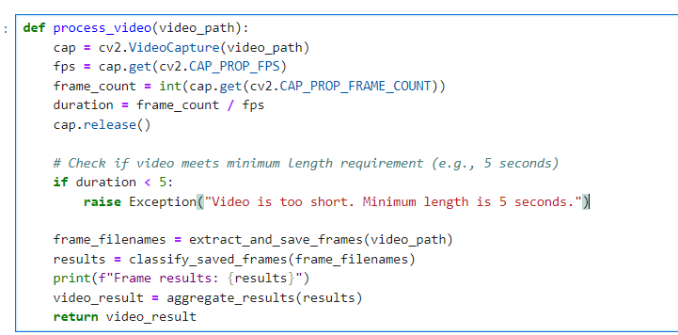

# **9. Define Gradio Interface**

