**Video 1**

Step 1: npm install truffle

Step 2: npx truffle unbox (alternative to npx truffle init. Truffle init did not generate the default files hence used unbox)

Step3: Created HelloWorld.sol and 3_helloworld_migration.js files

Step 4: npx truffle compile

Step 5: npx truffle develop

Step 6: truffle migrate

Step 7: Experimentation/Interacting with the contract

**Video 2**

**Modified the HelloWorld.sol and** 3_helloworld_migration.js files. Executed steps 4 through 6. The below are the results after interacting with the contract

**Modified HelloWorld.sol to include minimum ether checks**

Introduced Helloworld2.sol and modified 3_helloworld_migration.js accordingly. The results of interacting with the contract:

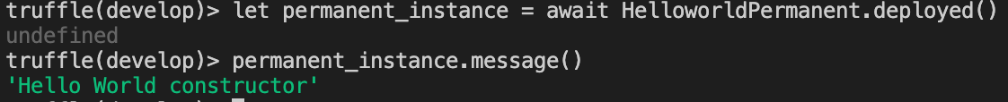

**Video 3**

**Wrote unit test cases. The below are the results**

**Failed scenario**

**Added more tests**

