Name - Aishwarya Bagul

PRN No- 240340127033

1.Creating EC2 instance

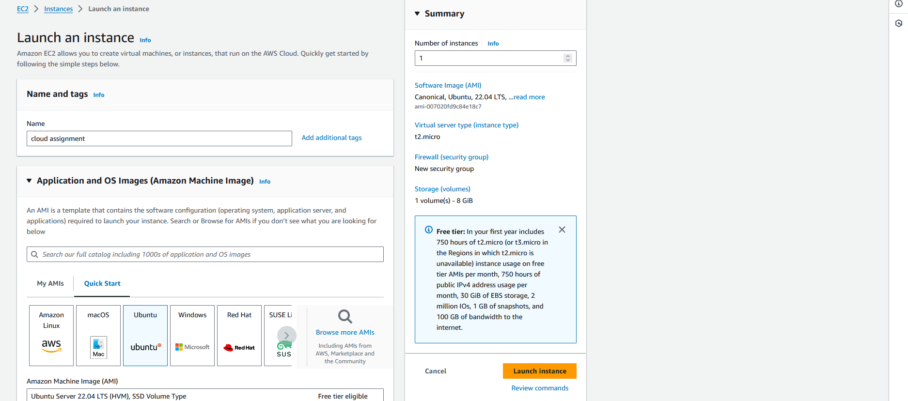

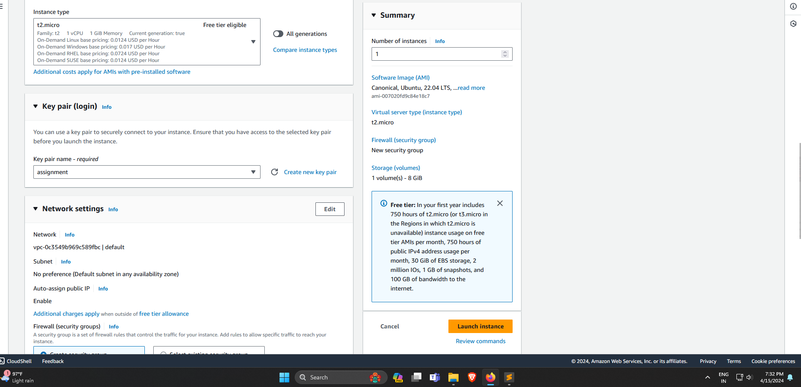

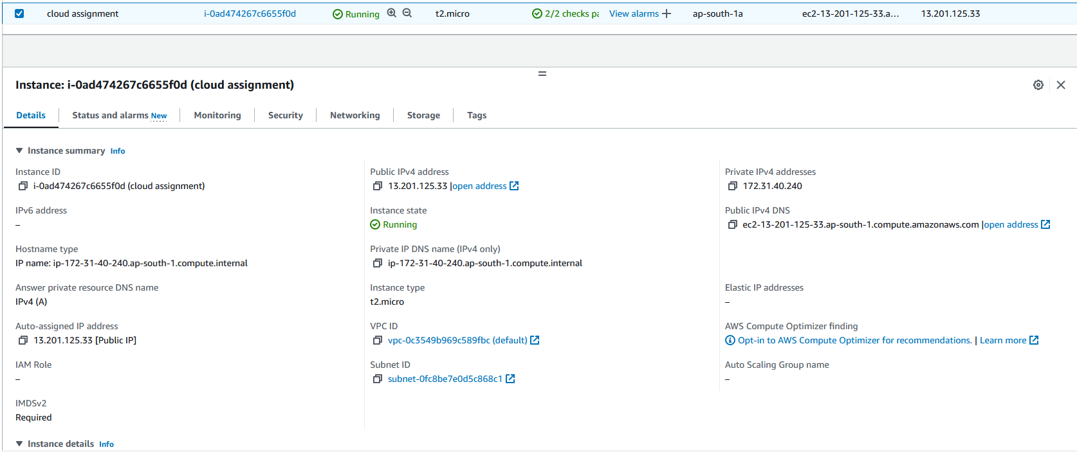

2. Installing Docker

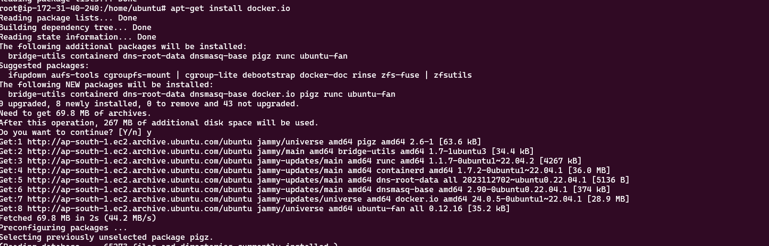

3. Status of Docker service

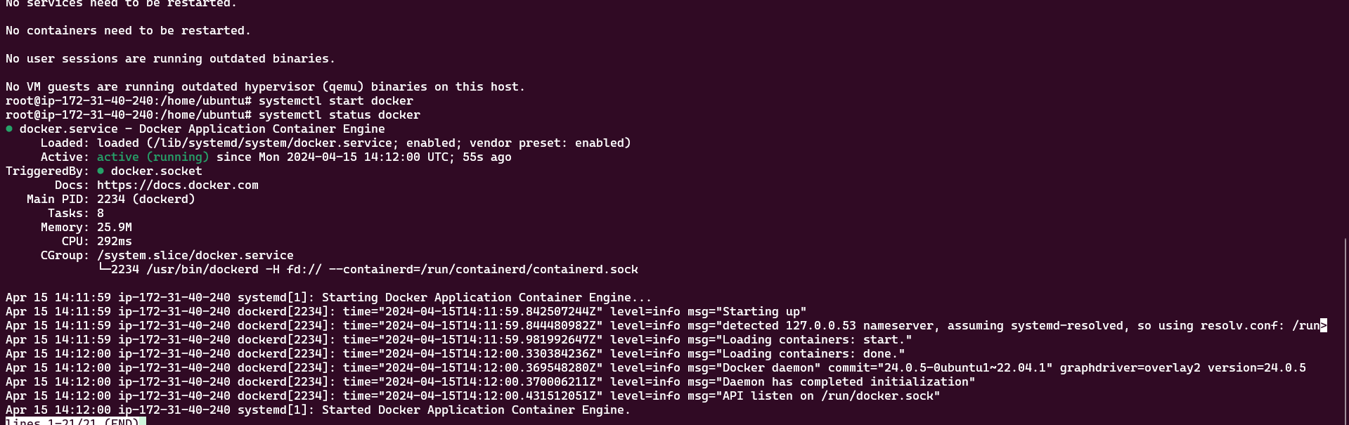

4. Creating docker container based on httpd image

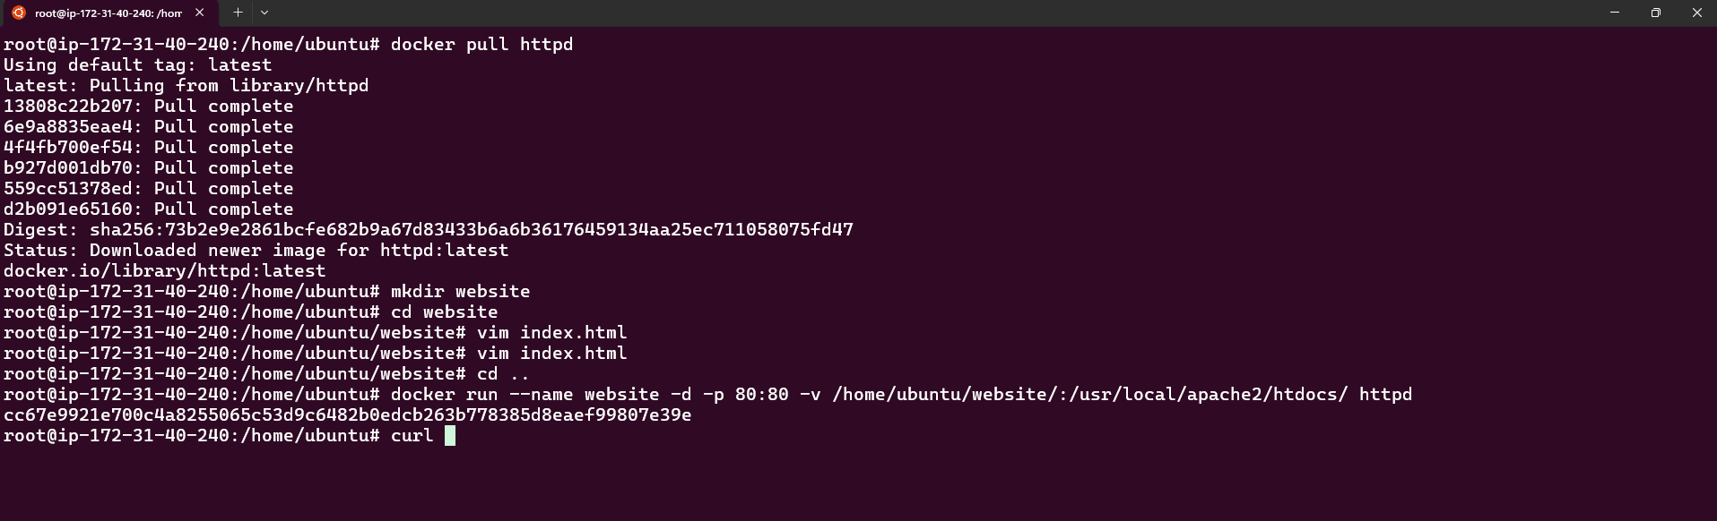

5. Accessing website hosted on EC2 instance

