# WHAT IT IS:

Our main aim was to create a reverse image search application (for which we will be providing a 2 page report).

Two kinds of the same application have been provided. One is for the administrators(Admin.java) while one is for clients(Client.java).

Both applications perform normal image search where a user can choose whether they want to download the images resulting from their search, and supports the following queries:

1. Search by Photographer
2. Search by Type
3. Search by Model
4. Search by Description

In addition to the queries mentioned above, the Admin application supports other queries such as:

1. ALTER TABLE
2. DROP TABLE
3. UPLOAD NEW PHOTO
4. SHOW TABLES
5. CREATE TABLE/ENTER CUSTOM QUERY

A lot of time and effort has been put to make a minimalistic UI that is easy to use and understand.

_____________________________________________________________________________________

# HOW TO MAKE IT WORK:

PATH TO CODE = /usa/adang/DBProject/

!!! IMPORTANT – YOU NEED TO BE CONNECTED TO THE UNIVERSITY OF DELAWARE NETWORK TO BE ABLE TO ACCESS THE DATA !!!

- - - - - - - - - Database credentials have been hardcoded into the application. - - - - - - - - -

Steps to Use Client Application:

1. Change Directory to /usa/adang/DBProject
2. Compile java file Client.java usng ‘javac Client.java’ ( without the ‘ ’ )
3. Use the following command to start the app:

java -classpath .:/usr/share/java/mysql-connector-java-5.1.28.jar Client

1. UI is self-explanatory, proceed as required.

Steps to Use Admin Application:

1. Change Directory to /usa/adang/DBProject
2. Compile java file Admin.java usng ‘javac Admin.java’ ( without the ‘ ’ )
3. Use the following command to start the app:

java -classpath .:/usr/share/java/mysql-connector-java-5.1.28.jar Admin

1. UI is self-explanatory, proceed as required.

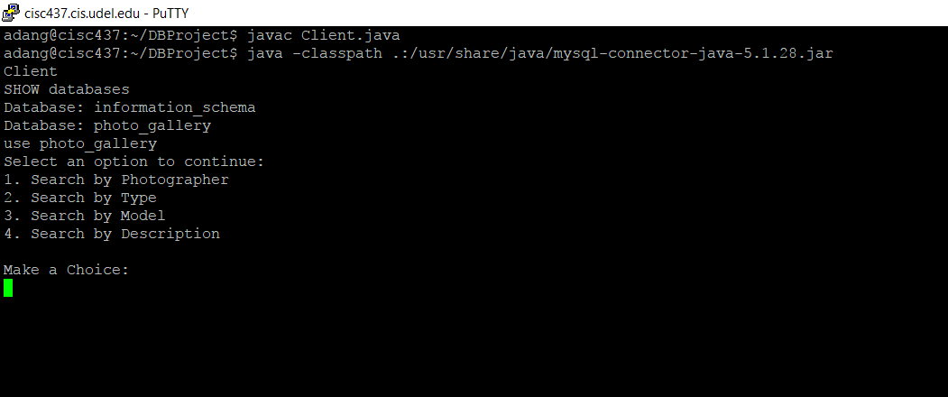 CLIENT SCREENSHOT 1

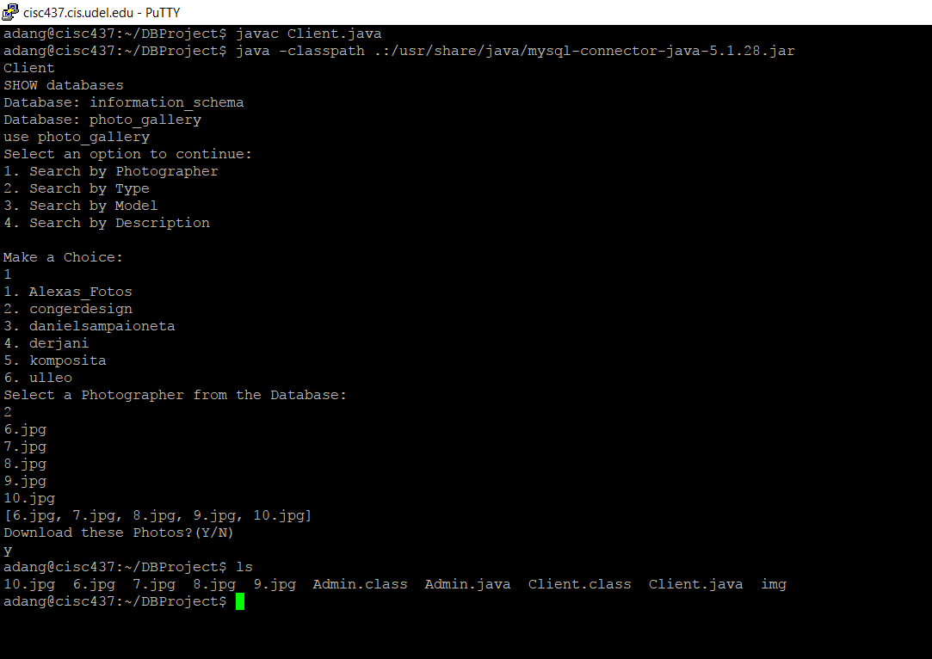 CLIENT SCREENSHOT 2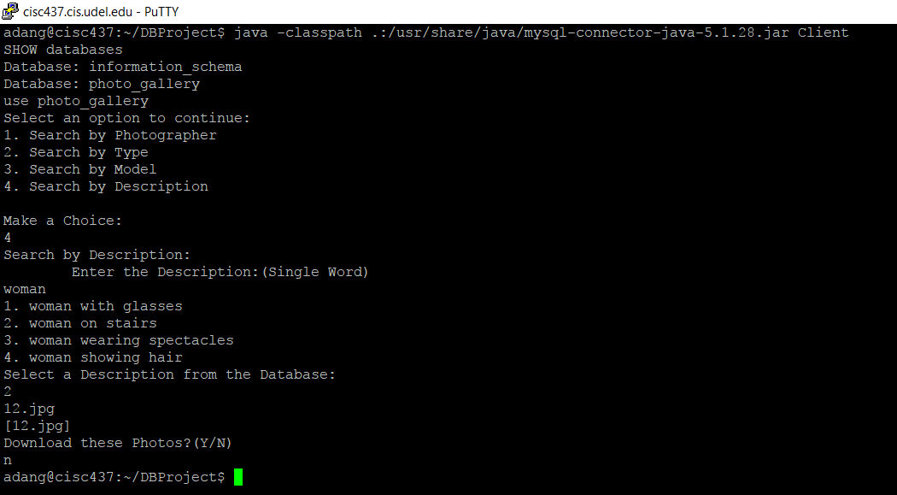 CLIENT SCREENSHOT 3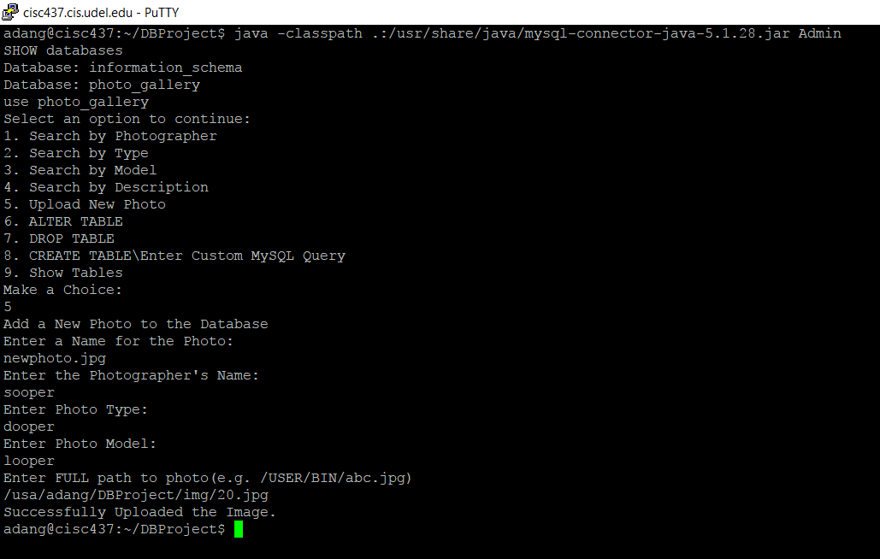 ADMIN SCREENSHOT 1