System Config/Version

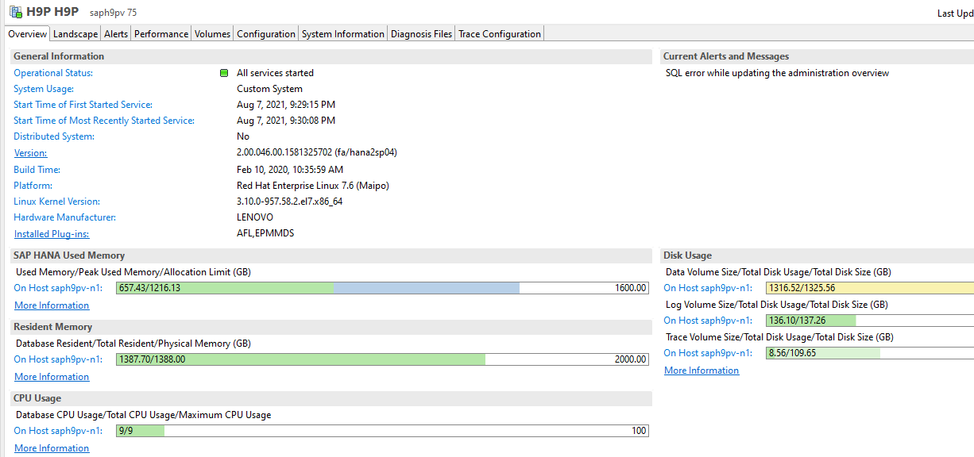

Memory manager

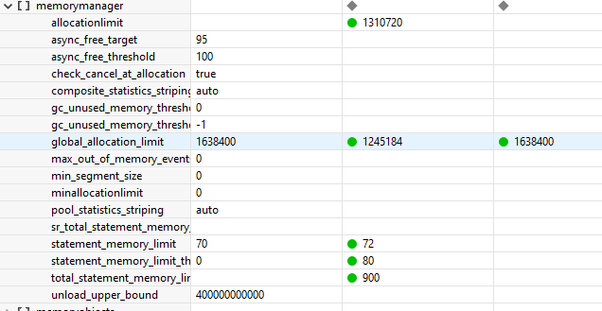SDA odbc config

SDA SQL server connect

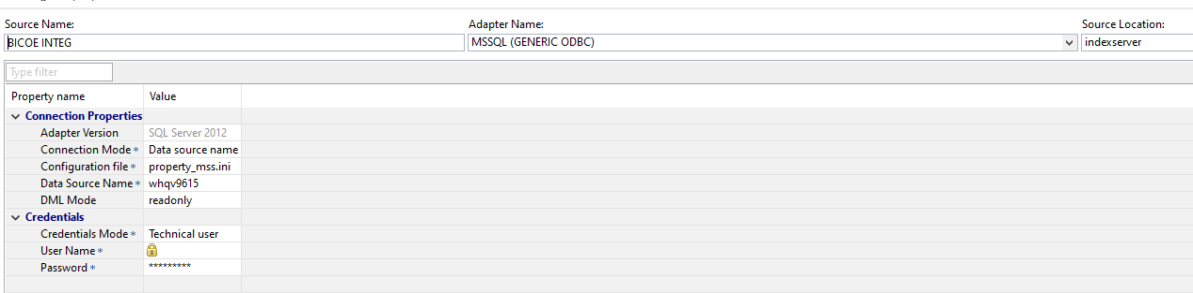

SDI ABAP Adapter

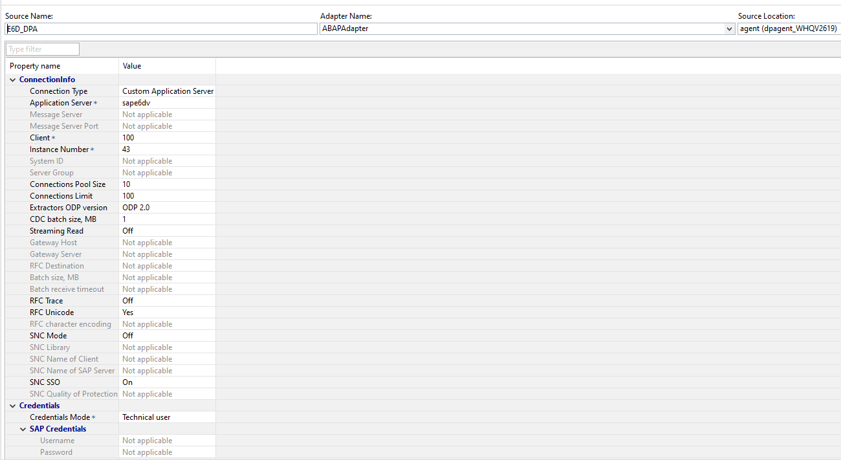

Connect to HANA sources in BW application

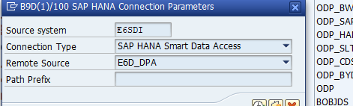

1. **UDF Multivalue input into where clause of Table function select**

FUNCTION "_SYS_BIC"."BW_CALC_VIEWS.UDF::TF_MULTIVALUE_TO_TABLE" (IP_VALUE nvarchar(9000))

RETURNS Table ("val" NVARCHAR(100))

LANGUAGE SQLSCRIPT

SQL SECURITY INVOKER

DEFAULT SCHEMA ORDER_FAILURE AS

cleantext nvarchar(9000);

items nvarchar(100) ARRAY;

pos integer;

BEGIN

cleantext := :IP_VALUE || ',';

cleantext := REPLACE(REPLACE(REPLACE(:cleantext, '(', ''), ')', ''), '''', '');

pos := 1;

WHILE LOCATE(:cleantext,',') > 0 DO

items[:pos] := RTRIM(LTRIM (SUBSTR_BEFORE(:cleantext,',')));

cleantext := SUBSTR_AFTER(:cleantext,',');

pos := :pos + 1;

END WHILE;

rst = UNNEST(:items) AS ("val");

return SELECT * FROM :rst;

END;

1. **UDF for multivalue input param as placeholder in select of a table function**

FUNCTION "_SYS_BIC"."BW_CALC_VIEWS.UDF::Z_TF_MULTIVALUE_INPUT_PARAMETER" (IP_VALUE nvarchar(5000))

--, delimiter nvarchar(15))

RETURNS Table(

I_LIST_STR NVARCHAR(5000))

LANGUAGE SQLSCRIPT

SQL SECURITY INVOKER AS

BEGIN

/*****************************

Write your function logic

*****************************/

DECLARE cnt int;

DECLARE temp_input nvarchar(5000);

DECLARE slice NVARCHAR(100) ARRAY;

DECLARE delimiter nvarchar(15);

temp_input = :IP_VALUE;

delimiter = ',';

cnt = 1;

WHILE length(temp_input) > 0 DO

if instr(temp_input, delimiter) > 0 then

slice[:cnt] = substr_before(temp_input,delimiter);

temp_input = substr_after(temp_input,delimiter);

cnt = :cnt + 1;

else

slice[:cnt] = temp_input;

break;

end if;

END WHILE;

tab2 = UNNEST(:slice) AS (I_LIST);

return

--select I_LIST from :tab2;

SELECT STRING_AGG(I_LIST,',') AS I_LIST_STR

FROM :tab2;

END;

Keep flag example

Rank and partition example

Union pivot Graphic example

SQL server SDA connection scenario

Flow graph

Task monitor – Replication and flowgraph tasks

Odata

Odata sample url for test

Odata XSJS input to table scenario

Sample scripts



