**Graph & figures**

1. **Tree.png**

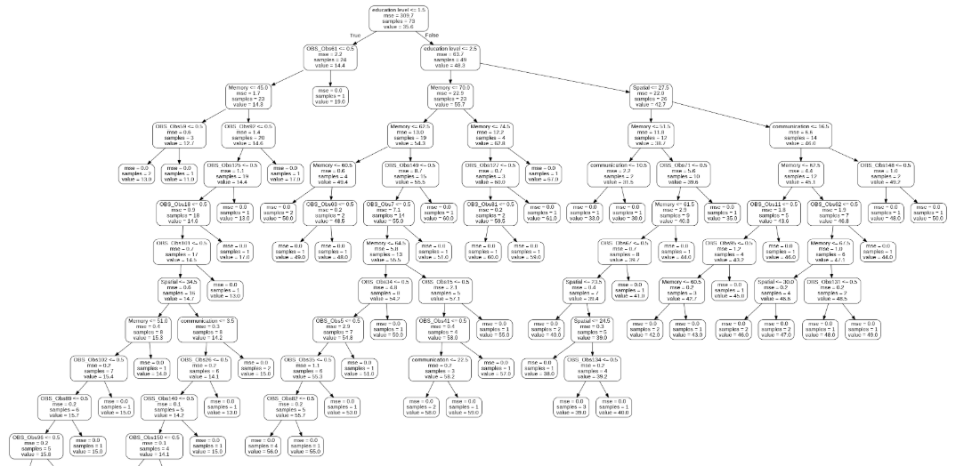

1. **Short_tree.png**

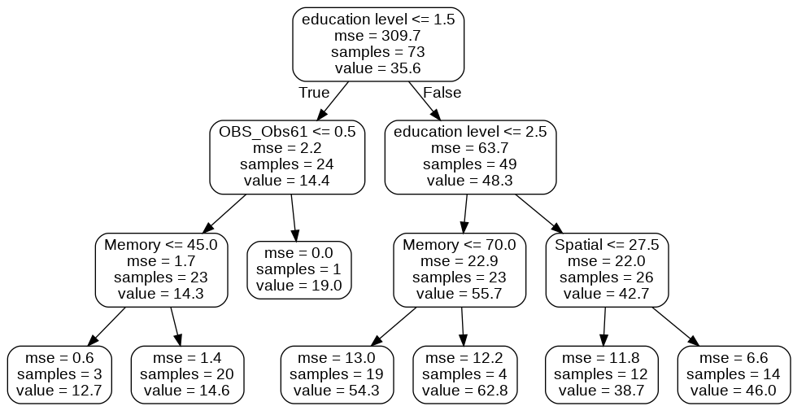

1. **GRAPH**

