**CODE**

**In[ ]**

# Pandas is used for data manipulation

**import pandas as pd**

# Read in data as pandas dataframe and display first 5 rows

features = pd.read_csv('Manova.csv')

features.head(5)

Out[]

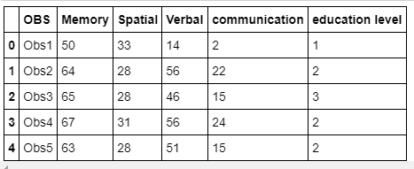

**In [ ]:**

print('The shape of our features is:', features.shape)

**Out[ ]**

The shape of our features is: (150, 6)

**In [ ]:**

features = pd.get_dummies(features)

features.head(5)

**Out[ ]:**

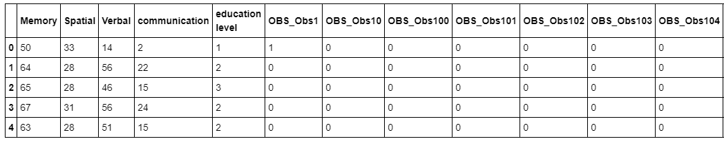

155 columns

**In [ ]:**

print('Shape of features after one-hot encoding:', features.shape)

**Out[ ]**

Shape of features after one-hot encoding: (150, 155)

**In[ ]**

# Use numpy to convert to arrays

**import** **numpy** **as** **np**

# Labels are the values we want to predict

labels = np.array(features['Verbal'])

# Remove the labels from the features

# axis 1 refers to the columns

features= features.drop('Verbal', axis = 1)

# Saving feature names for later use

feature_list = list(features.columns)

# Convert to numpy array

features = np.array(features)

**In [ ]:**

# Using Skicit-learn to split data into training and testing sets

**from** **sklearn.model_selection** **import** train_test_split

# Split the data into training and testing sets

train_features, test_features, train_labels, test_labels = train_test_split(features, labels, test_size = 0.25,random_state = 42)

**In [ ]:**

print('Training Features Shape:', train_features.shape)

print('Training Labels Shape:', train_labels.shape)

print('Testing Features Shape:', test_features.shape)

print('Testing Labels Shape:', test_labels.shape)

**Out[ ]**

Training Features Shape: (112, 154)

Training Labels Shape: (112,)

Testing Features Shape: (38, 154)

Testing Labels Shape: (38,)

**In [ ]:**

# Import the model we are using

**from** **sklearn.ensemble** **import** RandomForestRegressor

# Instantiate model

rf = RandomForestRegressor(n_estimators= 1000, random_state=42)

# Train the model on training data

rf.fit(train_features, train_labels);

**In [ ]:**

rf_new = RandomForestRegressor(n_estimators = 100, criterion = 'mse', max_depth = **None**,

min_samples_split = 2, min_samples_leaf = 1)

**In [ ]:**

# Use the forest's predict method on the test data

predictions = rf.predict(test_features)

# Calculate the absolute errors

errors = abs(predictions - test_labels)

# Print out the mean absolute error (mae)

print('Mean Absolute Error:', round(np.mean(errors), 2), 'degrees.')

**Out[ ]**

Mean Absolute Error: 2.34 degrees.

**In [ ]:**

# Calculate mean absolute percentage error (MAPE)

mape = 100 * (errors / test_labels)

# Calculate and display accuracy

accuracy = 100 - np.mean(mape)

print('Accuracy:', round(accuracy, 2), '%.')

**Out[ ]**

Accuracy: 93.25 %.

**In [ ]:**

# Import tools needed for visualization

**from** **sklearn.tree** **import** export_graphviz

**import** **pydot**

# Pull out one tree from the forest

tree = rf.estimators_[5]

# Export the image to a dot file

export_graphviz(tree, out_file = 'tree.dot', feature_names = feature_list, rounded = **True**, precision = 1)

# Use dot file to create a graph

(graph, ) = pydot.graph_from_dot_file('tree.dot')

# Write graph to a png file

graph.write_png('tree.png');

**In [ ]:**

print('The depth of this tree is:', tree.tree_.max_depth)

**Out[ ]**

The depth of this tree is: 12

**In [ ]:**

# Limit depth of tree to 2 levels

rf_small = RandomForestRegressor(n_estimators=10, max_depth = 3, random_state=42)

rf_small.fit(train_features, train_labels)

# Extract the small tree

tree_small = rf_small.estimators_[5]

# Save the tree as a png image

export_graphviz(tree_small, out_file = 'small_tree.dot', feature_names = feature_list, rounded = **True**, precision = 1)

(graph, ) = pydot.graph_from_dot_file('small_tree.dot')

graph.write_png('small_tree.png')

**In [ ]:**

# Get numerical feature importances

importances = list(rf.feature_importances_)

# List of tuples with variable and importance

feature_importances = [(feature, round(importance, 2)) **for** feature, importance **in** zip(feature_list, importances)]

# Sort the feature importances by most important first

feature_importances = sorted(feature_importances, key = **lambda** x: x[1], reverse = **True**)

# Print out the feature and importances

[print('Variable: **{:20}** Importance: **{}**'.format(*pair)) **for** pair **in** feature_importances];

**In [ ]:**

# New random forest with only the two most important variables

rf_most_important = RandomForestRegressor(n_estimators= 1000, random_state=42)

# Extract the two most important features

important_indices = [feature_list.index('Spatial'), feature_list.index('Memory')]

train_important = train_features[:, important_indices]

test_important = test_features[:, important_indices]

# Train the random forest

rf_most_important.fit(train_important, train_labels)

# Make predictions and determine the error

predictions = rf_most_important.predict(test_important)

errors = abs(predictions - test_labels)

# Display the performance metrics

print('Mean Absolute Error:', round(np.mean(errors), 2), 'degrees.')

mape = np.mean(100 * (errors / test_labels))

accuracy = 100 - mape

print('Accuracy:', round(accuracy, 2), '%.')

**Out[ ]**

Mean Absolute Error: 3.67 degrees.

Accuracy: 90.47 %.

**In [ ]:**

**from** **IPython.display** **import** Image

Image('tree.png')

**In [ ]:**

**from** **IPython.display** **import** Image

Image('small_tree.png')

**In [ ]:**

**import** **matplotlib.pyplot** **as** **plt**

%matplotlib inline

# Set the style

plt.style.use('fivethirtyeight')

# list of x locations for plotting

x_values = list(range(len(importances)))

# Make a bar chart

plt.bar(x_values, importances, orientation = 'vertical')

# Tick labels for x axis

plt.xticks(x_values, feature_list, rotation='vertical')

# Axis labels and title

plt.ylabel('Importance'); plt.xlabel('Variable'); plt.title('Variable Importances');