**1) Visualize the daily temperature changes over time in a city and give your conclusion[Input: days = list(range(1, 32)) ]# Daily temperature data (replace with your own data) [temperature = [65, 68, 70, 72, 75, 76, 78, 80, 81, 79, 75, 72, 70, 68, 67, 69, 70, 73, 75, 76, 78, 80, 81, 82, 83, 82, 80, 78, 76, 74, 71]]**

import matplotlib.pyplot as plt

days = list(range(1, 32))

temperature = [65, 68, 70, 72, 75, 76, 78, 80, 81, 79, 75, 72, 70, 68, 67, 69, 70, 73, 75, 76, 78, 80, 81, 82, 83, 82, 80, 78, 76, 74, 71]

plt.figure(figsize=(10, 5))

plt.plot(days, temperature, marker='o', color='b')

plt.title('Daily Temperature Changes')

plt.xlabel('Day of the Month')

plt.ylabel('Temperature (Fahrenheit)')

plt.grid(True)

plt.show()

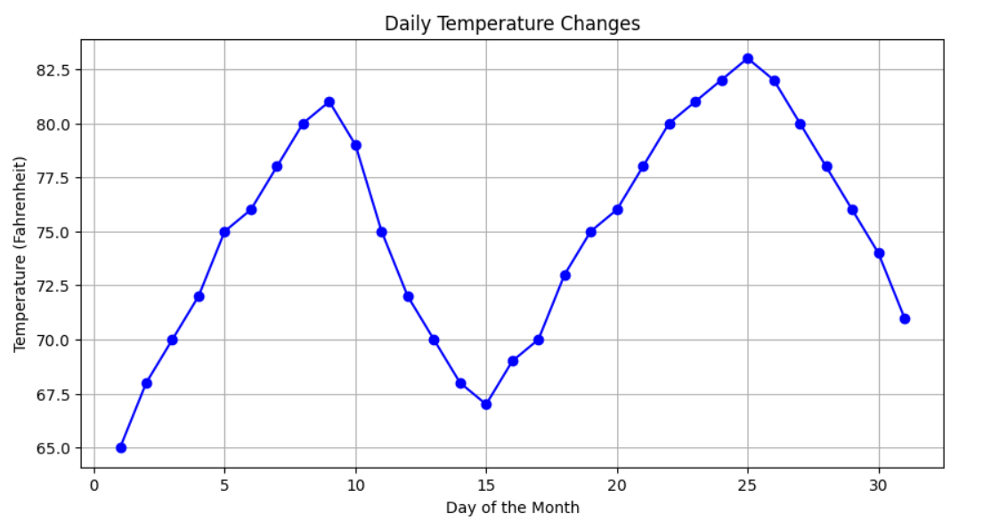

**2) Create a line plot to visualize the daily closing prices of a stock over a year and give your conclusion.**

**Input: days = list(range(1, 78))**

**# Daily closing prices of a stock (replace with your own data)**

**stock_prices = [100, 105, 110, 115, 112, 120, 118, 125, 128, 130, 132, 135, 138, 140, 142, 144, 145, 148, 150, 155, 160, 158, 162, 165, 170, 172, 175, 178, 180, 182, 185, 188, 190, 192, 195, 198,200, 198, 195, 193, 190, 188, 185, 182, 180, 178, 175, 172, 170, 168, 165, 162, 160, 158, 155, 152, 150, 148, 145, 143, 140, 138, 135, 132, 130, 128, 125, 123, 120, 118, 115, 112, 110, 108, 105, 103, 100]**

import matplotlib.pyplot as plt

days = list(range(1, 78))

stock_prices = [100, 105, 110, 115, 112, 120, 118, 125, 128, 130, 132, 135, 138, 140, 142, 144, 145, 148, 150, 155, 160, 158, 162, 165, 170, 172, 175, 178, 180, 182, 185, 188, 190, 192, 195, 198, 200, 198, 195, 193, 190, 188, 185, 182, 180, 178, 175, 172, 170, 168, 165, 162, 160, 158, 155, 152, 150, 148, 145, 143, 140, 138, 135, 132, 130, 128, 125, 123, 120, 118, 115, 112, 110, 108, 105, 103, 100]

plt.figure(figsize=(12, 6))

plt.plot(days, stock_prices, marker='o', color='b')

plt.title('Daily Closing Prices of a Stock Over a Year')

plt.xlabel('Day')

plt.ylabel('Stock Price (USD)')

plt.grid(True)

plt.show()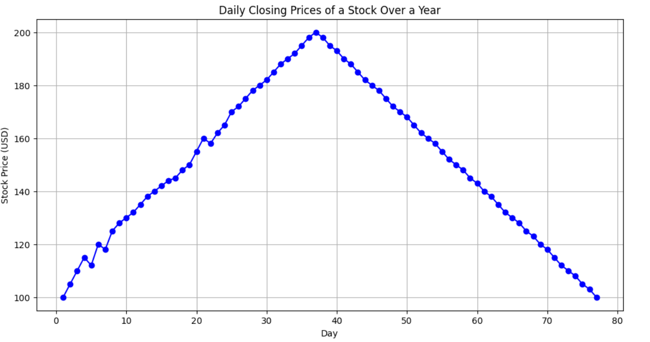

**3)Create a bar chart to represent monthly expenses in different spending categories and give your conclusion. Input: categories = ['Rent', 'Groceries', 'Utilities', 'Entertainment', 'Transportation'] # Monthly expenses in dollars (replace with your own data) expenses = [1200, 400, 200, 150, 250]**

import matplotlib.pyplot as plt

categories = ['Rent', 'Groceries', 'Utilities', 'Entertainment', 'Transportation']

expenses = [1200, 400, 200, 150, 250]

plt.bar(categories, expenses, color='skyblue')

plt.title('Monthly Expenses in Different Categories')

plt.xlabel('Categories')

plt.ylabel('Expenses (USD)')

plt.show()

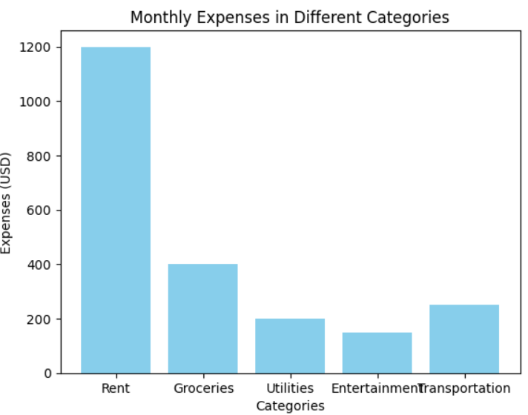

**4)Create a histogram to represent the distribution of product prices in a retail store and give your conclusion.Input: product_prices = [24.99, 34.99, 49.99, 64.99, 39.99, 54.99, 79.99, 99.99, 29.99, 44.99, 59.99, 69.99, 84.99, 109.99, 119.99, 89.99, 74.99, 124.99, 69.99, 54.99]**

import matplotlib.pyplot as plt

product_prices = [24.99, 34.99, 49.99, 64.99, 39.99, 54.99, 79.99, 99.99, 29.99, 44.99, 59.99, 69.99, 84.99, 109.99, 119.99, 89.99, 74.99, 124.99, 69.99, 54.99]

plt.hist(product_prices, bins=5, color='skyblue', edgecolor='black', alpha=0.7)

plt.title('Distribution of Product Prices')

plt.xlabel('Price Range',fontsize=16)

plt.ylabel('Frequency')

plt.show()

