UNIT-TESTING
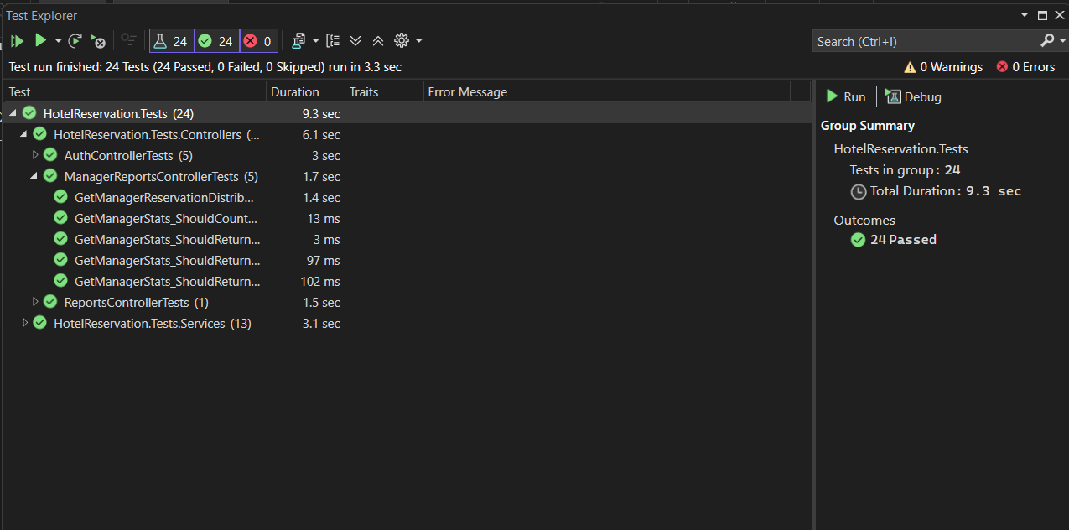
Authenticated user login(manager)
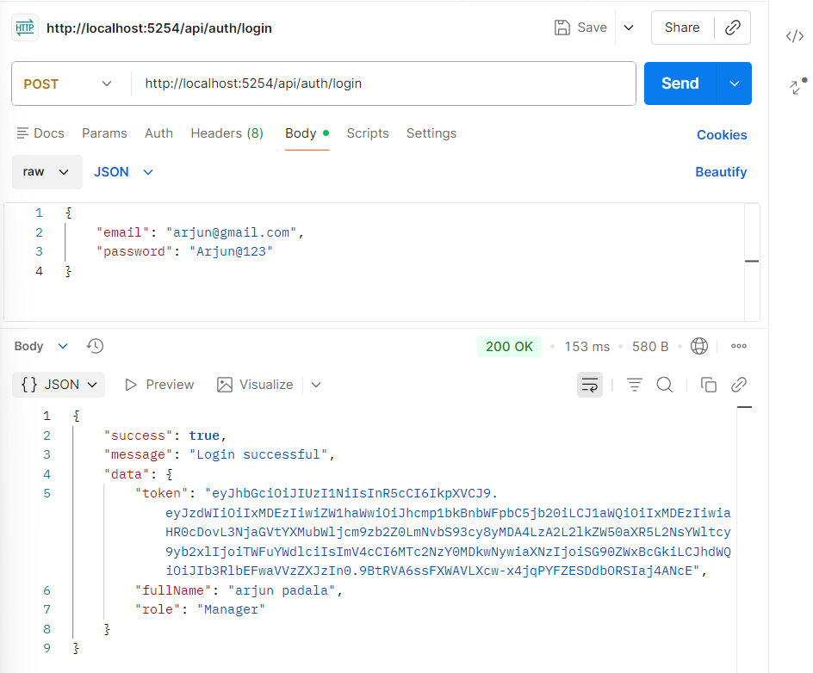
Authenticated user login(guest)

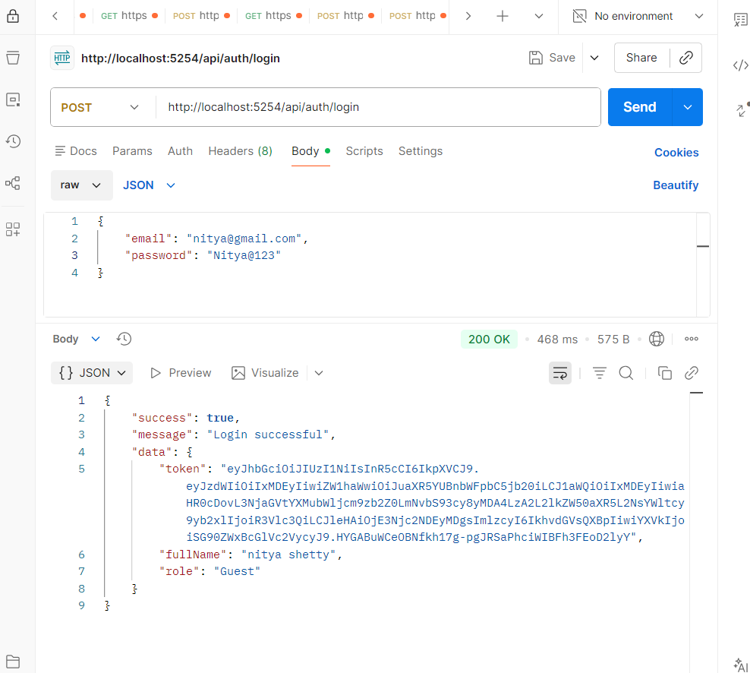
Guest registration
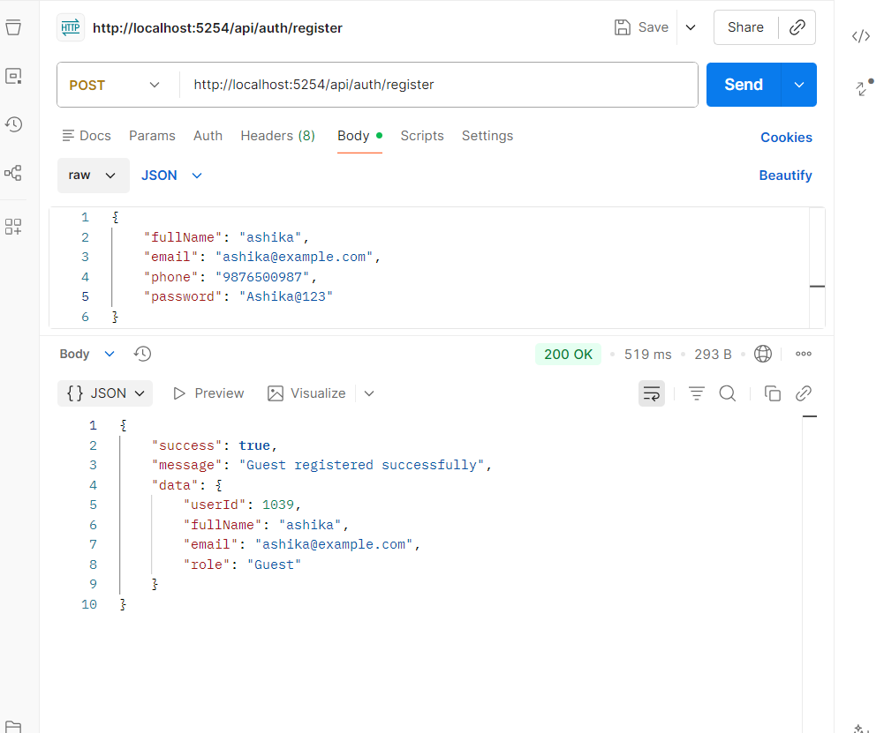

Profile edit on self
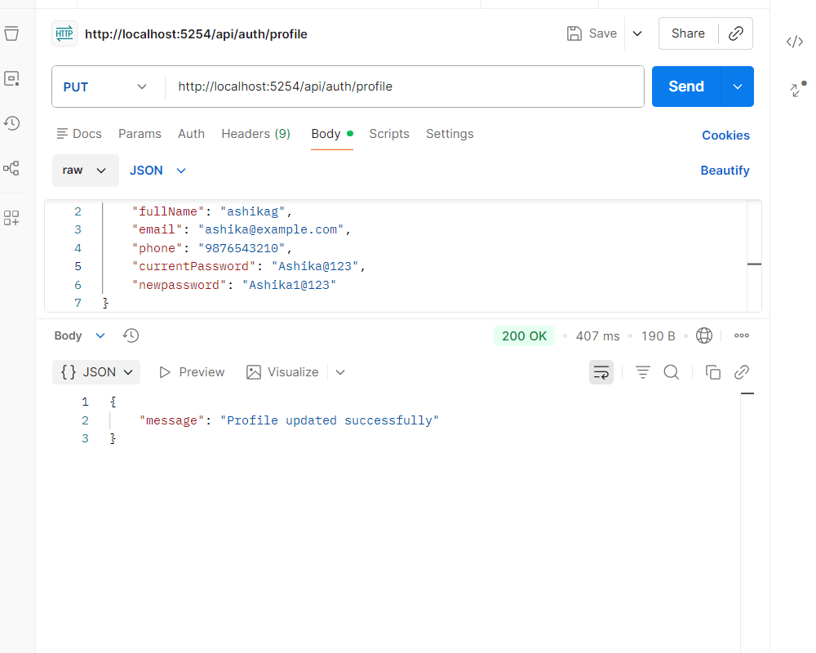

Admin login (using seeded data)
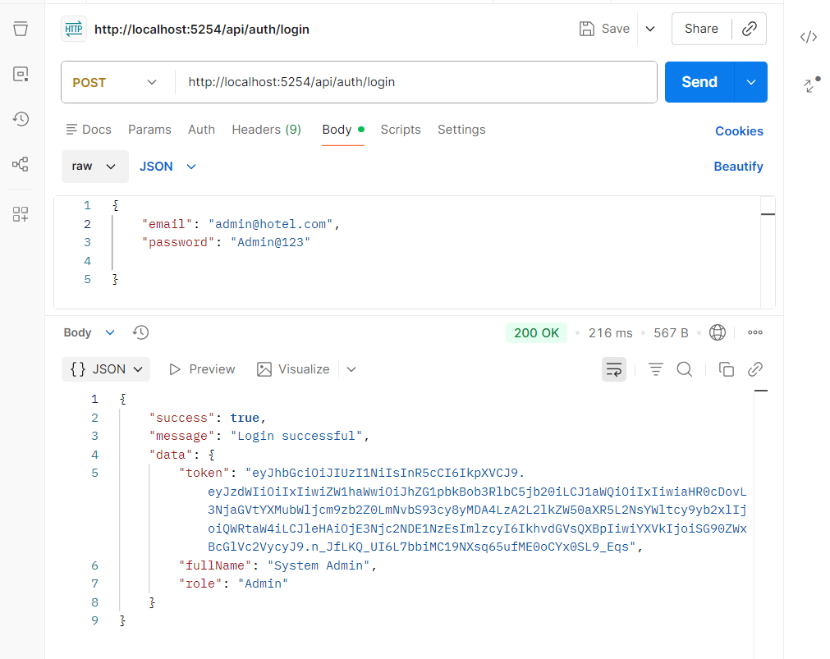
Get hotels by id(any authenticated user)

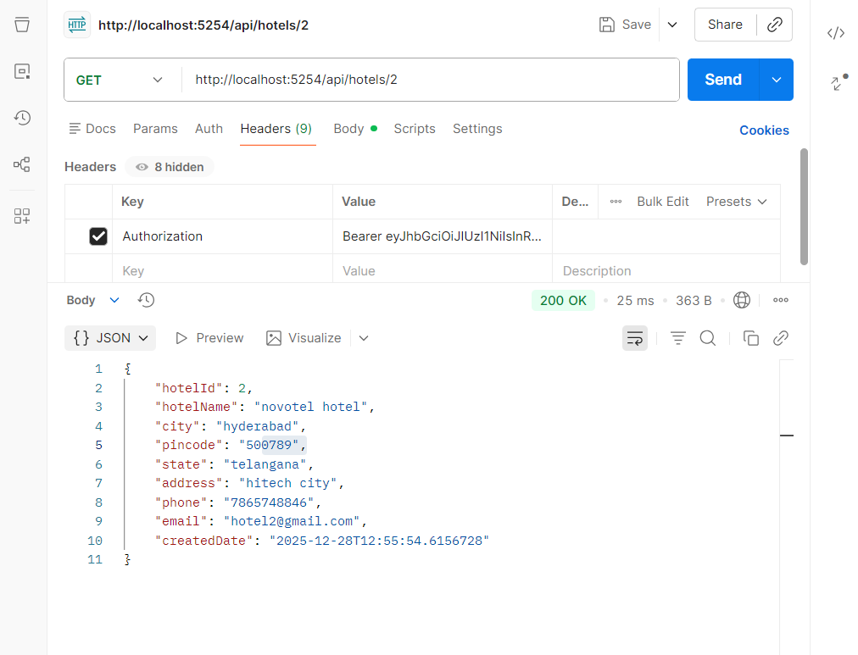
Creating new hotel(by admin only)
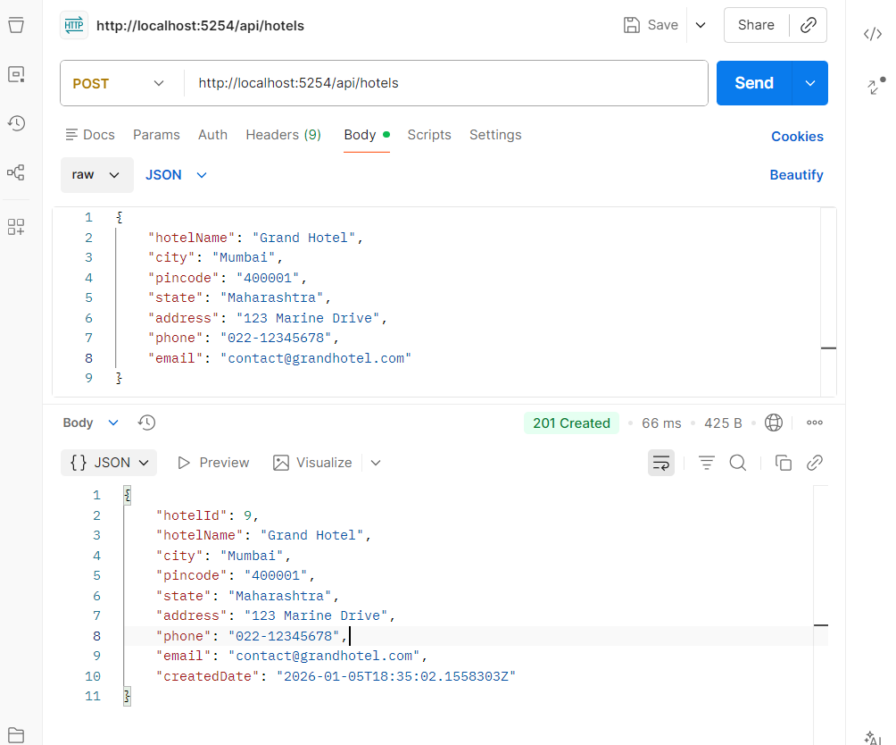

Update hotel (by admin only)

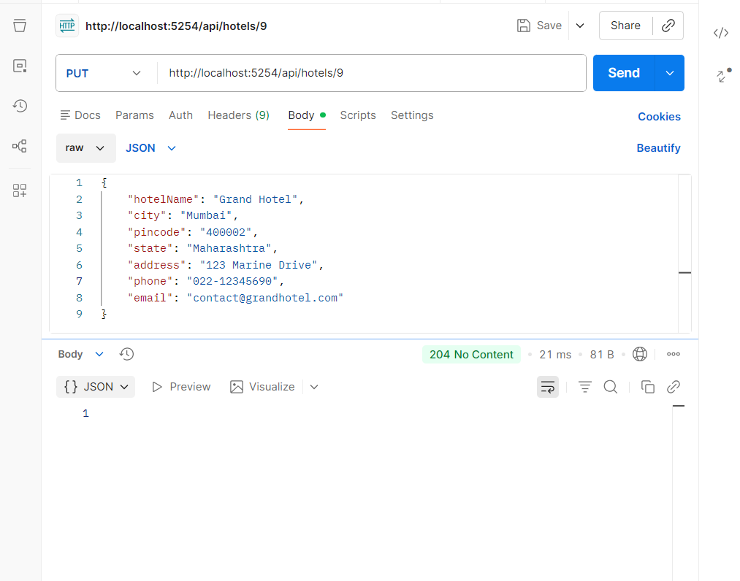
Deleting a hotel (by admin only)
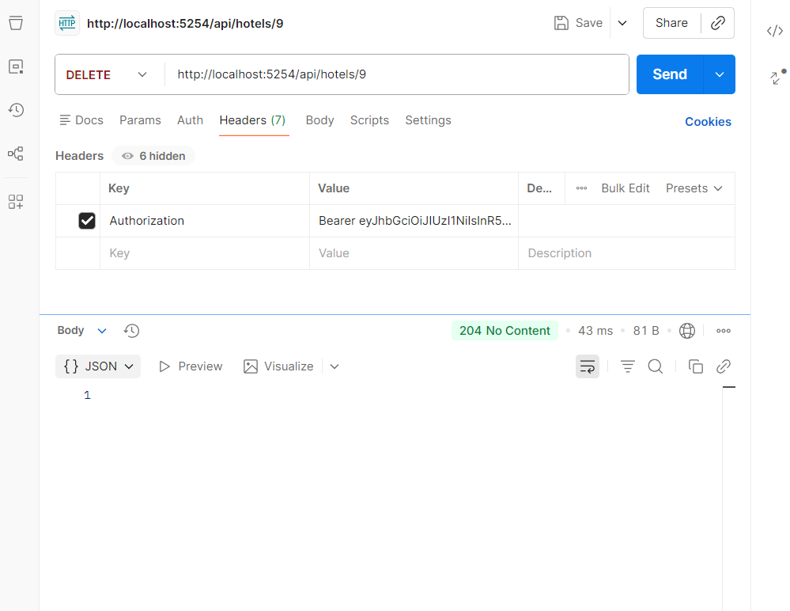
Getting all room types(any authenticated user)

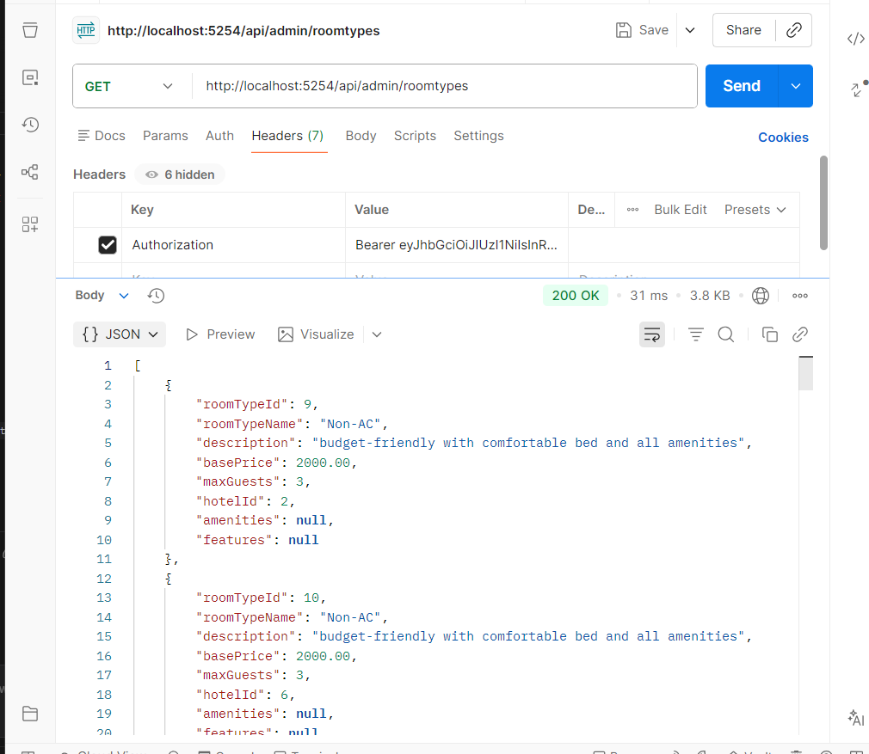
Creating new roomtype (by admin only)

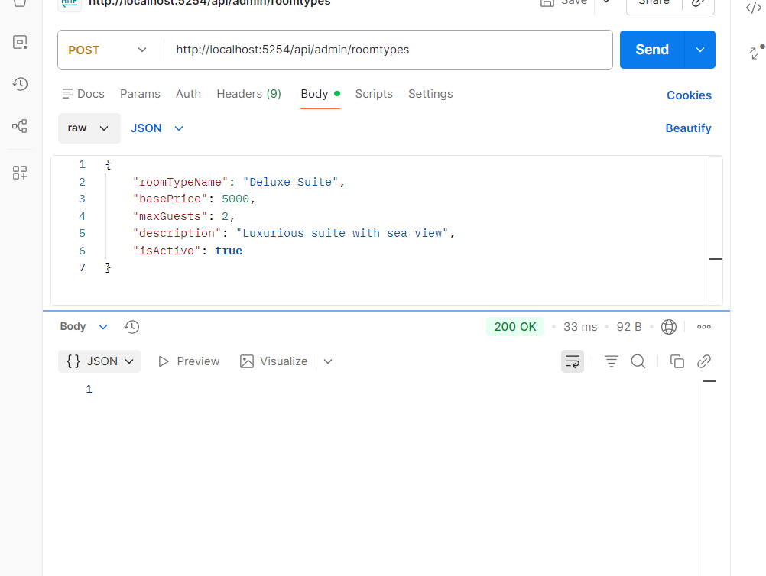

Get rooms of all hotels(authenticated user)
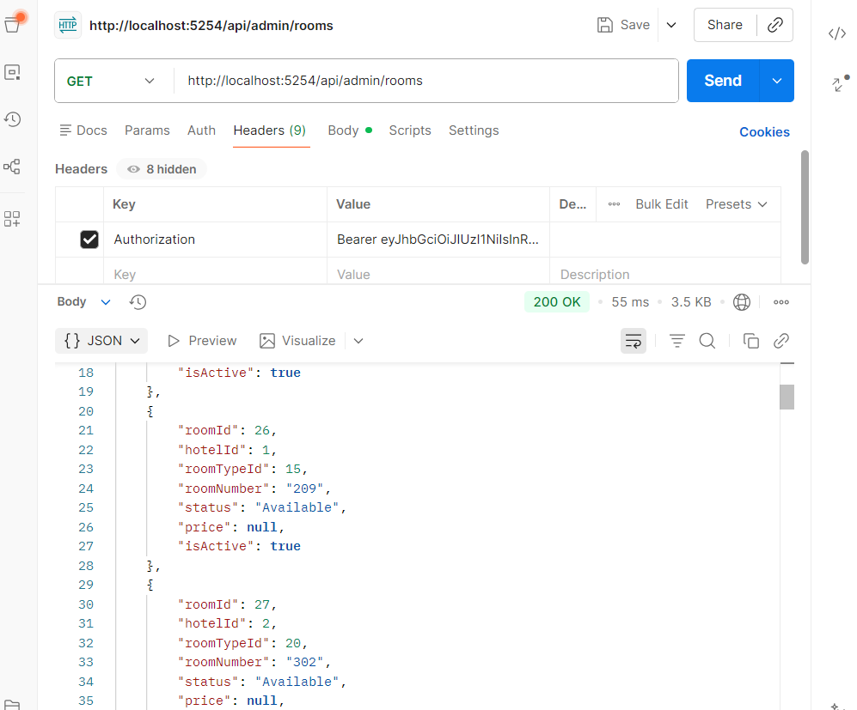
Get rooms of hotel assigned to that manager(authenticated manager)

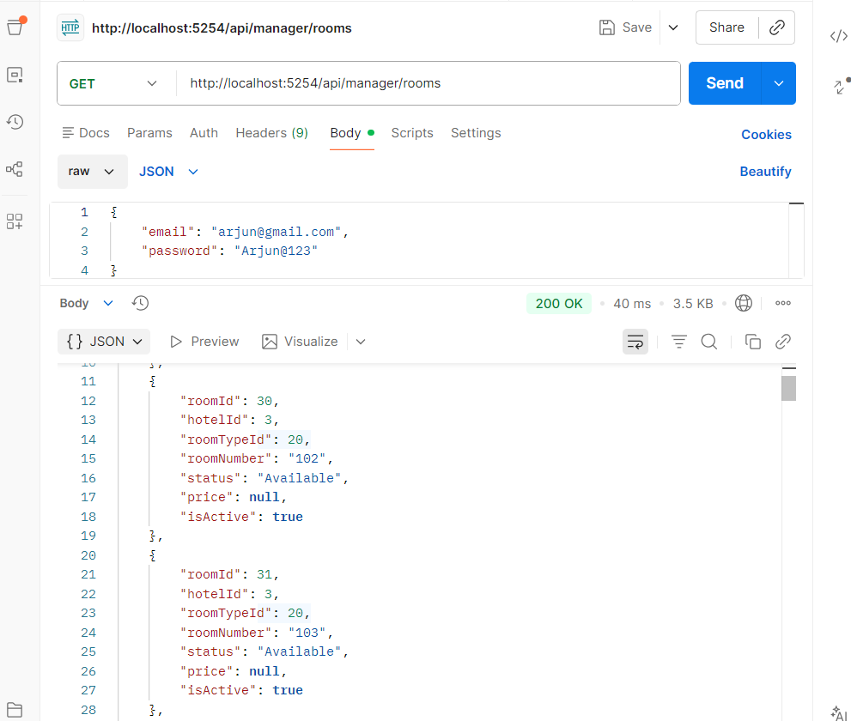

Get room by id for the hotel assigned to that manager(authenticated manager)
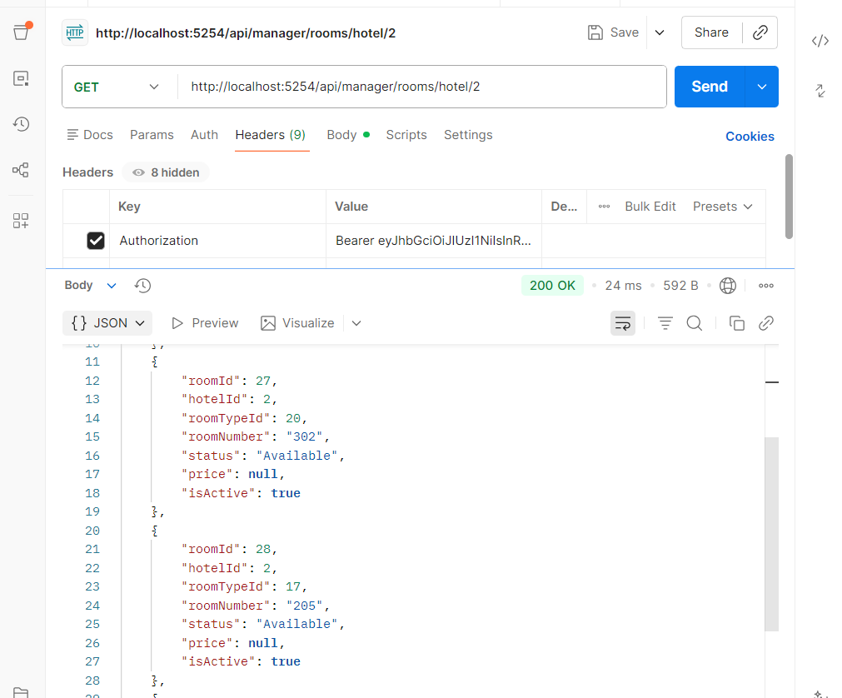
Add rooms for the hotel assigned to that manager(authenticated manager)

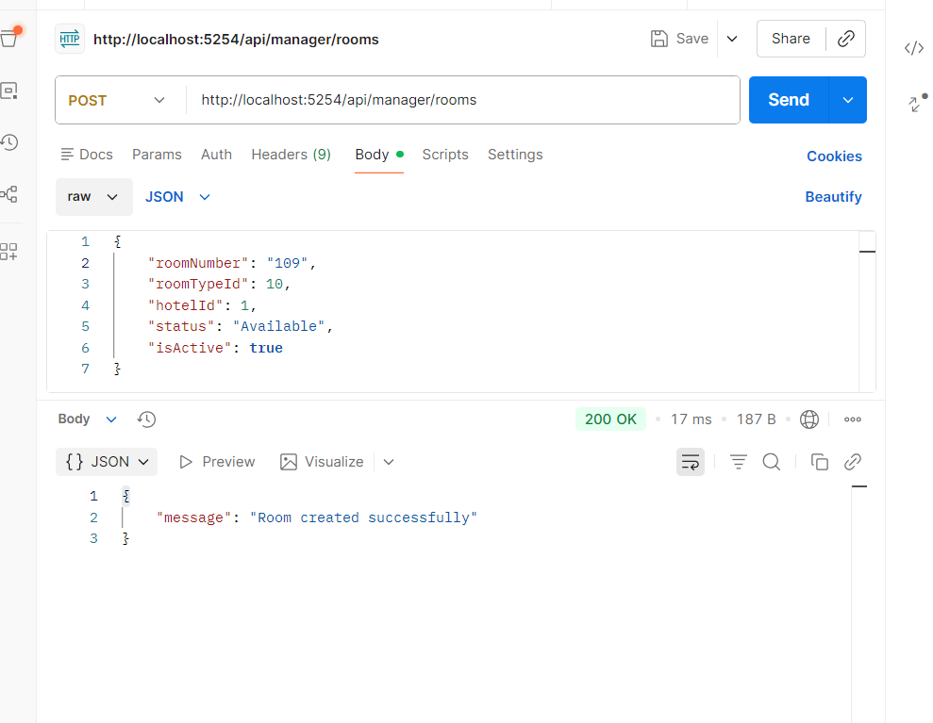
Update room by id for the hotel assigned to that manager(authenticated manager)

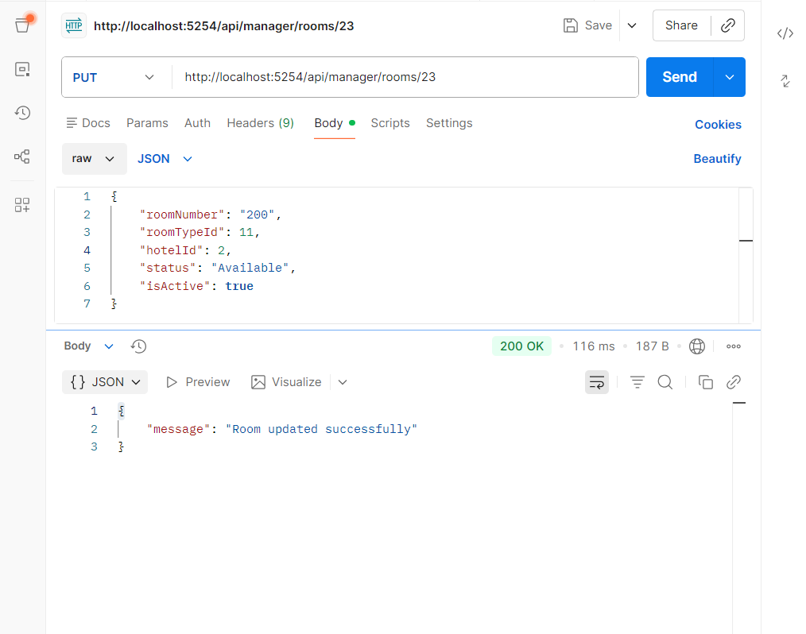
Guest search for rooms (authenticated guest)
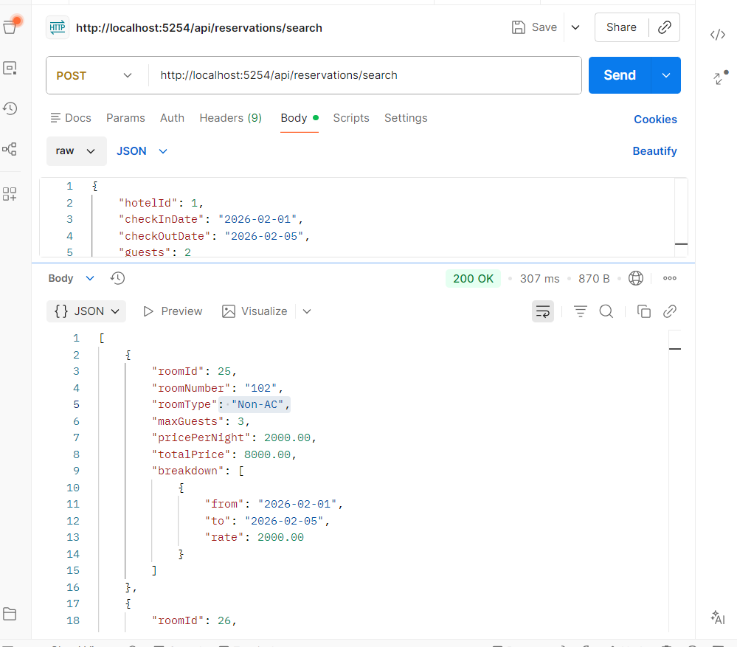
Creating reservation by guest

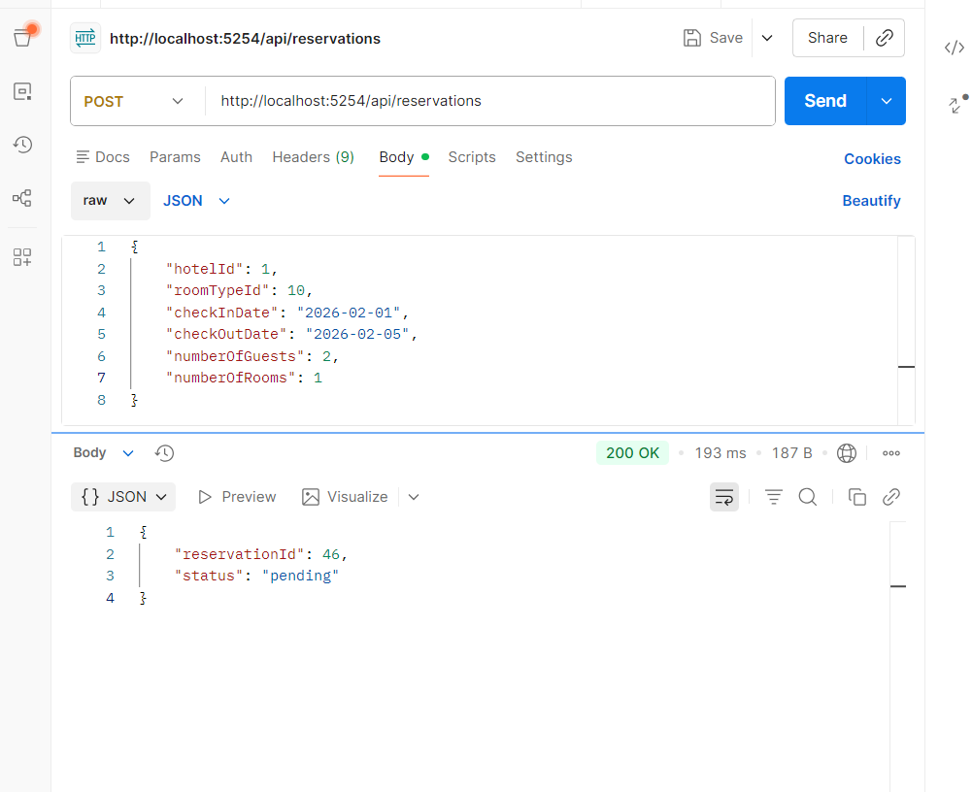
Get reservations by userid
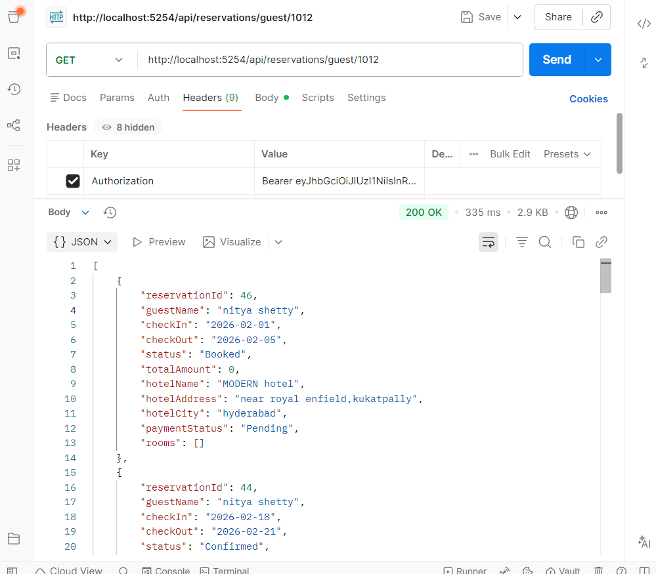
Cancelling reservation by guest

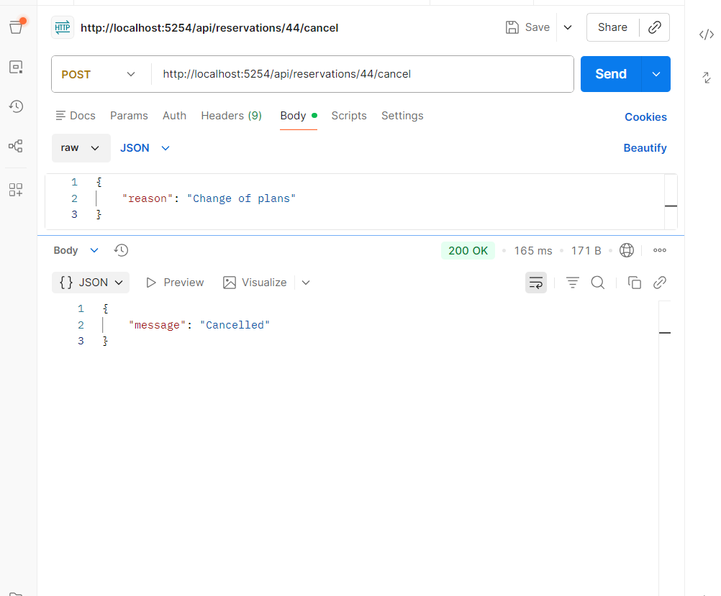
Updating status to checkin by receptionist

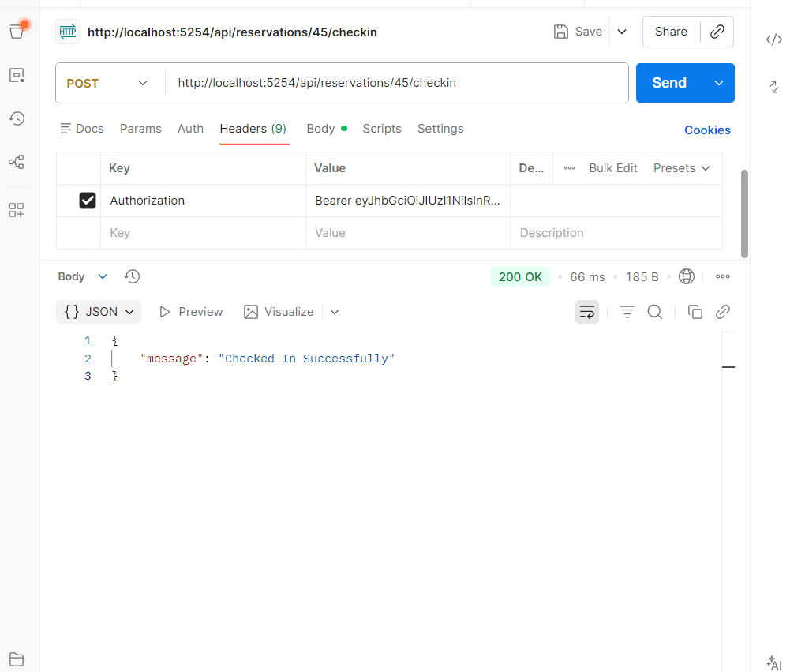
Updating status to checkout by receptionist

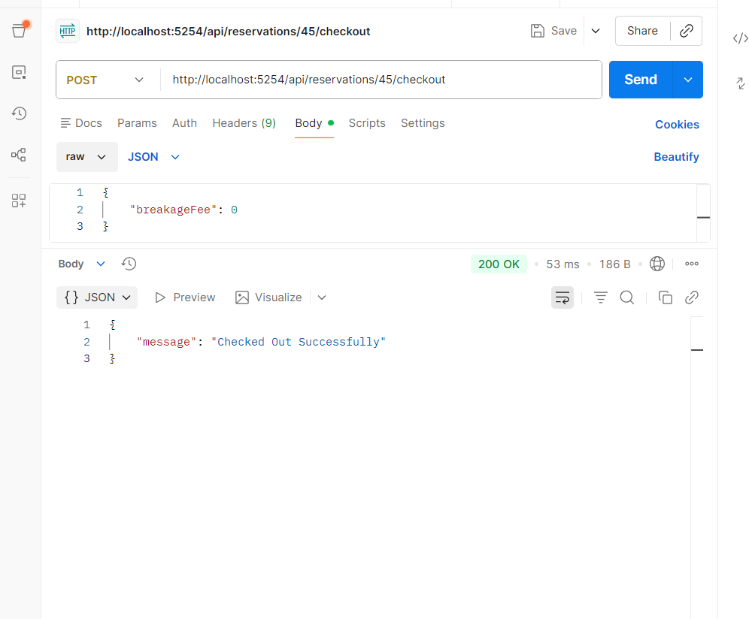

Getting all pending reservations of the hotel assigned to the manager(by manager)

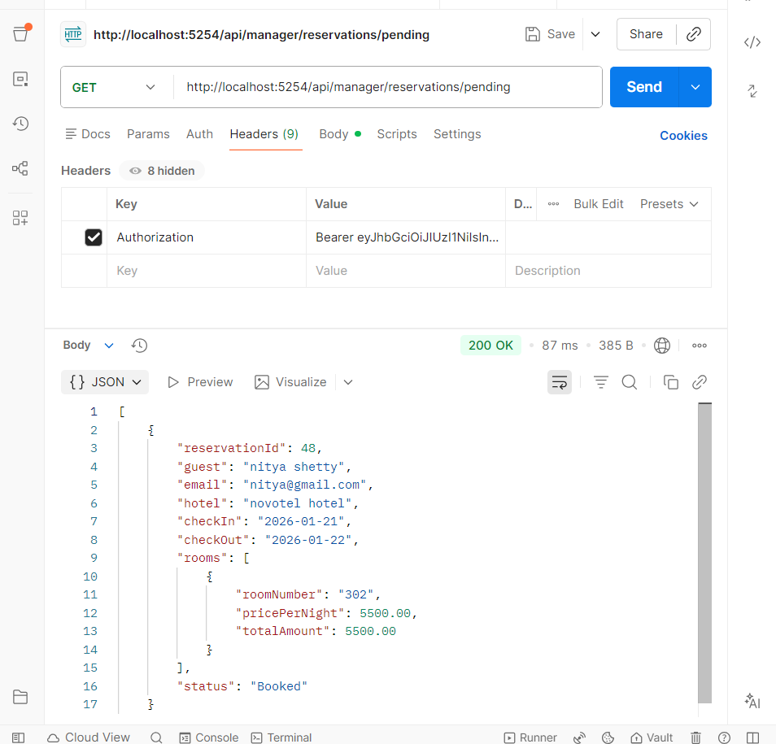
Approve reservation (by manager)

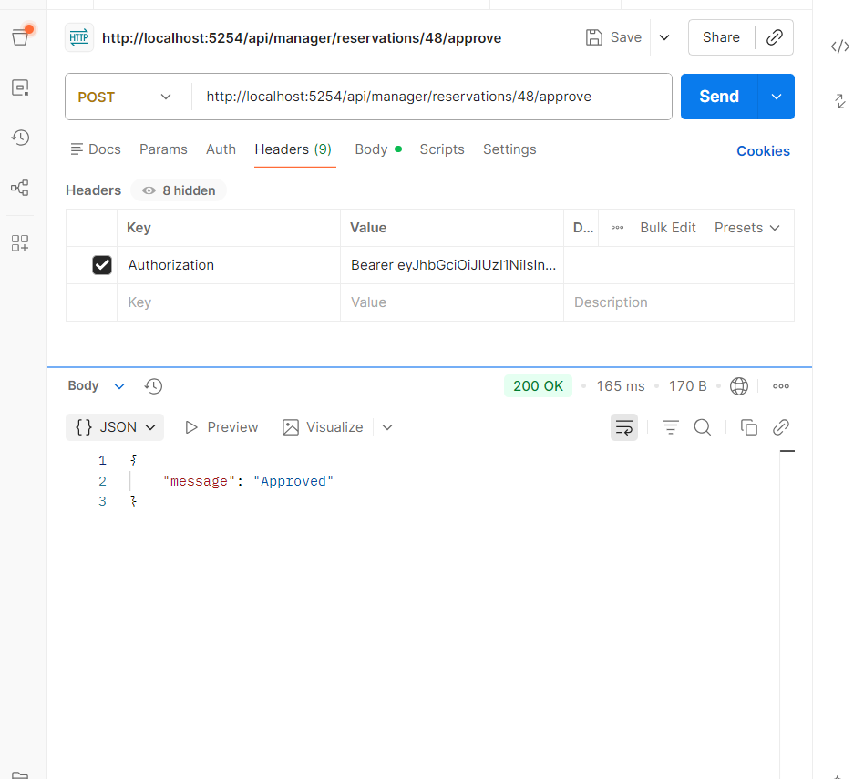
Rejecting reservation(by manager)

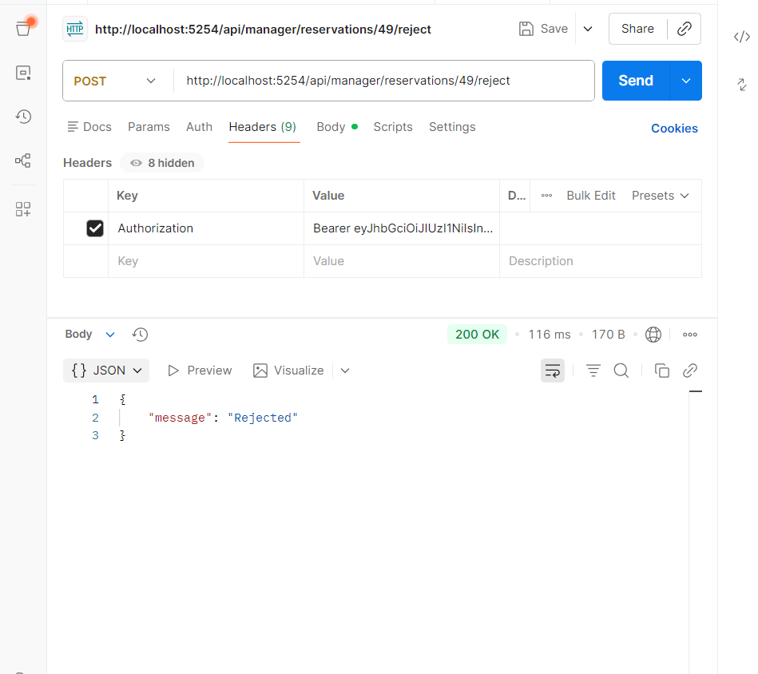
Getting Invoice preview (by guest)
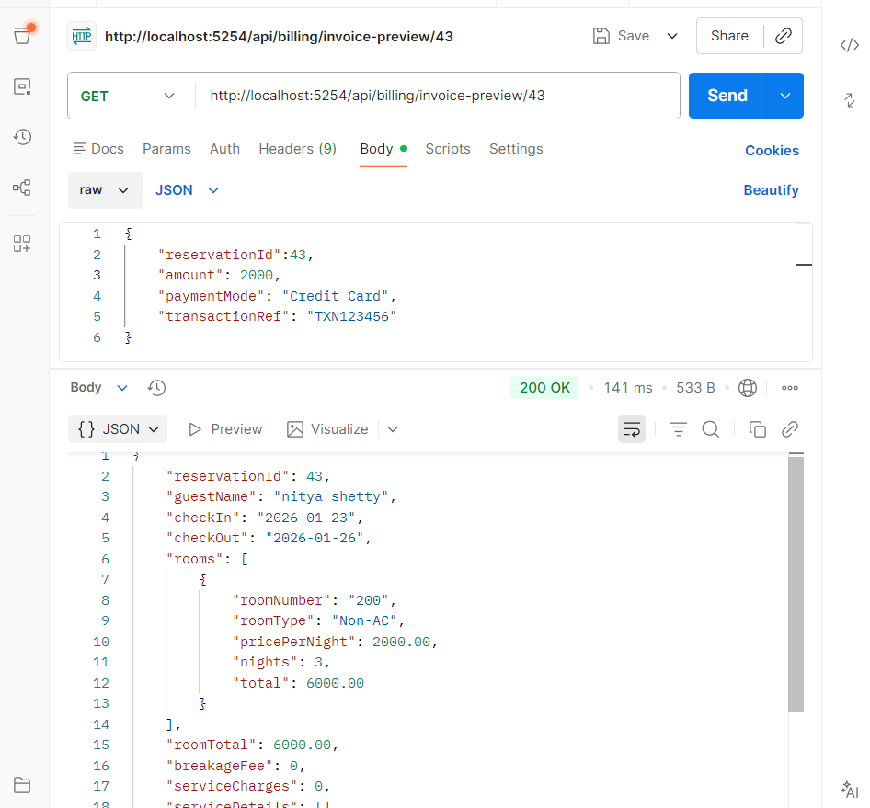
Creating payment(by guest)

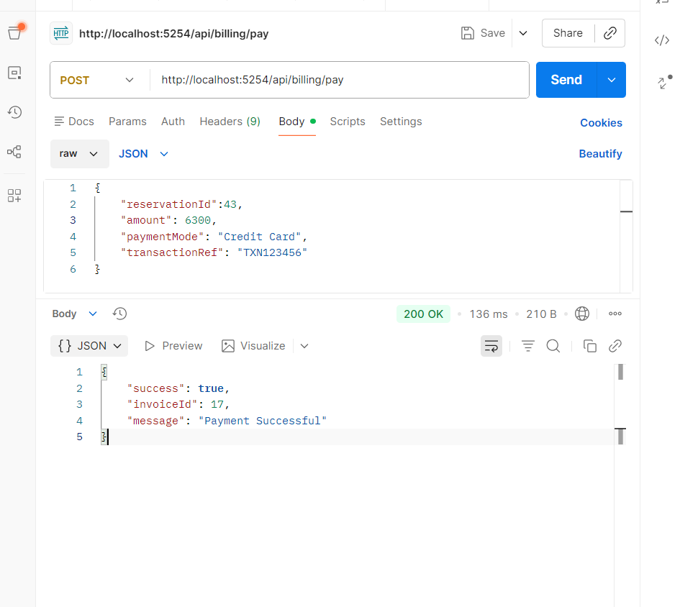

Service request creating (by checkedin guests only)
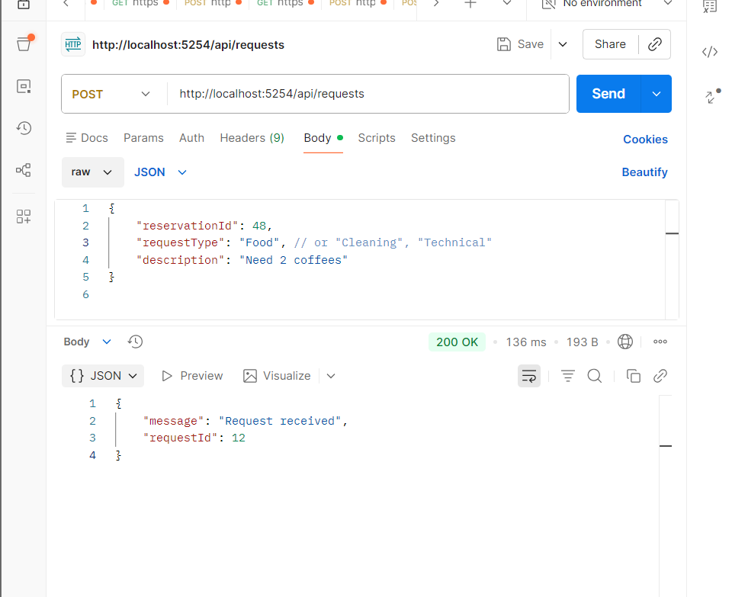
Getting all pending service requests of that hotel assigned to the receptionist(by receptionist)
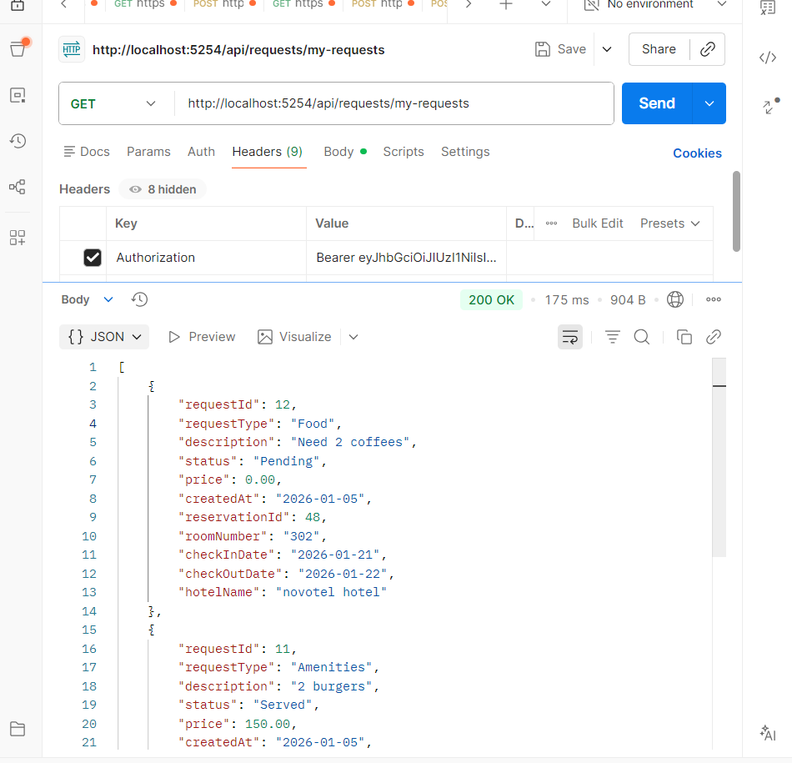
Getting service request by id

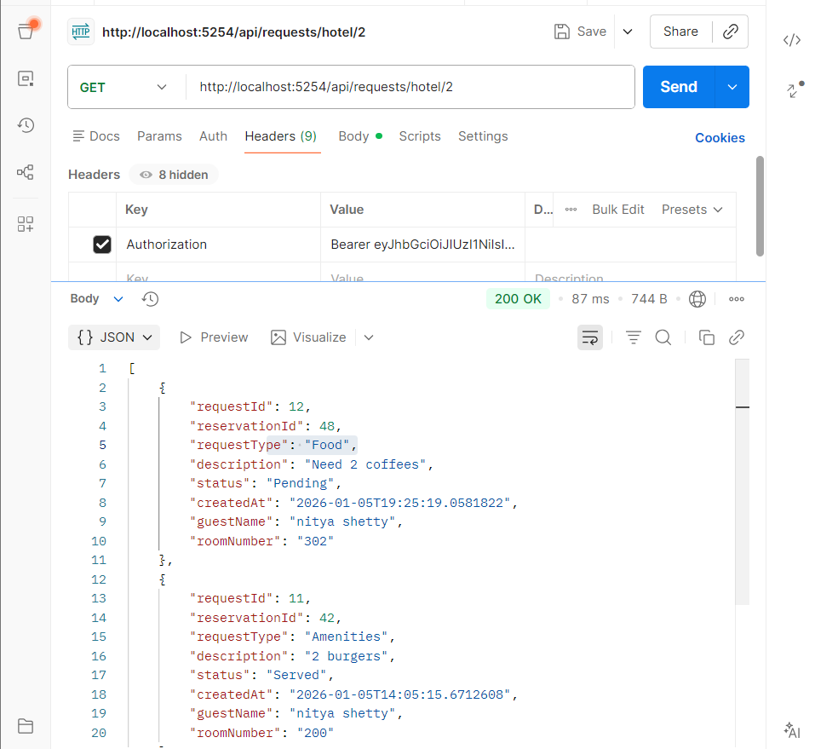
Receptionist serve the request by charging some price

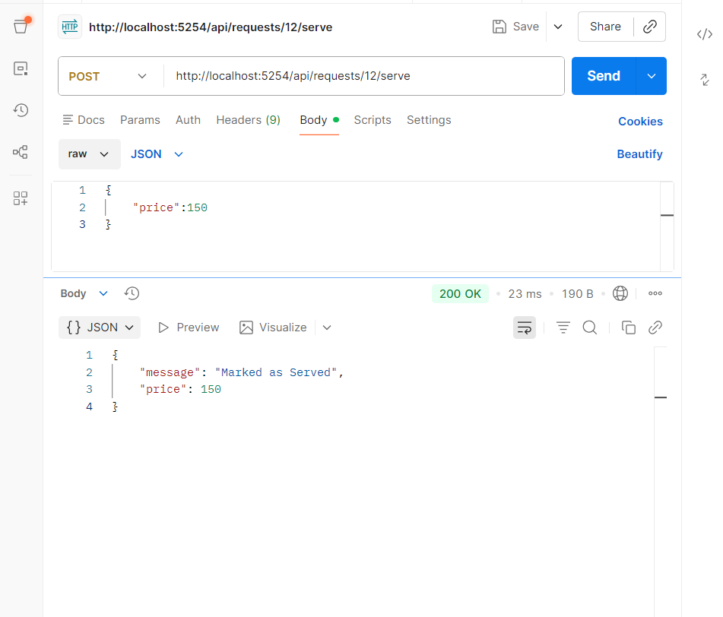

Getting notifications by guest

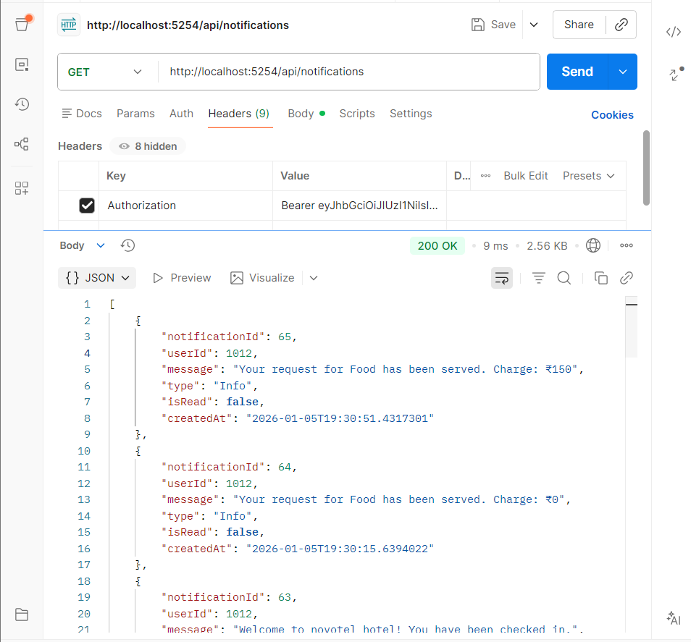
Reading notifications by guest

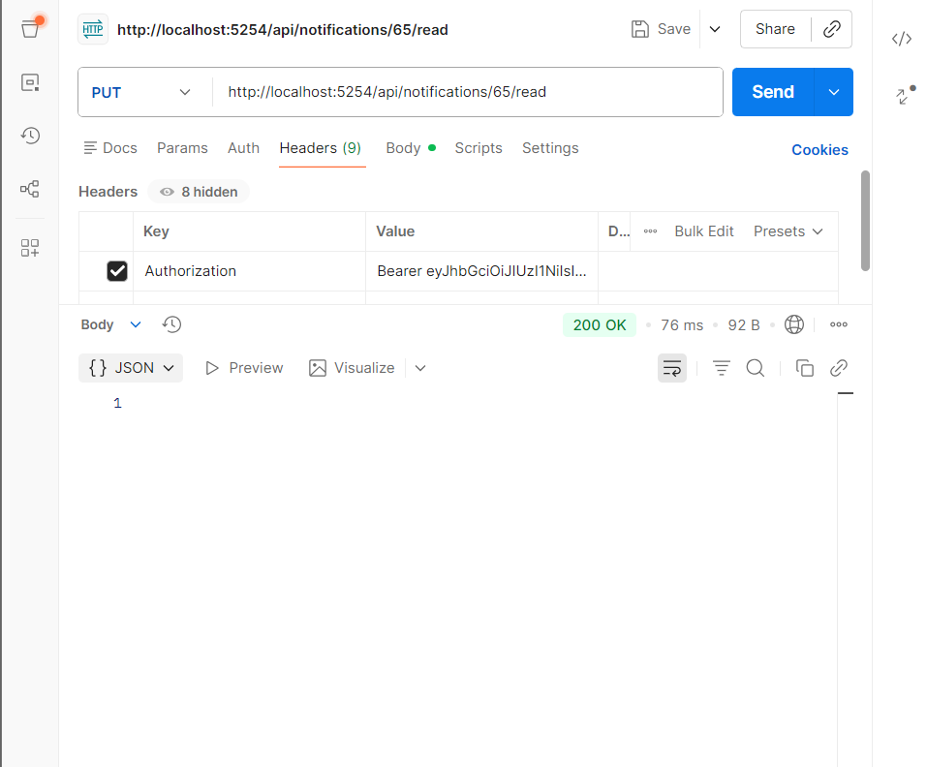

User – hotel assignment creation (by admin only)
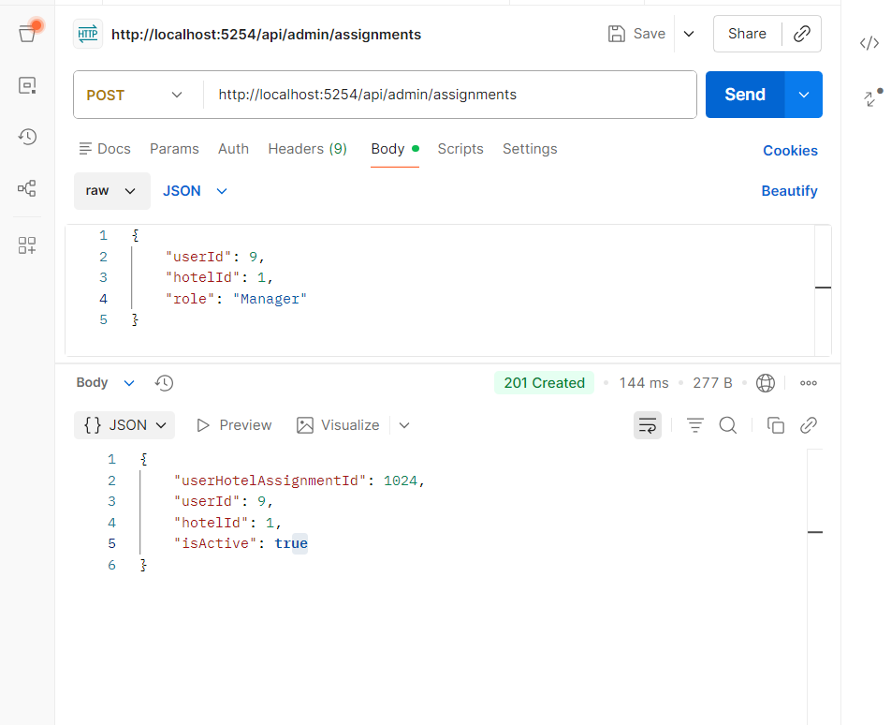
Getting user-hotel assignments

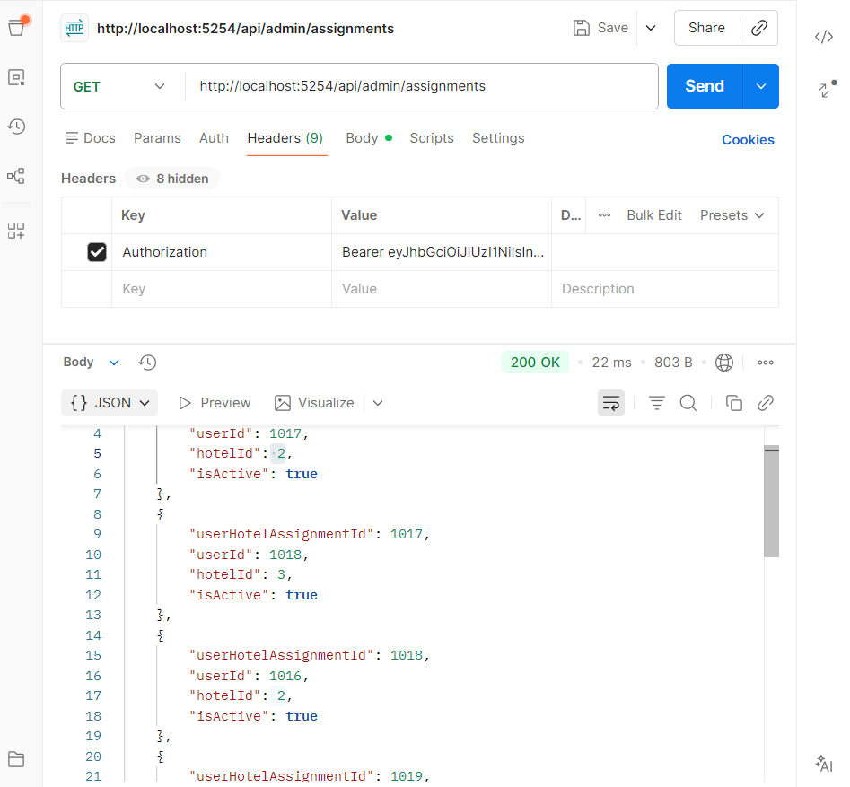

Reports statistics(by manager if assigned to one hotel)
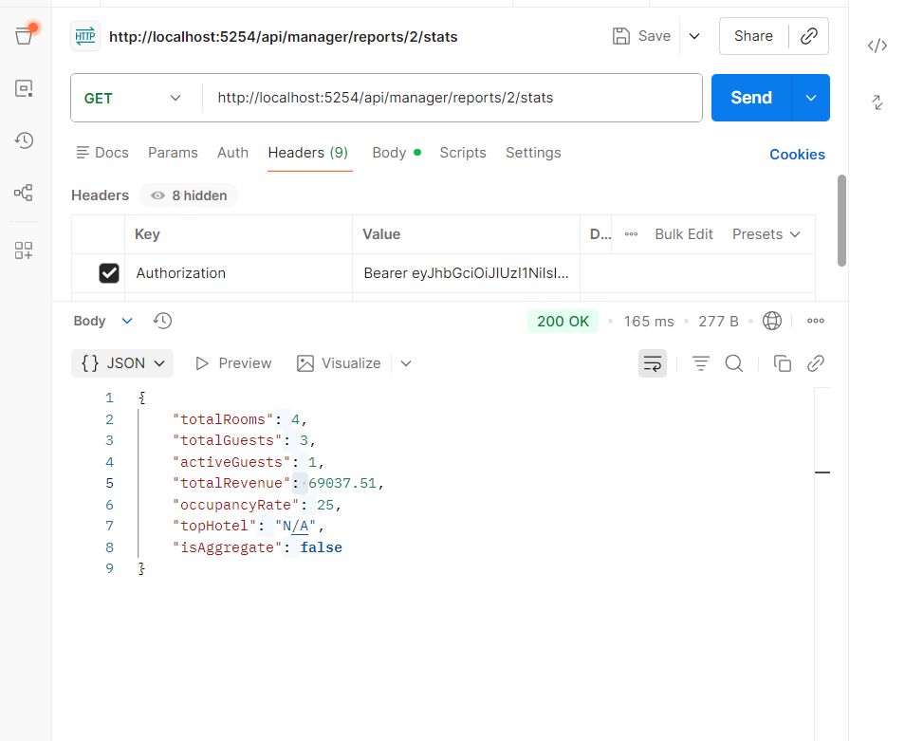

Reports statistics(by super manager assigned to all hotels)
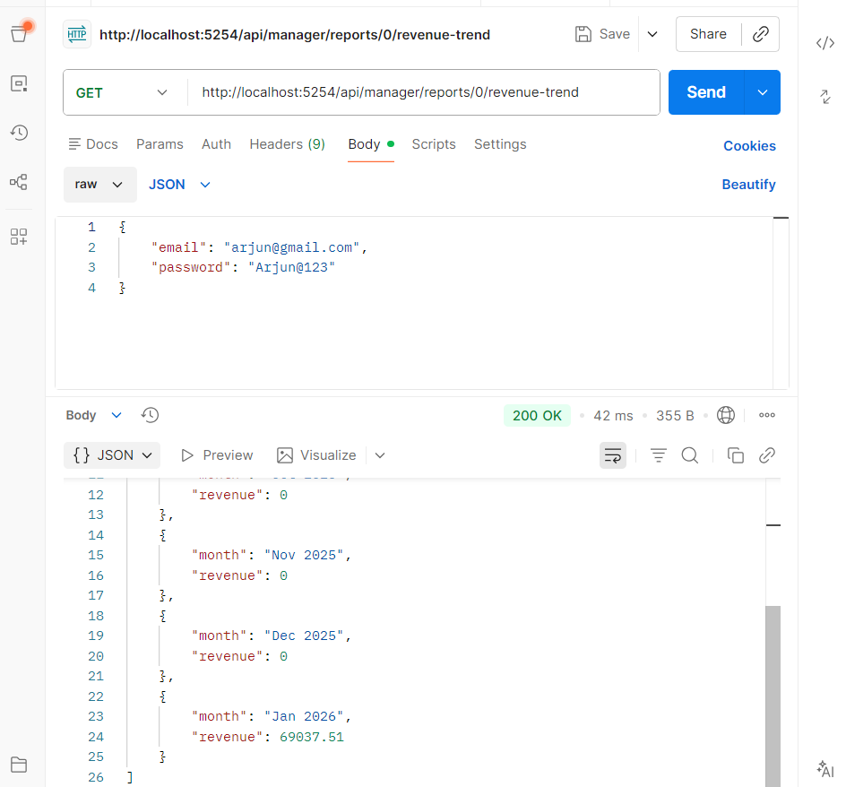
Getting Seasonal pricing (by authenticated user)

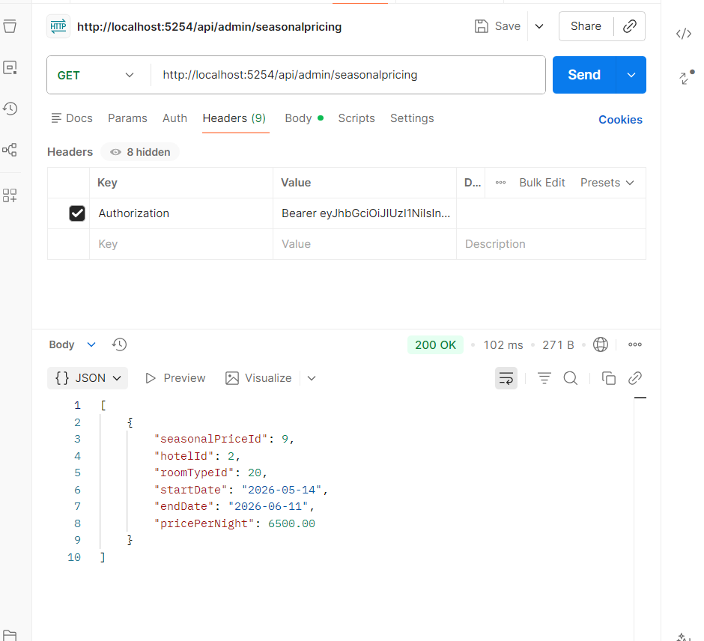
Getting Seasonal pricing by id (by authenticated user)

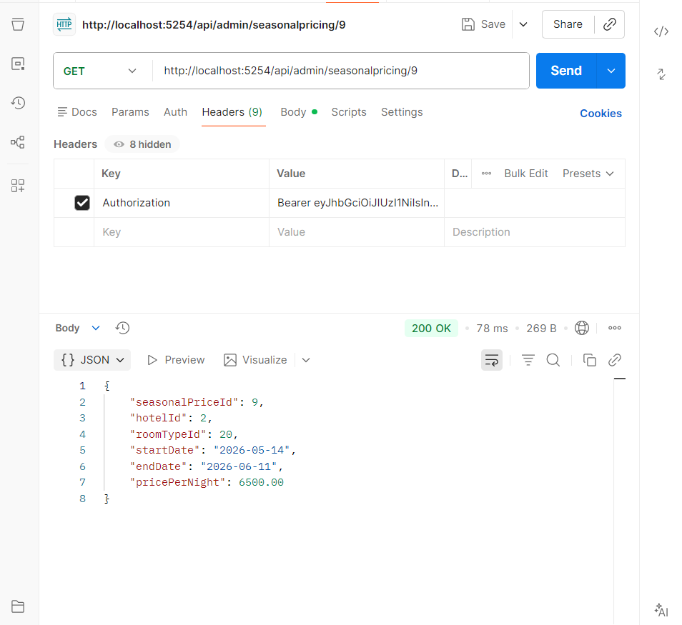
adding Seasonal pricing by id (by admin only)

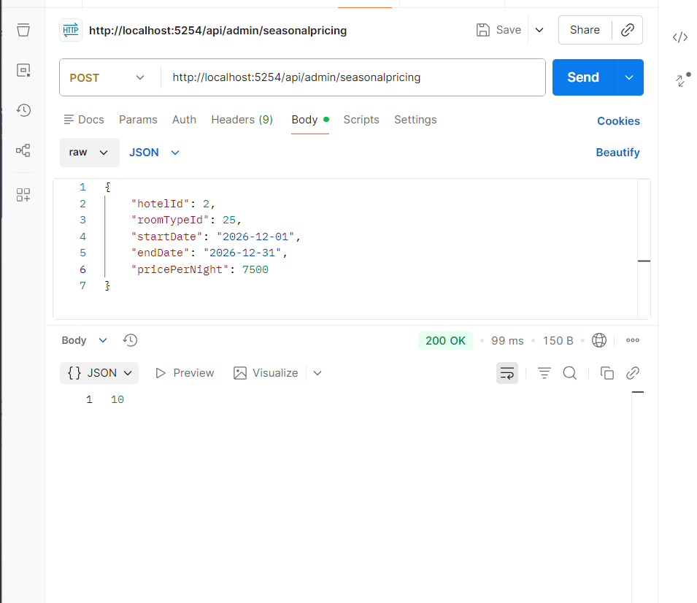

Registering walkin guest (by receptionist only)

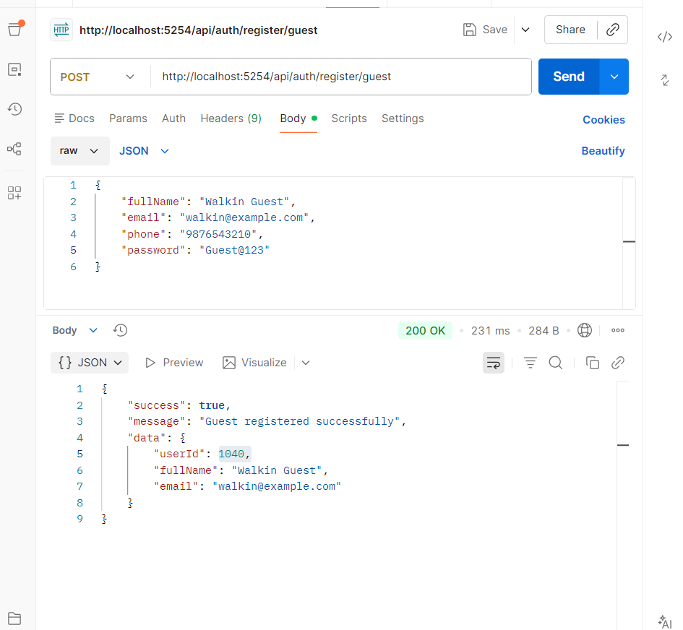

Walkin reservation search(by receptionist)
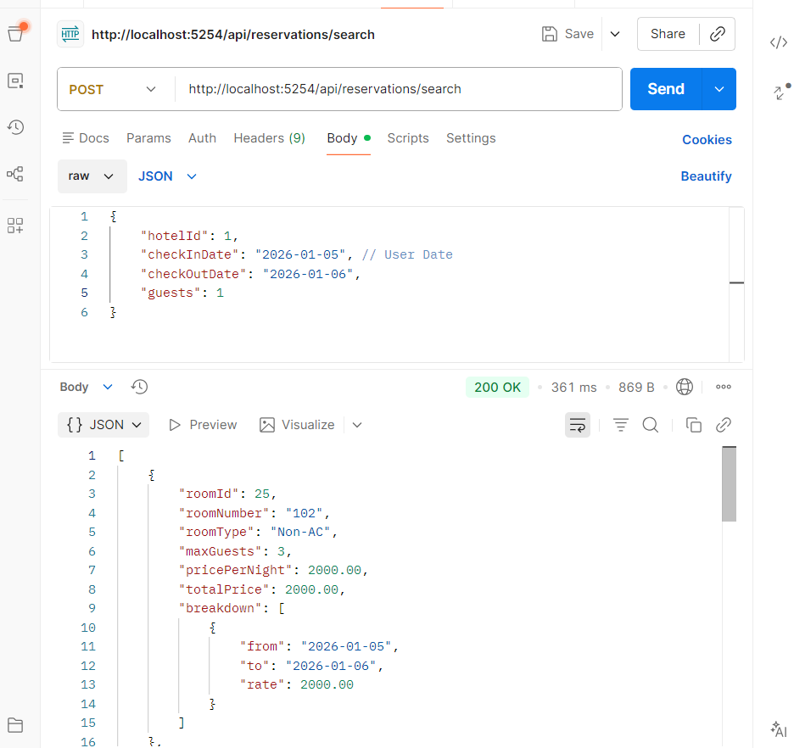

Creating Walkin reservation (by receptionist)

