HEART DISEASE
CLASSIFICATION
MLOps Project Report
End-to-end machine learning workflow with model tracking,
REST API, monitoring, containerization and Kubernetes deployment
Name: Aishwarya Jadhav
Roll no. : 2025ae05900
https://github.com/aishwaryaj10/heart-disease-mlops

1. Abstract
This project implements an end-to-end MLOps pipeline for binary heart disease classification. The workflow covers data loading and preparation, exploratory data analysis (EDA), preprocessing, training and comparison of machine-learning models, experiment tracking with MLflow, automated tests, serving predictions through a FastAPI REST API, monitoring with Prometheus metrics, containerization with Docker, and local Kubernetes deployment. The selected model is based on cross-validation F1 score to reduce reliance on a single train/test split. The application exposes health and metrics endpoints in addition to a prediction endpoint.

2. Problem Statement and Objectives
The objective is to build a reproducible and deployable machine-learning service that predicts whether a patient record indicates the presence of heart disease. The output is a binary class (0 = no disease indicated; 1 = disease indicated by the dataset's target mapping) and an estimated model probability. This is an educational classification prototype and is not intended for clinical diagnosis.
- Prepare the Cleveland heart-disease dataset and inspect its quality and distributions.
- Train and compare Logistic Regression and Random Forest models.
- Track experiments and evaluation metrics with MLflow.
- Package the best cross-validation model behind a validated REST API.
- Add automated tests, request logging and Prometheus metrics.
- Build a Docker image and deploy the service to a local Kubernetes cluster.
- Document setup, execution, limitations and reproducibility.

3. Dataset and Exploratory Data Analysis
The project uses the Cleveland heart-disease dataset with 303 records and 14 columns: 13 input features and one target column. Features include age, sex, chest-pain type (cp), resting blood pressure (trestbps), cholesterol (chol), fasting blood sugar (fbs), resting ECG (restecg), maximum heart rate (thalach), exercise-induced angina (exang), oldpeak, slope, ca and thal.
The source file contains missing values represented by '?'. Inspection identified 4 missing values in ca and 2 in thal. The preparation step removes rows with missing values and converts the original target into a binary label: target = 0 remains 0, while target values greater than 0 become 1. The EDA notebook (notebooks/01_heart_disease_eda.ipynb) examines dataset shape, sample records, data types, summary statistics, missing values, duplicates, target distribution, numeric feature distributions, boxplots, feature correlations and categorical feature counts.
EDA plots are descriptive and help identify data patterns; correlations and group differences do not establish causal relationships. Any class imbalance and small dataset size should be considered when interpreting model results.

4. Methodology and Model Development
The data preparation module loads the dataset, handles the missing-value marker and creates a processed binary target. Preprocessing separates numeric and categorical features. Numeric features use median imputation followed by standard scaling; categorical features use most-frequent-value imputation. The preprocessing transformations are incorporated into the model pipeline so that training and inference use consistent transformations.
Two candidate algorithms are evaluated: Logistic Regression and Random Forest. Evaluation includes cross-validation F1 and held-out test metrics: accuracy, precision, recall, F1 score and ROC-AUC. The candidate with the higher mean cross-validation F1 is selected. This selection criterion is important because choosing a model solely from test-set results would overuse the test set.

5. Results
Model | CV F1 mean | Accuracy | Precision | Recall | Test F1 | ROC-AUC
Logistic Regression | 0.8035 | 0.8333 | 0.8462 | 0.7857 | 0.8148 | 0.9487
Random Forest | 0.7847 | 0.8667 | 0.8846 | 0.8214 | 0.8519 | 0.9403
Logistic Regression was selected because its mean cross-validation F1 score (0.8035) was higher than Random Forest's (0.7847). Random Forest performed better on this particular test split for accuracy, precision, recall and test F1, while Logistic Regression achieved the higher ROC-AUC. The results show that model rankings can vary by metric and split; the selection rule was based on cross-validation F1.

6. MLOps Architecture and Tools
Data | Cleveland dataset → validation / preparation → processed CSV
Experimentation | Preprocessing pipeline → Logistic Regression and Random Forest → cross-validation and test evaluation
Tracking and artifacts | MLflow experiment tracking; model, comparison CSV and metadata saved under artifacts/
Serving | FastAPI REST service with /predict, /health and /metrics endpoints
Observability | Structured request logging and Prometheus counters / request-duration histogram
Packaging and deployment | Docker image heart-disease-api:1.2 → Kubernetes Deployment and NodePort Service
Quality and delivery | Pytest automated tests and GitHub Actions CI workflow

7. API, Monitoring and Deployment
The FastAPI service provides a prediction endpoint (/predict) that accepts the required feature values, validates the request schema and returns a binary prediction with a probability. The /health endpoint supports health checks, while /metrics exposes Prometheus-compatible metrics. The service records request count by method, endpoint and status; request duration; and prediction counts by predicted class. Patient feature values are not intentionally written to application logs.
The application is containerized using Docker and was tested locally on port 8000. A Kubernetes manifest defines a Deployment with one replica, readiness/liveness health probes, resource requests and limits, and a NodePort Service (port 30080). The local cluster deployment was verified with a running pod; port forwarding to localhost:8081 was used to access the service where direct NodePort access was not available in the local environment. This is a local deployment, not a public cloud deployment.

8. Testing and Validation
Automated tests were run with pytest: 9 tests passed. Additional checks confirmed that the dataset structure is valid, the saved model accepts test samples, predictions are valid binary labels, and predicted probabilities are valid. The API was exercised through its health, metrics and prediction endpoints. Docker container logs confirmed application startup and endpoint requests. Kubernetes status showed the deployment and pod running. A Starlette/httpx deprecation warning appeared during tests; it did not cause test failures.

9. Reproducibility and Execution
- Create and activate a Python virtual environment, then install dependencies from requirements.txt.
- Run training from the repository root with: python -m src.heart_mlops.train
- Run tests with: python -m pytest tests -v
- Start the API locally with: uvicorn api.main:app --reload
- Open API documentation at: http://127.0.0.1:8000/docs
- Build the Docker image using the provided Dockerfile and run the container on port 8000.
- Apply deployment/k8s.yaml to a configured local Kubernetes cluster and verify resources with kubectl.
The repository includes source code, tests, Docker and Kubernetes configuration, model artifacts, the EDA notebook, CI configuration and README documentation. The source repository is: https://github.com/aishwaryaj10/heart-disease-mlops

10. Limitations, Risks and Future Work
- The dataset is small and historical; performance may not generalize to other populations or clinical settings.
- The binary target combines all original positive target levels into one class, which loses severity information.
- The test metrics are estimates from one split and may vary with a different split or random seed.
- No external clinical validation, fairness audit or prospective evaluation has been performed.
- The current Kubernetes deployment is local and single-replica; it is not a highly available production service.
- Future work could include data/version tracking, model-drift alerts, threshold calibration, fairness analysis, CI checks for container builds, and deployment to a managed environment.

11. Conclusion
The project demonstrates the major stages of an MLOps workflow: data preparation and EDA, model comparison, experiment tracking, automated testing, API serving, monitoring, Docker packaging and Kubernetes deployment. Logistic Regression was selected using mean cross-validation F1, while the evaluation results document trade-offs across metrics. The implementation is a reproducible educational prototype that illustrates how a machine-learning model can be moved from experimentation to a monitored service. It must not be used as a medical diagnostic tool.
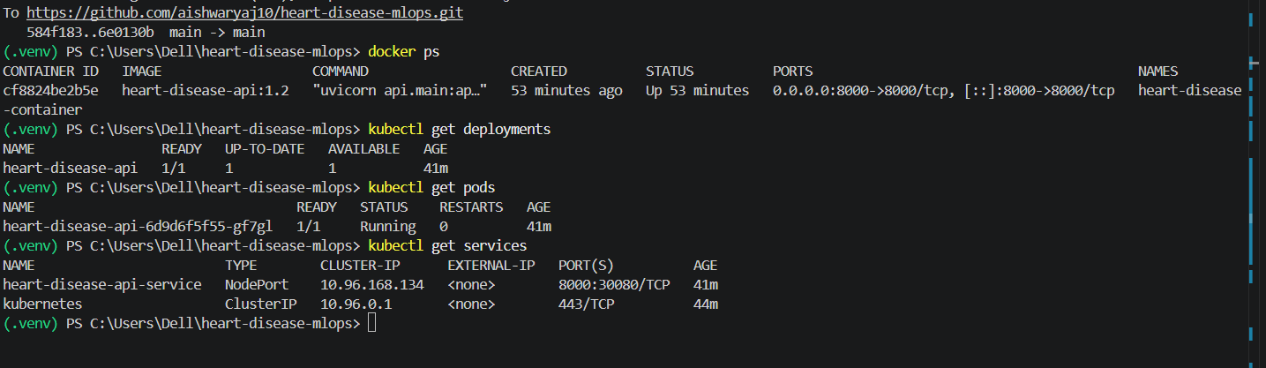

Appendix A. Key Project Artifacts
- notebooks/01_heart_disease_eda.ipynb — exploratory data analysis
- src/heart_mlops/ — data loading, preprocessing, training and prediction modules
- artifacts/heart_disease_model.joblib — selected trained model
- artifacts/model_comparison.csv — candidate model metrics
- artifacts/model_metadata.json — model metadata
- api/main.py — FastAPI service and monitoring instrumentation
- tests/ — automated tests
- Dockerfile — container image definition
- deployment/k8s.yaml — Kubernetes Deployment and Service
- .github/workflows/ci.yml — automated test workflow
- README.md — setup, execution and deployment documentation

