HR EMPLOYEE MANAGEMENT SYSTEM
Project Documentation
Java 17 • Spring Boot 4.1.1 • MySQL • Spring Security
Prepared by: Aishwarya J.
Application URL: http://localhost:8080
Swagger UI: http://localhost:8080/swagger-ui/index.html

1. Project Overview
The HR Employee Management System is a backend REST API developed using Java and Spring Boot. It provides endpoints for employee management and includes related HR modules for departments, attendance, leave requests and performance reviews. MySQL is configured for persistent storage through Spring Data JPA/Hibernate. The project also includes DTOs, mapper components, validation, centralized exception handling, pagination, custom repository queries, transactions, auditing, caching, scheduling, Actuator, HikariCP and Swagger/OpenAPI.

2. Objectives
- Provide REST APIs for employee and HR-related operations.
- Separate controllers, service interfaces, implementations, repositories, entities, DTOs and mappers.
- Validate incoming requests and handle exceptions centrally.
- Support employee pagination, sorting, keyword search and filters.
- Persist data in MySQL using JPA/Hibernate.
- Expose API documentation and operational health/metrics endpoints.
- Use transactions, auditing, logging, caching and scheduling where configured.

3. Modules
Module | Purpose
Employee | Create, retrieve, update, delete, list, search and filter employee records.
Department | Manage departments and their relationship with employees.
Attendance | Maintain attendance records associated with employees.
Leave | Manage employee leave requests, dates, reasons and statuses.
Performance Review | Maintain employee review dates, ratings and comments.

4. Technologies
Technology | Use
Java 17 | Application development.
Spring Boot 4.1.1 | Backend REST application.
Spring Web | REST endpoints and JSON responses.
Spring Data JPA / Hibernate | ORM and persistence.
MySQL | Relational database.
Spring Security | Basic Authentication for protected endpoints.
Maven | Build and dependency management.
Bean Validation | Request and entity validation.
Spring Cache | Cache employee lookup results.
Spring Scheduling | Scheduled task execution.
Spring Boot Actuator | Health and metrics monitoring.
HikariCP | JDBC connection pooling.
Swagger / Springdoc OpenAPI | API documentation and interactive testing.

5. System Architecture
The application follows a layered structure so responsibilities remain separated.
Client (Postman / Swagger UI) → Controller → Service Interface → Service Implementation → Mapper / DTO → Repository → MySQL

6. Project Structure
Package | Purpose
com.example.hr.config | Application configuration such as auditing and related configuration.
com.example.hr.controller | REST API endpoints.
com.example.hr.dto.request | Incoming request DTOs.
com.example.hr.dto.response | Outgoing response DTOs.
com.example.hr.entity | JPA entities.
com.example.hr.enums | Status and rating enumerations.
com.example.hr.exception | Custom exceptions and global exception handling.
com.example.hr.mapper | Entity and DTO conversion.
com.example.hr.repository | Database operations and custom queries.
com.example.hr.scheduler | Scheduled task.
com.example.hr.service | Service interfaces.
com.example.hr.service.impl | Business logic and transaction boundaries.

7. Main Entities
Entity | Purpose
Department | Department details and the department-to-employee relationship.
Employee | Employee number, personal/contact details, job title, joining date, salary, status and department.
Attendance | Attendance date/status and employee relationship.
LeaveRequest | Leave type, start/end dates, reason, status and employee relationship.
PerformanceReview | Review date, rating, comments and employee relationship.

8. Important Relationships
- One Department can have many Employees.
- Many Employees belong to one Department.
- Attendance records are associated with an Employee.
- Leave requests are associated with an Employee.
- Performance reviews are associated with an Employee.

9. Authentication and Security
The project configuration uses Spring Security HTTP Basic authentication for protected API requests. Application credentials are supplied through environment variables rather than hard-coded into application.properties. The exact authorization rules should be confirmed against the current security configuration before documenting individual public/protected routes.
Scenario | Expected result
Valid credentials | Protected endpoint can be accessed if authorized.
Invalid or missing credentials | Authentication is rejected for a protected endpoint.

10. DTOs and Mapper Layer
Request and response DTOs separate API payloads from JPA persistence entities. Mapper components convert between entities and DTO representations. Employee responses include department details without exposing the entity graph directly.
Layer | Purpose
Request DTO | Validates incoming data.
Response DTO | Defines the fields returned to clients.
Mapper | Converts between DTOs and entities.

11. Important Business Validations
- Required fields and string lengths are checked with Bean Validation annotations.
- Employee email is validated as an email address.
- Employee salary must be positive.
- Status and rating fields use defined enum values.
- Leave date ranges are validated.
- Missing resources and database integrity failures are handled through the exception structure.

12. Pagination and Sorting
The employee list supports page number and page size parameters. The controller validates page and size values and applies ascending last-name sorting.
GET /api/employees?page=0&size=5
The response contains page content and metadata such as page number, page size, total elements and total pages.

13. Customized Queries
Query approach | Purpose
JPQL keyword search | Search employee first name, last name or email using a keyword.
JPQL fetch query | Retrieve an employee together with the associated department.
Native SQL count | Count employees by status.
Repository-derived queries | Filter employees by status or department and perform case-insensitive duplicate checks.

14. REST API Documentation
Method | Endpoint | Purpose / evidence
POST | /api/employees | Create employee — captured; 201 Created.
GET | /api/employees/{id} | Get employee by ID — captured; 200 OK.
GET | /api/employees?page=0&size=5 | Paginated employee listing — captured; 200 OK.
GET | /api/employees/search?keyword=Arun&page=0&size=5 | Keyword search — captured; 200 OK.
GET | /api/employees/status/{status} | Filter employees by status; endpoint present in reviewed controller.
GET | /api/employees/department/{departmentId} | Filter employees by department; endpoint present in reviewed controller.
PUT | /api/employees/{id} | Update employee.
DELETE | /api/employees/{id} | Delete employee.

Swagger UI: http://localhost:8080/swagger-ui/index.html
OpenAPI JSON: http://localhost:8080/v3/api-docs

15. Application Flow
Client Request → Controller → DTO Validation → Service Business Logic → Mapper → Repository → MySQL → DTO Response

16. Example Requests

Create Employee
POST /api/employees
{
"employeeNumber": "EMP002",
"firstName": "Priya",
"lastName": "Sharma",
"email": "priya.sharma@example.com",
"phone": "9876543211",
"jobTitle": "HR Executive",
"joiningDate": "2026-10-12",
"salary": 35000,
"departmentId": 3
}

Get Employee by ID
GET /api/employees/2

Search Employees
GET /api/employees/search?keyword=Arun&page=0&size=5

17. Advanced Features
- Transactions: service methods use transaction annotations; read methods use read-only transactions where appropriate.
- Auditing: createdAt and updatedAt fields are configured for Spring Data JPA auditing.
- Caching: employee-by-ID lookup uses @Cacheable and update/delete operations evict the corresponding cache entry.
- Scheduling: a scheduled task logs a daily HR employee summary event at 9:00 AM; the current implementation logs the event rather than sending a report.
- Actuator: health, info and metrics endpoints are exposed.
- HikariCP: pool name and connection-pool size/timeouts are configured.

18. Monitoring and Operations
Feature | Endpoint / setting | Observed result
Health | /actuator/health | Overall UP; MySQL component UP.
Metrics index | /actuator/metrics | Metric list available in Actuator.
HikariCP connections | /actuator/metrics/hikaricp.connections | Metric shows pool HREmployeeHikariPool and value 2.
Swagger UI | /swagger-ui/index.html | Swagger page displays HR API endpoints.
OpenAPI | /v3/api-docs | OpenAPI specification endpoint.
Database | hr_employee_management_db | Datasource URL is configured through DB_URL with a local MySQL default.

19. Postman Testing Order
- Create employee.
- Get employee by ID.
- List employees using pagination.
- Search employees using a keyword.
- Test status and department filters.
- Test update and delete routes.
- Test validation and missing-resource responses.
- Test authentication behavior.
- Review Swagger and Actuator endpoints.

20. Snapshots of HR Employee Management System
The following evidence consists of original screenshots taken from the user's local project, Eclipse/STS, browser and Postman.

1. Swagger UI — API documentation
Swagger UI shows the HR Employee Management System API and its available endpoints.
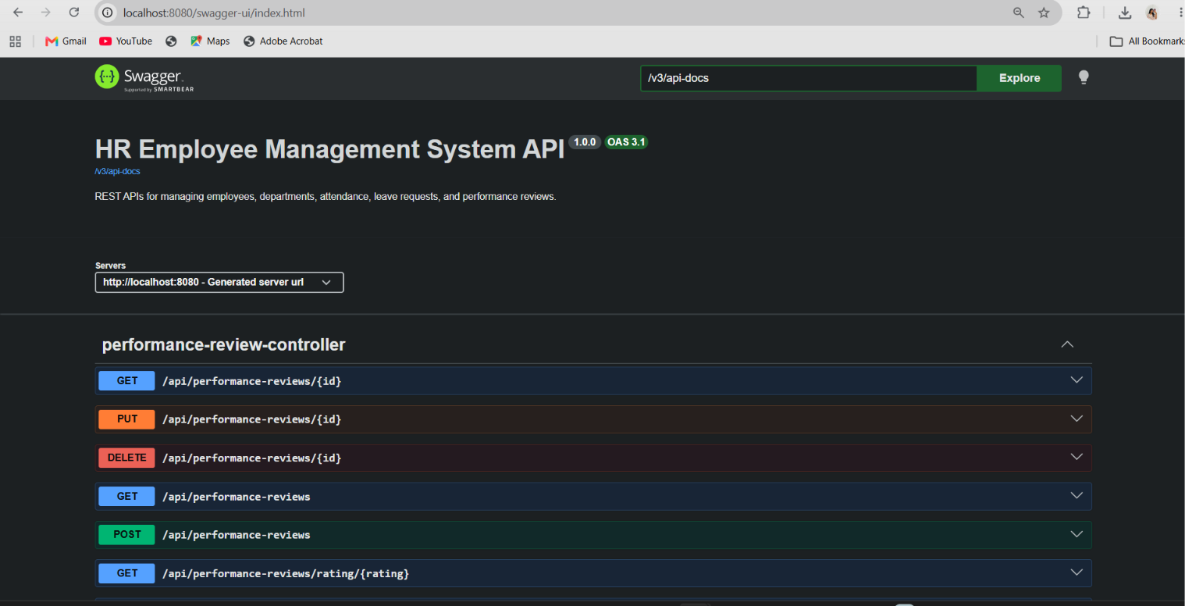
Original project screenshot

2. Actuator health endpoint
The health response reports overall status UP and the MySQL database component status UP.
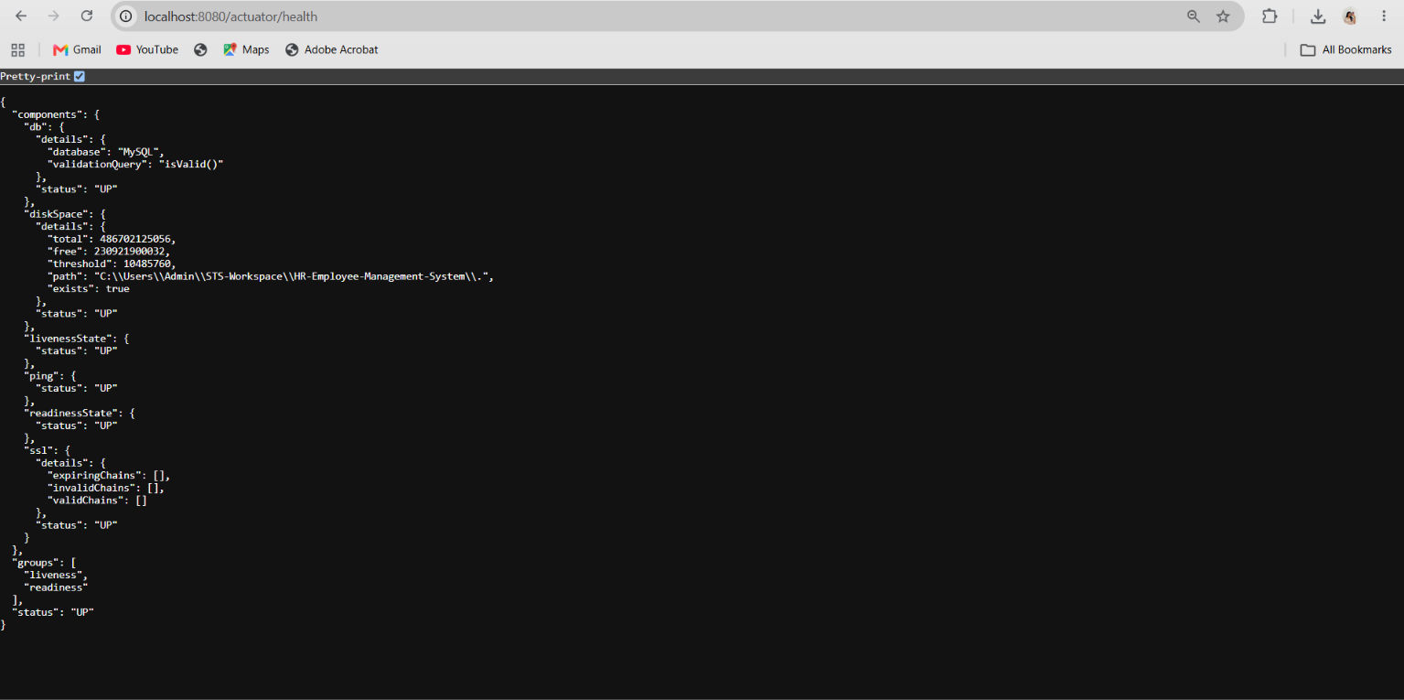
Original project screenshot

3. HikariCP connection metric
The hikaricp.connections metric identifies HREmployeeHikariPool and reports a total connection value of 2.
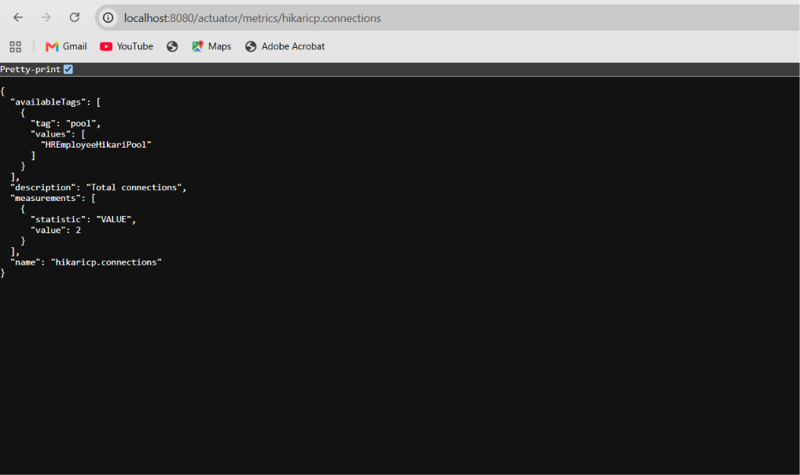
Original project screenshot

4. Application properties — datasource and pool
The screenshot shows MySQL datasource environment variables, HikariCP settings, JPA settings, Actuator exposure, and cache/logging configuration.
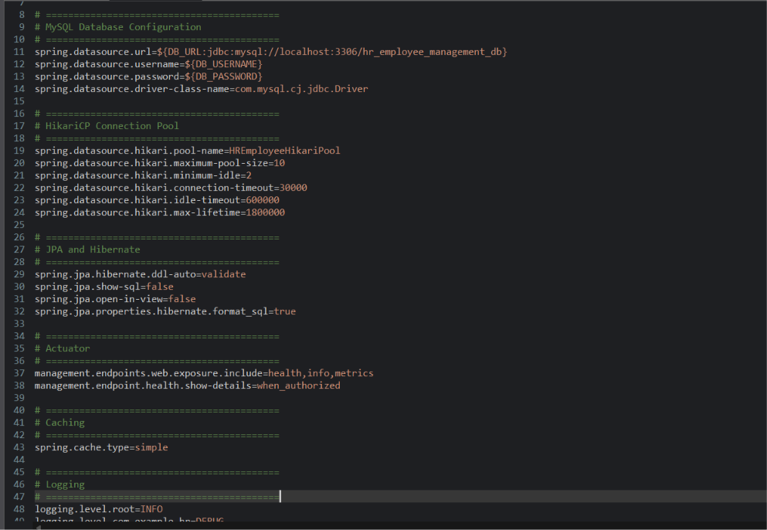
Original project screenshot

5. Maven test execution
The Eclipse Console shows 11 tests run, zero failures, zero errors, zero skipped, and BUILD SUCCESS.
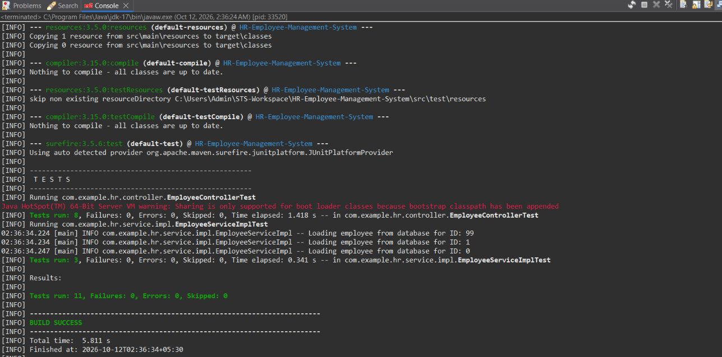
Original project screenshot

6. Eclipse/STS project structure
The Package Explorer shows the actual application packages, resources, and test packages.
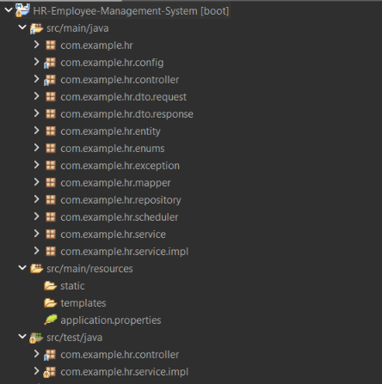
Original project screenshot

7. Create employee — POST
Postman returns 201 Created for EMP002, Priya Sharma, assigned to department 3 (Human Resources).
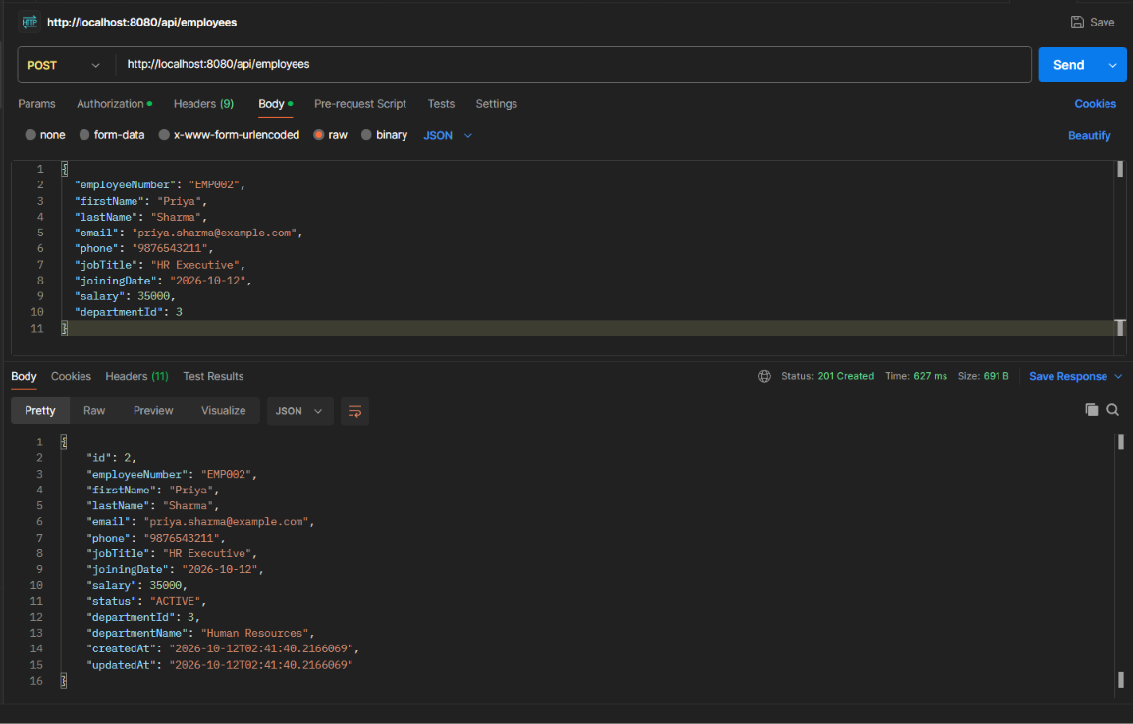
Original project screenshot

8. Get employee by ID — GET
Postman returns 200 OK for employee ID 2, EMP002.
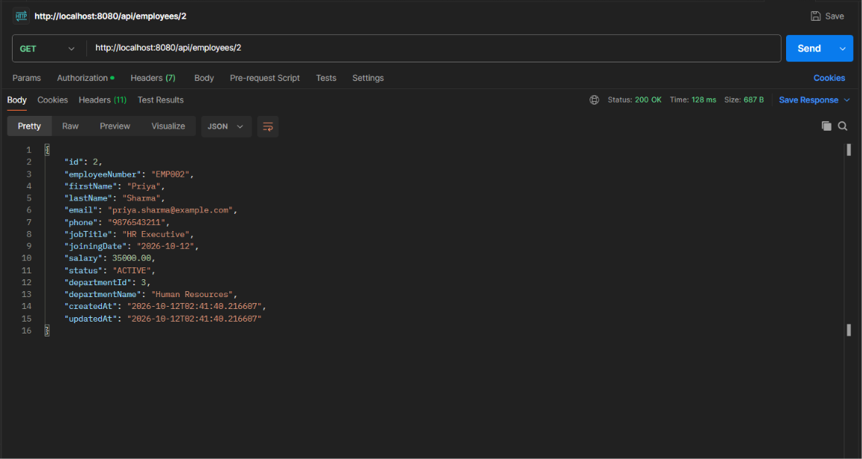
Original project screenshot

9. Employee listing with pagination
The paginated employee endpoint returns 200 OK with page=0 and size=5.
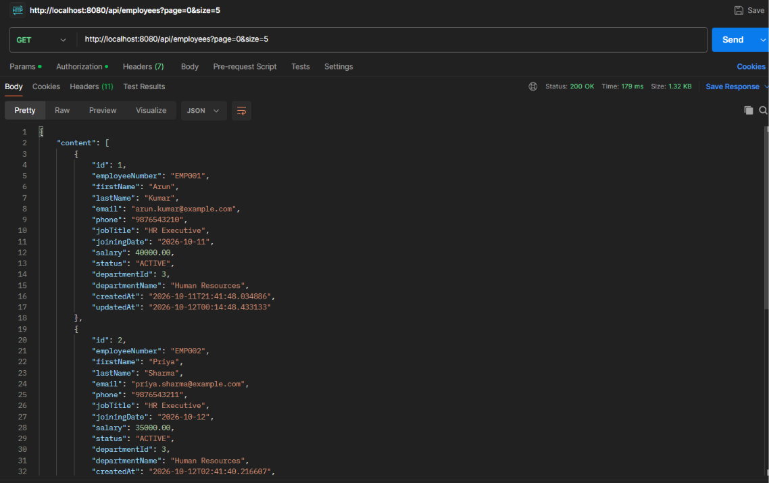
Original project screenshot

10. Employee keyword search
The search endpoint returns 200 OK for keyword Arun and shows one matching employee.
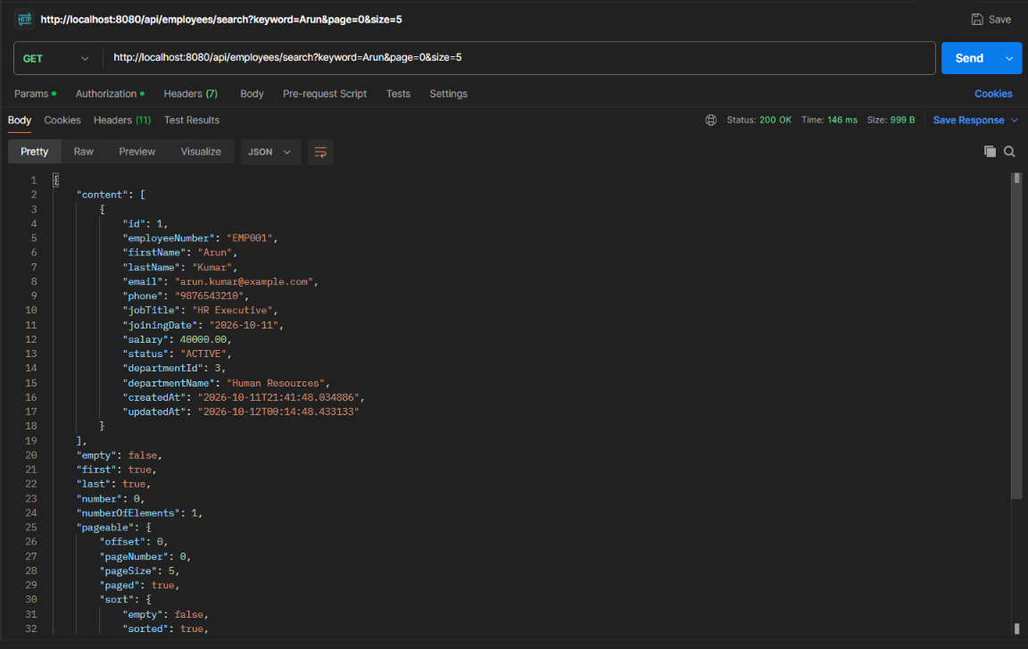
Original project screenshot

21. Common Errors
Error / issue | Suggested check
401 Unauthorized | Check Basic Authentication credentials for protected endpoints.
400 Bad Request | Review request fields and validation messages.
404 Not Found | Verify endpoint path and resource ID.
409 Conflict | Check unique fields and database constraints.
MySQL connection failure | Confirm MySQL is running and DB_URL/DB_USERNAME/DB_PASSWORD are set.
Port 8080 already in use | Stop the other process or configure a different server.port.
Swagger unavailable | Confirm the application is running and open /swagger-ui/index.html.
HikariCP metric unavailable | Verify Actuator exposure and datasource initialization.

22. Project Summary
The HR Employee Management System demonstrates a layered backend REST application using Java 17, Spring Boot 4.1.1, Spring Data JPA/Hibernate and MySQL. The project includes employee and HR domain modules, DTOs and mappers, validation, exception handling, pagination, custom repository queries, Basic Authentication configuration, transactions, auditing, caching, scheduling, Actuator, HikariCP and Swagger/OpenAPI. Original screenshots provide evidence of API documentation, health, connection metrics, configuration, successful Maven tests, project structure and employee API calls.
— End of Project Documentation —

