HR EMPLOYEE MANAGEMENT SYSTEM
Project Documentation
Java 17 • Spring Boot 4.1.1 • MySQL • Spring Security
- AISHWARYA.J

1. Project Overview
The HR Employee Management System is a backend REST API application developed using Java and Spring Boot. It provides APIs for managing employees, departments, attendance, leave and performance reviews. MySQL is used for persistent data storage, while Spring Security provides Basic Authentication and BCrypt password encoding. The application also includes validation, centralized exception handling, DTOs and mappers, pagination and sorting, custom JPQL/native queries, transactions, auditing, caching, scheduling, Actuator, HikariCP and Swagger/OpenAPI.

2. Objectives
- Provide REST APIs for employee and HR-related operations.
- Manage departments, employees, attendance, leave and performance reviews.
- Use MySQL with Spring Data JPA/Hibernate for persistence.
- Validate incoming requests and handle errors centrally.
- Separate API models from entities using DTOs and mapper classes.
- Support pagination and sorting for employee retrieval.
- Provide customized JPQL and native SQL queries.
- Secure protected APIs using Spring Security Basic Authentication and BCrypt.
- Implement transactions, auditing, caching and configurable scheduling.
- Provide monitoring through Spring Boot Actuator and connection-pool metrics.
- Provide Swagger/OpenAPI documentation for API testing.
- Support DEV, TEST and PROD YAML configuration profiles.

3. Modules
Module | Purpose
Employee | Create, update, retrieve, delete and search employee records.
Department | Manage departments and their employee relationships.
Attendance | Maintain employee attendance records and statuses.
Leave | Manage employee leave requests, types and statuses.
Performance Review | Store employee review periods, ratings, comments and dates.

4. Technologies
Technology | Use
Java 17 | Application development
Spring Boot 4.1.1 | Backend REST application
Spring Data JPA / Hibernate | ORM and persistence
MySQL | Database
Spring Security | Basic Authentication and endpoint protection
BCrypt | Password encoding
Maven | Build and dependency management
Bean Validation | Request validation
Spring Cache | Application caching
Spring Scheduling | Scheduled operations
Spring Boot Actuator | Monitoring and operations
HikariCP | JDBC connection pooling
Swagger / Springdoc OpenAPI | API documentation and testing
YAML Profiles | DEV / TEST / PROD configuration

5. System Architecture
The project follows a layered architecture so that each layer has a clear responsibility and the application remains maintainable and testable.
Client (Postman / Swagger UI)
↓
Controller Layer
↓
Service Interface
↓
Service Implementation
↓
Mapper / DTO
↓
Repository Layer
↓
MySQL Database

6. Project Structure
Package | Purpose
config | Security, auditing, caching, scheduling and pagination configuration.
controller | REST API endpoints.
service | Business service interfaces.
service.impl | Business logic implementations and transactions.
repository | Database operations using Spring Data JPA.
entity | JPA entities mapped to database tables.
dto | Request and response data transfer objects.
mapper | Entity ↔ DTO conversion.
exception | Custom exception and centralized exception handling.
enums | Employee, attendance, leave and review status/type values.
scheduler | Configurable scheduled HR report operation.

7. Main Entities
Entity | Purpose
Department | Stores department information and department-to-employee relationship.
Employee | Stores employee code, personal details, job title, salary, joining date, status and department.
Attendance | Stores employee attendance date, status and check-in/check-out times.
Leave | Stores leave type, dates, reason, status and employee relationship.
PerformanceReview | Stores review period, rating, comments, review date and employee relationship.

8. Important Relationships
- One Department can have many Employees.
- Many Employees belong to one Department.
- One Employee can have many Attendance records.
- One Employee can have many Leave records.
- One Employee can have many Performance Reviews.
The employee-side one-to-many collections are not mapped into DTOs, preventing unnecessary loading and circular serialization.

9. Authentication and Security
Authentication is implemented using Spring Security Basic Authentication. Protected API requests require valid credentials. A BCryptPasswordEncoder bean is configured so the application does not store the configured password as plain text.
Client sends Basic Authentication
↓
Spring Security authenticates credentials
↓
BCrypt verifies password
↓
Authenticated request reaches protected Controller
Scenario | Expected Result
Valid credentials | Protected endpoint is accessible.
Invalid credentials | 401 Unauthorized.
Unauthenticated protected request | Authentication is required.

10. DTOs and Mapper Layer
DTO classes keep the REST API model separate from persistence entities. Custom mapper components convert entities to DTOs and DTOs to entities.
DTO | Purpose
DepartmentDto | Department request/response data.
EmployeeDto | Employee request/response data including departmentId.
AttendanceDto | Attendance request/response data including employeeId.
LeaveDto | Leave request/response data including employeeId.
PerformanceReviewDto | Performance review request/response data including employeeId.

11. Important Business Validations
- Required employee and department fields are validated.
- Employee email must satisfy @Email validation.
- Employee salary must be positive.
- Enum fields are restricted to their defined enum values.
- Performance review rating must be between 1 and 5.
- Missing resources are returned through ResourceNotFoundException.
- Validation failures are handled by GlobalExceptionHandler with HTTP 400.
- Database constraint violations are handled centrally with HTTP 409.

12. Pagination and Sorting
Employee listing supports Spring Data Pageable for page number, page size and sorting.
GET /api/v1/employees?page=0&size=5&sort=salary,desc
Pagination response is configured using Spring Data Web Support DTO serialization.

13. Customized Queries
Query | Type | Purpose
findEmployeesByDepartmentName | JPQL | Find employees using the department name.
findEmployeesWithMinimumSalary | Native SQL | Find employees whose salary is greater than or equal to a supplied minimum.

GET /api/v1/employees/department?departmentName=Information%20Technology%20%26%20Engineering
GET /api/v1/employees/minimum-salary?minimumSalary=70000

14. REST API Documentation
Method | Endpoint | Purpose
POST | /api/v1/departments | Create department
GET | /api/v1/departments | List departments
GET | /api/v1/departments/{id} | Get department
PUT | /api/v1/departments/{id} | Update department
DELETE | /api/v1/departments/{id} | Delete department
POST | /api/v1/employees | Create employee
GET | /api/v1/employees | List employees / pagination / sorting
GET | /api/v1/employees/{id} | Get employee
PUT | /api/v1/employees/{id} | Update employee
DELETE | /api/v1/employees/{id} | Delete employee
GET | /api/v1/employees/department | JPQL department search
GET | /api/v1/employees/minimum-salary | Native minimum-salary search
POST | /api/v1/attendance | Create attendance
GET | /api/v1/attendance | List attendance
POST | /api/v1/leaves | Create leave
GET | /api/v1/leaves | List leave
POST | /api/v1/performance-reviews | Create performance review
GET | /api/v1/performance-reviews | List performance reviews

15. Application Flow
Client Request
↓
Controller
↓
DTO Validation
↓
Service Business Logic
↓
Mapper
↓
Repository
↓
MySQL
↓
DTO Response

16. Example Requests
Create Employee
POST /api/v1/employees
{
"employeeCode": "EMP004",
"firstName": "Priya",
"lastName": "Kumar",
"email": "priya.kumar@example.com",
"phone": "9876543210",
"jobTitle": "HR Executive",
"salary": 60000,
"joiningDate": "2026-10-08",
"status": "ACTIVE",
"departmentId": 1
}
Employee pagination and sorting
GET /api/v1/employees?page=0&size=5&sort=salary,desc
Minimum salary search
GET /api/v1/employees/minimum-salary?minimumSalary=70000

17. Advanced Features
- Transactions: service operations use @Transactional; read operations use readOnly transactions where appropriate.
- Auditing: createdAt and updatedAt are automatically maintained using Spring Data JPA auditing.
- Caching: @Cacheable and @CacheEvict are used for service read/write operations.
- Scheduling: the HR employee report scheduler is configurable through hr.scheduler.employee-report-delay.
- Actuator: health, info, metrics and loggers endpoints are exposed for monitoring.
- HikariCP: connection-pool sizing and pool names are configured per environment.
- YAML Profiles: DEV, TEST and PROD datasource and operational settings are separated.
- API Versioning: REST endpoints use the /api/v1 prefix.

18. Monitoring and Operations
Feature | Endpoint / Configuration | Purpose
Health | /actuator/health | Application and database health.
Metrics | /actuator/metrics | Available application metrics.
HikariCP Active | /actuator/metrics/hikaricp.connections.active | Active connection count.
HikariCP Max | /actuator/metrics/hikaricp.connections.max | Configured maximum pool size.
Swagger UI | /swagger-ui/index.html | Interactive API documentation.
OpenAPI | /v3/api-docs | OpenAPI specification.
Scheduler | hr.scheduler.employee-report-delay | Configurable scheduler timing.

The project uses separate application-dev.yml, application-test.yml and application-prod.yml files. Database credentials are supplied through environment variables rather than committed as plain-text secrets.

19. Postman Testing Order
Step | Test
1 | Basic Authentication / authorized request
2 | Create department
3 | Create employee
4 | Get employee
5 | Update employee
6 | List employees with pagination and sorting
7 | JPQL department search
8 | Native minimum-salary search
9 | Attendance APIs
10 | Leave APIs
11 | Performance Review APIs
12 | Validation failure
13 | Missing resource / 404
14 | Duplicate constraint / 409
15 | Actuator and Swagger

20. Snapshots of HR Management System
The following snapshots are taken from the project's actual Postman testing evidence.
A. Successful Employee API Response
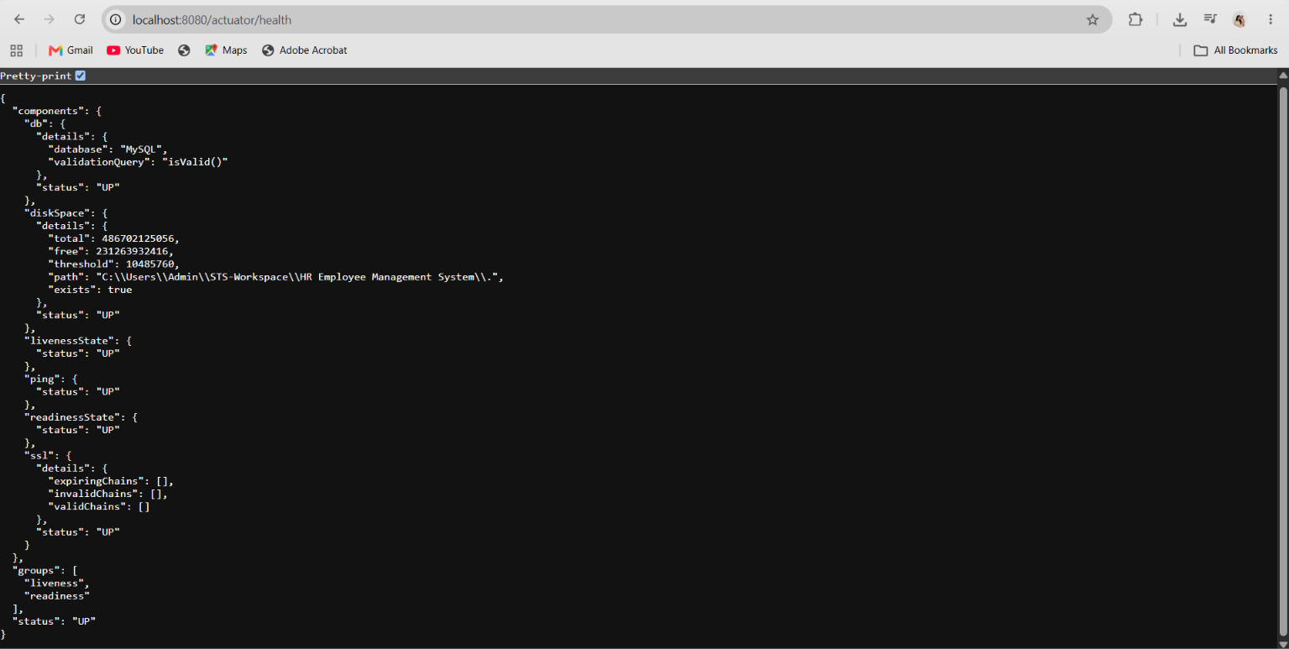
B. Validation Error Response
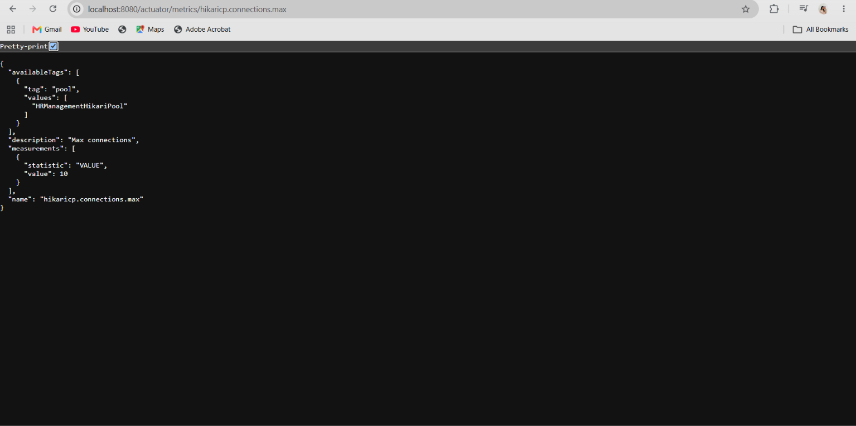
C. Duplicate Constraint Response
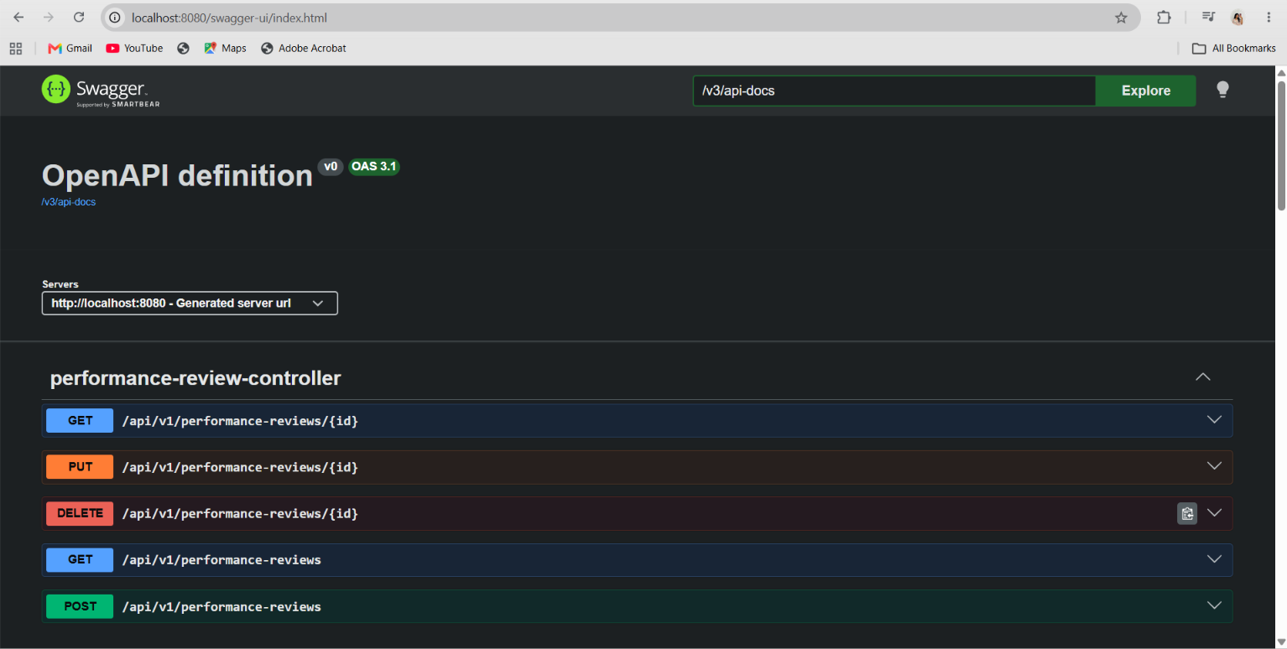
D. Additional Postman API Snapshots
The following screenshots are authentic Postman test results from the HR Employee Management System.
Duplicate employee constraint — 409 Conflict
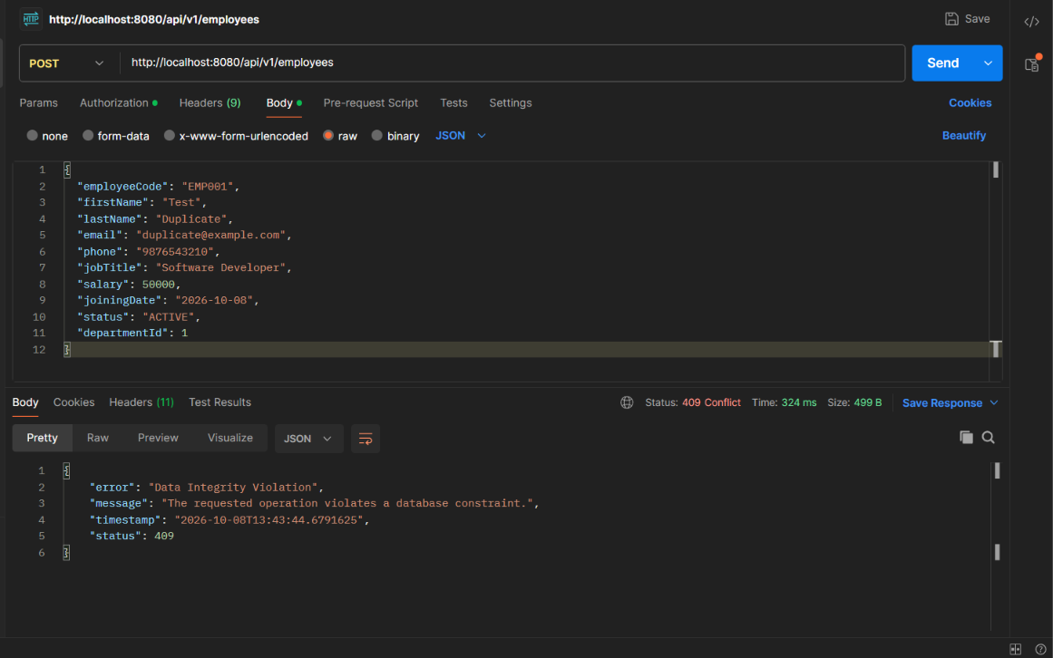
Employee validation test — 400 Bad Request
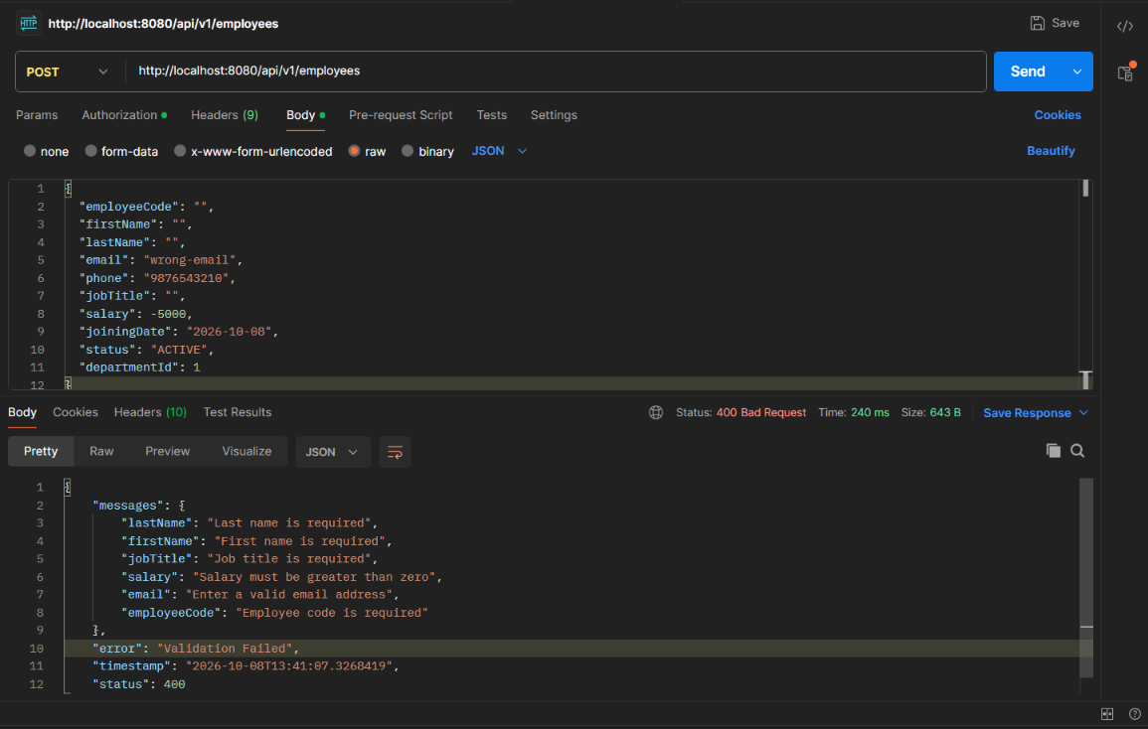
Employee GET by ID — 200 OK
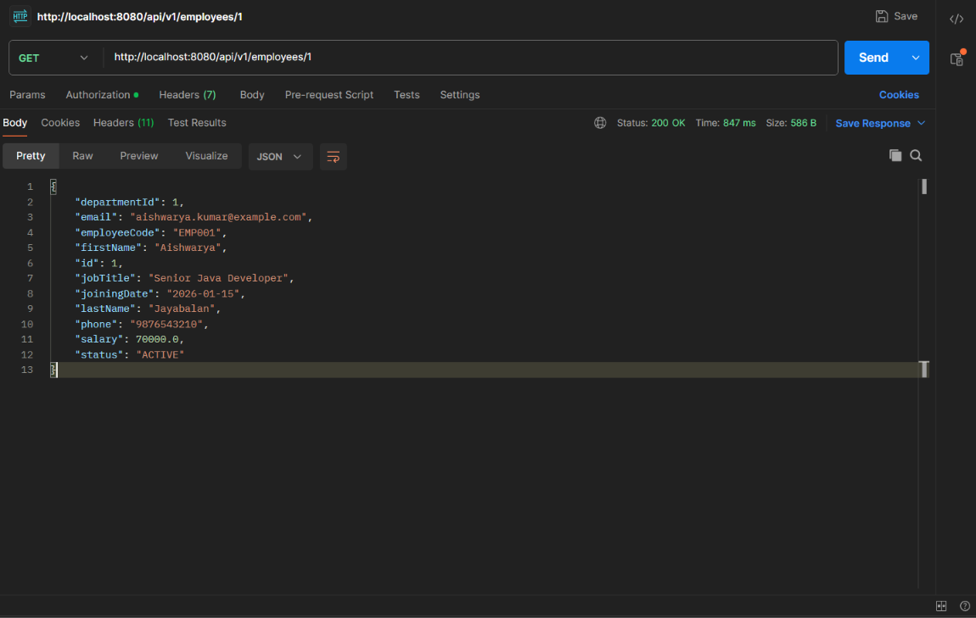

21. Common Errors
Error | Solution
401 Unauthorized | Provide valid Basic Authentication credentials.
403 Forbidden | Verify the authenticated user has the required access.
400 Bad Request | Check request fields and validation constraints.
404 Not Found | Verify the resource ID and endpoint.
409 Conflict | Check unique/database constraints such as employeeCode or email.
MySQL connection error | Start MySQL and verify environment variables and datasource settings.
Port 8080 already in use | Stop the other process or change server.port.
Swagger unavailable | Verify the application is running and open /swagger-ui/index.html.
HikariCP metric unavailable | Verify Actuator exposure and the datasource has initialized.

22. Project Summary
The HR Employee Management System demonstrates a complete backend REST application using Java 17 and Spring Boot 4.1.1. It combines REST APIs, Spring Data JPA/Hibernate, MySQL, validation, centralized exception handling, DTOs, custom mappers, pagination and sorting, customized JPQL/native queries, Basic Authentication with BCrypt, transactions, auditing, caching, scheduling, Actuator, HikariCP, Swagger/OpenAPI and environment-specific YAML profiles. The layered architecture and versioned /api/v1 endpoints make the application suitable for professional demonstration, testing and further extension.
— End of Project Documentation —

