SQL Basics – Assignment # 3
Part I – Interactive SQL queries.
This assignment is based on the CUSTOMERS-PRODUCTS-AGENTS-ORDERS.
For each question, load the files below that should be in this assignment folder:
create.sql -- to create the tables
insert.sql -- to load the data.

To load the scripts, open the file, select all, open A SQL command line prompt (MySQL or SQL Server or Oracle) and Paste it. Note that you might have to make minor modifications in the data type depending which DBMS you use. After you load the tables (insert.sql), from the SQL prompt type in the commands in bold

SQL>SELECT * FROM Customers;
SQL>SELECT * FROM Products;
SQL> SELECT * FROM Orders;
SQL>SELECT * FROM Agents;

you should have the following data shown below:
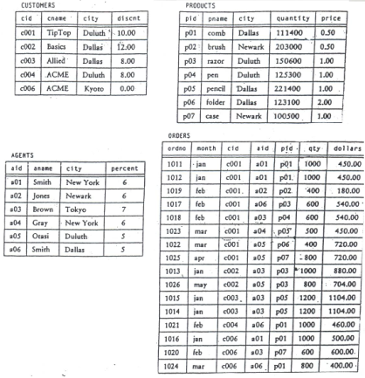
For the following queries, some have the answers that are in bold. Just copy and paste the SQL command in bold and show the result. I want to see the question, the SQL query and the result.

1) List name of products located in Dallas.
SELECT pname FROM products WHERE city = 'Dallas'; note that it needs to be straight quotes, not curly such as ‘Dallas’ (wrong);
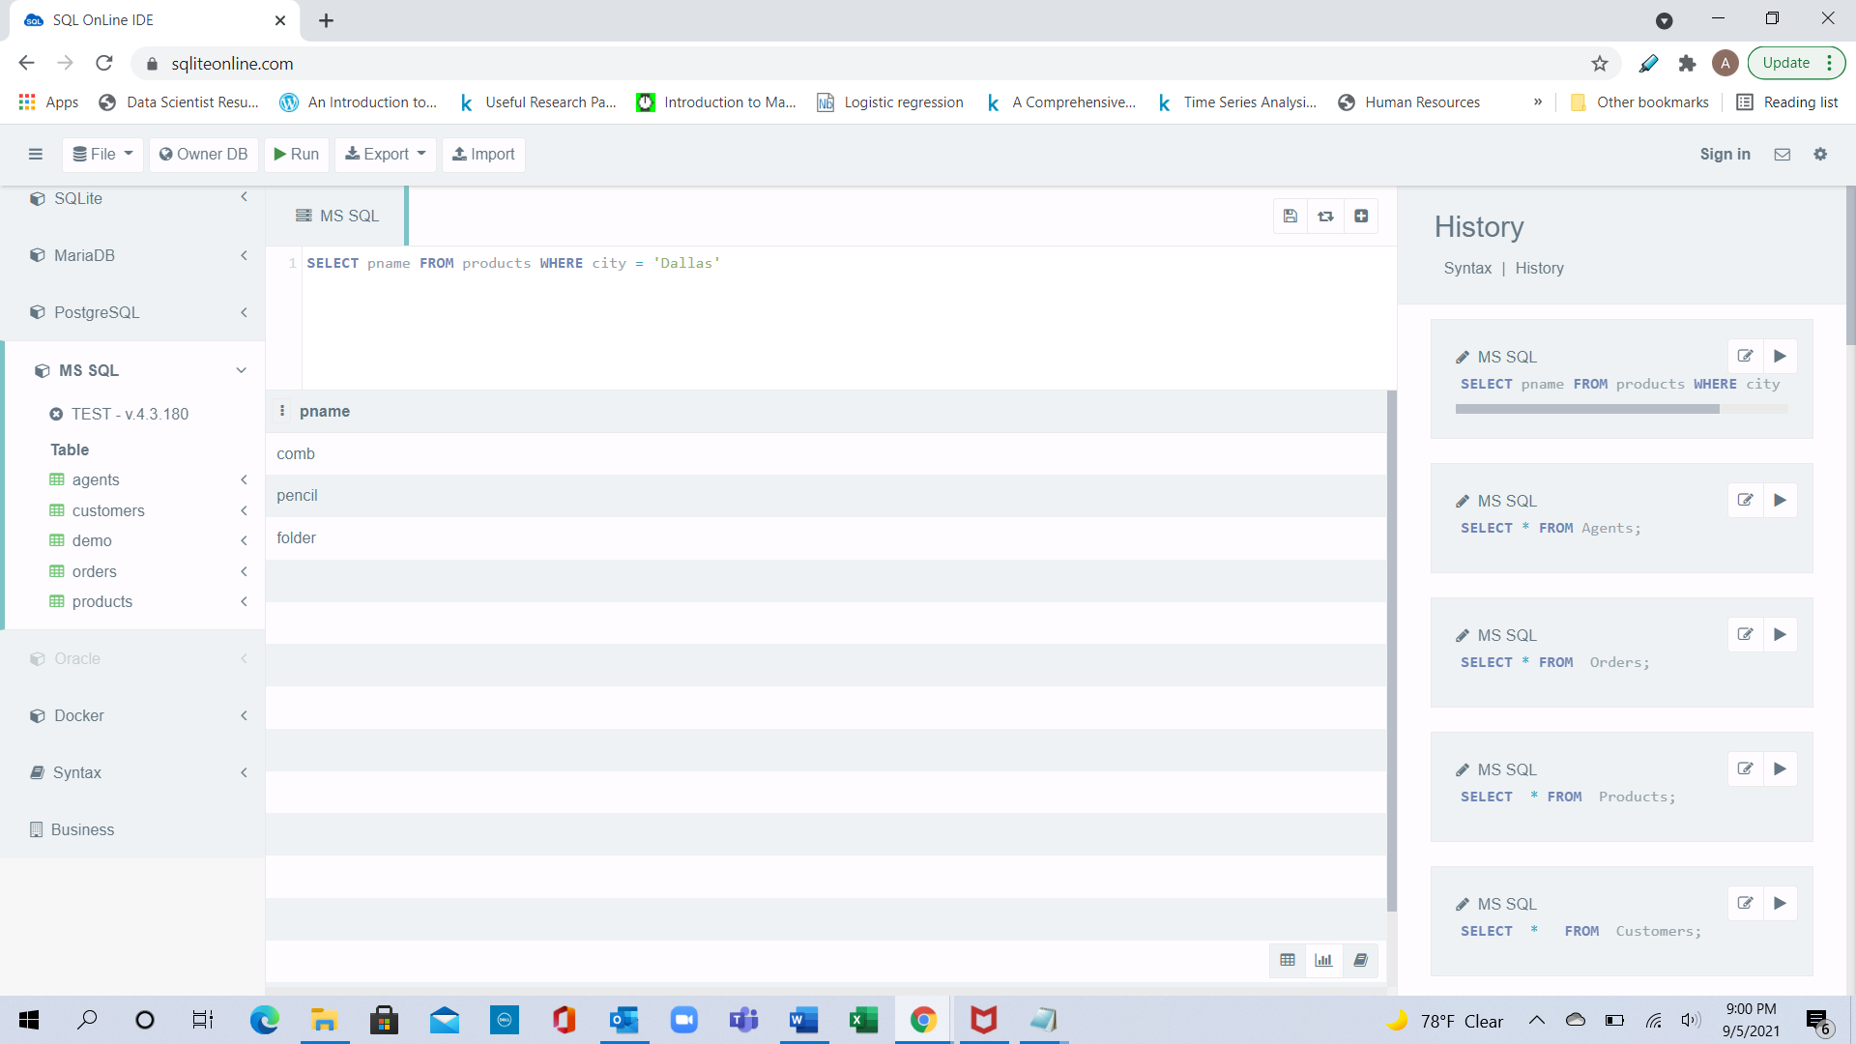

2) List name of products that are not located in Dallas;
Ans: - SELECT pname FROM products WHERE city <> 'Dallas'
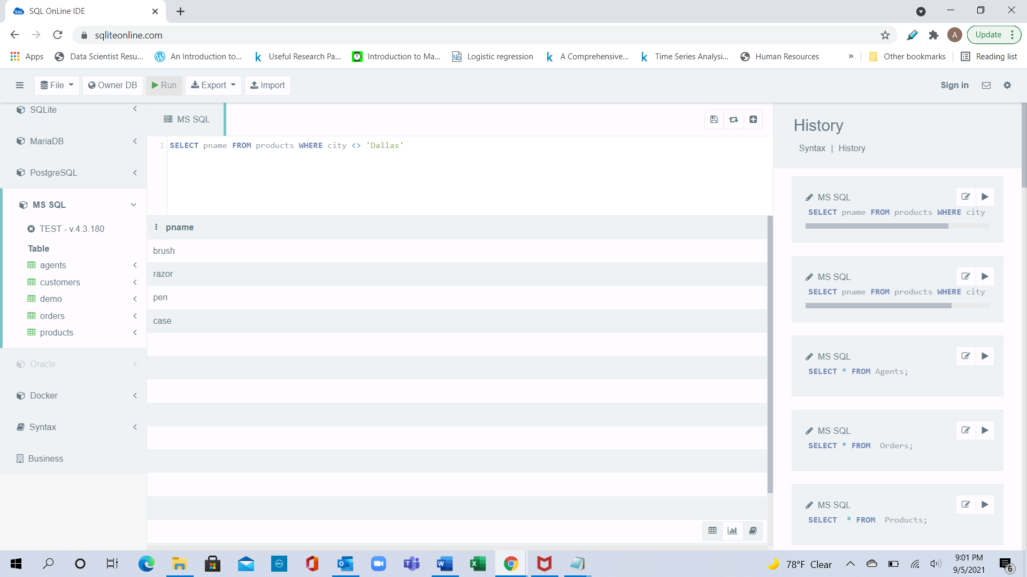

3) List aid of Agents that placed an order for customer c003 or customer c006.
Ans: - SELECT DISTINCT aid FROM orders WHERE cid IN ('c003', 'c006')
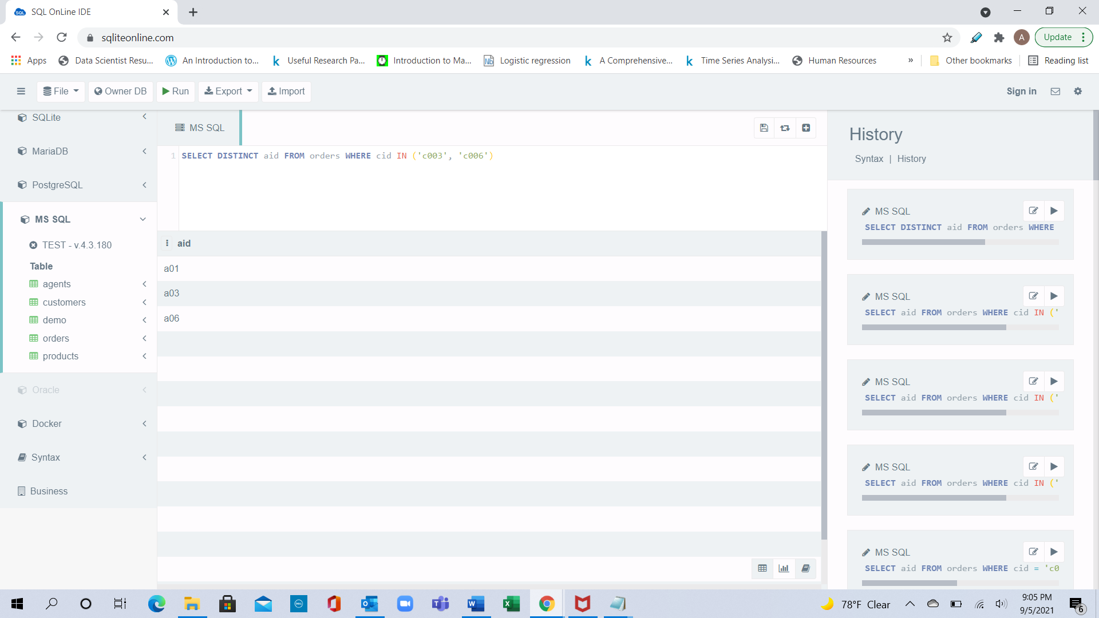

4) List pid of Products that were Ordered for customer c003 or customer c006.
Ans: - SELECT DISTINCT pid FROM orders WHERE cid IN ('c003', 'c006')
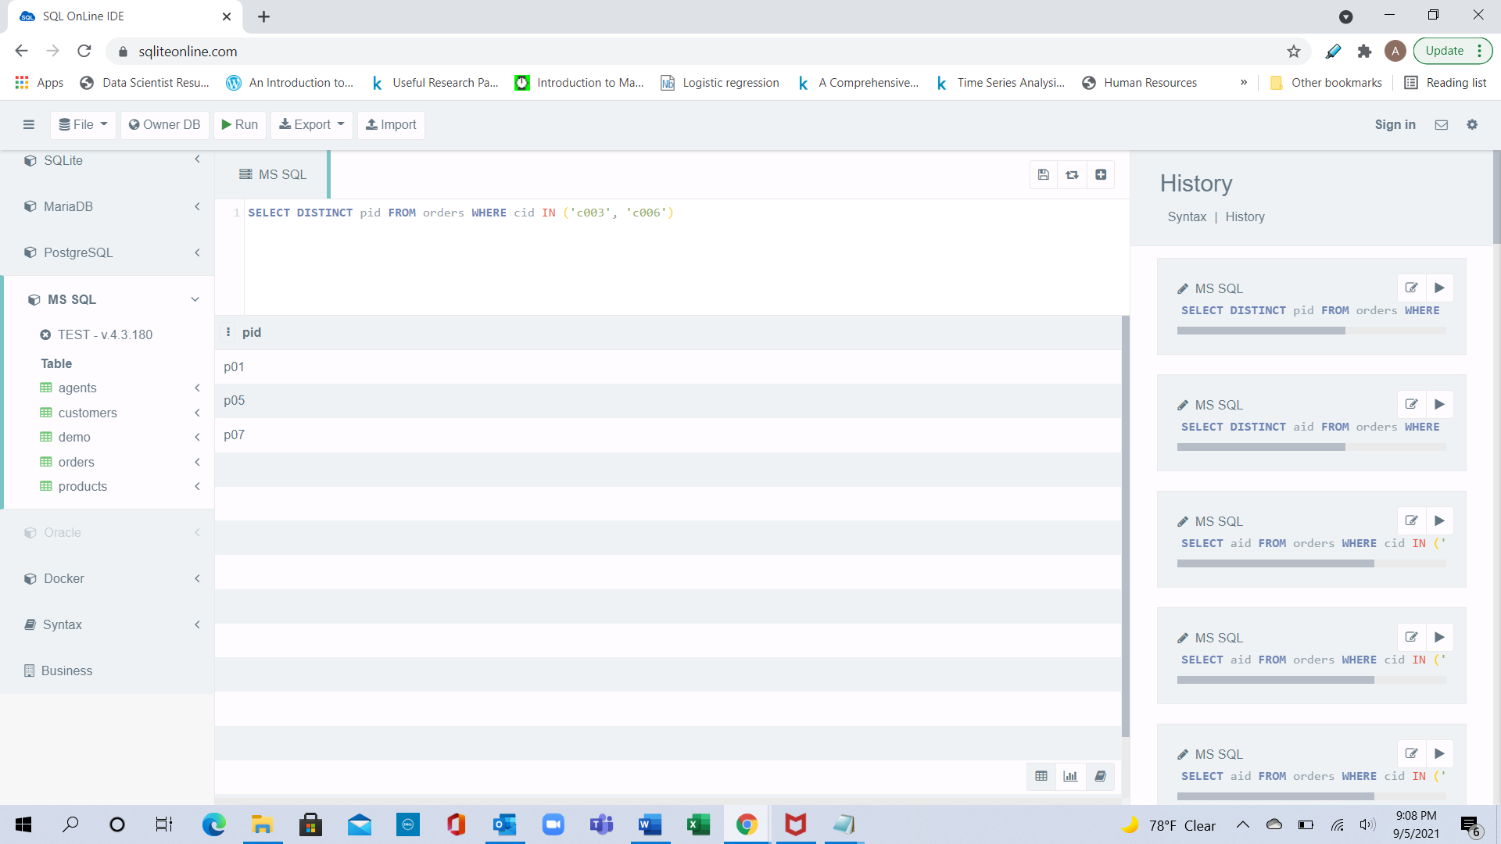

5) List the sum in dollars of all orders
Ans: - SELECT sum(dollars) as Total FROM orders
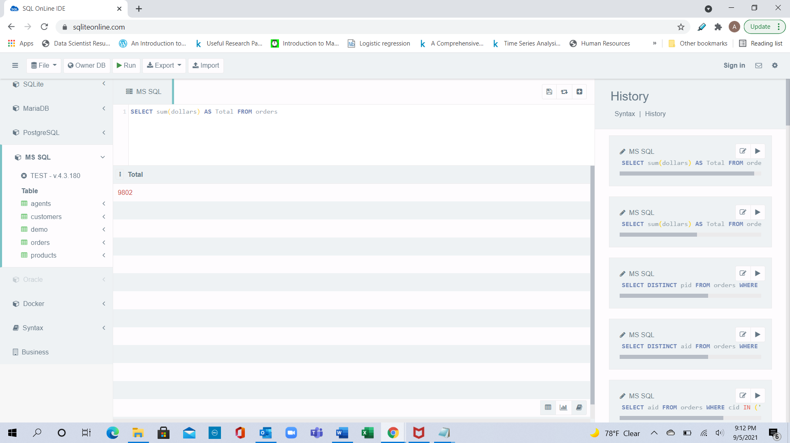

6) List the Customers table ordered by name (in ascending order)
Ans: - SELECT * FROM customers order by cname ASC
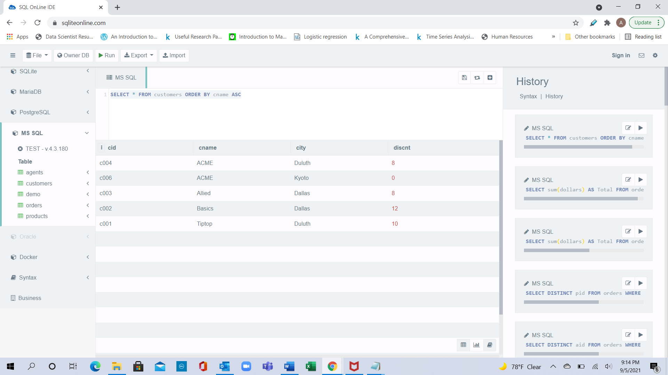

7) List the sum in quantity ordered by pid (Interactive SQL -> Constructing SQL Queries - advance -> Functions and Group By).
Ans: - SELECT pid, sum(qty) FROM orders GROUP BY pid order by pid ASC
