Atria University · Centre of Excellence
Solar–BESS Dispatch Simulator — System Design v2
Baseline Scenarios 1–3 · includes build guide, variable dictionary, user-input map, and output samples · status: implemented (dispatch_sim v1)
1. HOW THE SYSTEM IS BUILT — STEP BY STEP
The build follows the team plan's order, bottom-up, each layer tested before the next:
Step | What is built | Why in this order
1 | DSM settlement module (core/dsm_settlement.py): deviation % of Available Capacity per Reg 6(2); marginal volume-limit band slices at contract-rate-linked charges per Reg 8(4). Band tables read from dsm_bands.yaml. | The regulation math is the highest-risk piece; 20 hand-computed tests pin it before anything depends on it
2 | Battery model (core/battery.py): SoC bookkeeping, C-rate and SoC 10–90% limits, one-way efficiency √RTE, throughput counter. | Pure physics, testable in isolation; both S2 and S3 reuse it
3 | Ledger (core/ledger.py): for each 15-min block combines schedule vs delivered → DSM settlement, degradation, O&M → a profit row. | One P&L definition shared by every scenario — numbers stay comparable
4 | Runners (runners/rules.py): S1, S2, S3 as thin rule layers that only decide the schedule and how power flows; everything else is the shared engine. | Adding Scenario 5 later means adding one runner, nothing else
5 | IO (io/loaders.py, io/report.py): CSV/JSON/YAML in, xlsx out. | Input and output contracts frozen last, once the engine is stable
6 | CLI (cli.py) + sample day data: one command runs everything end to end. | The demonstrable 'input in → output out' the director asked for
2. WHERE THE USER INPUTS, WHAT COMES OUT
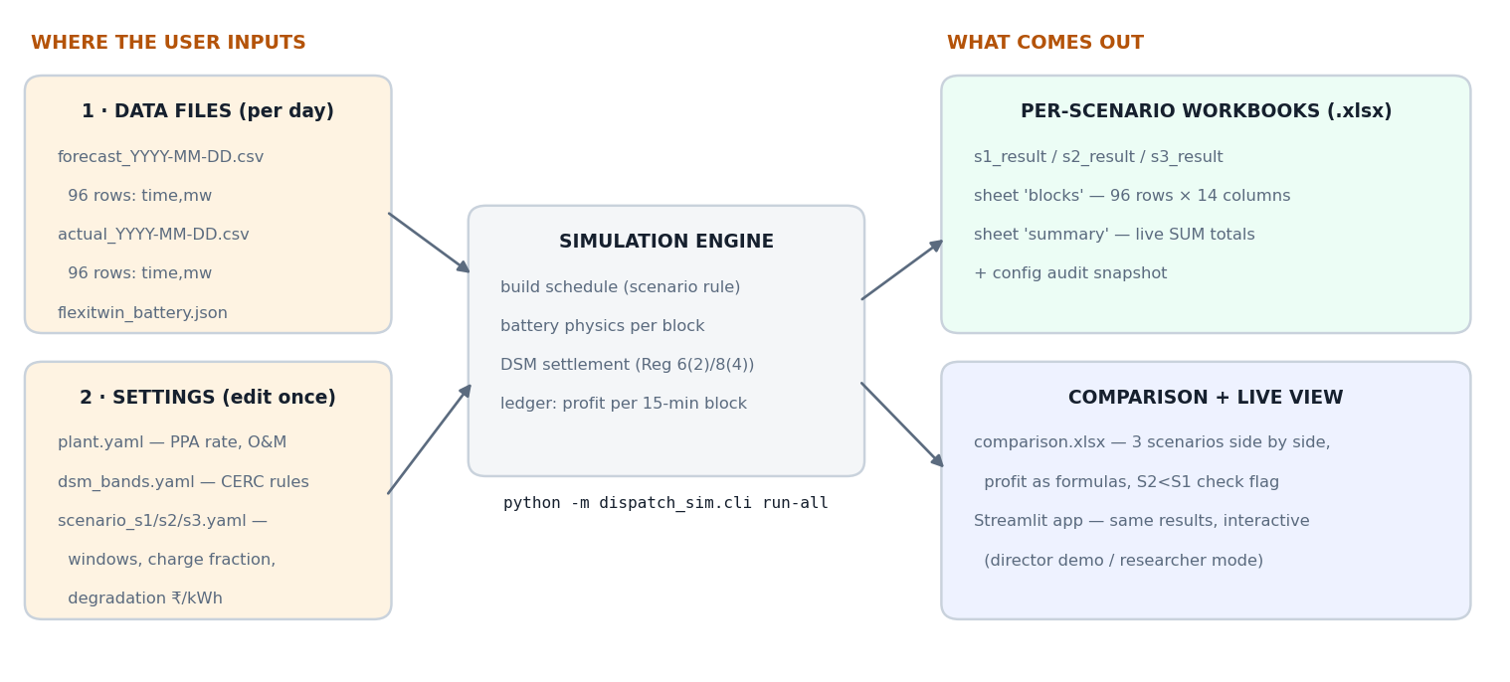
Two kinds of user input, deliberately separated: per-day data files (the forecast and actual CSVs from the forecasting module and plant telemetry, plus the flexitwin battery export) and edit-once settings (YAML files holding the commercial terms, CERC bands, and scenario rules). An analyst never touches Python code to change an assumption — only YAML.
3. VARIABLE DICTIONARY — EVERY INPUT THE SIMULATION TAKES
Grouped by where the user provides it. NC = needs confirmation from the named team; the value shown is the working placeholder.
A · Time-series data files (per day)
Variable | Unit | Meaning | Source
forecast_mw[t], t=0..95 | MW | Day-ahead generation forecast per 15-min block; becomes the basis of the submitted schedule | Forecasting module CSV
actual_mw[t] | MW | Realized generation per block | Plant telemetry CSV
B · Plant & commercial (plant.yaml)
Variable | Unit | Meaning | Source
plant_mw = 10 | MW | Installed capacity; AvC per block = plant_mw × 0.25 MWh — the DSM denominator | Project spec
ppa_rate = 2.60 (NC) | ₹/kWh | Flat PPA contract rate; also the base for every DSM band charge | Signed PPA (range 2.5–3.5)
om_inr_per_day = 20,000 (NC) | ₹/day | Fixed O&M, allocated equally to 96 blocks (decision D4) | Project finance team
C · CERC DSM rules (dsm_bands.yaml)
Variable | Unit | Meaning | Source
denominator = available_capacity | — | Basis of deviation %: AvC per Reg 6(2); 'blended' supported for the 2026 amendment | CERC DSM 2024
volume_limits_pct = [5, 10, 20] | % of AvC | VL1/VL2/VL3 band edges for solar; deviation split marginally across them | Reg 8(4) (NC vs notified text)
over_rates = [1.0, 0.9, 0.5, 0] | × PPA rate | What the seller is PAID per band for over-injection | Reg 8(4)
under_rates = [1.0, 1.1, 1.5, 2.0] | × PPA rate | What the seller PAYS per band for under-injection | Reg 8(4)
D · Battery (flexitwin JSON) — used by S2 and S3
Variable | Unit | Meaning | Source
batteryUsableCapacity = 40 | MWh | Usable energy capacity | flexitwin
cRateMW = 20 (NC) | MW | Max charge/discharge power | Battery spec sheet
roundTripEfficiency = 0.88 (NC) | — | RTE; one-way η = √RTE applied on charge and on discharge | Battery spec sheet
socMinPct/socMaxPct = 10/90 (NC) | % | Operating SoC window | Assumed, needs sign-off
degradation = 2.5 (NC) | ₹/kWh | Cost per kWh of throughput × 0.5 (decision D3); the single most sensitive input | Estimated ₹2–3
E · Scenario rules (scenario_s2/s3.yaml)
Variable | Unit | Meaning | Source
revise_schedule_for_rte = true | — | S2: schedule = forecast × RTE, so the plant schedules what it can actually deliver (decision D1) | Design decision
charge_window = 09:00–14:00 (NC) | — | S3: when the battery charges | To be agreed with team
discharge_window = 18:00–22:00 (NC) | — | S3: when it discharges (one cycle/day) | To be agreed with team
charge_fraction = 0.35 | — | S3: share of in-window generation diverted to the battery | Tunable
schedule_integrated = true | — | S3: planned charge/discharge baked into the schedule so timed discharge earns full PPA rate (decision D2) | Design decision
4. WHAT THE SIMULATION COMPUTES PER BLOCK (DERIVED, NOT INPUT)
For every 15-min block t: scheduled_mwh and delivered_mwh; deviation = delivered − scheduled; deviation % = deviation ÷ AvC; the deviation is split into marginal band slices and charged/paid per the rate tables above; degradation = block throughput × 1000 × ₹/kWh × 0.5; om = om_inr_per_day ÷ 96; and finally profit = ppa_revenue + dsm_receivable − dsm_payable − degradation − om. Battery blocks additionally record state of charge. The identity profit-components = actual×rate − penalty is unit-tested.
5. WHAT THE OUTPUT LOOKS LIKE
Each scenario writes one workbook. Sheet “blocks” is the plan's required 96-row spreadsheet — actual render of a generated file:
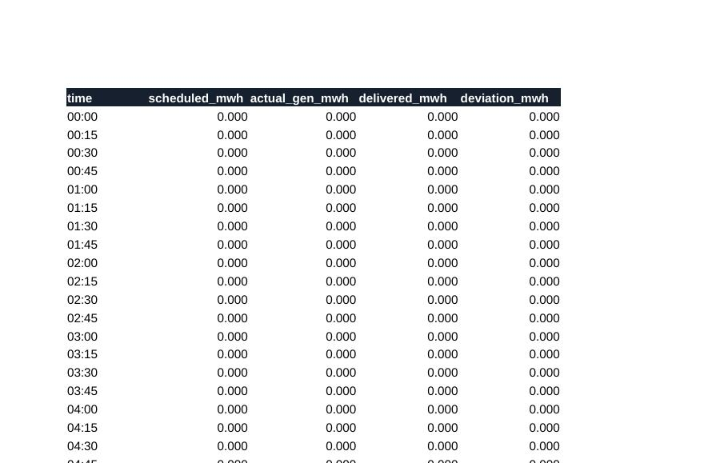
Sheet “summary” holds live SUM formulas over the blocks plus the config audit snapshot; comparison.xlsx puts the three scenarios side by side with profit as formulas and the built-in S2-worse-than-S1 check. The same ScenarioResult feeds the Streamlit app for the director's live demo. Sample-day results: S1 ₹118,777 · S2 −₹37,583 · S3 ₹80,523 — confirming the plan's expectation that under a flat PPA the battery cannot pay for itself on DSM avoidance alone.
6. RUN IT
python -m dispatch_sim.cli run-all --forecast sample_data/forecast_2026-06-14.csv --actual sample_data/actual_2026-06-14.csv --battery sample_data/flexitwin_battery.json --out output/
Swapping the sample CSVs for real forecast-module output and telemetry requires no code changes — the input contract (96 rows, columns time,mw) is the only requirement.

