DIGITAL ASSIGNMENT -1
Natural Language
Processsing

NyayaSethu: Validity –

Aware Precedent Retrieval and

Summarization for Indian Case Law

Done By :

Aishwarya Nachammai - 23MIS1080
Deepika K - 23MIS1011

1. Project Title
- NyayaSet – Validity Aware Precedent Retrieval and Summarization for Indian Case Law

- NyayaSethu – A bridge to Justice between the person’s situation and the body of law that governs it.

- Precedent Retrieval is the finding. The user supplies a plain description of the dispute and the system returns prior judgements that turn on the same point of view

- Summarization is the reading. Rather that serving a forty-page judgement or a fixed summary, the system produces a short account written specifically against user’s facts.

- Validity awareness is the checking. Every retrieved judgement carries a verdict on whether it is still good law. Read Citations -> Categorize treatments -> Distinguished or Overruled -> Weight to Larger / Senior Benches -> Combine to form a query able status report.

2. Problem Statement

First — what precedent actually is. In India, when a court decides a case, the rule it lays down binds later courts facing similar situations. So the law isn't only what's written in the statute books; it's also the accumulated decisions interpreting them. A lawyer arguing today reaches back into that pile.

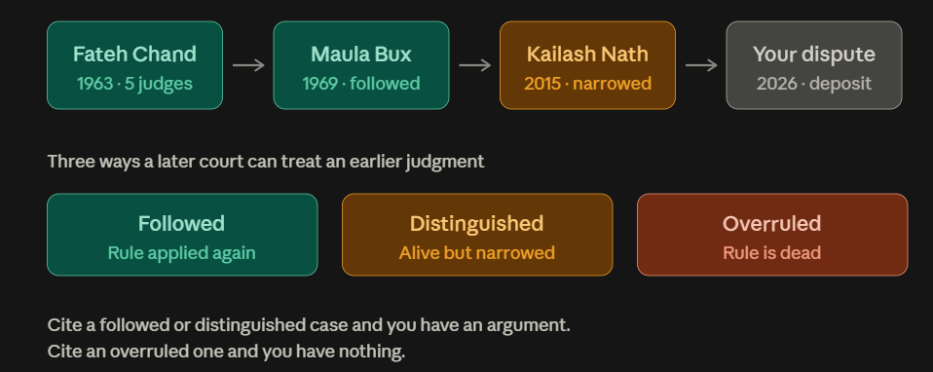

But the pile isn't static. A later court can follow an earlier judgment, distinguish it (say the facts here are different, so it doesn't apply — the judgment survives), or overrule it (say the earlier view was wrong — the judgment dies). Here's a real chain, all four about the same question: can you keep someone's money without proving you lost anything?

Second — what's inside one judgment. A judgment is not a page of "the rule." It's twenty to fifty pages of prose, and the part that actually binds later courts is a couple of sentences buried in it. Different sentences do different jobs. Here's Fateh Chand, flattened into its parts.The Ratio line is the one that binds. Everything above it is context. And notice the vocabulary — earnest money, sale deed, vendor. A gratuity case deciding the identical principle would share none of those words. That's why word-matching search fails: it compares the grey rows, which are long and full of incidental nouns, and ignores the teal rows, which are short and carry the actual meaning.

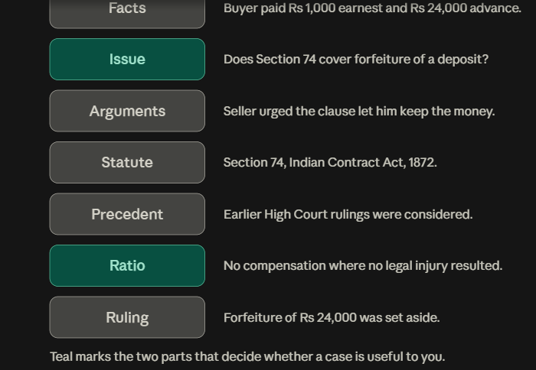

Third — what the system does. Four steps, in the order a lawyer would do them by hand. Now the formal version, ready to drop into the report.

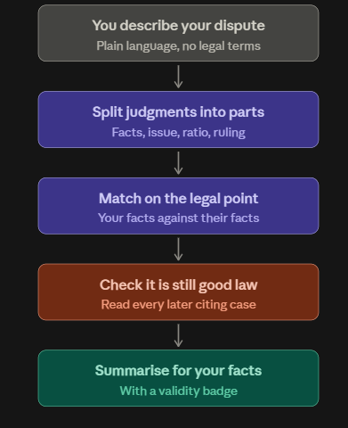

Problem Statement :

Need. India is a common-law jurisdiction: under Article 141 the law declared by the Supreme Court binds every court in the country, and High Court decisions bind the courts below them. A practitioner preparing any matter must therefore locate the prior judgments that govern it, extract the binding proposition from among thousands of words of narration and argument, and confirm that the proposition has not since been narrowed or destroyed. All three steps are performed manually today, against a backlog exceeding 55 million pending cases.

Necessity. Each step resists the tools available. Retrieval is defeated by vocabulary: two judgments deciding the same principle may share almost no terms, because one concerns a tenancy and the other an employment gratuity, while two judgments sharing every term may answer entirely different questions. Reading is defeated by length: Indian judgments average around four thousand words and carry no section headings, so the operative sentences must be found by reading the whole. Verification is defeated by absence: India has no public equivalent of the citator services available in other common-law systems, and the distinction that matters most in practice — between a precedent that was distinguished on its facts and therefore survives, and one that was overruled and therefore does not — is nowhere surfaced automatically.

Differentiation from existing work. Commercial platforms retrieve by keyword and rank by citation frequency, favoring prominent judgments over apposite ones. Research on prior-case retrieval ranks whole documents without explaining relevance. Research on legal summarization produces a single generic headnote per judgment, served identically to every user regardless of the question being researched. Indian Kanoon deploys two closer features — machine-learned structural segmentation into eight categories, and a "reliability of precedents" signal labelling cited-case discussion as relied by party, accepted by court, negatively viewed, or no clear sentiment. Neither closes the gap. The reliability signal is inward-looking, annotating how a given judgment treated the cases it cites, with no aggregation across all later judgments into a verdict on whether a precedent still stands; its categories are sentiment rather than doctrine, so distinguishing and overruling collapse into one bucket despite opposite legal consequences; it applies no weighting for bench strength, although a coordinate bench cannot overrule a larger one; and it is proprietary, with no published evaluation. Segmentation, reliability and search also remain three disconnected features, none feeding the others.

Why do large language models not resolve this. An LLM summarizes a judgment placed before it competently, and recognises shared principle across differing vocabulary. It fails on the parts that determine whether a legal research tool is usable. It cannot search a corpus of millions of long judgments that will not fit in a prompt, so retrieval remains an unsolved external problem whose quality caps the whole system. Asked for authorities directly, it generates plausible case names and citations that do not exist — a failure mode that has already produced professional sanctions in several jurisdictions. It cannot determine how a judgment was later treated, because that depends on documents it may never have read, and it reports a guess in the same confident register as a fact. Empirically, the IL-TUR benchmark shows general-purpose LLMs trailing task-specific models on Indian prior-case retrieval, and the Legals study shows the same for rhetorical-role classification. This project therefore reports an LLM baseline in its results rather than assuming one.

What this work solves. Given a query case expressed as an unstructured factual narrative, a corpus of prior judgments, and the citation graph over that corpus, the system produces a ranked set of precedents relevant to the legal issue rather than to lexical overlap; for each, a summary conditioned on the querying facts stating the issue, material facts and ratio decidendi in relation to them; and a doctrinal validity label drawn from followed, distinguished, overruled, or insufficient evidence, inferred by classifying every later judgment that cites the precedent and aggregating those judgments with weight given to bench strength and recency. Every asserted claim is traceable to a source sentence, and generated summaries pass an entailment check against the source before being shown.

Scope. The system is assistive, not advisory. Outcome prediction, sentencing and bail recommendation are outside its scope. The corpus is restricted to English-language Supreme Court and High Court judgments.

3. Justification Analysis

3.1 Need — the scale of the problem
In March 2026 the total number of cases pending across all levels of the Indian judiciary crossed 55.8 million, including over 180,000 pending for more than thirty years in the district and High Courts, with 49 million of the 55 million sitting in the district courts alone. The Supreme Court closed March 2026 with 93,143 cases pending — the highest in three decades. Analysis by Daksh puts the average time to disposal at nine years by 2026. Pendency of court cases in India +2
Precedent research is a direct input to case preparation, and under Article 141 it is not optional — the law declared by the Supreme Court binds every court in the country. Judgments in the standard Indian benchmarks average roughly four thousand words, with constitutional matters running well beyond ten thousand. Time spent locating and reading authority is time not spent disposing of matters.
Verify these figures against the live NJDG portal before submission and cite the retrieval date; they update daily.

3.2 Gap — what exists and where it stops
Existing capability | What it does | Where it stops
Keyword search on commercial platforms | Boolean and phrase search, citation-count ranking | Matches vocabulary, not legal issue; ranks by prominence over aptness; returns unsegmented judgments
Indian Kanoon structural analysis | A machine-learned model automatically segments any judgment over five paragraphs into Facts, Issues, Arguments by Appellant, Arguments by Respondent, Precedent Analysis, Analysis of Law, Court's Reasoning and Conclusion | Segmentation is offered as a reading aid; it does not feed retrieval, and paragraph-level granularity mixes roles within a paragraph
Indian Kanoon reliability of precedents | Extracts the discussion around each cited case and labels the court's opinion as Relied by Party, Accepted by Court, Negatively viewed by Court, or No clear sentiment | Inward-looking (how this judgment treats its cites), never aggregated into a verdict on a precedent; sentiment rather than doctrine, so distinguishing and overruling collapse together; no bench-strength weighting; proprietary, with no published evaluation
Prior-case retrieval research (AILA, IL-PCR, CaseLink) | Ranks candidate prior cases against a query case | Treats judgments as flat text or graph nodes; offers no explanation of relevance
Legal summarization research (IN-Abs, DELSumm, LED variants) | Produces one headnote per judgment | Identical output for every user regardless of the issue being researched
Citator services (Shepard's, KeyCite) | Flag whether an authority remains good law | Commercial, foreign, with no Indian public or research equivalent
The gap is not that structural segmentation is unavailable — it is deployed and commoditised. Nor is it that no treatment signal exists — a sentiment-based one ships free on Indian Kanoon. The gap is that no system aggregates treatment across all citing judgments into a doctrinal verdict on whether a precedent still stands, distinguishes surviving-but-narrowed from dead, weights that judgment by bench strength, or connects any of this to retrieval and summarization in one pipeline. That intersection is unoccupied.

3.3 Why large language models do not close it
An LLM summarizes a supplied judgment competently and abstracts across differing vocabulary. It fails on the load-bearing parts. It cannot search a corpus of millions of long judgments that will not fit in a prompt, so retrieval remains an external problem whose quality caps the system. Asked for authority directly, it fabricates case names and citations that sound correct and do not exist — a failure that has already produced professional sanctions in several jurisdictions. It cannot determine how a judgment was later treated, since that depends on documents it may never have read, and it reports the guess in the same register as a fact. The IL-TUR benchmark, which spans rhetorical role prediction, prior case retrieval and summarization over long Indian judgments, was introduced precisely because these tasks are grounded in real legal workflow rather than in testing law knowledge, and general LLMs trail task-specific models on its retrieval tasks. LegalSeg reports the same for rhetorical role classification, where instruction-tuned models highlight the limitations of LLMs on the task. The project therefore reports an LLM baseline in its results table rather than assuming the comparison. arXivarXiv

3.4 Feasibility
- Data exists. LegalSeg (7,000+ documents, 1.4M sentences), the OpenNyAI corpus (354 judgments, 13 roles), IL-PCR, AILA, IN-Abs, IN-Ext and ILDC are all publicly released for research. No annotation is required to begin.
- The novel component has free supervision. The OpenNyAI scheme already distinguishes Precedent Relied Upon, Precedent Not Relied Upon and Precedent Overruled at sentence level. These become distant supervision for the doctrinal treatment classifier — which is what makes an otherwise ambitious component tractable in one semester.
- A baseline is available for free. The Indian Kanoon API returns structural analysis and reliability labels, giving a deployed commercial comparison point at zero cost.
- Compute is modest. Every selected model is under 500M parameters and fine-tunes on a single T4 or P100. No proprietary API is needed for the core pipeline.
- Progress is measurable weekly. Retrieval and summarization both have established automatic metrics on the chosen benchmarks, so each stage is evaluable as it lands rather than only at the end.

3.5 Academic justification
The project exercises the ISWE310L syllabus rather than wrapping an API. It covers domain-specific tokenisation and sentence segmentation, TF-IDF and BM25 term weighting, sequence labelling with CRFs, contextual embeddings and transfer learning from a domain-adapted encoder, bi-encoder and cross-encoder ranking, long-context sequence-to-sequence generation, natural-language inference, and intrinsic and extrinsic evaluation of both retrieval and generation. The rhetorical-role stage applies discourse structure directly, connecting to the discourse-relations material in the course. It is also live research: a February 2026 study built a fifteen-category structural classifier on roughly 6,500 Indian Kanoon segments, reaching 84% accuracy with fused Legal-BERT and Indian Legal-BERT models, confirming both the difficulty and the currency of the area. Springer

3.6 Ethical justification
The system informs; it does not decide. Outcome prediction, sentencing and bail recommendation are excluded by design. Every generated sentence is grounded in an identified source sentence and gated by an entailment check, so a user can audit any claim. The validity label is reported with a confidence score and an explicit insufficient-evidence class rather than being forced to a verdict, and is presented as an aid to verification rather than a legal determination. Corpus documents are already public judicial records; no additional personal data is collected, and party names appear only as published

4. Literature Survey
Fifteen works were reviewed across five strands: rhetorical structure of legal judgments, domain-adapted language models, prior-case retrieval, legal summarization, and benchmarks and surveys. For each, the table records the system or artefact contributed, the problem it addresses, its key technical points, and the specific limitation this project exploits.

4.1 Reviewed Works
Paper, year, venue | System / artefact | Problem it solves | Key points | Limitation / gap for this work
Bhattacharya, Paul, Ghosh, Ghosh & Wyner (2019), JURIX | First rhetorical-role labeller for Indian judgments | Indian judgments carry no section headings, so no part of a judgment can be addressed programmatically | 7 roles: Facts, Ruling by Lower Court, Argument, Statute, Precedent, Ratio, Ruling by Present Court  CRF-BiLSTM sequence model over sentence features  50 Supreme Court cases across five law domains | Corpus of 50 documents is too small to generalise; roles used descriptively, never connected to retrieval
Bhattacharya, Poddar, Rudra, Ghosh & Ghosh (2021), ICAIL — DELSumm | Rule-guided extractive summarizer over rhetorical segments | Generic summarizers over-sample narration and under-sample the binding proposition | Allocates the summary length budget across roles by expert-specified weights  Demonstrates that role structure measurably improves legal summaries  Outperforms general extractive baselines on Indian judgments | Extractive only; role weights are hand-set and identical for every user and every query — no conditioning on who is asking
Kalamkar, Tiwari, Agarwal, Karn, Gupta, Raghavan & Modi (2022), LREC — OpenNyAI | Annotated corpus for automatic structuring of Indian judgments | Absence of a shared, expert-designed rhetorical-role scheme for Indian law | 354 judgments from Supreme Court, High Courts and district courts  12–13 roles including Precedent Relied Upon, Precedent Not Relied Upon and Precedent Overruled  Transformer baselines released alongside the corpus | The three precedent-treatment roles are annotated but never used downstream — this project repurposes them as distant supervision for validity classification
Malik, Sanjay, Nigam, Ghosh, Guha, Bhattacharya & Modi (2021), ACL — ILDC | Indian Legal Documents Corpus for judgment prediction and explanation | Lack of a large-scale Indian legal corpus with gold explanations | ≈35,000 Supreme Court judgments  ILDC-expert subset carries expert explanation annotations  Established Indian legal NLP as a benchmark-driven field | Framed as outcome prediction, which this project deliberately excludes on ethical grounds; used here only as a retrieval corpus
Nigam et al. (2025) — LegalSeg / RhetoricLLaMA | Largest rhetorical-role dataset plus an instruction-tuned LLM baseline | Role labelling models were data-starved and untested against modern LLMs | Over 7,000 documents and 1.4 million annotated sentences  Multiple architectures compared, including hierarchical and LLM-based  Instruction-tuned LLMs underperform specialised sequence models | Stops at segmentation; supplies the evidence for choosing an encoder-plus-CRF over an LLM in Stage 1 but builds nothing on top
MARRO (2025), Artificial Intelligence and Law | Multi-headed attention model for rhetorical role labelling | Sentence-level classifiers ignore inter-sentence dependency in long judgments | Attention over sentence sequences captures long-range role structure  Evaluated on Indian and UK Supreme Court judgments  Released labelled data for both jurisdictions | Advances accuracy on a solved-in-principle sub-task; no downstream retrieval, summarization or treatment application
Shukla, Bhattacharya, Poddar, Mukherjee, Ghosh, Goyal & Ghosh (2022), AACL-IJCNLP | IN-Abs, IN-Ext and UK-Abs summarization benchmarks | No standard datasets or evaluation protocol for Indian judgment summarization | IN-Abs: ≈7,130 judgment–headnote pairs  IN-Ext: 50 judgments with expert extractive summaries broken out segment-wise  Systematic comparison of extractive and abstractive methods | Produces one generic headnote per judgment; the segment-wise IN-Ext annotations are the closest proxy available for query-focused evaluation but were not built for it
Paul, Mandal, Goyal & Ghosh (2023), ICAIL — InLegalBERT, InCaseLawBERT | Transformers further pre-trained on Indian case law | General and non-Indian legal encoders mis-handle Indian legal register and citation forms | Pre-training corpus of ≈5.4 million Indian court cases plus over 1,000 central Acts  Consistent gains over BERT and LEGAL-BERT on Indian legal tasks  Openly released weights | Encoder only, with a 512-token limit; no retrieval or summarization system is built on top, leaving long-document handling unsolved
Joshi, Paul, Sharma, Goyal, Ghosh & Modi (2024), ACL — IL-TUR | Multi-task Indian legal benchmark with public leaderboard | Indian legal NLP tasks were evaluated in isolation with incomparable protocols | Tasks include rhetorical role prediction, prior case retrieval (IL-PCR), statute identification and summarization  Documents average around 4,000 words  Grounded in real legal workflow rather than law-exam knowledge | General-purpose LLMs trail task-specific models on prior case retrieval — this is the measured headroom the project targets, and the source of its LLM baseline
AILA shared task (2019–2021), FIRE | Precedent and statute retrieval benchmark for Indian law | No standard evaluation for retrieving prior cases from a factual scenario | 50 query case descriptions against 2,914 candidate prior cases  Expert relevance judgments  Parallel statute-retrieval sub-task | Small query set; BM25 has remained competitive across editions, indicating dense retrieval has not yet been applied effectively to this data
Tang, Qiu & Huang (2025), COLIEE — CaseLink | Graph neural network over a global case citation graph | Text similarity alone misses the connectivity structure of case law | Inductive graph learning with case nodes and citation edges  LLM text embeddings as node features  Contrastive objective with node-degree regularisation; second place in COLIEE 2025 Task 1 | Canadian and English corpora with structured judgments; retrieval only, with no summarization and no reasoning about how a case was treated
Deng, Dou, Zhou, Zhang & Mao (2024), Findings of ACL | Element-aware legal case retrieval | Whole-document similarity conflates incidental facts with legally operative ones | Decomposes cases into legal elements before matching  Element-level representation outperforms flat document embedding  Validates the principle behind role-partitioned retrieval | Chinese civil-law setting where judgments are already structured; the segmentation step it presupposes is the hard part in the Indian context
Feng, Li & Ng (2024), ACL | Survey of legal case retrieval | Fragmented literature across jurisdictions and task formulations | Consolidates task definitions, datasets and metrics  Identifies explanation of relevance as an open problem  Notes the persistent strength of lexical baselines | A survey — it confirms the gap rather than filling it; used here to justify the explanation and validity components
Augmented Question-guided Retrieval, AQgR (2025), arXiv:2508.04710 | RAG pipeline over structured summaries of Indian case law | Retrieval emphasises factual similarity over the legal issue, and gives no explanation of relevance | Generates targeted legal questions from a factual scenario to drive retrieval  Structured summaries compress judgments to fit LLM context and enable field-wise similarity  States explicitly that Indian judgments require rhetorical role segmentation because they are unstructured | No validity or treatment signal; evaluated manually by legal experts on a small set because no structured-summary dataset exists — reproducibility is limited
Segment First, Retrieve Better (2025), arXiv:2508.00679 | Rhetorical-role-based query construction for legal search | Flat queries against flat documents ignore the argumentative structure of both | Queries decomposed by role before retrieval  Compares lexical, dense and LLM-based retrieval under role segmentation  Confirms role-aware retrieval outperforms whole-document matching on Indian data | Establishes that role-aware retrieval works, which removes it from this project's novelty claim; summarization and precedent validity remain unaddressed

4.2 Deployed Systems Reviewed
Two non-academic reference points were examined, since a project that claims a gap must account for what is already shipping.
System | Capability | Problem it solves | Key points | Limitation / gap for this work
Indian Kanoon — Structural Analysis (free tier, also exposed via API) | Automatic segmentation of judgments into eight structural categories | Readers cannot navigate a long unheaded judgment to the part they need | Applies to every document longer than five paragraphs  Categories: Facts, Issues, Arguments by Appellant, Arguments by Respondent, Precedent Analysis, Analysis of Law, Court's Reasoning, Conclusion  Machine-learned; supports colour marking or reading a single category | Segmentation is a reading aid only, not connected to search; paragraph-level granularity mixes roles within a paragraph; no published evaluation
Indian Kanoon — Reliability of Precedents (free tier) | Labels the discussion around each case cited within a judgment | A reader cannot tell how the court regarded the authorities it cites | Labels: Relied by Party, Accepted by Court, Negatively viewed by Court, No clear sentiment  Extracts all discussion around each cited case  The nearest deployed analogue to a citator signal in India | Inward-looking — never aggregated across citing judgments into a verdict on a precedent; sentiment rather than doctrine, so distinguishing and overruling collapse into one label; no bench-strength weighting; proprietary and unevaluated
Multifaceted structural classification of Indian legal judgments (2026), Discover Artificial Intelligence | Fifteen-category structural classifier trained on Indian Kanoon segments | Structural classification suffers from complex legal language, class imbalance and scarce annotation | ≈6,500 manually annotated judgment segments  Domain lexicon of 5,000 legal n-grams supporting TF-IDF features  Fused Legal-BERT and Indian Legal-BERT reaches 84% accuracy and 84% weighted F1 | Confirms structural classification is an active, near-commodity research area; strengthens the case for placing this project's contribution downstream of segmentation rather than in it

4.3 Synthesis
The reviewed literature converges on four findings that jointly determine the design of this project.
- Rhetorical structure is a reliable and now well-resourced signal for Indian judgments. It has moved from a 50-document research curiosity in 2019 to a 1.4-million-sentence dataset in 2025 and a deployed commercial feature on Indian Kanoon. Segmentation is therefore treated here as necessary infrastructure, not as a contribution.
- Domain-adapted encoders outperform both general-purpose models and non-Indian legal models, while instruction-tuned LLMs trail specialised models on role labelling and prior-case retrieval. This settles the architecture choices in Stages 1 to 3 and justifies reporting an LLM baseline rather than adopting an LLM-only pipeline.
- Retrieval and summarization are consistently studied in isolation. Retrieval work ranks documents without explaining relevance; summarization work produces a single generic headnote regardless of the querying user. The 2025 AQgR work is the closest to unifying them and still stops short of conditioning summaries on the user's own facts.
- The question a practitioner asks first — whether an authority is still good law — has no doctrinal treatment for Indian case law in any reviewed work. The nearest artefacts are annotations that exist but are unused (the OpenNyAI precedent-treatment roles) and a commercial sentiment signal that is inward-looking, undifferentiated between distinguishing and overruling, and unevaluated.
The research gap addressed by this project is therefore located precisely: not in segmenting judgments, and not in the existence of a treatment signal, but in aggregating treatment across all citing judgments into a doctrinal validity verdict weighted by bench strength, and in unifying that verdict with role-aware retrieval and query-conditioned summarization under an open, reproducible evaluation

5. Dataset Description and Analysis

5.1 Datasets Selected
Eight public resources are used across the five pipeline stages. All are released for research, so no manual annotation is required to begin.
Dataset | Composition | Stage served
LegalSeg (NAACL 2025) | 7,120 Indian Supreme Court and High Court judgments; 7 rhetorical roles at sentence level; released as train/validation/test CSV and JSON | Stage 1 — rhetorical role classifier training and evaluation
OpenNyAI / Kalamkar (LREC 2022) | 354 judgments across Supreme Court, High Courts and district courts; 40,305 sentences; 13 roles including Precedent Relied Upon, Not Relied Upon and Overruled | Stage 4 — distant supervision for doctrinal validity classification
IL-PCR (from IL-TUR, ACL 2024) | Indian prior-case retrieval pairs with relevance judgments | Stages 2–3 — retrieval training and primary evaluation
AILA 2019 (FIRE) | 50 query case descriptions against 2,914 candidate prior cases with expert relevance judgments | Stages 2–3 — secondary benchmark, comparable to published BM25 results
IN-Abs | ≈7,130 Supreme Court judgment and headnote pairs | Stage 5 — abstractive summarizer fine-tuning
IN-Ext | 50 judgments with expert extractive summaries provided segment-wise | Stage 5 — role-coverage evaluation; proxy for query-focused assessment
ILDC | ≈35,000 Supreme Court judgments | Retrieval index expansion and citation graph construction
Citation graph (derived) | Cited-by edges extracted from citation strings across the above corpora | Stages 3–4 — authority prior and evidence collection for validity labelling

5.2 LegalSeg — Corpus Statistics
LegalSeg is the backbone of Stage 1 and therefore of everything downstream, so it was analysed in detail. The figures below are computed from the corpus statistics released with the dataset.
Statistic | Train | Validation | Test
Documents | 4,984 | 1,424 | 712
Sentences | 1,122,507 | 293,370 | 149,881
Mean sentences per document | 225 | 206 | 210
Mean tokens per sentence | 34 | 30 | 32
Implied tokens per document | 7,650 | 6,180 | 6,720
Total: 7,120 documents and 1,565,758 sentences across the three splits. Note that the paper's headline figure of 1,487,149 sentences does not reconcile with the sum of the per-split counts; flag this and use the per-split totals, which are the ones that matter for training.

5.3 Analysis
Finding 1 — the corpus is half unlabelled by design.
Half of all sentences carry the None label: headers, citations, tabular fragments and procedural boilerplate that belong to no rhetorical role. This sets a majority-class accuracy baseline of 50.0%. Any model reported at, say, 78% accuracy has therefore improved on a trivial baseline by less than it appears, which is why macro-F1 rather than accuracy must be the headline metric for Stage 1.
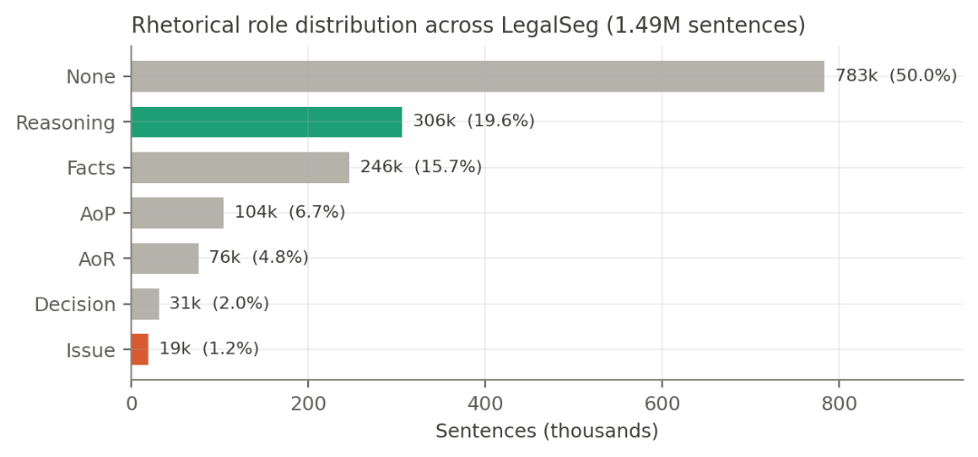
Figure 1 — Role distribution across all splits. Reasoning (teal) and Issue (coral) are the two roles the retrieval stage depends on.
Finding 2 — the two roles the project needs most are the two the data has least of.
Stage 2 matches the user's legal question against candidate judgments' Reasoning segments, and Issue statements anchor what a case is about. Reasoning is comfortable at 306,148 sentences. Issue is the rarest content label in the corpus at 18,893 sentences — 1.21% of everything — giving a 16:1 spread between the largest and smallest content classes. A classifier optimising unweighted loss will learn to predict Issue almost never and still post a respectable aggregate score, while silently starving the retrieval index of the segments it needs.
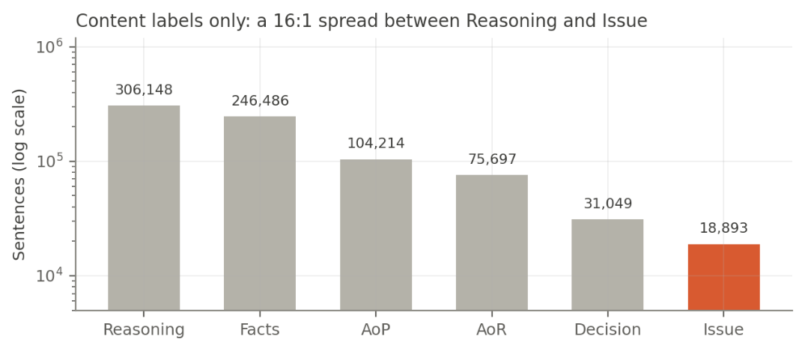
Figure 2 — Content labels on a log scale. Issue sits an order of magnitude below Reasoning and Facts.
Mitigation adopted: class-weighted cross-entropy with weights inversely proportional to frequency; macro-F1 as the reported metric; mandatory per-class F1 breakdown in every result table; and a specific acceptance threshold on Issue and Reasoning recall before Stage 2 is built on top.
Finding 3 — every judgment overflows a standard transformer by an order of magnitude.
At 225 sentences of 34 tokens, the mean training document runs to roughly 7,650 tokens — 14.9 times the 512-token limit of BERT-family encoders, and still well past Longformer's 4,096. This is not an edge case affecting long outliers; it is the average document. It settles two architecture decisions: Stage 1 must process documents in overlapping sentence windows rather than in one pass, and Stage 5 requires a long-context encoder-decoder (Legal-LED at 16,384 tokens) rather than BART or PEGASUS.
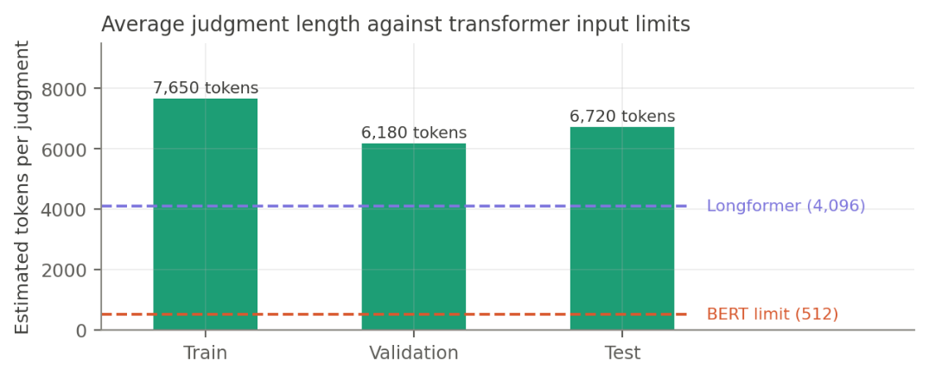
Figure 3 — Mean judgment length against transformer input limits.
Finding 4 — sentence length varies by role, and Issue is the longest.
Issue sentences average 41 tokens against a corpus mean of 34, while Decision sentences average 26. Issue statements are long because they are formally framed ("The question that falls for consideration is whether…"); decisions are short because they are dispositive. This is a usable signal: length is a cheap feature that partially separates the rarest class, and it also means Issue segments consume disproportionate space in a truncated summarizer input, reinforcing the role-priority ordering used in Stage 5.
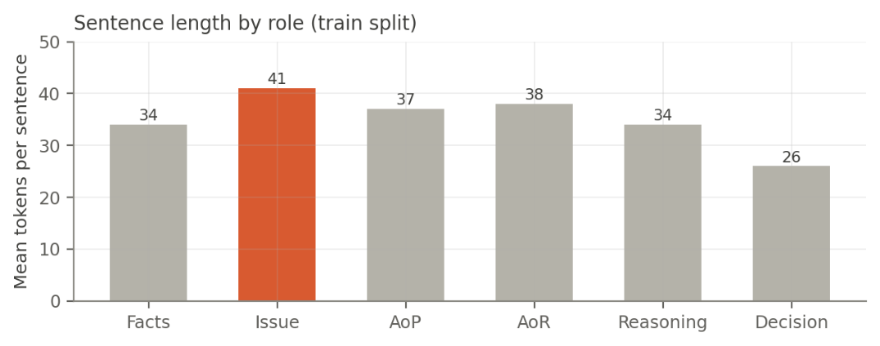
Figure 4 — Mean sentence length by role, training split.
Finding 5 — LegalSeg is twenty times larger than any prior Indian corpus, but the annotations this project needs are in the small ones.
LegalSeg's 7,120 judgments dwarf the earlier corpora, but it uses a 7-label scheme that does not include the precedent-treatment roles. Those exist only in the 13-label corpora — Kalamkar's 354 judgments and Malik's 100. Stage 4 therefore trains on roughly two orders of magnitude less data than Stage 1, which is the single largest risk in the project and is why the work plan measures treatment-label coverage in Week 2, before committing to the component.
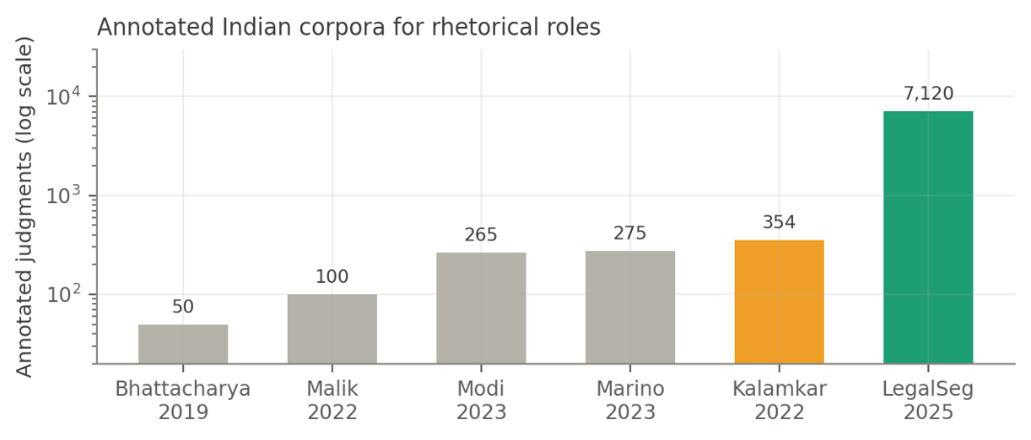
Figure 5 — Annotated Indian rhetorical-role corpora. Teal is the Stage 1 source; amber is the Stage 4 source.

5.4 Further Analyses Scheduled for Week 2
- Citation graph statistics — node and edge counts, in-degree distribution, and the proportion of precedents with enough citing judgments to support a validity label. This determines the practical coverage of Stage 4.
- Distribution of the three precedent-treatment labels within the OpenNyAI corpus, to quantify how severe the Overruled class scarcity is.
- Compression ratio of headnotes against source judgments in IN-Abs, to set the summary length budget.
- Query-document lexical overlap in AILA and IL-PCR, to quantify how much of the retrieval task BM25 can solve and therefore how much headroom the dense retriever has.
- Sentence-splitter validation on a manually checked 200-sentence sample, since citation strings and legal abbreviations break standard splitters.

5.5 Data Challenges and Handling
Challenge | Handling
Half the corpus is None; accuracy is misleading | Report macro-F1 with a per-class breakdown; state the 50.0% majority baseline in every results table
16:1 imbalance, with Issue rarest | Class-weighted loss; acceptance threshold on Issue and Reasoning recall before Stage 2 depends on them
Mean document is 14.9x the BERT limit | Overlapping sentence windows for Stage 1; Legal-LED with 16K context for Stage 5
Treatment labels exist only in a 354-document corpus | Measure coverage in Week 2; restrict Stage 4 to the most-cited subset if coverage is thin, and report coverage as a finding rather than hiding it
Standard sentence splitters break on citations and abbreviations | Legal-aware splitter with a citation-pattern and abbreviation exception list, validated on a manual sample
Published sentence totals do not reconcile | Use per-split counts; note the discrepancy in the report
No gold dataset for query-focused summaries | IN-Ext segment-wise summaries as proxy, plus a documented human evaluation on 20–30 pairs

6. Proposed Methodology
The pipeline separates into an offline phase that runs once over the corpus and an online phase that runs per query. This split matters practically: the expensive work — role classification over 7,000 judgments, embedding every segment, building the citation graph — is amortised, so query latency stays acceptable.
Stage 0 — Corpus construction. Datasets are merged and de-duplicated on case identifier. Text is normalised, split with a legal-aware sentence splitter, and citation strings extracted by regular expression over standard Indian reporter formats to build the directed cited-by graph.
Stage 1 — Rhetorical role segmentation. Each sentence is encoded with InLegalBERT; the sequence of sentence vectors passes through a BiLSTM and a CRF that scores the whole label sequence, enforcing the canonical ordering of roles. Documents averaging 7,650 tokens are processed in overlapping windows and stitched. Class-weighted loss addresses the 16:1 imbalance, with macro-F1 reported per class.
Stage 2 — Role-aware hybrid retrieval. The index is partitioned by role. Query facts match candidate Facts; the query's legal question matches candidate Reasoning. BM25 runs alongside an InLegalBERT bi-encoder over 512-token chunks with max-pooling, and the two ranked lists combine by Reciprocal Rank Fusion. Tuned for Recall@100.
Stage 3 — Reranking. An InLegalBERT cross-encoder rescores the shortlist on (query facts, candidate reasoning) pairs, combined with a PageRank authority prior over the citation graph. Output: top 10.
Stage 4 — Doctrinal validity assessment. For each retrieved precedent, every citing sentence in the corpus is collected with context and classified into followed, distinguished, or overruled, using the OpenNyAI precedent-treatment roles as distant supervision. Mentions aggregate with weight by bench strength and recency into a document-level verdict, abstaining as insufficient evidence where support is thin.
Stage 5 — Query-focused summarization. Legal-LED, fine-tuned on IN-Abs, receives the query facts followed by role-ordered segments (Issue, Reasoning, Decision first) and emits five fixed fields. An NLI entailment filter drops any generated sentence the source judgment does not entail; the rejection rate is reported alongside ROUGE

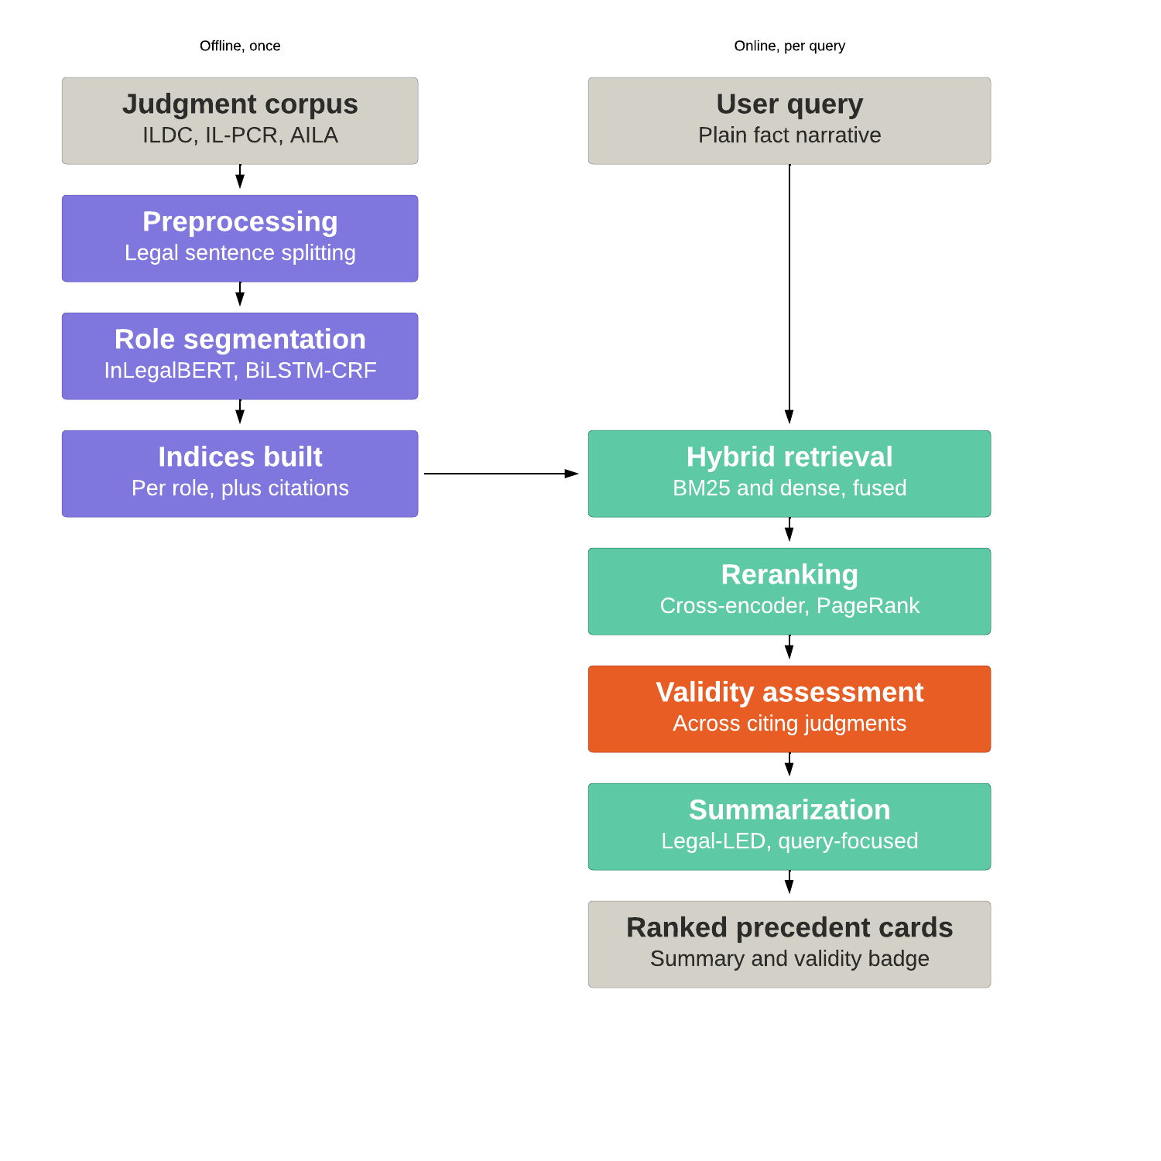

7. Algorithm Selection
Task | Selected | Alternatives considered | Rationale
Text representation | InLegalBERT | LEGAL-BERT, RoBERTa, BERT-base | Pre-trained on ~5.4M Indian court cases; reported gains over general and non-Indian legal encoders
Role labelling | InLegalBERT + BiLSTM-CRF | Independent sentence classifier; RhetoricLLaMA | CRF enforces canonical role ordering; LegalSeg shows instruction-tuned LLMs underperform here
Class imbalance | Weighted cross-entropy, macro-F1 reporting | Oversampling, focal loss | Measured 16:1 spread and a 50.0% majority baseline make unweighted accuracy meaningless
Long documents | 512-token windows, 128 stride, max-pool | Longformer encoder, hierarchical attention | Mean document is 7,650 tokens — 14.9× the BERT limit; chunk-and-pool is the cheapest correct handling
Sparse retrieval | BM25 (Okapi) | TF-IDF cosine, query-likelihood Dirichlet | Strong published AILA baseline; catches exact statute and citation matches dense models blur
Dense retrieval | InLegalBERT bi-encoder | ColBERT late interaction, Sentence-BERT | Corpus embeddings computed offline; ColBERT retained as a stretch goal
Rank fusion | Reciprocal Rank Fusion | Linear interpolation, learning-to-rank | Parameter-free; BM25 scores and cosine similarities have no common scale
Reranking | InLegalBERT cross-encoder | monoT5, LLM listwise reranking | Full query-document attention on a 100-item shortlist; compute acceptable at that depth
Authority prior | PageRank over citation graph | GNN (CaseLink-style), raw in-degree | Interpretable, untrained, cheap; GNN listed as an extension
Validity classification | InLegalBERT 3-way over citing sentences, bench-weighted aggregation | Keyword rules; zero-shot LLM prompting | Distant supervision available from OpenNyAI precedent roles; both alternatives reported as baselines
Summarization | Legal-LED (16K) fine-tuned on IN-Abs | BART, PEGASUS, LongT5, GPT-class API | Only open option that ingests a full judgment untruncated; API model used as upper-bound comparison
Faithfulness | DeBERTa-MNLI sentence-level entailment | SummaC, QAFactEval, manual review | Lightweight, auditable, produces a countable rejection log
Retrieval metrics | MAP, nDCG@10, P@10, MRR, Recall@100 | Accuracy, F1 | Standard on AILA and IL-PCR, so results compare directly to published work
Summary metrics | ROUGE-1/2/L, BERTScore, entailment rate, role coverage, human Likert | ROUGE alone | ROUGE rewards lexical overlap and is a poor proxy for legal correctness

8. Work Plan
The work plan is represented through the project timeline and task-tracking visuals below, covering the staged development, evaluation, and integration activities.
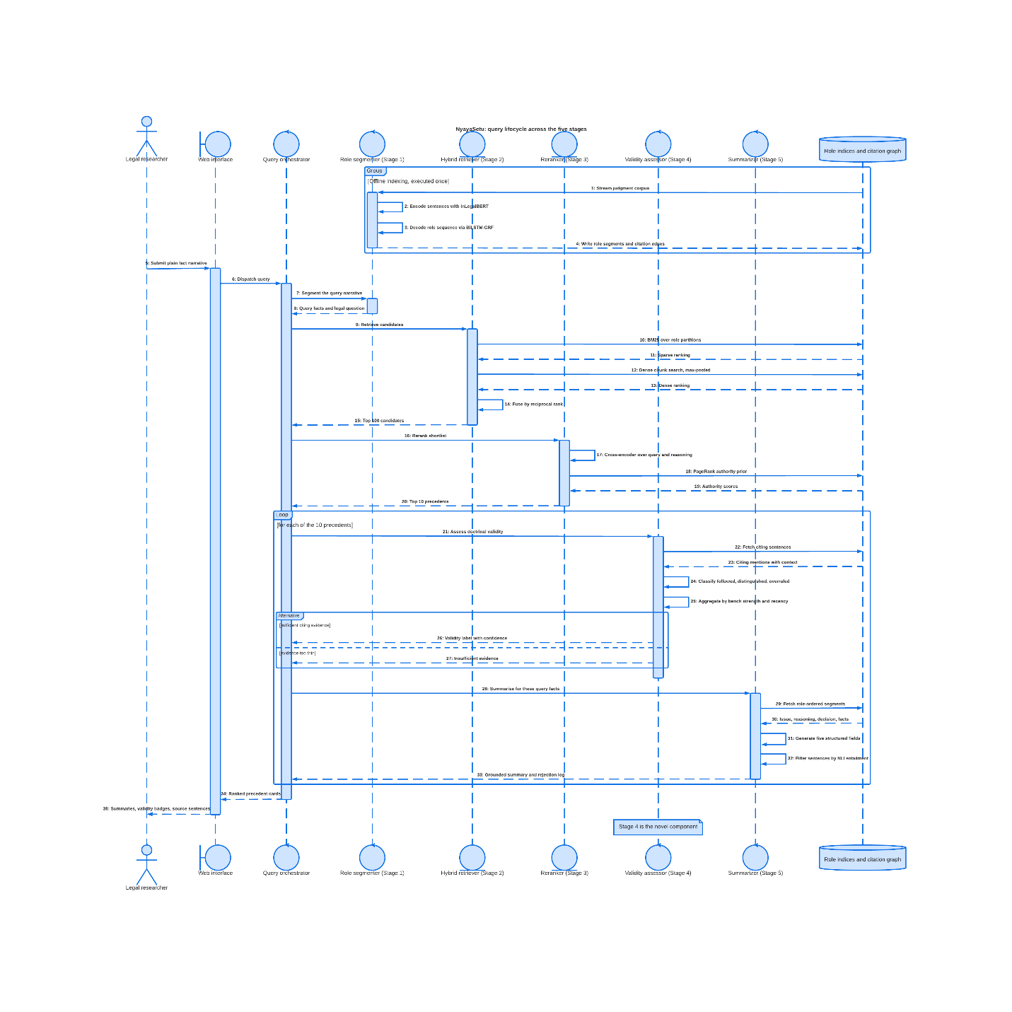
Work-plan timeline
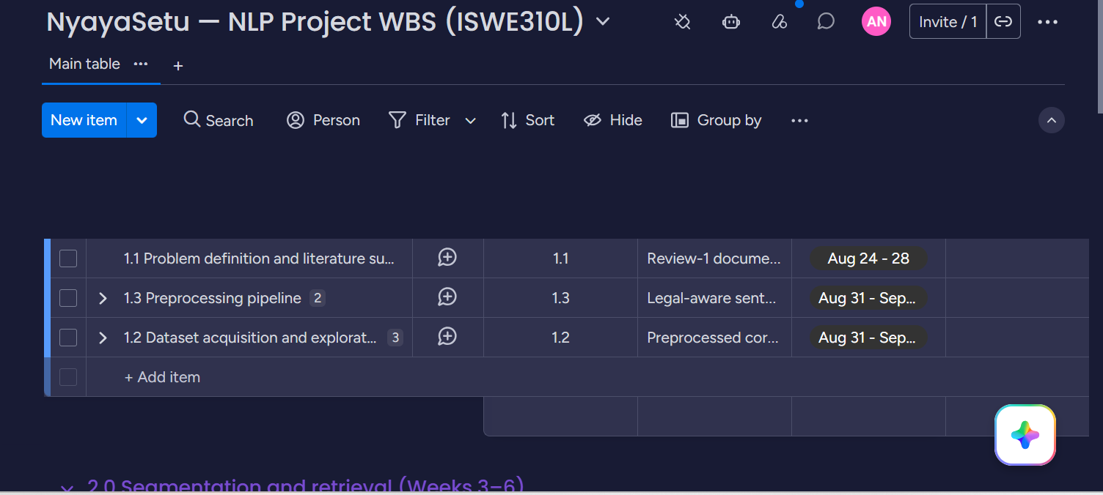
Project work-board overview
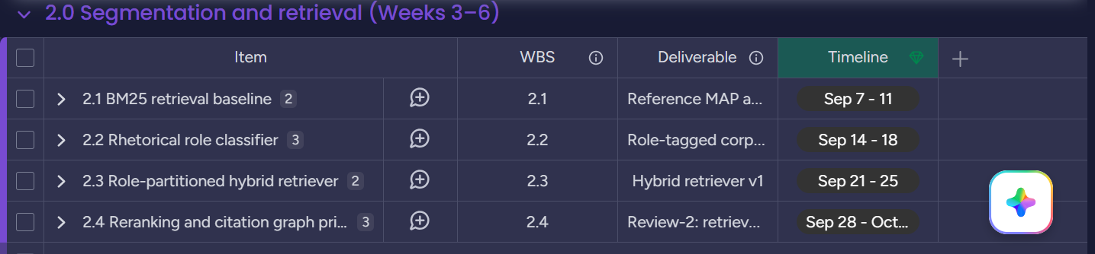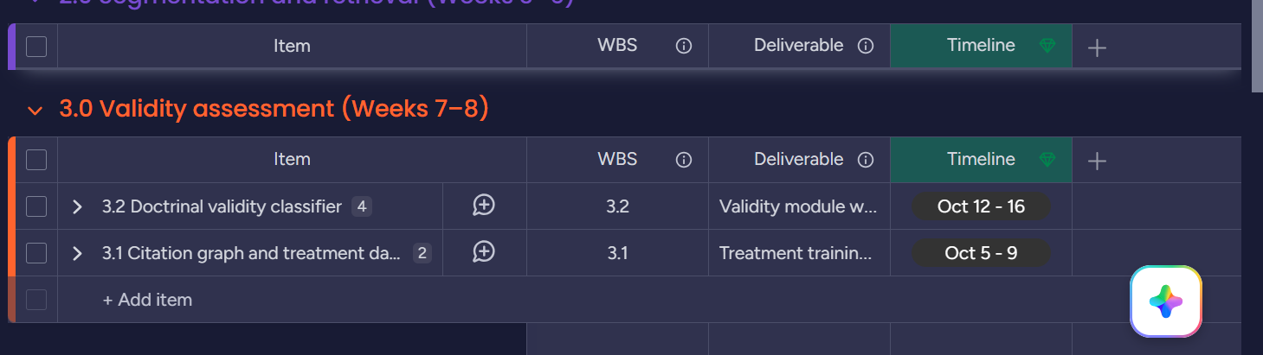
Task tracking — Stage 3
Task tracking — Stage 2
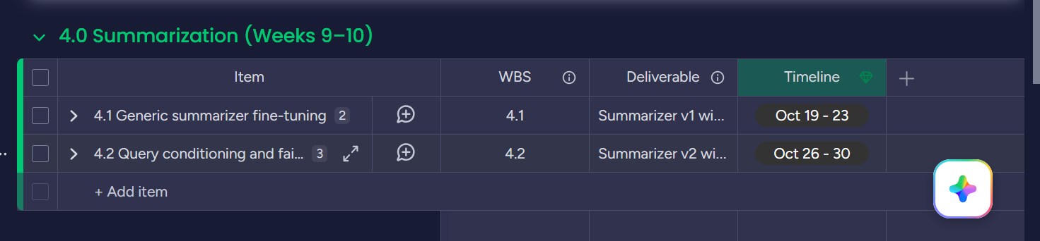
Task tracking — Stage 4
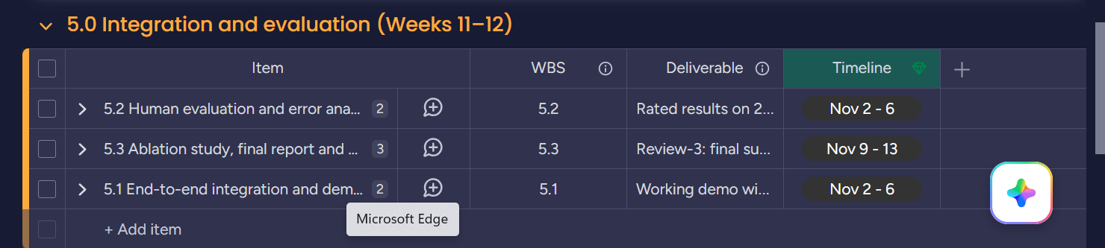
Task tracking — Stage 5

9. Expected Results
Component | Metric | Baseline | Target
Role classification | Macro-F1 over 7 roles | 50.0% majority-class accuracy; published LegalSeg baselines | Match or exceed reported transformer baselines; Issue and Reasoning recall reported explicitly
Retrieval — hybrid vs sparse | MAP, nDCG@10 | BM25, measured Week 3 | 10–20% relative MAP improvement on IL-PCR
Retrieval — reranked | P@10, MRR | Hybrid retriever v1 | Further gain, with per-component ablation isolating each contribution
Validity classification | Macro-F1 over 3 classes; coverage % | Keyword rules; zero-shot LLM; Indian Kanoon sentiment labels | Beat the rule baseline; separate distinguished from overruled where Indian Kanoon cannot; report coverage honestly
Summarization — generic | ROUGE-1/2/L, BERTScore on IN-Abs | Untuned Legal-LED | Improvement over untuned, comparable to published IN-Abs results
Summarization — query-focused | Role coverage on IN-Ext; blind human rating 1–5 | Generic summarizer output | Higher rated relevance for the same judgment under differing queries — the central claim
Faithfulness | Sentence-level entailment rate | Unfiltered generation | Measurable reduction in unsupported sentences, rejection log published
End-to-end | LLM-only pipeline comparison | GPT-class retrieval-and-summarize | Win on validity accuracy and faithfulness even if summary fluency is comparable

