E-Commerce Sales Analysis Using MySQL and Power BI
Project Type: Data Analytics Portfolio Project
Tools Used: MySQL, SQL, Microsoft Power BI, DAX

1. Project Overview
E-commerce businesses generate large amounts of data about orders, products, customers, payments, reviews, and deliveries. Analysing this data helps businesses understand their sales performance and improve customer satisfaction.
This project analyses the Brazilian Olist e-commerce dataset using MySQL and Microsoft Power BI. SQL queries are used to extract and analyse business information, while Power BI dashboards present the results through interactive visualisations.
The project focuses on sales performance, product categories, customer behaviour, payment methods, customer reviews, and delivery performance.

2. Project Objectives
The main objectives of this project are:
- Calculate total product sales and average order value.
- Analyse monthly sales trends.
- Identify top-performing product categories.
- Understand customer distribution across states.
- Analyse customer review scores.
- Compare payment methods by payment value.
- Evaluate order statuses and delivery performance.
- Present business findings using Power BI dashboards.

3. Dataset Description
This project uses the Brazilian Olist e-commerce dataset, which contains information about customers, orders, products, sellers, payments, and customer reviews.
The analysis uses seven tables:
- Customers: Customer identifiers and location details.
- Orders: Order dates and order statuses.
- Order Items: Products purchased, prices, and seller information.
- Payments: Payment types and payment amounts.
- Products: Product details and category information.
- Reviews: Customer ratings and review information.
- Sellers: Seller identifiers and location details.
These tables provide information for analysing sales, customer behaviour, product performance, and delivery outcomes.

4. Tools and Technologies Used
Tool | Purpose
MySQL | Storing and querying the dataset
SQL | Analysing sales and business performance
Microsoft Power BI | Creating interactive dashboards
DAX | Calculating measures and key performance indicators
CSV files | Providing the original dataset

5. Project Methodology
The project follows these steps:
Step 1: Data collection
The Brazilian Olist dataset was obtained in CSV format.
Step 2: Database creation
A MySQL database named ecommerce_sales was created.
Step 3: Data import
The seven dataset tables were imported into MySQL.
Step 4: SQL analysis
SQL queries were used to calculate sales, analyse order statuses, compare payment methods, examine customer reviews, and evaluate delivery performance.
Step 5: Power BI connection
The data was connected to Microsoft Power BI to create visualisations and calculate key performance indicators.
Step 6: Dashboard development
Three dashboards were developed to present sales, product and customer performance, and delivery insights.
Step 7: Business interpretation
The results were used to identify patterns and support data-driven business decisions.

6. Power BI Dashboard Development
Three interactive dashboards were developed to analyse different aspects of the e-commerce business.

6.1 Dashboard 1: Sales Overview
Purpose: To understand overall sales performance and payment preferences.
Key Performance Indicators (KPIs):
- Total Sales
- Average Order Value
- Delivered Orders
- Cancelled Orders
Visualisations:
- Top 10 Product Categories by Sales
- Monthly Sales Trend
- Payment Methods by Total Value
Business value: This dashboard helps identify sales trends, understand product category performance, and compare the value of different payment methods.

6.2 Dashboard 2: Product and Customer Analysis
Purpose: To understand customer distribution and customer satisfaction.
Visualisations:
- Sales by Customer State
- Orders by Customer State
- Customer Review Scores
- Total Reviews
- Review Score Filter
Business value: This dashboard helps identify important customer locations and understand how customers rate their shopping experiences.

6.3 Dashboard 3: Delivery and Business Insights
Purpose: To evaluate delivery performance and order fulfilment.
Key Performance Indicators:
- Average Delivery Time
- On-Time Deliveries
- Late Deliveries
Visualisations:
- Order Status Distribution
- On-Time vs Late Deliveries
Business value: This dashboard helps monitor delivery performance and identify opportunities to improve customer experience.

7. Key Project Results
The analysis produced the following results:
Metric | Result
Total product sales | R$13,591,643.70
Average product sales per order containing items | R$137.75
Total orders | 99,441
Delivered orders | 96,478
Cancelled orders | 625
Total unique reviews | 98,410
Average review score | 4.09 out of 5
Average delivery time | Approximately 12.50 days
Note: Total product sales are calculated using product item prices and exclude shipping charges. Delivery metrics depend on orders with the required date information.

8. SQL Analysis
MySQL was used to analyse the e-commerce dataset and extract useful business information.
The main SQL analyses performed were:
- Sales Analysis: Calculated total product sales and average sales per order containing items.
- Order Status Analysis: Examined delivered, cancelled, shipped, and other order statuses.
- Product Category Analysis: Identified product categories generating the highest sales.
- Monthly Sales Analysis: Analysed sales trends across different months.
- Customer Analysis: Examined customer distribution across Brazilian states.
- Payment Analysis: Compared payment methods by transaction count and total payment value.
- Review Analysis: Analysed customer ratings and calculated the average review score.
- Delivery Analysis: Compared actual delivery dates with estimated delivery dates to identify early, on-time, and late deliveries.
SQL aggregation functions, filtering, grouping, joins, and date calculations were used where appropriate.

9. Business Insights and Recommendations
The project findings provide several useful business insights.

9.1 Sales Performance
Total product sales were approximately R$13.59 million.
Recommendation: Monitor monthly sales trends and investigate periods with unusually high or low sales to improve sales planning.

9.2 Customer Satisfaction
The average customer review score was 4.09 out of 5.
Recommendation: Monitor low-rated reviews and investigate recurring complaints to identify opportunities to improve customer satisfaction.

9.3 Delivery Performance
The analysis identified both on-time or early deliveries and late deliveries.
Recommendation: Monitor late deliveries, investigate the causes of delays, and work with sellers and delivery partners to improve fulfilment performance.

9.4 Customer Distribution
Customer analysis showed that São Paulo had the largest customer count among the states examined.
Recommendation: Study customer demand by state to support regional marketing and delivery planning.

9.5 Payment Preferences
Credit cards represented the largest payment value among the payment methods analysed.
Recommendation: Monitor payment preferences and ensure that customers have convenient and reliable payment options.
These recommendations are based on the patterns identified in the project. Further analysis would be needed to determine the causes of these patterns.

10. Skills Demonstrated
This project demonstrates the following technical and analytical skills:
- SQL querying and data aggregation
- Relational database management using MySQL
- Data analysis and validation
- Power BI dashboard development
- DAX measures and KPI calculations
- Data visualisation
- Business insight generation
- Analytical problem-solving

11. Conclusion
The E-Commerce Sales Analysis project demonstrates how SQL and Microsoft Power BI can be used together to analyse real-world business data.
MySQL was used to query and analyse sales, customers, products, payments, reviews, and delivery information. Power BI was used to present the findings through three interactive dashboards.
The project helped develop practical skills in data analysis, KPI calculation, dashboard creation, and business interpretation. It also demonstrates how data analytics can support informed business decisions.

12.Dashboard Screenshots

12.1 Sales Overview Dashboard
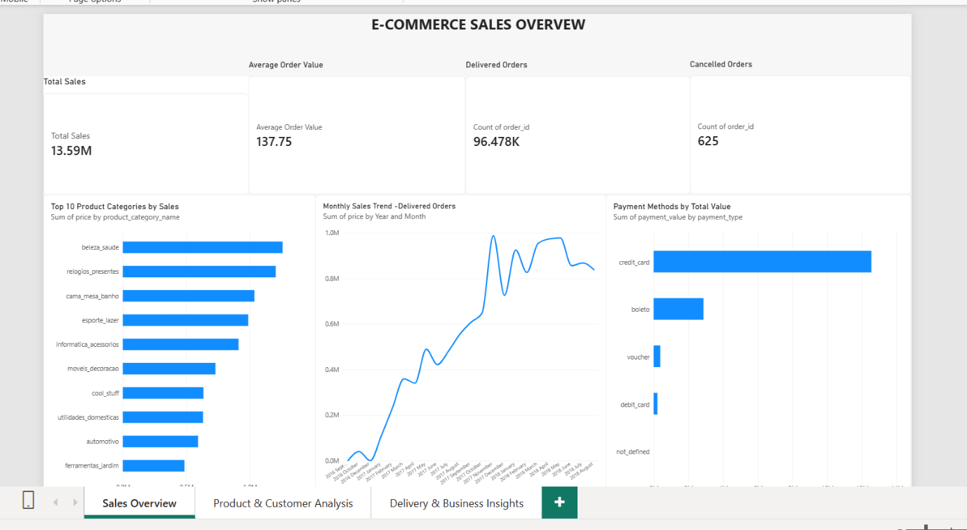

12.2 Product and Customer Analysis Dashboard
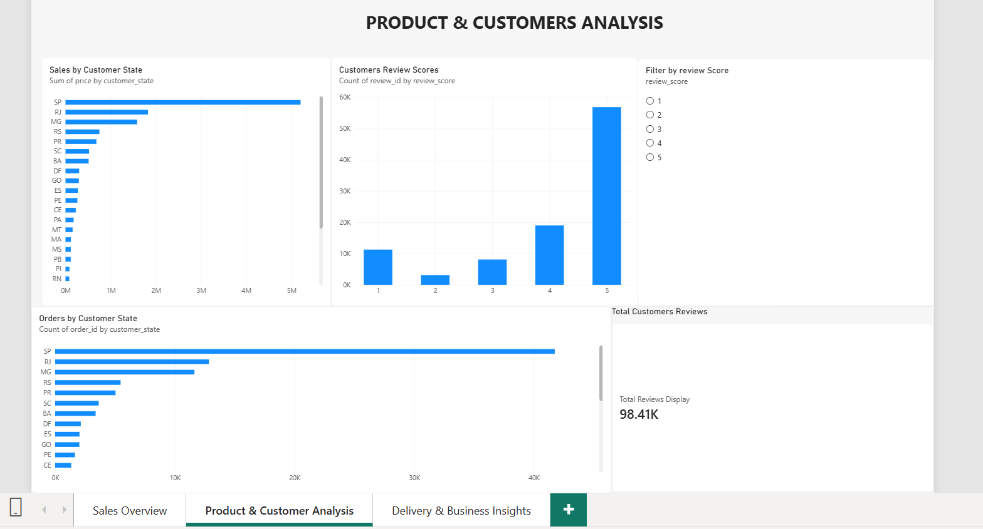

12.3 Delivery and Business Insights Dashboard
