Odd–Even Number Flowchart
Algorithm: Check whether a number is divisible by 2.
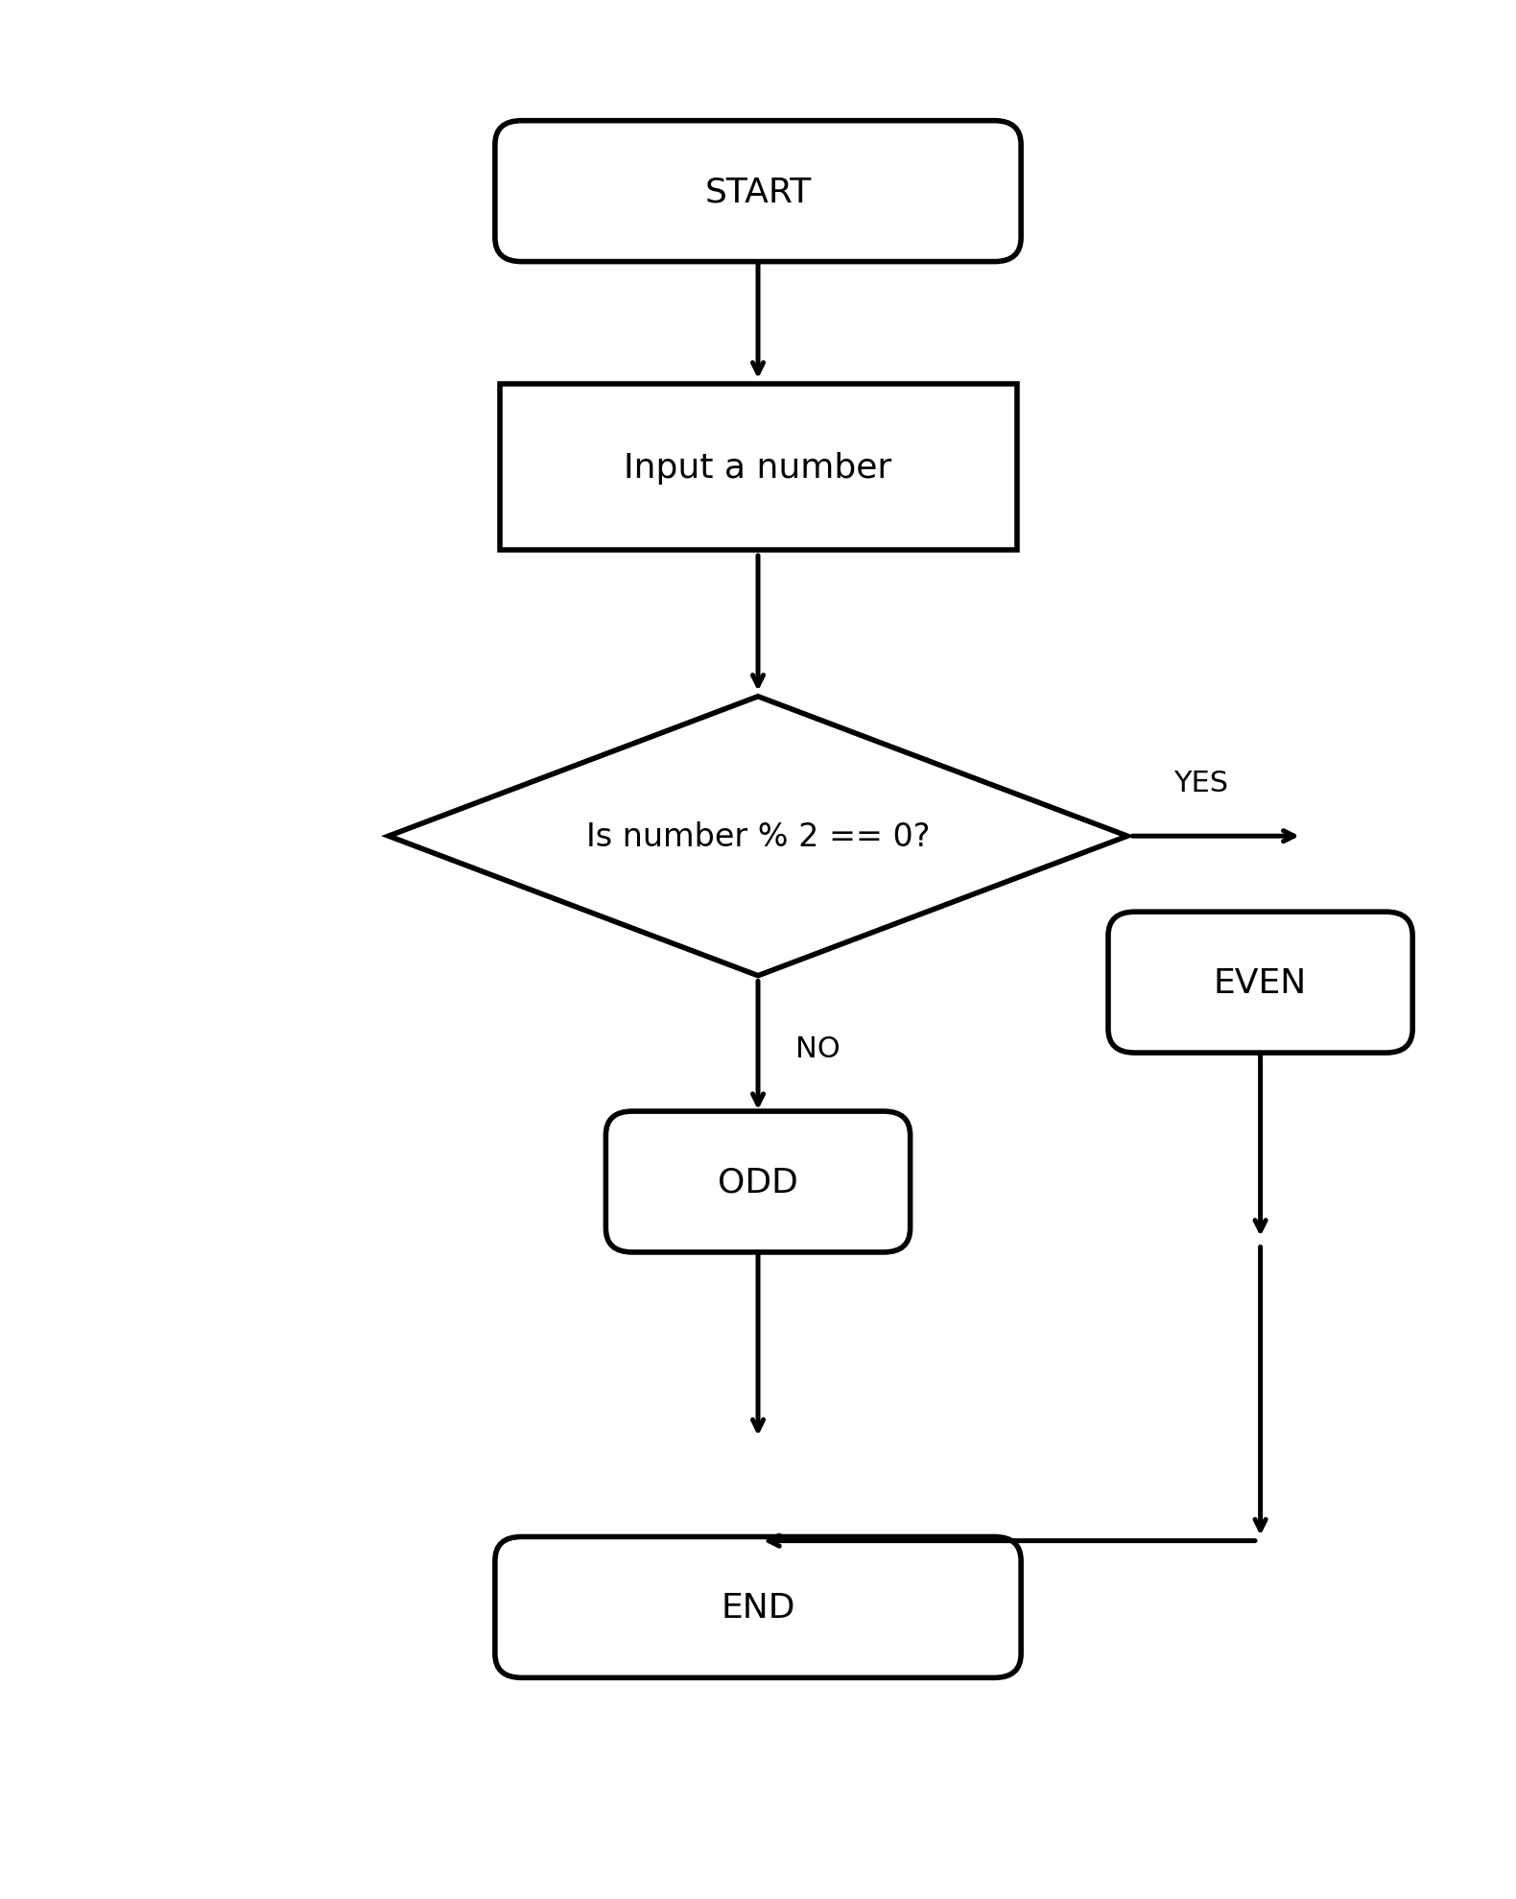

Logic: If number % 2 == 0, the number is EVEN; otherwise, it is ODD.

