Bringing people with shyness together

Team: Aishwarya Navale & Manouj Kumar Govindaraju

Date Created: September 05, 2018

Date Last Updated: September 06, 2018

# Project Overview

## Purpose

Social anxiety is the fear of situations which involves communication and interaction with other people. This problem is reported to be present in almost all areas of a person’s life. This fear is chronic and it does not cure on its own.

The purpose of this project is to help people overcome social anxiety and to improve confidence levels. It also aims at building the existing communities for these people. This project is assumed to serve as a CBT by itself.

## Objective

The key objective of this project is to design a technological solution which will reduce the anxiety level of a person suffering from social anxiety, irrespective of his/her age and location. Helping people overcome the fear of being introduced to other people and the fear of having a normal conversation is the target scope of this project.

The main goals of this project are:

* To create a Virtual Reality application to connect people within their community (of people with the same issue).
* To enable users to interact with strangers and ultimately expand the community.

# Research

## Audit of Design Precedents

Review of existing work and products. Design precedents are anything that already exists that can inform or influence your design. This includes anything that can create meaning for your design solution or even help you communicate it to others (for example, “it’s like Uber for _____ ” would mean that Uber is a design precedent even if the scenario in which someone uses the new product is much different from a scenario in which someone currently uses Uber).

## Competitive Analysis

Summarize your team’s evaluation of ‘competitor’ products such as websites, apps, etc.. Competitor products differ from precedents in that precedents are not necessarily in direct competition with your target users or stakeholders. Document how yours is/would be different.

## Heuristic Review

Summarize your team’s heuristic review of existing ‘competitor’ products.

## Stakeholders

Include a summary of key stakeholders including your Stakeholder Mapping diagram.

## User Interviews and Observations

Outline your interview process. How did you select your interviewees? Which stakeholder group(s) are they part of? Who are they demographically?

### Interview Questions

List the questions you prepared ahead of the interview. You may not ask all these questions to each interviewee but think of this as your bank of prepared questions. If you find that during the interview, you have pressing questions that are not in this list, definitely ask them. Completing this ahead of time ensures you are prepared to have a productive interview.

### Interview Findings and Observations

You should use interview worksheet(s) to help design the interviews and take notes. Keep these sheets for your reference, scan/take photos of them for your online documentation and to share with your team members. Include links and thumbnail images to them here.

#### Interview: Interviewee Name

Summarize what you learned and observed for each interview. What did you learn via your interviews? Describe any patterns or general insights you discovered through your interviewing.

#### Interview: Interviewee Name

Summarize what you learned and observed for each interview. What did you learn via your interviews? Describe any patterns or general insights you discovered through your interviewing.

#### Interview: Interviewee Name

Summarize what you learned and observed for each interview. What did you learn via your interviews? Describe any patterns or general insights you discovered through your interviewing.

### Summary of Research Findings

Then synthesize your findings after conducting the interview here.

# 

# Modeling

## Audience

Who are you targeting with your design solution? (This should be at least alluded to in the Objective section and then further described here.)

## Personas

### Persona Name

Describe the type of person you are designing this for. Include full persona documentation (based on empathy mapping) or at least an overview of each persona plus links to the complete diagram/visual for this persona.

### Persona Name

Describe the type of person you are designing this for. Include full persona documentation (based on empathy mapping) or at least an overview of each persona plus links to the complete diagram/visual for this persona.

### Persona Name

Describe the type of person you are designing this for. Include full persona documentation (based on empathy mapping) or at least an overview of each persona plus links to the complete diagram/visual for this persona.

## Concept Map

A visual that shows how your ideas/concepts are interrelated ([examples](http://creately.com/diagram-community/popular/t/concept-map)).

This may include representing domain factors beyond individual users and customers.

# 

# Requirements Definition

## User Scenarios (Context Scenarios)

Scenarios or stories about the ideal user experiences explain how the product fits into each persona's life and environment, and how it helps them achieve their goals. You should have at least a couple scenarios for each persona.

### Scenario Name

Describe a sample scenarios for how this product would actually be used and from the perspective of one of your user persona(s). Use visuals including Storyboards and media such as Animatics and other video/time-based media.

### Scenario Name

Describe a sample scenarios for how this product would actually be used and from the perspective of one of your user persona(s). Use visuals including Storyboards and media such as Animatics and other video/time-based media.

### Scenario Name

Describe a sample scenarios for how this product would actually be used and from the perspective of one of your user persona(s). Use visuals including Storyboards and media such as Animatics and other video/time-based media.

## Requirements (Design Considerations)

Describe necessary capabilities of the product. What are the key factors that drive your design solution. For example: what are the functional and data needs, user mental models, design imperatives, product vision, business requirements, technology needed?

Diagrams are welcome and encouraged throughout this section.

## Key Functionality

What are the key factors that drive your design solution?

* What should a user be able to do? When (how quickly) can they do it?
* What are key features that the app must have in order for the user to successfully use it?
* What are possible failure conditions and how are they handled?
* What one-time operations are done at the first execution (i.e., after installation)?
* If the user creates entries of any kind (e.g., bookmarks), what are the limitations?
* Generalize these ideas, and be as detailed and thorough as you can—because errors or misunderstandings here will mean extra work and rewriting code down the road.
* What does the application do? What application states (high-level descriptions of core user scenarios) will the user encounter (a) the first time using site, (b) when creating ___, (c) when doing X, Y, or Z)? Consider the type of feedback a user should receive with each event.

# 

# Design Framework

## Sitemap

A detailed model of a website's content.

## User Flows

### Task Name

A user flow is the path a user takes through a website to complete a logical task. This are at a much more detailed level than a high-level user scenario. Include the related diagram for this task user flow but also have a full-size, high resolution version in your documentation. Link to this high res version here too.

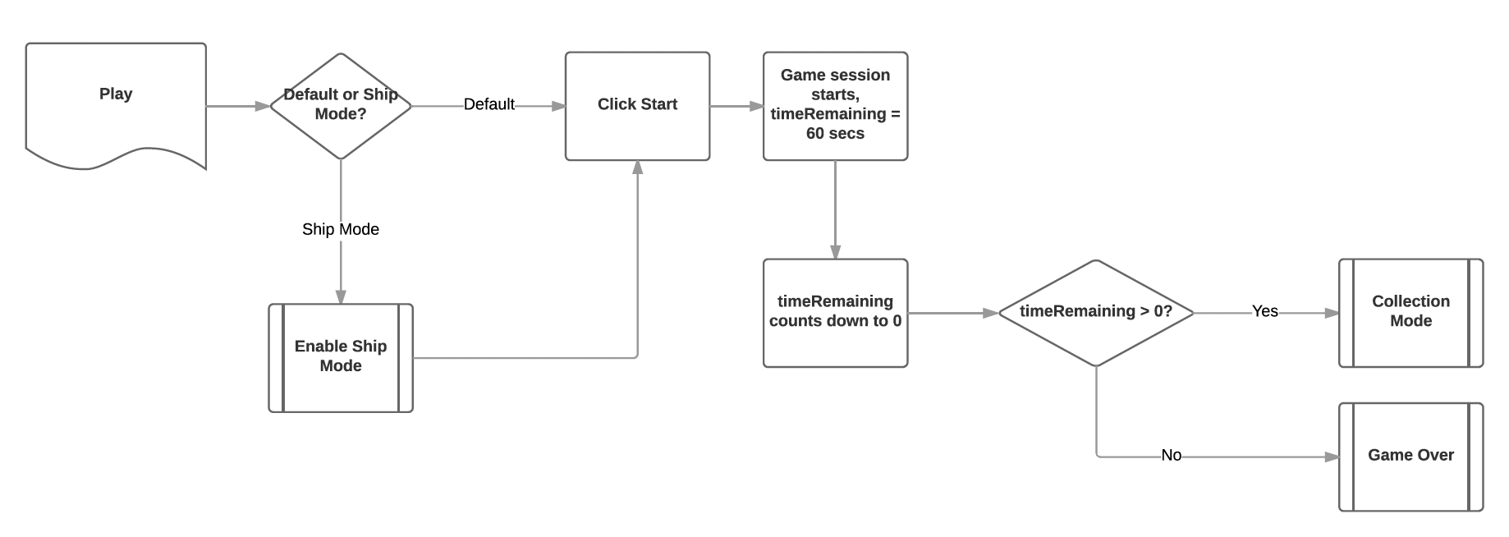

### Task Name

A user flow is the path a user takes through a website to complete a logical task. This are at a much more detailed level than a high-level user scenario. Include the related diagram for this task user flow but also have a full-size, high resolution version in your documentation. Link to this high res version here too.



### Task Name

A user flow is the path a user takes through a website to complete a logical task. This are at a much more detailed level than a high-level user scenario. Include the related diagram for this task user flow but also have a full-size, high resolution version in your documentation. Link to this high res version here too.



## 

## Wireframes

Page schematics or screen blueprints. Should outline what the experience looks like with a low-fidelity representation (for example, don’t worry about styling the interface).

## Visual mockups

A static high-fidelity visual design draft of a UI design.

## Interactive mockups

Screenshots and **link(s) to an interactive prototype** of your design.