1. In the below elements which of them are values or an expression? eg:- values can be integer or string and expressions will be mathematical operators.

*

'hello'

-87.8

-

/

6

* **\*** and **/** are mathematical operators.
* **'hello'** is a string value.
* **-87.8** and **6** are numeric values (a float and an integer, respectively).
* **-** and **+** can be either mathematical operators or unary operators, depending on how they are used in a statement.

2. What is the difference between string and variable?

**Variable is used to store data whereas string is a datatype**

3. Describe three different data types.

**String, bool, num [int,float,complex], list, tuple, dictionary, set**

4. What is an expression made up of? What do all expressions do?

5. This assignment statements, like spam = 10. What is the difference between an expression and a statement?

6. After running the following code, what does the variable bacon contain?

bacon = 22

bacon + 1

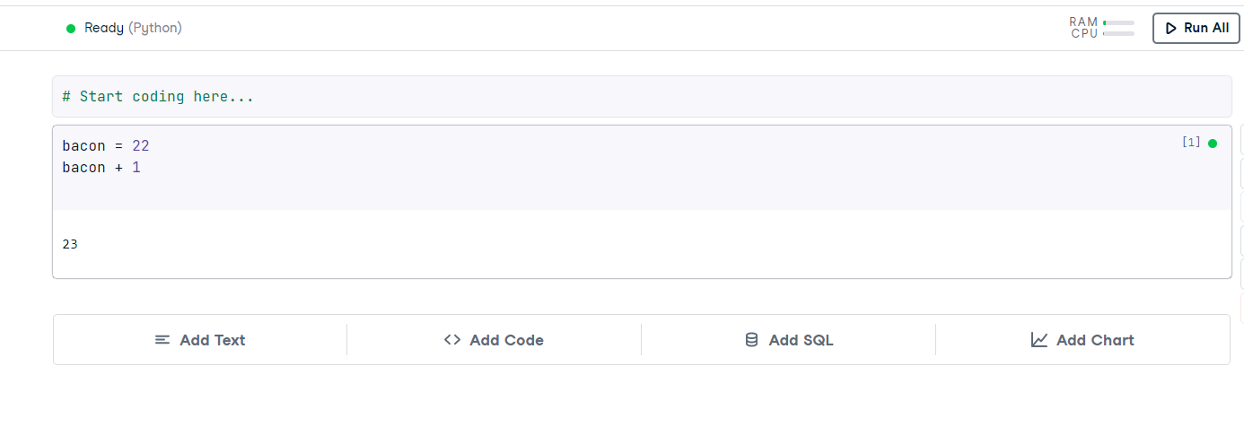

bacon = 23

7. What should the values of the following two terms be?

'spam' + 'spamspam' =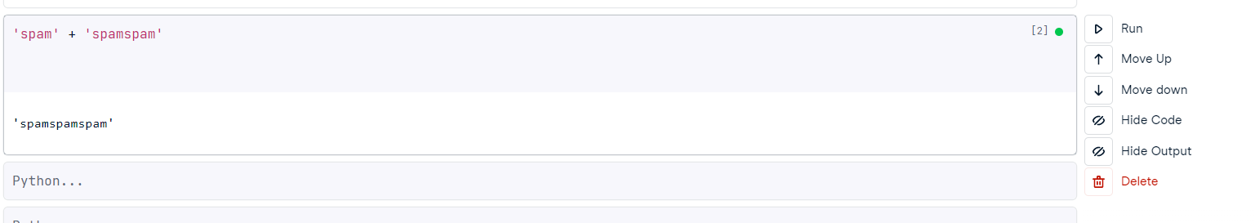

'spam' * 3

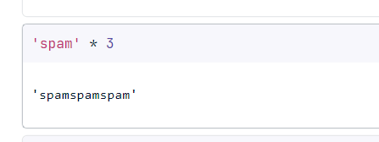

8. Why is eggs a valid variable name while 100 is invalid?

Name eggs is valid because it started with alphabet while 100 started with digit.

9. What three functions can be used to get the integer, floating-point number, or string version of a value?

The **int() , float() , and str( )** functions will evaluate to the integer, floating-point number, and string versions of the value passed to them.

10. Why does this expression cause an error? How can you fix it?

'I have eaten ' + 99 + ' burritos.'

Converting 99 to str (99) and it is fixed

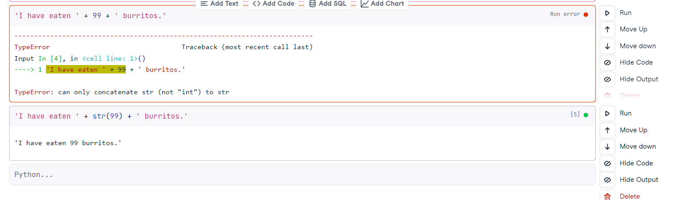

2,3,6,7,8,10

1,4,5,9

Remaining Question ANSWERS:

4TH = In Python, an expression is a combination of values, variables, operators, and function calls that can be evaluated to produce a result.

Expressions are used to represent and perform calculations or operations on data. For example, the following are all expressions in Python:

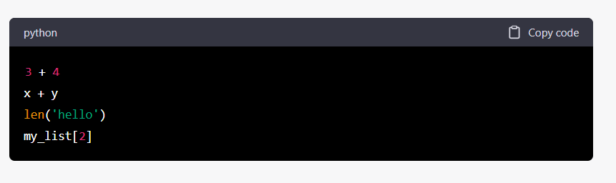In the above examples, 3 + 4 and x + y are expressions that evaluate to a numeric value (assuming that x and y are assigned numeric values). len('hello') is an expression that evaluates to the length of the string 'hello'. my_list[2] is an expression that evaluates to the third element in the list my_list.

Overall, expressions are fundamental building blocks of Python programming and are used extensively in mathematical and logical operations, as well as in accessing and manipulating data structures such as lists, dictionaries, and tuples.

**5th question answer**

Ans 5th = **In programming, an expression is a combination of values, variables, operators, and function calls that produce a result. It can be used as a part of a larger expression, as a parameter to a function or method, or as the target of an assignment statement.**

A statement, on the other hand, is a unit of code that performs an action. It can be an assignment statement, an if statement, a while loop, a function definition, and so on. A statement usually does not produce a value on its own, although it may use expressions to compute a result.

In the example you provided, "spam = 10" is an assignment statement that assigns the value 10 to the variable "spam". The expression on the right-hand side of the equals sign, "10", is an example of a simple expression.

In summary, an expression is a combination of values and operators that can be evaluated to produce a result, while a statement is a unit of code that performs an action, such as assigning a value to a variable.

x = 25 *# a statement*

x = x + 10 *# an expression*

spam = 10 is a statement , is a unit of code that performs an action