1,4,5,6,7,8,13

1.What are the two values of the Boolean data type? How do you write them?

**True and False are two different types of Boolean datatypes**

2. What are the three different types of Boolean operators?

3. Make a list of each Boolean operator's truth tables (i.e. every possible combination of Boolean values for the operator and what it evaluate ).

4. What are the values of the following expressions?

(5 > 4) and (3 == 5) = False

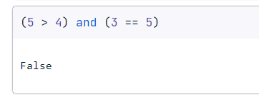

not (5 > 4) = False

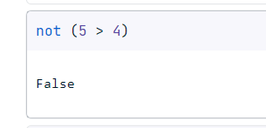

(5 > 4) or (3 == 5) = True

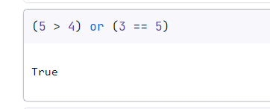

not ((5 > 4) or (3 == 5))

(True and True) and (True == False) = False

(not False) or (not True) = True

5. What are the six comparison operators?

> (greater),<(less),>= (greater than or equal to) ,<= (less than or equal to), ==, !=(not equal to)

6. How do you tell the difference between the equal to and assignment operators? Describe a condition and when you would use one.

Assignment is = and Equal is ==

7. Identify the three blocks in this code:

spam = 0

if spam == 10:

print('eggs')

if spam > 5:

print('bacon')

else:

print('ham')

print('spam')

print('spam')

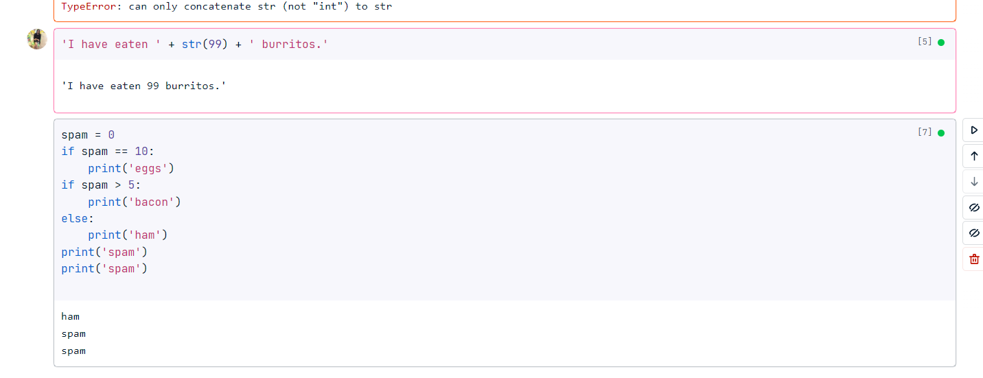

8. Write code that prints Hello if 1 is stored in spam, prints Howdy if 2 is stored in spam, and prints Greetings! if anything else is stored in spam.

spam = 2 # or any other value

if spam == 1:

print("Hello")

elif spam == 2:

print("Howdy")

else:

print("Greetings!")

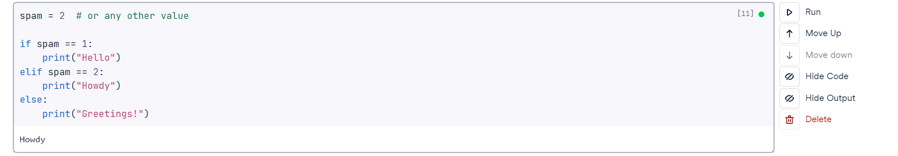

9.If your programme is stuck in an endless loop, what keys you’ll press?

If your Python program is stuck in an endless loop, you can press **Ctrl + C** to send a **Keyboard Interrupt** signal to the running program. This will terminate the program and raise a **Keyboard Interrupt** exception.

10. How can you tell the difference between break and continue?

The main difference between **break** and **continue** is that **break** is used to exit the loop entirely, while **continue** is used to skip the current iteration of the loop and move on to the next iteration.

11. In a for loop, what is the difference between range(10), range(0, 10), and range(0, 10, 1)?

Range(10): It will print numbers from 0 to 9

Range(0,10): It will print numbers from 0 to 9

Range(0,10,1): It will print numbers skipping alternate numbers

12. Write a short program that prints the numbers 1 to 10 using a for loop. Then write an equivalent program that prints the numbers 1 to 10 using a while loop.

for i in range(1,11):

print(i)

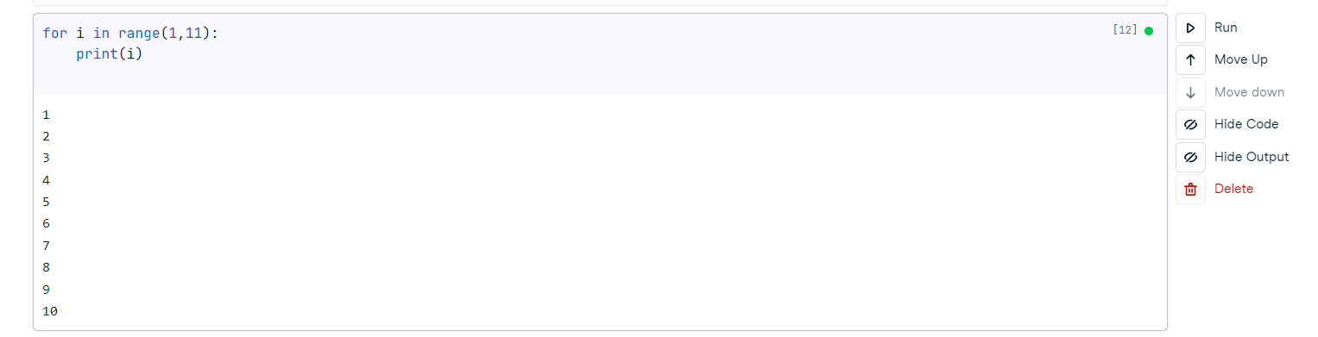

13. If you had a function named bacon() inside a module named spam, how would you call it after importing spam?

Two ways :

1. First Method

From spam import bacon

Bacon ()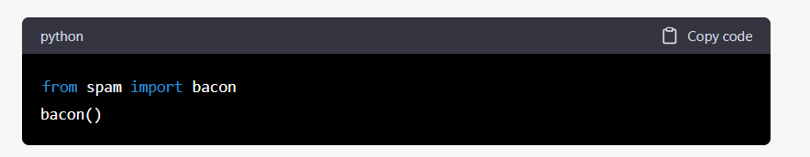

1. Second Method

Import spam

Spam.bacon()

