- Appliaction UI which contains Connect Jira button which will allow user to connect with jira
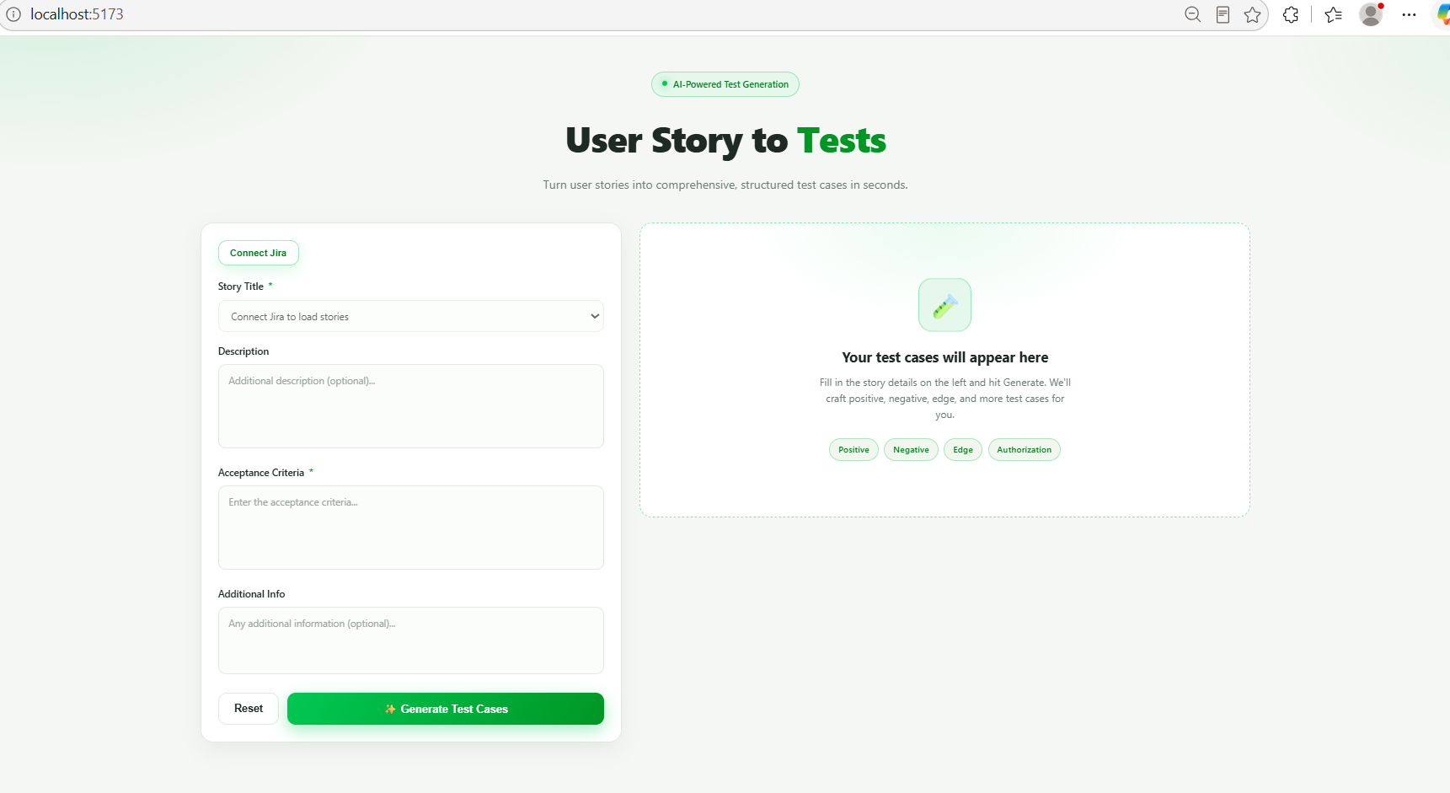

- When user click on “Connect Jira” button a dialog box will be displayed, here user will enter Base url, Email ID and Jira API Token
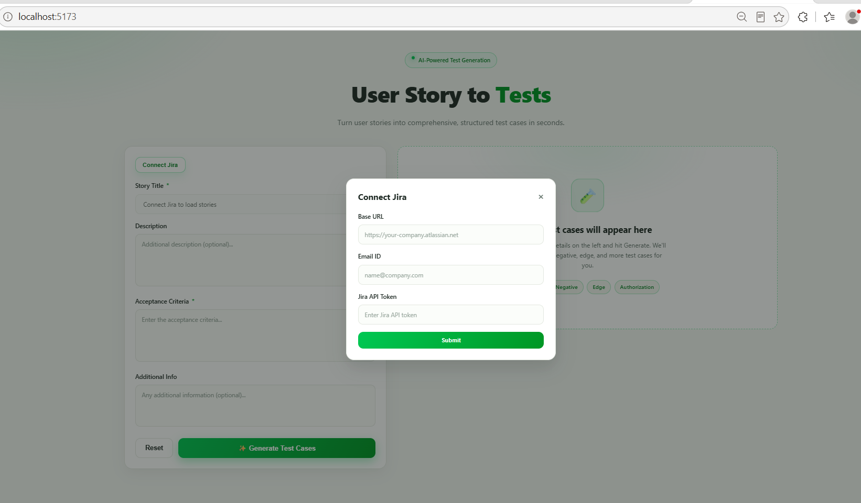
- Once user populate all details then user click on “Submit” button to establish the connection between Jira and application such that it will fetch all stories in application
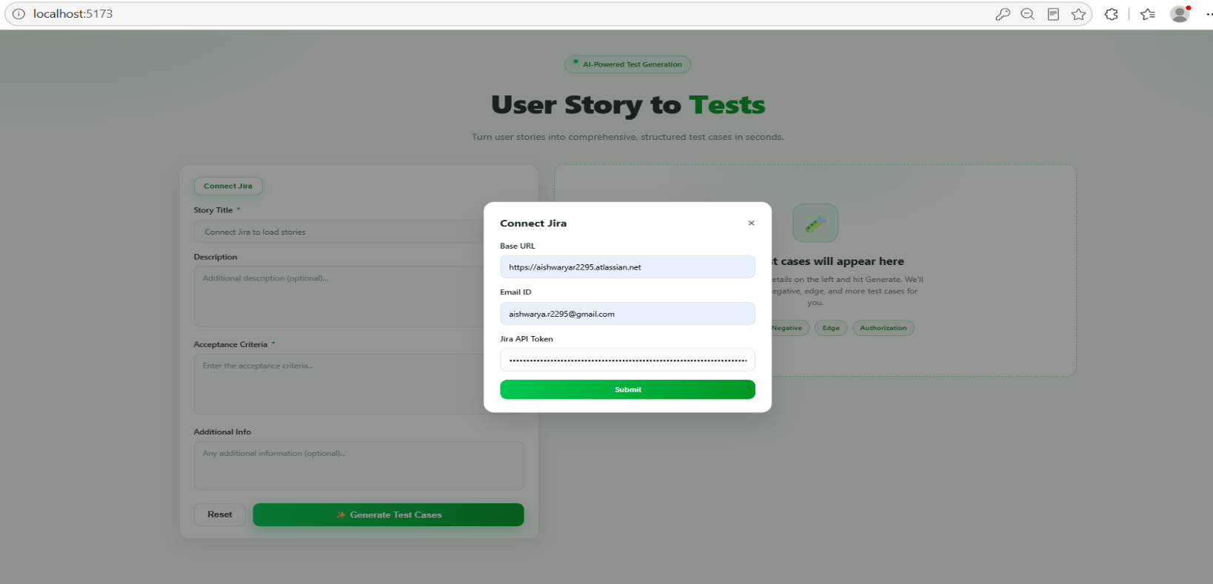

- After successful connection the title of “Connect Jira” button will be converted to “Reconnect Jira”
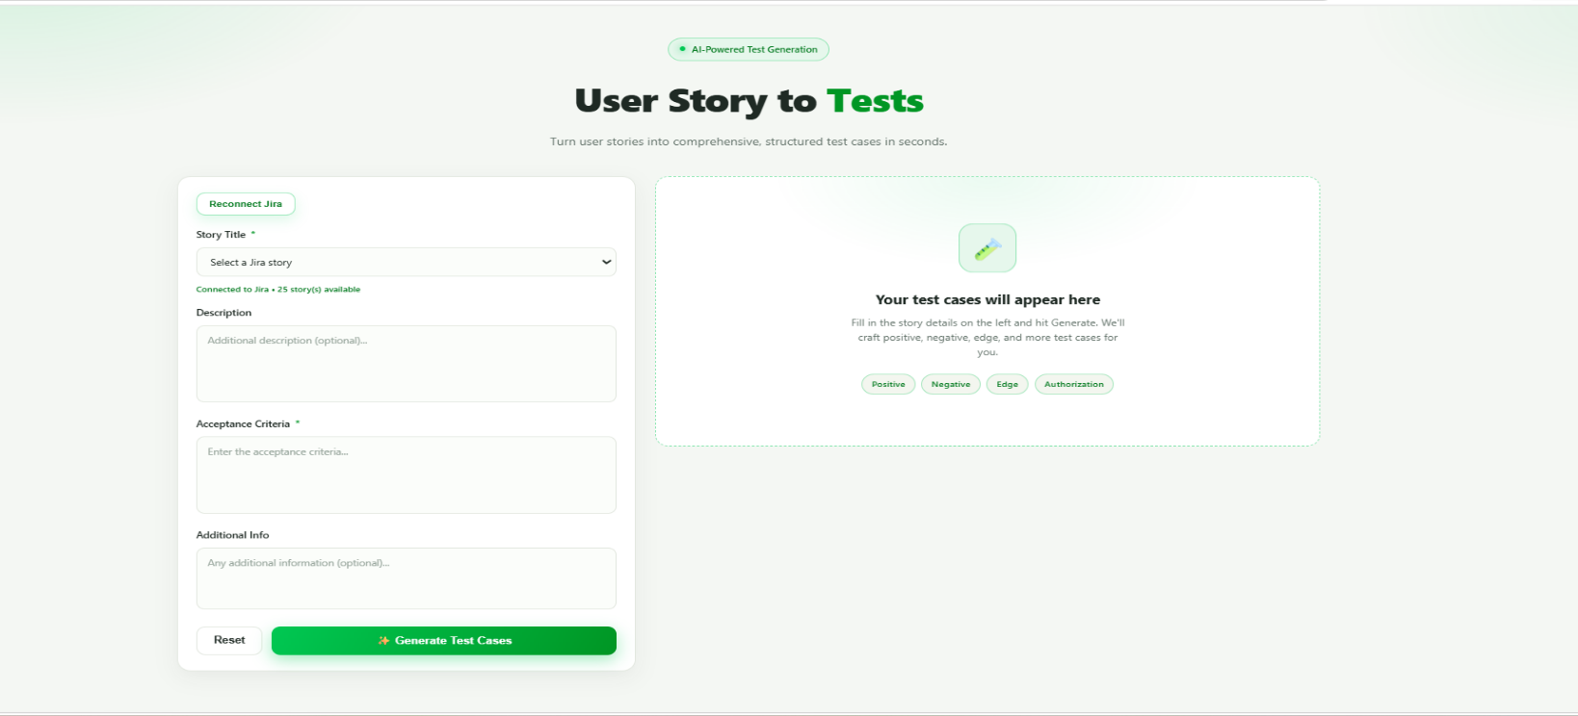

- Now “Story title” field will contain all list of stories from jira
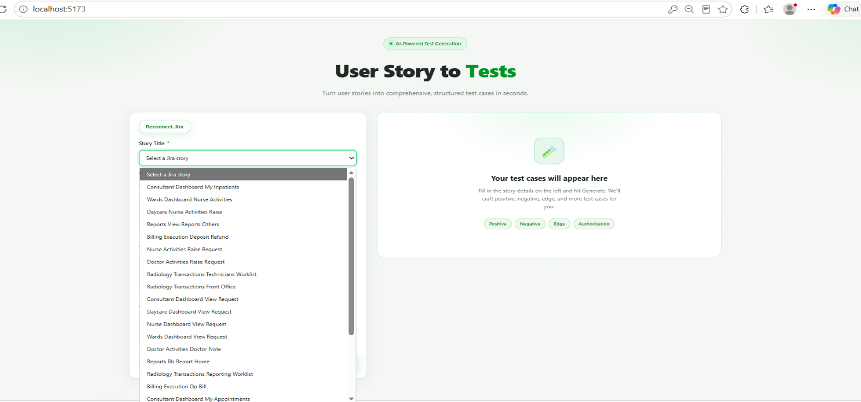

- When user select any story, details related to that story will be fetched from Jira
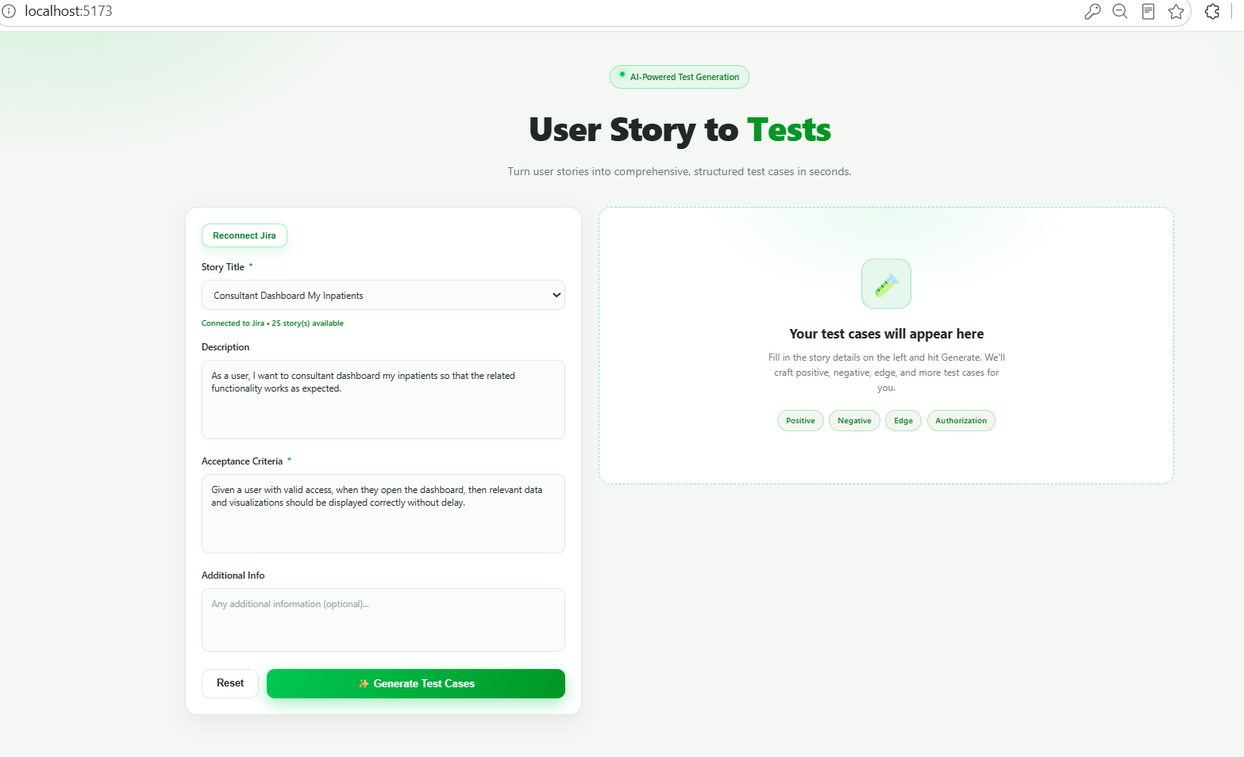

- Click on “Generate Testcases” button to generate testcases
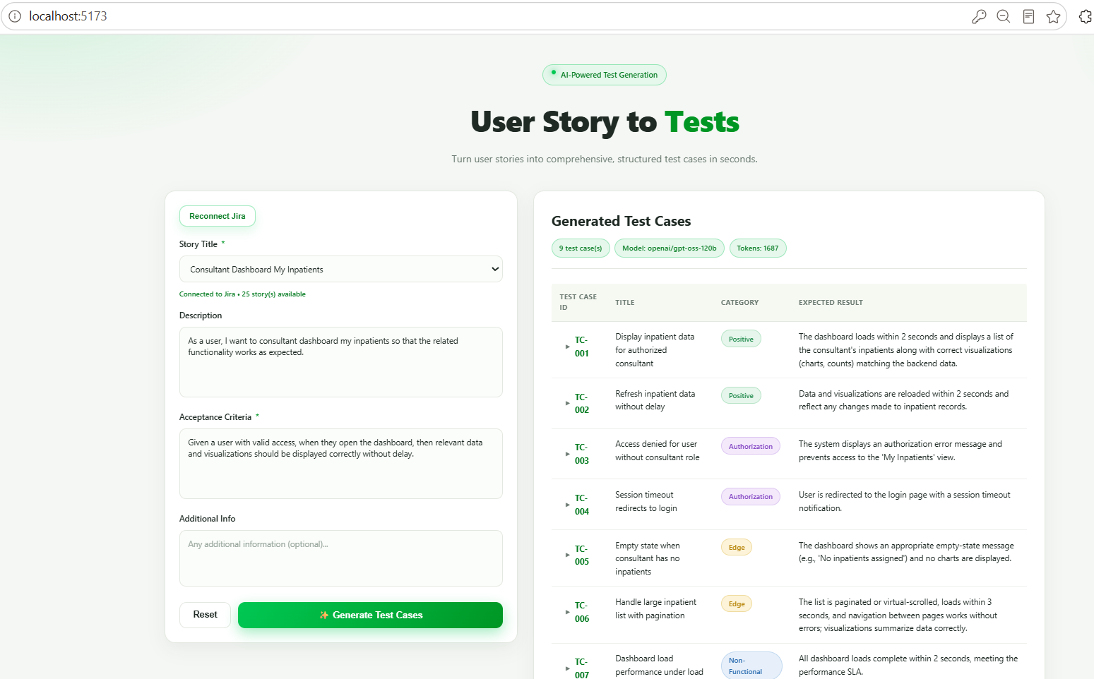

- When user click on “Reset” button both input and output side of data will get cleared but jira will remain connected and “Story Title” field will be set to default value
